Making It Real Forum
“How do we listen to people as equals?”
Update on our November Workshop – 13th Nov 2025
In this update, we want to tell you about a workshop that was held in November at County Hall. We want to share the background to the workshop, what happened on the day and to let you know how you can be involved in the next steps.

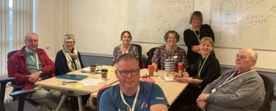
The workshop included people and carers with lived experience and staff from the County Council

Workshop background and content
In July 2025, we had three workshops that focused on different aspects of the department’s recent re-structure to an All-Age Service. From these workshops, consent and advocacy were identified as areas we needed to think more about in assessment and review conversations.
As a next step, we planned our November workshop to discuss how the department listens to people as equals, and thought about the following questions:
- What works and helps? What do we need to see more of?
- What does not work that we should stop doing?
- What practical steps can we recommend to the forum?

The following table shows the slides we used to start the workshop
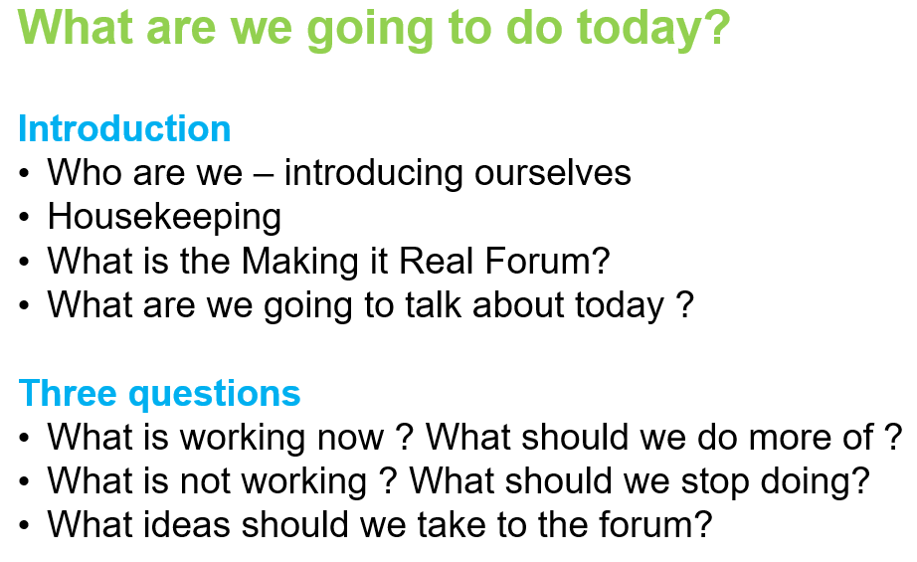
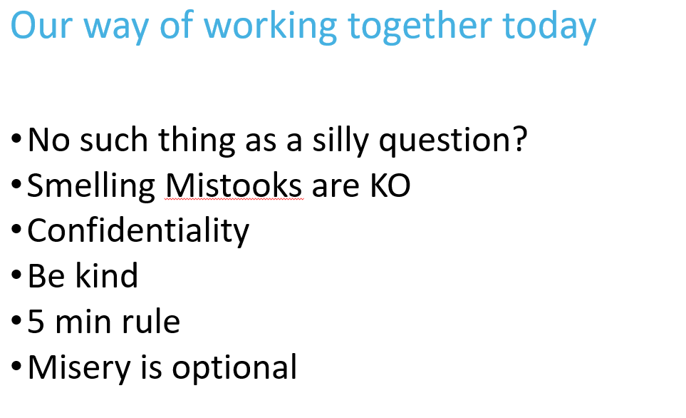
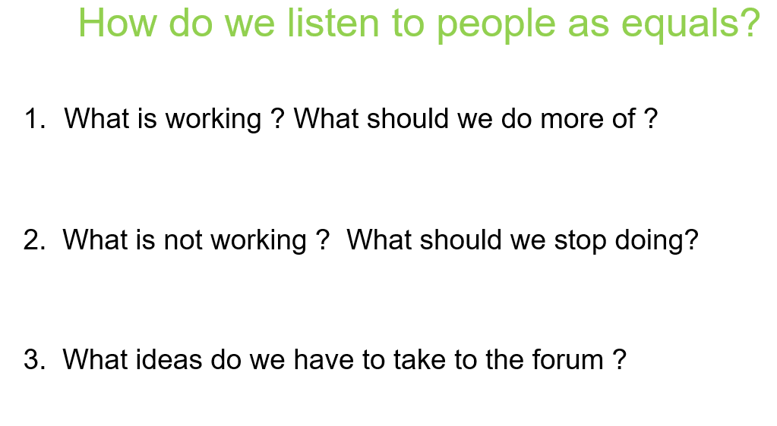
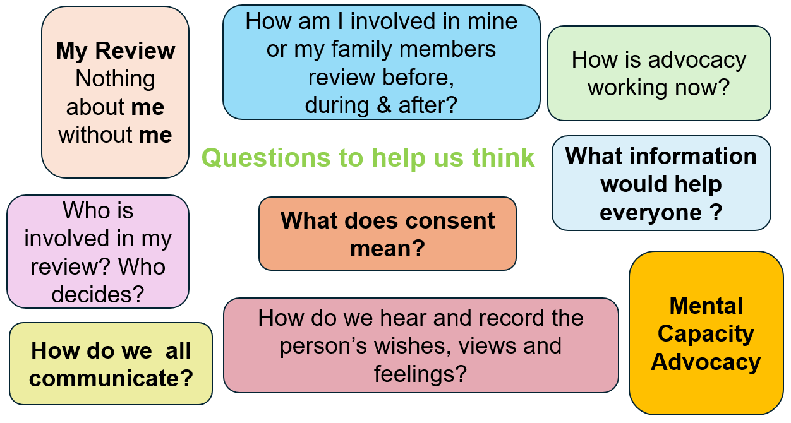

Workshop outputs
There were some great conversations and people used post it notes to capture their thoughts. The conversation started small with groups of 1-2 people but ended up with the whole room grouping the ideas and agreeing on the priorities.
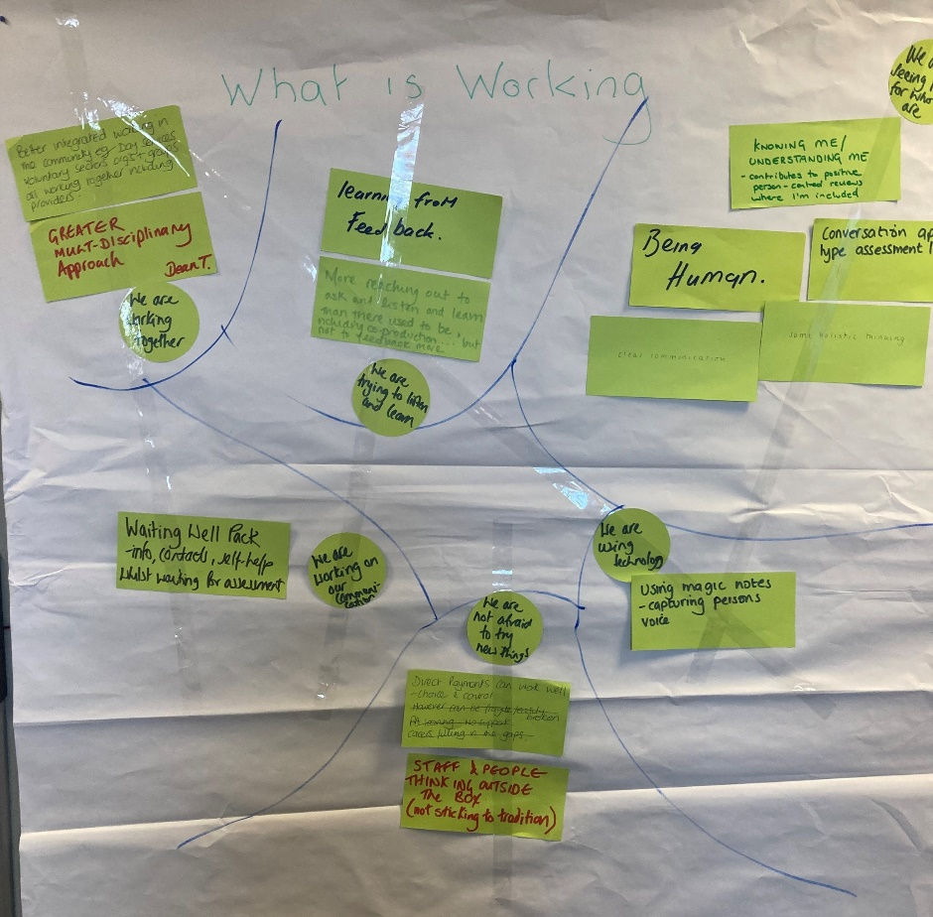

What is working well?

1. “We are seeing people for who they are”
People feel more recognised and included when the focus is on the individual.
- Knowing me and understanding me contributes to positive person-centred reviews where I am included.
- Being human.
- Conversations tailored to the type of assessment.
- Some holistic thinking.
- Clear communication.

2. “We are using technology”
Digital tools are helping to improve recording and capture the person’s voice.
- Using technology.
- We are using Magic Notes.
- Capturing the person’s voice.

3. “We are not afraid to try new things”

Teams are increasingly open to new ideas and creative solutions.
- We are not afraid to try new things.
- Direct payments can work well; choice and control is given.
- Staff and people thinking outside the box.
- Not sticking to tradition.

4. “We are working on our communication”

Efforts are being made to strengthen communication and keep people informed.
- Working on our communication.
- Waiting well pack - info, contacts, and self-help while waiting for assessment.

5. “We are trying to listen and learn”
The culture is shifting toward feedback, learning, and shared decision-making.
- Learning from feedback.
- More reaching out to ask, listen, and learn than there used to be before including co-production (but feedback could be increased).
- We are trying to listen and learn.

6. “We are working together”
Partnership working across sectors is improving.
- Better integrated working in the community of Day services, voluntary sector, providers, and groups working together.
- Greater working together including providers.

We are working together.

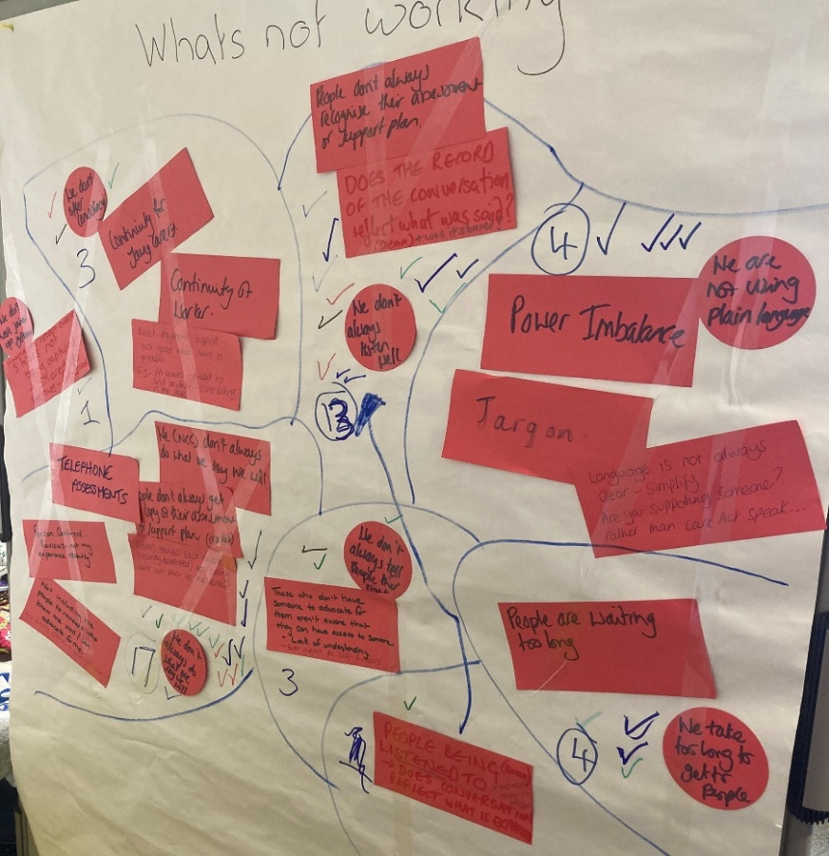

What is not working well?

1. “We (NCC) don’t always do what we say we will”
- People don’t always get a copy of their assessment or support plan drafted.
- Carer review – fact sheet recently developed not being sent out prior to reviews.
- Not including the people in the review who know me well and can advocate for me.
- Person-centred reviews not my experience recently.
(17 votes)

2. “We don’t always listen well”
- People said people don’t always recognise their assessment or support plan.
- Does the record of conversation reflect what was said and what was shared?
- We don’t always listen well.
- People being listened to, does conversation reflects what was expressed.
(13 votes)

3. “We take too long to get to people”
- People are waiting too long.
- We take too long to get to people

(4 votes)

4. “We are not using plain language”
- We are not using plain language.
- Power imbalance
- Jargon.
- Language is not always clear- simplify
- Are you supporting someone? rather than “carer speak”?
- Telephone assessment

5. “We don’t always tell people their risks”
- We don’t always tell people their risks.
- Those who don’t have someone to advocate for them aren’t aware that they can have access to someone. “Lack of understanding.”

Better support for self-funders. (3 votes)

6. “We don’t offer consistency”
- Continuity for young carers.
- Continuity for workers.
- Direct payment support not good when we have a problem. e.g.PA leavers — need to find another PA.Carers filling in the gaps. (3 votes)

7. “We don’t have a joined-up system”
- We don’t have a joined-up system.
- Stories are not being captured and shared. (1 vote)

What’s next?
Friday 5th December
Members of the Making It Real forum are going to meet on Friday 5th December to discuss the workshop and the potential actions that could be taken forward to address the issues that were identified
Wednesday 7th January
The next meeting of the Making it Real forum takes place on Jan 7th and as part of that meeting:
- We will review the potential actions arising from the November workshop
- We will be discussing the next topic that will be explored which is the potential for people to be supported by a named Social Care worker

Thanks to people who came to the workshop if anyone has other thoughts on “How do we listen to people as equals?” please let us know and they will be shared at the next MIR forum meeting in January 2026.

You can share your ideas by emailing Our Voice.
ourvoice@nottscc.gov.uk

In the meantime, we will update our webpage with any actions agreed on December 5th
Adult Social Care Local Account | Nottinghamshire County Council

Further information about the Making It Real Forum (MIRF)
What is it?
The Making it Real Forum (MIRF) brings people and carers with lived experience of Adult Social Care (ASC) together with the Senior Leadership Team of the ASC department six times a year. Three people from our voice strategic co -production group attend to provide oversight, but other members of the public people are welcome to attend if they are interested in a particular topic.
The purpose of the Making it Real Forum is to oversee the Adult Social Care Local Account by making sure the quality of Adult Social Care in Nottinghamshire is good.
What does it do?
The MIRF use what people say at meetings, events, through surveys, complaints and at listening spaces to:
- Check how well the Adult Social Care department is doing against the Local Account by identifying where things are going well and areas that need improvement.
- Agreeing actions to make things better and check how well these are working.
- Promote a culture of involvement and feedback.
The MIRF want to make sure that people and carers with lived experience of social care can get involved and help co-produce solutions to problems that make a positive difference to people.
What are they currently focused on?
Following a workshop in July about the re-design of the Community and Therapy Teams into an All-Age service, the MIRF are focused on two workstreams:
How do we listen to people as equals?
- The workshop for this was held 13th November 2025
- MIRF members will now work with the outputs from that workshop to identify and deliver specific improvements
A named Social Care Worker
- Research undertaken by the Social Care Institute (SCIE) into the impact of having a consistent social care worker for people and carers shows incredibly positive outcomes.
- This workstream will explore the potential for us to adopt a named care worker approach and where this might be possible.
How can you be involved?
- If you would like to be involved in either or both workstreams then please contact the Coproduction team via their email address which is ourvoice@nottscc.gov.uk

