Parent and Carer Questionnaire:
Post-16 Travel Assistance Consultation

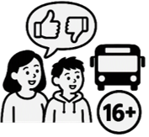
We want to know what you think about travel support for young people aged 16 to 25 with SEND (Special Educational Needs and Disabilities).


Your answers will help us understand what support is important to you and what you think about our ideas for changes in the future.


If you want more information, you can read our Post-16 Travel Assistance Consultation easy read. It tells you about the changes we are thinking about, and why we are changing Post-16 SEND Travel Assistance.

Section A: About you

A1) Where in Nottinghamshire do you live?

☐Ashfield


☐Bassetlaw

☐Broxtowe

☐Gedling

☐Mansfield

☐Newark and Sherwood

☐Rushcliffe


☐Nottingham City


☐Outside Nottinghamshire


☐Prefer not to say


☐Other or not sure


A2) Which school, college or place of learning does your young person go to?

Please write their school in the box below:


☐Or prefer not to say.


A3) How many days a week does your young person go to school, college or place of learning?

☐Less than 1 day
☐1–2 days
☐3–4 days
☐5 days


A4) Do you get Post-16 SEND travel assistance from Nottinghamshire County Council now?


☐Yes

☐No


☐Not sure

☐Prefer not to say


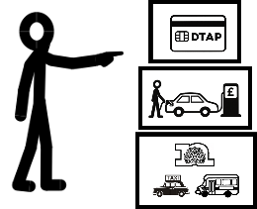
A5) If you do, what type of Post-16 SEND travel assistance do you get now?

☐Parent mileage
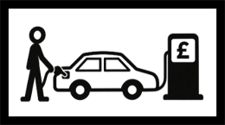

☐DTAP grant

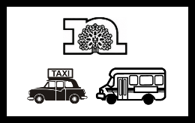
☐Council-organised transport

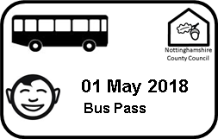
☐Bus pass with Independent Travel Training


☐Not sure


☐Prefer not to say


A6) How important is the travel assistance in helping the young person get to their education or training?

☐Essential (cannot get there without it)
☐Very important
☐Quite important
☐Not very important
☐Not important


☐Not sure



A7) How does the young person travel to their place of education or training at the moment?
Please tick all the ways they travel.

☐Council-arranged transport


☐Parent or carer transport


☐Public transport

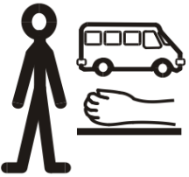
☐Supported travel with a personal assistant, escort or support worker


☐Taxi or private hire arranged by the family


☐More than 1 way

☐Other, please tell us in the box below



☐Not sure


A8) Is there anything else you want to say?
If there is, please write it in the box below.

Section B: What you think of our ideas for changes


The council is looking at different ways of giving travel support in the future.


Please read each option and tell us what you think.


Option 1 – A contribution for organised transport

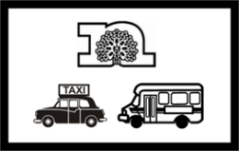
Learners aged 16 – 25 with SEND could still have council-organised transport.

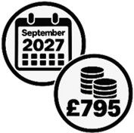
Learners aged 16 – 18 (in years 12 and 13) using council-organised transport would pay £795 a year for this from September 2027.

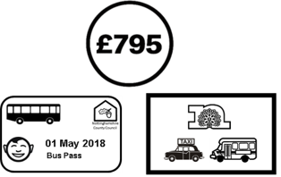
This is 7% of the cost of the transport, and the same amount of money that a council bus pass will cost for pupils using mainstream school transport.


Families with a household income below £7,400 a year would not pay.


This option would save the council about £0.4 million a year.


B1. Do you think the council should make this change from September 2027?

☐Strongly agree
☐Agree
☐Neither agree nor disagree

☐Disagree
☐Strongly disagree


Option 2 - Year 12 enhanced assessment from 2027 plus contributions


Post-16 learners already getting organised transport would keep getting it until they finish their post-16 education.


But from September 2027, learners starting year 12 could only get organised transport in exceptional circumstances.


If someone said they had exceptional circumstances, they would have to do an enhanced assessment (an assessment that is longer and more detailed) as part of their application for travel assistance.


If someone wanted for a DTAP (direct travel assistance payment) or parent mileage, they would not have to do an enhanced assessment.

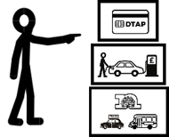
On someone’s application, they would say what sort of travel assistance they wanted.


If the council decides someone does not have exceptional circumstances, they would be offered a DTAP.


Learners aged 16- 18 (years 12 and 13) who had organised transport from September 2027 would pay £795 each year towards the cost of the transport.


This could save the council about £1.5 million a year.


B2. Do you think the council should choose this option from September 2027?

☐Strongly agree
☐Agree
☐Neither agree nor disagree
☐Disagree
☐Strongly disagree


Option 3 - Post 16 enhanced assessment from 2028 plus parental contributions


From September 2028, learners aged 16 -25 could only get organised transport in exceptional circumstances.


From September 2028, all learners in or going into post-16 education would need to apply for travel assistance.


If someone wanted to apply for organised transport, they would need to show they had exceptional circumstances.


To show they had exceptional circumstances, they would need to do an enhanced assessment.


An enhanced assessment is an assessment that is longer and more detailed.


If someone said they wanted a DTAP or parent mileage, they would not have to do an enhanced assessment.

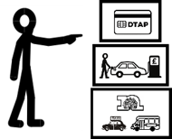
On someone’s application, they would say what sort of travel assistance they wanted.

If the council says someone does not have exceptional circumstances, they would be offered a DTAP instead.


Learners aged 16- 18 (years 12 and 13) who had organised transport from September 2027 would pay £795 each year towards the cost.


This option would save the council about £2.3 million a year.


B3. Do you think the council should make this change from September 2028?
☐Strongly agree
☐Agree
☐Neither agree nor disagree
☐Disagree
☐Strongly disagree

Option 4 - All Post 16 learners to have an enhanced assessment from 2027 plus parental contributions


From September 2027, learners aged 16-25 could only have organised transport in exceptional circumstances.


From September 2027 all learners in or going into post-16 education would need to apply for travel assistance.

If someone wanted to apply for organised transport, they would need to show they had exceptional circumstances.

Someone who wanted organised transport would need to do an enhanced assessment (an assessment that is longer and more detailed) as part of their application.
If someone said they wanted a DTAP or parent mileage, they would not have to do an enhanced assessment.

On someone’s application, they would say what kind of travel assistance they wanted.

If the council says someone does not have exceptional circumstances, they would be offered a DTAP instead.

Learners aged 16- 18 (years 12 and 13) who had organised transport from September 2027 would pay £795 each year towards the cost.


This option could save the council about £3.1 million a year.

B4. Do you think the council should make this change from September 2027?

☐Strongly agree
☐Agree
☐Neither agree nor disagree
☐Disagree
☐Strongly disagree


B5. Do you have anything else you want to tell us about these options?

Please write your answer in the box below

Section C: What would changes mean for you?


C1) If you had to pay towards transport costs, what would help you?


☐Discount for low-income households (annual income of £7,400 or less)


☐Discount for low-income households Please tell us what you think should be called low-income in the box below.


☐Instalment payments
Paying a bit at a time instead of all at once.


☐Other
Please tell us your ideas in the box below.


C2) If you had to pay towards transport costs, what would you be most likely to do?

☐Keep using council-organised transport and pay the contribution.


☐Stop using council-organised transport.


☐Apply for a Direct Travel Assistance Payment (DTAP) grant instead and organise my own transport.

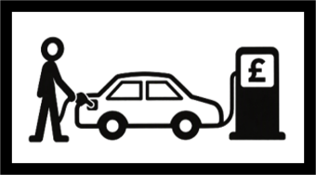
☐Ask for a parental mileage allowance and organise my own transport.

☐Nothing; I don’t use council-organised transport.


☐Unsure; it would depend on the cost.

☐Don’t know.


☐Other/ something different.


C3) If you were offered a DTAP and not organised transport, how would you be most likely to use it to help your young person get to school?

Please tick all the options you would use.


☐I would drive my child or young person myself.

☐Another parent, carer or family member would provide transport.

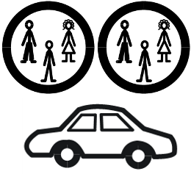
☐I would share transport arrangements with another family.


☐I would use the payment to pay for a taxi or private transport arrangement.

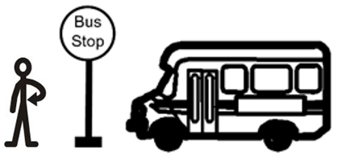
☐I would use the payment to support my child to travel independently by public transport.

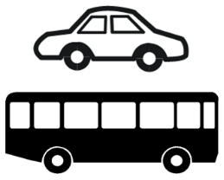
☐I would combine family transport with independent travel.
☐I would use public transport with support from a parent, carer or travel buddy.
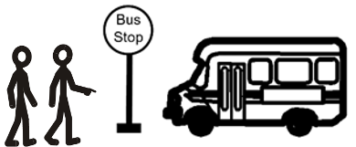

☐I would arrange transport through a personal assistant or support worker.


☐I am not sure how I would use the payment.

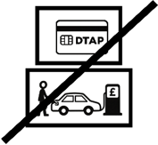
☐I do not think a DTAP would meet my child or young person's needs.

☐Other
Please tell us what this would be in the box below.


C4) How confident would you feel that a DTAP would enable your child to get to school or college?


☐Very confident
☐Fairly confident
☐Neither confident nor unconfident
☐Not very confident
☐Not at all confident


C5) Please tell us more about this in the box below.

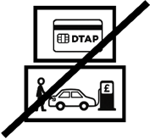
C6) If you think a DTAP would not work for your family, what are the main reasons?

Please tick all the boxes that apply to you.


☐My child or young person has complex SEND needs.


☐My child or young person cannot travel safely without specialist transport.

☐I cannot provide transport myself.


☐It would take too much time to arrange transport.


☐It would cost too much money to arrange transport.

☐My work commitments would stop me from providing transport.

☐My caring responsibilities for other family members would make it difficult to provide transport.

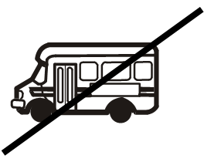
☐There is no suitable alternative transport available in my area.


☐I would need help to arrange transport.

☐Other
Please tell us what this is in the box below.

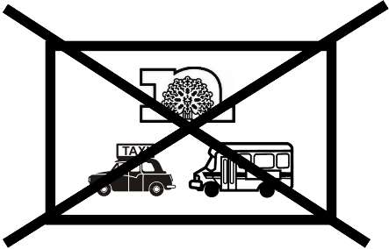
C7) If you were not offered organised transport, would any of the following happen to your family?


☐My child would not be able to go to the school they go to now.


☐Going to school would be more difficult.


☐I would need to work fewer hours.


☐I would not be able to keep my job.


☐I would need support to arrange transport.


☐None of the above.


☐Other
Please tell us what this is in the space below.


C8) Do you have anything else you would like to say about the options?

Please write this in the space below.


Thank you for answering our questions and taking part in our consultation.

Links in this document
Post-16 SEND Travel Assistance Consultation: easy read
https://www.nottinghamshire.gov.uk/global-content/easy-read-library/post-16-send-travel-assistance-consultation-easy-read

For the standard version of this information, go to:
Post-16 SEND travel assistance policy consultation | Nottinghamshire County Council
https://www.nottinghamshire.gov.uk/education/travel-to-schools/post-16-send-travel-assistance-policy-consultation#HowToHaveYourSay

This easy read was first published 20 October 2026
This information was last updated 20 October 2026

