
The Big Conversation

Adult Social Care in Nottinghamshire

November 2025

Contents

Introduction and context: Building on the 2023 Big Conversation |  | 3
How the report is set out | 3
Nottinghamshire County Council’s vision for social care | 4
Nottinghamshire’s Practice Framework | 5
What happened since the last conversation? | 6
The Big Conversation: Building on before | 6
Timeline and focus | 8
How we communicated and engaged with people | 8
Working with Our Voice | 9
Who did we hear from? | 10
People’s different experiences | 12
What’s changed and what more does Nottinghamshire need to do? | 14
Wishes for the future | 18
About people and their care – survey | 22
Measuring against the Practice Framework | 27
What people who draw on social care said | 31
What carers said | 42
Acknowledgements | 51

Introduction and context: Building on the 2023 Big Conversation

The Nottinghamshire Big Conversation, first delivered by Community Catalysts in 2023, provided a vital opportunity for people who draw on care and support, family and friend carers, and communities across the county to share their experiences and ideas. The insights gathered during that engagement shaped key priorities for Adult Social Care and established a strong foundation for ongoing dialogue with residents.

Building on this success, we undertook a new round of Big Conversations to continue listening and learning from people across Nottinghamshire. This follow-up phase aimed to deepen understanding of what matters most to local communities, explore how views and experiences may have evolved, and ensure that a wide and diverse range of voices were included.

This second phase has been shaped by the principles of openness, inclusion, and collaboration — continuing the spirit of the first Big Conversation while broadening its reach through additional events and focused engagement with groups who may not have contributed last time.

How the report is set out

The first part of this report explains Nottinghamshire’s aims and the main ideas guiding the changes they want to make. We then give a short update on what has happened since the last Big Conversation in 2023, including how we built on previous work and how we carried out this work in 2025.

After that, we describe who we heard from and pick out the main things people told us, based on different groups and experiences who we have heard less from previously. We also share a simple, high-level view of what has changed between 2023 and 2025, and what people hope for in the future. These early sections are there to help you quickly understand the key messages.

The rest of the report contains much more detail from the events, conversations, meetings and the survey, with the information grouped separately for people who draw on care and support and for carers, so you can explore as much detail as you need.

Nottinghamshire County Council’s vision for social care

Nottinghamshire County Council has adopted the Social Care Future Vision for social care.

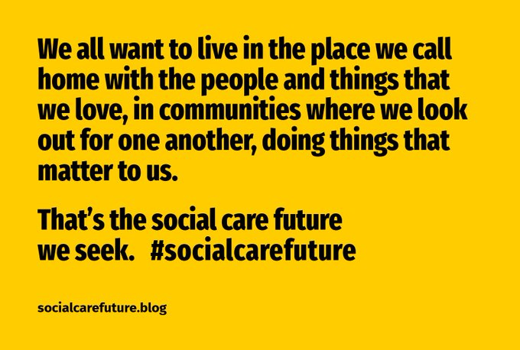

This is underpinned by five key changes necessary to realise this vision:

- Communities where everyone belongs
- Living in the place we call home
- Leading the lives we want to live
- More resources, better used
- Sharing power as equals

The Council is also using and working towards Making It Real ambitions developed by us at Think Local Act Personal (TLAP) and the National Co-production Advisory Group (NCAG) and have aligned their Local Account (adult social care strategy) to them.

Making It Real describes what a good life is from the perspective of people who draw on care and support and family and friend carers which is described in “I” statements. It also describes what organisations should be doing to live up to those expectations in “We” statements.

Making It Real can be used to co-produce priorities in local places and develop action plans to work towards them. It can also be used directly with people and those that work with them to help support conversations about what matters to people.

There are six themes of Making It Real:

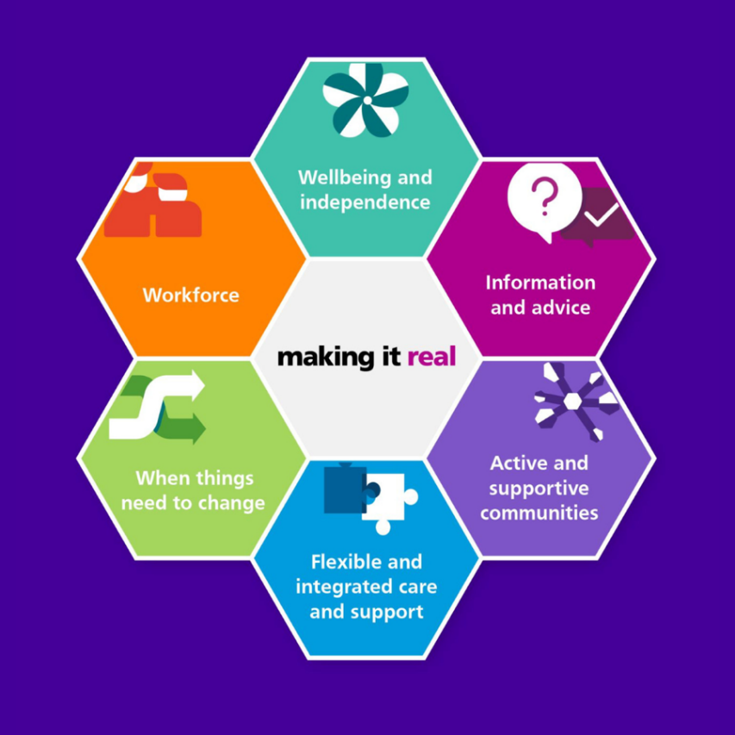

Nottinghamshire’s Practice Framework

The Council’s Adult Social Care has developed a Practice Framework to define their own vision for local people and the way they will operate in line with this vision and Making It Real.
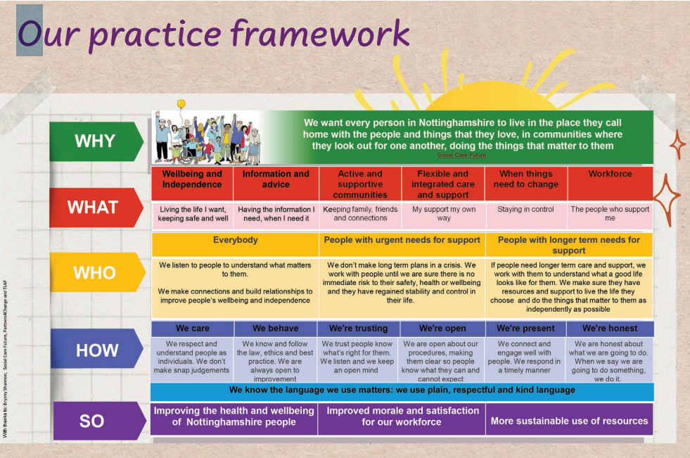

What happened since the last conversation?

Nottinghamshire County Council’s Local Account (April 2024), co-produced with the Our Voice Group, and what people said was important to them in the 2023 Big Conversation, set priorities for Adult Social Care. The Making It Real Forum
reviews progress has shaped what good care reviews look like and helped create a new Quality Assurance Framework. A progress report now shows how these priorities (listed below) are being delivered.

- Wellbeing and independence
- Information and advice
- Active and supportive communities
- Flexible and integrated care and support
- When things need to change
- Workforce

The Big Conversation: Building on before

This new round of engagement built directly on the successful methods used in 2023 — combining open community events, targeted sessions, and surveys — while widening the reach to include even more voices and better reflect the richness and diversity of the county.

A core ambition this year was not only to match the breadth of engagement achieved in 2023, but to deepen it by extending our outreach to communities we may hear from less often. By working closely with local organisations and trusted community leaders, we strengthened connections, provided tailored support where needed, and created more welcoming pathways for people to participate. This helped ensure the conversation remained truly inclusive, representative, and grounded in people’s lived experience.

Nottinghamshire is committed to building on these foundations with renewed ambition — fostering ongoing relationships, embedding continuous learning, and placing co-production firmly at the heart of everything they do. Through future Big Conversations, regular feedback, and strong co-production partnerships, they want to continue to evolve together with their communities, shaping change that is owned and driven by the people it affects most.

This report also includes insight from wider feedback mechanisms including:

- Quality Assurance Audit (2024/25)
- Compliments and Complaints (2024/25)
- Safeguarding Feedback Survey (2025)

Between April and November 2025, we worked with partners and local networks to design and deliver a programme of activity that included:

- 7 district-level Big Conversation events
These events were held in every Nottinghamshire district, providing opportunities for people to share their experiences in familiar, local settings. Each event was designed to be welcoming, accessible, and rooted in community participation. This also included a visual facilitator (Dr Pen Mendonça) who captured the conversations in a visual way.

- A dedicated listening event with the Deaf community
This event created space for Deaf residents and those who use British Sign Language to share their views in an accessible environment, ensuring that communication support and interpretation were available throughout.

- 18 focused engagement events/conversations/insight with specific community groups
Alongside open events, we worked closely with a range of groups, community leaders and those working with people to encourage participation and learn about experiences from people whose voices were less prominent last time.

This included:

  - The Women’s Centre
  - People living with dementia and their carers
  - Those connected to Making Every Adult Matter (MEAM) networks
  - People with experience of homelessness or substance use services
  - Young carers
  - Members of the Indian community
  - Roma and Traveller Community
  - Supported living
  - Specialist college
  - Mencap services
  - Day services
  - Providers of residential care

These sessions were organised in collaboration with trusted local partners, using approaches that supported people to engage in ways that felt comfortable and meaningful to them.

- County-wide survey
Two electronic surveys and a Word Easy Read survey ran throughout August and September, closing in mid-October. This provided another way for people to share their views, particularly those unable to attend events in person.

- One pager

Additionally, as we were learning as we went there was a clear ask to develop a quick facilitation one-page guide as an alternative to the survey and prompt to support community leaders, people working in social care and others to have their own conversations with people and make it easier for people to understand what it was about and to encourage conversations in different settings.

Together, these strands of work have helped to build a fuller, more inclusive picture of local experiences and perspectives — strengthening the connection between the council, its partners, and the communities they serve.

Timeline and focus

Our engagement ran from April through to November, following three broad phases:

- Planning and preparation (April – July)
We developed partnerships, refined engagement materials, and identified opportunities to reach a broad and diverse range of people.

- Engagement and participation (August – mid-October)
The seven district events, targeted sessions, and surveys took place during this period, supported by ongoing outreach and promotion through local networks.

- Analysis and reporting (October – November)
Insights and feedback from all activities were brought together to inform this report and support the continued development of Adult Social Care strategies.

How we communicated and engaged with people

We knew that people might want to talk about many different things — not just adult social care — so we made sure everyone involved in listening and facilitating had the right training to make people feel heard and respected. Think Local Act Personal, National Co-production Advisory Group, and Our Voice co-produced and delivered bespoke facilitation training to support this.

We worked hard to make sure The Big Conversation was open, accessible, and easy for everyone to get involved in. Good communication and inclusion were at the heart of everything we did.

We developed a targeted communication and engagement plan, which involved extensive channels and connections.

The Council launched a dedicated webpage and accessible videos—including subtitles and a BSL version—to explain The Big Conversation and encourage participation, sharing them at events and meetings to keep the project front of mind.

The videos were co-produced with Our Voice, a local group that helps make sure people’s experiences and ideas are heard. Our Voice helped write the script and people from Day Services supported the development of the graphic video, making sure the message was clear, inclusive, and spoke to everyone.

The Council, TLAP, Our Voice, and NCAG worked together and reached out to the Voluntary Community Sector (VCS), providers and groups. Staff were encouraged to share information about The Big Conversation with people who use social care services and family and friend carers. TLAP and NCAG spoke to over 100 Voluntary and Community Organisations and providers to share the information, promote the events and gain feedback.

The Council is committed to using what people shared in as many ways as possible, so the ideas and experiences collected could help different teams and organisations across Nottinghamshire. By listening to what’s working well and what isn’t, Nottinghamshire is helping to shape adult social care that truly works for everyone.

We recognise that Nottinghamshire has undertaken targeted work in specific areas, post the Big Conversations in 2023 but it is possible that some respondents have not yet benefited from these initiatives, while others who participated previously may have seen improvements or changes in their experiences.

Working with Our Voice

A special thanks and mention must go to Our Voice, Nottinghamshire County Council’s co-production group, who we worked closely with, co-designing and co-producing much of the work.

We set up weekly planning between Our Voice and TLAP/NCAG to plan aspects of the Big Conversations activity, including the targeted engagement and without which it would not have been possible. We also used these meetings to pick up actions from the NCC Project Group, update on progress, flag any concerns, and kept the project on track with an Action Log, all creating a sense of ownership for both groups.

A Project Reference Group was set up, which met monthly as well as weekly calls between the project team and TLAP/NCAG.


Who did we hear from?

Surveys

In total 93 people filled out the survey.

42 people who draw on care and support, and 51 family and friend carers.

Listening events

There were 8 events; 7 district events, and 1 with people who use British Sign Language. 168 people attended events.

Meetings, individual conversations, and feedback

We also had individual or group conversations with people who requested it and with people working directly with people. We spoke to or heard from 165 people this way.

Other insight
We have a total of 984 insights. This includes insights from Quality Assurance Audits (41), Compliments (135), Complaints (362) and Safeguarding Survey Feedback (20).

We have included wider departmental feedback to ensure that voices who may not have been involved in the Big Conversations are also core to developing the Local Account and will draw experiences and insights from multiple channels.

People’s different experiences

What we heard from marginalised communities and groups

In line with the local authority’s ambition to ensure that the voices of marginalised groups are integral to all future discussions, we have chosen to present their perspectives in a dedicated section. This reflects the focused effort made to establish ongoing relationships with these communities and enables us to identify any differences in their experiences. As this work continues to develop, these voices will be incorporated seamlessly alongside those of the wider population, ensuring that all contributions are treated with equal importance.

- Deaf community and people accessing Notts Deaf Society (NDS)
- Notts Women’s Centre
- Roma/Traveller community (from a survey and engaging with staff who work directly with people)
- Indian Community Centre members
- People from Change, Grow, Live group (experience of substance use, homelessness, complex needs)
- People living in residential or supported living
- People using day services or specialist colleges.

Access to culturally competent services: People valued services that understood and were tailored to culture, ethnicity, addressed language barriers and didn’t reinforce simplistic stereotypes or make assumptions. There was a clear steer not to assume that because of someone’s culture that they are more likely to take on caring roles. Roles are changing within different communities (such as the Indian Community), people are more aware of services and are seeking out support, but that this doesn’t always meet their cultural needs, underscoring the need for services to adapt to evolving cultural and social realities. Services must recognise and accommodate cultural, dietary, linguistic, and religious needs, as generic placements and ineffective signposting often fail to meet these requirements, leading to dissatisfaction and disengagement.

Provision of a range of specialist services offering gender-responsive support to women currently involved in the criminal justice system or those at risk of entering it make a difference; examples include: employment support, finance and debt services, accommodation, family and relationship support and emotional well-being and social inclusion offer lifestyle support to help women integrate into their communities and improve their mental health. Support that is trauma-informed, person-centred, and prioritises each woman’s unique experiences. “..services run from the perspective of and geared towards women. You get support from a woman’s point of view- you don’t have to explain your position or where you are coming from”

Inclusive community spaces for specific groups create positive outcomes: community spaces such as the Women’s Centre are valued as welcoming, inclusive spaces where women from diverse backgrounds can gather. Alongside expert legal advice, signposting and other services targeted at women (above), events like Black History Month celebrations, coffee mornings, and social activities foster a sense of belonging and community. The Centre is appreciated not only for its support services but also for its role in creating peer support and opportunities for social interaction and cultural expression, alongside courses such as Mental Health and Wellbeing tailored to women of colour to provide learning and development opportunities.

Access to creative-based support around mental health: Mental health support was a recurring theme. People from marginalised groups welcomed creative-based approaches to dealing with mental health challenges e.g. the ‘Writing for Wellness’ course or combining coffee and chat sessions with Crafting to improve mental health. These initiatives provided creative, therapeutic outlets and helped participants explore mental health in a supportive, non-stigmatising way.

Voluntary and community services plugging gaps within social care: Some felt that problems accessing health and social care, housing and other services or poor quality services meant that people reached crisis point and voluntary sector organisations had to ‘plug the gap’ and were more trusted by local people to provide the right support than adult social care. These centres offered focal points for accessing services, but their roles are not always recognised or utilised effectively by local authorities, resulting in missed opportunities for culturally appropriate support.

Feeling shame and barriers to trust: Some people, especially those with complex needs who don’t engage with traditional services or who face multiple challenges like homelessness, substance use, or living in residential care, talked about feeling shame or embarrassment making it hard to trust professionals or ask for help. It’s important for staff to recognise this, actively remove stigma and work in a non-judgemental way. Approaches like the ‘Change Grow Live’ group supported people experiencing multiple trauma over a sustained period to have a voice in shaping services and care in a supportive, peer-led environment.

Technology, equipment and Independence workers for some communities are a lifeline. Personal alarms and other adaptations are vital but must fit the needs of the groups they serve. People welcomed opportunities to feedback and collaborate to troubleshoot issues with equipment. Promoting Independence Workers and similar roles were flagged as helpful to access services and gain choice and freedom.

Viewing lived experience as a resource: Members of the Change Grow Live group experiencing multiple disadvantages expressed a strong desire to contribute and support others using their lived experience as an asset. They wanted recognition of their resilience and strength, with calls to involve lived experience voices in service design and delivery.
“There is an army of strength and energy that is not being used to help support others to find a way through difficult experiences.”

What needs to change?

Partnership working and meaningful co-production with communities: there was emphasis on the importance of ongoing partnership working, co-production, and effective communication between commissioners, providers, and communities to ensure services meet actual needs. Some called for more formal and frequent opportunities to provide feedback to commissioners so that provider and community perspectives are incorporated into commissioning decisions, allowing for responsive changes based on feedback and real-world outcomes.

Role of co-production groups: the role of Strategic Co-production Groups like 'Our Voice' in holding strategic leaders to account and ensuring that co-production is embedded in service design, with an emphasis on involving a diverse range of community members.

Trauma informed practice: Trauma-informed practice is vital because it recognises that people’s behaviours, choices and needs are often shaped by past experiences of harm or adversity, and it ensures support is offered with empathy, safety and understanding rather than judgement — creating the conditions for trust, healing and genuine partnership.

What’s changed and what more does Nottinghamshire need to do?

Reviewing the report from 2023 and feedback from 2025 below are some of the areas that have changed:

- Wellbeing & independence

What’s changed?

There is a greater focus on technology-enabled care and adaptations, with more people reporting direct benefits. The engagement with a wider range of communities has highlighted specific barriers and needs, such as culturally competent provision and support for people with complex needs.

What more does Nottinghamshire need to do?

Feedback continues to emphasise independence, with more positive comments about home adaptations and technology (e.g., fall detectors, personal alarms). People report feeling safer and more confident at home, and there is evidence of improved support for hospital discharge. However, issues persist around housing suitability, local variation, and reliance on family for transport and heavier tasks. The desire for consistency across districts remains strong.

___________________________________________________________________

- Support to live your life

What’s changed?

There is more evidence of person-centred care and flexible support, but persistent challenges with staffing and continuity. The expansion of day services and community activities is noted, though closures and reduced access still impact some groups.

What more does Nottinghamshire need to do?

Feedback shows increased appreciation for tailored support, day services, and volunteering opportunities. People value relationships with long-term workers and personal assistants, describing them as “teammates.” However, staff shortages, turnover, and gaps in provision for those with profound disabilities or mental health needs remain concerns.

__________________________________________________________________

- Connections & community

What’s changed?

The feedback reflects broader engagement with minority and marginalised groups, identifying new gaps and opportunities for community inclusion. There is a call for more hybrid communication models and investment in community hubs.

What more does Nottinghamshire need to do?

There is a stronger emphasis on inclusive community spaces, peer support, and culturally competent services. For example, women talked about the value of culture-specific training courses like the mental health and wellbeing for black and mixed heritage women that educate women about systems of historical oppression that create inequality today.

Coffee mornings, befriending schemes, and volunteering are highlighted as sources of belonging. However, rural isolation, digital exclusion, and transport challenges continue to affect participation. _____________________________________________________________

- Feeling safe

What’s changed?

There is more explicit feedback about the role of technology and adaptations in promoting safety, but ongoing concerns about staffing and housing persist.

What more does Nottinghamshire need to do?

Safety remains a priority, with positive feedback about adaptations and technology. Some people feel safer with fall detectors and predictable routines, but others still report anxiety due to poor hospital discharge planning, unsuitable housing, and lack of trained carers.

___________________________________________________________________

- Information & advice

What’s changed?

Some people said that they have noticed that the website had improved and the Notts Help Yourself was really useful. People who had worked with a community coordinator shared that this made a positive impact on their experiences. There is a stronger call for accessible formats and a “single front door” for information. The role of community coordinators is valued, but systemic barriers remain.

What more does Nottinghamshire need to do?

While some improvements are noted (e.g., better websites, community coordinators, Notts Help Yourself), many still find information fragmented and inaccessible, especially for Deaf and neurodiverse residents. Digital exclusion and lack of BSL/easy-read formats are recurring issues.

___________________________________________________________________

- Money & finances

What’s changed?

There was an increase in comments about the positive impact of Direct Payments in supporting people to live life their way.

What more does Nottinghamshire need to do?

Financial pressures remain, and whilst more positive experiences with Direct Payments were flagged and discussed there still remains some confusion about eligibility, process and costs. Carers and self-funders continue to seek clearer guidance and parity in support. There was feedback about the need for transparent financial processes and support for managing payment.

- Workforce

What’s changed?

Although new roles are clearly making a positive difference, systemic challenges around stability, coordination, and consistency in workforce deployment remain.

What more does Nottinghamshire need to do?

Many people reported highly positive experiences with individual practitioners who demonstrated person-centred, empathetic, and respectful approaches, emphasising the critical value of relational practice in delivering effective care. Carers particularly recognised improvements linked to roles such as care coordinators and independence workers, noting that these positions have enhanced navigation of services and access to support. However, recurring concerns centred on workforce continuity and consistency, training in areas such as BSL, autism and dementia as well as frequent changes in paid carers or social workers and a lack of a named, ongoing point of contact.

___________________________________________________________________

- Inclusion, diversity & co-production

What’s changed?

The feedback from different groups has given a much better understanding of different people’s experiences, which is really positive. What’s especially encouraging is that people want to be involved in designing and delivering services, and the feedback about engaging with a wider range of groups was overwhelmingly positive. People not only shared their views—they showed a strong desire to be part of the process.

What more does Nottinghamshire need to do?

To build on the work this year, from what we heard Nottinghamshire need to continue building relationships with underrepresented groups, offer more accessible and culturally appropriate ways to get involved, and make it easier for people to share their experiences.

They also need to keep raising awareness of co-production opportunities, provide support for people to take part, and make sure everyone can contribute in a way that works for them.

Wishes for the future

The vision for adult social care in Nottinghamshire is clear: a system that is joined-up, accessible, person-centred, and fair. People want to be listened to, valued, and involved in decisions about their lives. Carers want recognition, support, and partnership. Different groups of people have specific needs for accessibility, information, and cultural connection.

Here we outline the key wishes for the future:

Wishes for people who draw on care and support

Assessment, listening, and respect

- Focus on the present: People want assessments to look at what their life is like now, while still noting their past where it helps.
- Being heard: People want to be properly listened to, without judgement or blame, and to have enough time to talk about what matters.
- Equal value: Everyone’s life should be valued equally, including people who use substances or face multiple challenges.

Joined-up and holistic services

- Joined-up support: Adult services should link well with children’s services so support doesn’t fall through gaps.
- Mental health and social care together: These should be connected, because each affects the other.
- Whole-person support: Social workers should consider sexual health, substance use, and mental health, as well as social care needs.

Advocacy and trauma-informed approaches

- More advocacy: People facing multiple disadvantages need more advocacy.
- Trauma-informed for all: Everyone should have access to trauma-informed support.

Communication, information, and accessibility

- Clear information: People want easy-to-understand information, including easy-read options, BSL versions, and one-stop shops for advice.
- Regular updates: People want consistent updates while waiting for services, with less reliance on online-only communication.
- Accessible technology: Lifeline alarms, websites, and equipment must be accessible for Deaf and disabled people, with staff trained in BSL and disability awareness.

Choice, control, and independence

- Personalisation: People want more choice and control over their care, including deciding when and how support ends.
- More opportunities: People want chances to explore the world, get paid work, volunteer, and take part in community life—not only attend day centres.

Safety and wellbeing

- Feeling safe: Feeling safe at home and in the community is vital. Families need better advice about dementia, and crisis support needs to be stronger.
- Quality services: People want reliable, high-quality providers and clear communication during changes, like when a provider closes.

Financial clarity and support

- Simple finances: People want clearer financial information and more help to understand processes, with fair treatment for self-funders.
- Support into work: Younger people, including blind and partially sighted people, need better support to get work or volunteering opportunities.

Inclusion and community

- Preventative support: People want continued investment in prevention, reducing loneliness, and community hubs for information and help.
- Celebrating success: Local connection issues shouldn’t stop people from being supported and celebrated when they make positive changes.

Ongoing dialogue, feedback, and working together

- Feedback and updates: People want to hear what happened after listening events and surveys, and to receive updates as the Local Account is being developed.
- Transparency: Keeping people informed helps them see how their voices are shaping plans.

Wishes for carers (including young carers)

Recognition and support

- Being valued: Carers want to be recognised as partners, not an afterthought, and to have their own wellbeing recognised.
- Respite and peer support: Flexible respite, peer support groups, and carer hubs are essential lifelines.

Information and navigation

- Simpler systems: Carers need support to navigate services with less paperwork, and clear guidance at key moments such as after diagnosis or during transitions.
- Accessible information: Tools like one-page profiles, a carers’ database, and ways to contact services directly (not just digital) are needed.

Financial and practical support

- Fair financial support: Carers face money pressures and want fair pay, clearer benefits, and help with hidden costs.
- Support for young carers: Young carers need information about the conditions they support, understanding from professionals, and opportunities to connect with other young carers.

Training and awareness

- Staff training: More training for social workers and staff to understand complex situations, hidden disabilities, dementia, autism and the needs of carers.
- Deaf awareness: Customer service and care staff need deaf awareness and BSL skills.
- Professionals recognising carers: Health professionals should notice and recognise young carers and ask about their needs.

Advocacy and aftercare

- More advocacy: Carers—especially those supporting people with multiple disadvantages—need more advocacy.

Choice, control, and involvement

- Involved in decisions: Carers want to be part of reviews and decisions, especially when services change or stop.
- Matching support: Better matching of carers with the people they support, and more chances for befriending and peer support.
- Travel and social life: Free travel cards and support groups are helpful, but more social opportunities are needed.
- Flexible education: Schools and colleges should be flexible and supportive of young carers.

Key areas for improvement for everyone

Lived experience as a strength: People with lived experience of multiple disadvantages want to use their experiences to support others. They want their resilience and strength to be recognised and used in designing and delivering services. This was a view shared by many across all engagement.

Growing co-production: More work is needed to raise awareness of groups like the Deaf Co-production Group and to help people connect with them. There could be more joint work or networking with Our Voice, NCC’s Strategic Co-production Group.

“It’s a big wide world out there… I just want to explore it”

About people and their care – survey

People who draw on care and support

The following data refers to the people who completed the survey.

Gender

- Male — 51%
- Female — 47%
- Prefer to self-describe- 2%

Age
- 35-44 — 24%
- 65-74 — 19%
- 25-34 — 17%
- 75+ — 17%
- 45-54 — 9%
- 55-64 — 7%
- 18-24 — 5%
- Prefer not to say — 2%

Ethnic origin*

- White – English/Welsh/Scottish/Northern Irish/British — 93%
- White – Irish — 3%
- Mixed – Black Caribbean & White — 2%
- Other ethnic origins — 2%

*The ethnic origin option list in the survey is from 2021 Census with Roma added but the above data shows the respondents’ answers only.

Access needs

89% of people report having a long-term health need or disability, with 8% preferring not to say.

- Mobility needs — 30%
- Mental health needs — 26%
- Communication needs — 12%
- Hearing needs — 10%
- Learning needs — 8%
- Vision needs — 5%
- Not applicable/other — 2%
- Prefer not to say — 7% (may indicate some respondents are reluctant to disclose their needs)

Type of care and support

For people who ticked something else, this included using the local authority to gain information advice and guidance, some self-funders, reablement and living at home with parents as main carers and working with Community Coordinators.

Caring

- 83% of those people are caring for people over 18
- 19% of people report they care for someone else which is unpaid

Care and support from family, friends, and other sources

- 66% of people report getting care and support from family and friends
- 32% of people saying they receive more than 50 hours of support per week
- 25% of people said the person supporting them is their sister

How care and support is paid for

- 40% of people’s care and support is paid for by the council (either through direct payment or paid directly from the council to provider or organisation).
- 21% of people pay for carer and support themselves.
- Importantly, nearly a quarter of people (21%) don’t know how their care and support is paid for.

Support from others

People talked about the support they received from their GP and health services. This was a mixed picture with some saying that they receive good support with others having more negative experiences. There were many positive experiences of many Voluntary and Community Sector (VCS) services and support.

Family and friend carers

The following data refers to the people who completed the survey.

Gender

- Female — 71%
- Prefer not to say — 15%
- Male — 14%

Age
- 55-64 — 41%
- 45-54 — 27%
- 65-74 —16%
- 75+ — 8%
- 18-24 — 0%
- 35-44 — 6%
- 25-34 — 1%
- Prefer not to say — 1%

Ethnic origin*

- White – English/Welsh/Scottish/Northern Irish/British — 88%
- Chinese – Asian/Asian British — 2%
- Prefer not to say – 10% (which may reflect privacy concerns or reluctance to disclose ethnicity)

*The ethnic origin option list in the survey is from 2021 Census with Roma added but the above data shows the respondents’ answers only.

Access needs
53% of carers reported having a long-term health need or disability, 35% reported no, with 12% preferring not to say.

- Vision needs — 31%
- Mental health needs — 24%
- Communication needs — 12%
- Other needs — 10%
- Learning needs — 9%
- Mobility needs — 7%
- Hearing needs — 5%
- Prefer not to say — 2%

Caring

- 66% of carers are in a caring role for 50 hours or more a week
- 57% of carers live with the person they care and support
- 73% of carers don’t live with other carers

Support from others

68% of carers get support from other organisations or services such as GP, health, and voluntary services.

Carers reported receiving support from a range of services including nurses, occupational therapists, respiratory physiotherapists, and community nurses, all of whom were valued for their practical help and understanding, flexibility and empathy.

The Carers Hub and local carer support groups and VCS and community organisations were highlighted as particularly important sources of advice, advocacy, and emotional support, often described as “lifelines”.

Support for carers

60% of carers told us they had a conversation/assessment with someone from the Carers Hub or Adult Social Care. Of that total, 79% said they felt listened to.

77% reported that they could talk about their needs and the impact of caring on their whole family.

However, only 55% of carers felt they could get a break from their caring role with 51% of those breaks coming from friends and family.

Additionally, when asked specifically if they could get support as a carer from an unpaid family member or friend, 54% answered yes.

For those who answered yes, the following word cloud highlights the most common responses to “Who supports you?”:

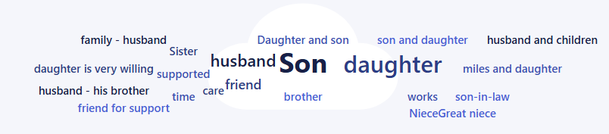

Measuring against the Practice Framework

The statements below show how Nottinghamshire County Council wants its staff to work. These results show how well we do against the following statements from the survey:

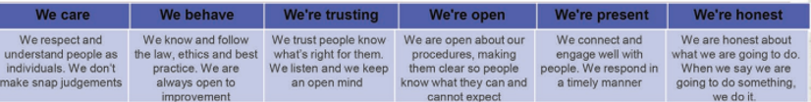

The responses show a difference between those drawing on care and support and carers, with carers much more likely to answer sometimes to all questions than always. The highest “never” and “sometimes” responses came from carers (73% in survey) in answer to the “We’re present” statement.

While it is hard to combine like for like as the 2023 report combined carers and people who draw on care and supports answers, what we can see is that from 2023 “never” and “sometimes” have increased for carers but decreased for people drawing on care and support (33% in survey) which demonstrates most people believe staff are either always or often present and shows improvement from the last survey.

Reflection on social care and social work systems

Many people gave positive examples of social workers and advisers who had helped them navigate the system and access the right support.

Many social workers were described as kind, respectful, caring, empathetic, and person-centred.
Families appreciated when workers listened attentively, understood the impact of disability, and treated individuals as unique people. Staff who went above and beyond, followed through on promises, and made people feel heard and supported were highly praised.

“My social worker really listened and helped me find the right support.”

“The adviser explained things clearly and helped me feel less overwhelmed.”

In the conversations with carers, they shared examples of social workers who offered practical help and clear information, and examples of when they felt heard and supported in their caring role. However, from the survey 36% reported that they felt those supporting them in their caring role were doing it well.

Carers’ responses from all engagement demonstrated a deep appreciation for good care and continuity but a frustration with system-level gaps including staff shortages, poor coordination, and a lack of appropriate expertise, particularly around dementia and autism, where paid carers often lack the right training or understanding, leading to distress and missed care needs.

A common theme was not having a named social worker or never seeing the same person twice creating the need to explain situations multiple times and delays with picking up agreed actions. This lack of continuity made it difficult to build trust or feel confident in the support being offered.
There were also concerns about the consistency of care and the ability to trust that support would be available when needed. “Not being told ‘why’ things can’t happen,” and “Hospital staff respecting care staff when unwell from residential care,” highlight the need for better communication and respect across services.

People wanted to see better inter-agency collaboration, and support to be joined up, especially between health and social care which included ensuring hospital discharge planning includes correct contacts and support.

There was a real emphasis on looking at holistic assessments and including whole family or carer and not seeing the person who is drawing on care and support and the person who is caring for them as separate. There was a lovely example of a couple who had had an assessment together and they had said that this helped those working with them see them as a couple and not separate people but interdependent which helped them get the right support.

Several people praised staff who know them well and have supported them for a long time, saying they are “passionate about learning new ways to support me as I get older.”

In some feedback it was recognised social workers were sometimes thwarted by the system, especially when other agencies didn’t listen or act.

From the compliments and complaints analysis the most common complaints were:

- Open complaint
- Communication issues
- Inadequate policy or service procedure
- Failure to follow process or procedure

Some of these also feature in the wider Big Conversation Feedback and wider feedback. There is likely more to delve into more detail within this which may be something to explore going forward in the next Big Conversation.

Co-production and involvement:
Many feel co-production is tokenistic or only happens “when it suits.” There is a strong desire for genuine involvement, earlier engagement, and visible feedback loops.

An example of great co-production was given at the Gedling BC around co-production of the Carer’s Hub.

Digital and technology use:
Digital exclusion is a barrier for many, but there is appetite for better use of technology alongside non-digital options. “ASC equivalent of NHS app,” and “Digital noticeboards,” were suggested as ways to improve access.

Honesty and transparency:
Honesty is valued more than promises. People want to be “seen, heard, and treated as individuals” and for systems to communicate clearly and compassionately. “A little humanity goes a long way,” and “Speak to the person as a real person,” were powerful reminders of what matters most.

Access:
Transport and mobility were recurring concerns. People described difficulties getting to appointments or accessing community activities. Limited transport options can also lead to isolation and reduced mental wellbeing. “I need transport to get to hospital/doctors appointments…”

Relational support over process:
People want support that feels personal, not just a tick-box exercise or driven by restrictions and time limits. They want someone who will listen in a ‘human’ way, adapt, and help them make choices about their own lives, in relation to their specific needs and circumstances.

Trust and respect matter most:
No matter someone’s background or circumstances, people want to feel respected and listened to. Building trust is essential—whether you’re a social worker, support staff, or a volunteer. People said that having someone who genuinely cares, who takes time to get to know them and their aspirations makes all the difference.

Human connection and continuity of care is vital:
Many described the impact of having a real relationship with someone who supports them — this could be a keyworker or a peer. “Staff help me organise things I want to do,” said one person in supported living. Both carers and people drawing on care spoke about the value of kindness and understanding and building relationships over time as vital. This could be undermined by high staff turnover and lack of named social workers.

Specific insight for safeguarding experiences

Data from all adults asked about their desired outcomes being met through a safeguarding enquiry stands at 86% (in survey), and those satisfied their outcomes were fully or mainly achieved is 95% (in survey).

Feedback from a specific survey of 20 people (self-selecting adults) showed a clear majority of respondents report positive experiences of the adult safeguarding process:

- Being listened to — 75%
- Feeling that focus was placed on what mattered to them — 65%
- Trusting the worker — 70%
- Achieving the outcome they needed — 65%

Free-text comments reinforce the positive side of the picture: timely contact, high standards of service, concrete outcomes (homes closed or moved, protocols put in place), respectful treatment and empathy. Nevertheless, a substantial minority describe poor listening, broken promises, inaction or even harm – themes picked up explicitly in comments about nothing being done, lack of interest, and differing opinions as to whether the right action was taken.

Suggestions for improvement cluster around better and clearer communication (email rather than anonymous calls; consistent follow-up), more responsive and joined-up processes (IT systems that talk to each other, immediate recording of cases), respect for client wishes (stopping when someone says no).

What people who draw on social care said

General

People spoke with passion and optimism about their aspirations, their wants, and their dreams. Many described the life they wished to lead — not one defined by services, but by purpose, connection, and opportunity. While day services were valued and seen as important sources of stability and social contact, people also talked about wanting more than traditional provision. For many, the central ambition was simple yet profound: to live a life like anyone else, with the right support to make that possible.

There was a strong sense of people wanting to contribute to their communities, through work, volunteering, and creative pursuits. Some shared examples of how Promoting Independence Workers had supported them to achieve these goals, helping them build confidence and expand their horizons. Others highlighted how accessible local facilities — such as nearby gyms and community centres — made it easier to stay fit, healthy, and socially connected.

The most striking insight was the desire to think bigger than “things to do,” and to focus instead on living a full life. As one participant beautifully expressed, “It’s a big wide world out there — I just want to go and explore it.” This sentiment captures the essence of people’s hopes for the future: freedom, inclusion, and equality of opportunity.

People also emphasised the importance of mutual respect and reliable support. They wanted professionals to recognise that those drawing on care and support can have busy, meaningful lives of their own. As one person explained, “Just because I’m disabled doesn’t mean I don’t have a life — so don’t assume I’ll be waiting in for you.” There was a strong call for communication that reflects respect and partnership — if someone is going to be late, they should say so, just as they would with anyone else.

Together, these aspirations point towards a shared vision of independence and belonging — a life that is not confined by systems but supported by them.

  - A place to call home

The concept of “home” is deeply personal and central to wellbeing. Most people said that they had a place they could call home adapted for their needs. People valued practical adaptations such as handrails, accessible showers, and input from occupational therapists (OTs), which increased safety and confidence.

90% of people from the survey said they had a place to call home. With 95% of people in the survey saying their home is adapted and equipped for them to live as they like.

“The adaptations [in my home] have made me feel safer”

“My home is adapted for me.”

However, some still rely heavily on family for transport and heavier tasks, indicating that adaptations alone don’t fully meet their needs.

Several people spoke of a significant lack of suitable accommodation, including around lack of space, especially for those with complex needs or requiring culturally sensitive support. Some residents expressed frustration that “supported living does not feel safe, comfortable or homely,” and that housing offered by social workers was sometimes inappropriate for their needs.

There were also concerns about local variation and inconsistency:

“There is a massive difference between services in different areas, need consistency across teams and districts.”

Being able to stay in their own home, live independently, with the right adaptations and support, was important to many. People also want care that is flexible and tailored to their needs—not just focused on personal care, but on their whole life.

  - Support to Live Your Life

Support to live a fulfilling and independent life was a recurring theme. People shared positive and challenging experiences.

Many expressed gratitude once support was in place, though for some delays often meant support arrived at crisis point. Continuity of staff built trust and improved outcomes.

People spoke about the difference good care makes to their independence, wellbeing, and quality of life:

“It functions very well and allows me to stay in my own home.”

“I attend two day centres which I love.”

Support also benefitted families:

“Helps my parents out so they can get a break.”

61% (in survey) of people said support was flexible, 17% (in survey) saying sometimes 22% (in survey) saying it wasn’t. Inflexible support did limit people’s ability to do desired activities, unless planned well in advance.

Carers, personal assistants (PAs), agencies, and social workers all play a crucial role in enabling daily living, emotional wellbeing, and independence.

While many praised the quality of care received others shared frustrations about inconsistency, long waiting times, staff turnover and shortages, and difficulty contacting social workers. Staffing gaps and a lack of continuity were seen as undermining trust and stability in care. Some people missed being able to go out, especially when a change in carers reduced their ability to access the community.

“I need someone who can help me prioritise when I’m exhausted.”

Day services, volunteering and community groups reduced isolation and built skills. However, closures reduced access and increased isolation, and there are gaps for those with complex needs. Whilst appreciating day services, some said that they don’t always create opportunities that people want or places they want to go.

“Social worker has been absent… I am waiting for another social worker.”

“Day services reduce isolation, build skills, purpose, and safety; friendships maintained.”

Many people said that support was tailored to them (78% in survey), however where people said “no” or “sometimes” people reported that the assessment process doesn’t enable tailored support.

Many people said they felt in control of their support (63% in survey) and that it helped them maintain autonomy and dignity. Social workers who helped with housing, appointments, care coordination, and crisis resolution were seen as effective.

However, transport and accessibility also continue to be barriers to full participation in community life. People shared that long waits for allocation, panel decisions, and care finalisation were frustrating and gaps in handover and hospital discharge led to escalation and confusion.

There are ongoing service gaps for people with profound disabilities, neurodiversity, and mental health needs. Support was sometimes time-limited, with “cliff-edges” when funding ends.

“Profound and complex disabilities —very few day services or respite options”

Direct Payments were described as life-changing, offering choice, flexibility, and greater control.

“This has given me the biggest DP package I have ever had… It means I can function as an independent adult.”

  - Connections

Social connections are vital for wellbeing. 32% (in survey) of people said they could not always spend time with people that matter to them, often due to reliance on others for transport or support.

People valued time with loved ones and support to go out. Many said they rely on support from carers, personal assistants (PAs), or family to help them go shopping, attend social groups, visit friends and family, or take part in hobbies.

Some described strong family networks, including help from mums, aunties, sisters, and friends. However, health, mobility and limited carer availability led to isolation for some. 67% (in survey) of people said they could visit places important to them.

“I’m often confined to one room all the time… I miss getting out”
“Having my PAs now means I can visit my sister”

“Regularly see my family and they visit and take me out.”

“My visits to friends and family never coincide with carer availability”

Day services, coffee mornings, befriending schemes, and volunteering opportunities were repeatedly mentioned as sources of social belonging and reduced isolation. Community groups can be very helpful and supportive and people value coffee mornings, volunteering, gym facilities, and the friendships they build through these.

Rural isolation and lack of local facilities and transport were significant barriers. Digital exclusion also limited access to information and social opportunities.

There were calls for more community hubs, inclusive activities, and hybrid communication models that combine digital and physical outreach.

A few people said they miss going out but don’t want to keep asking family for help or feel limited by needing care at specific times.

“I would love to visit my son in Devon more often… but I can’t get care while I’m away.”

Overall, people want support that helps them stay active, social, and connected to the places and people that matter to them. Flexible care, reliable transport, and understanding staff make a big difference in helping people live full and independent lives.
  - Feeling Safe

Feeling safe at home and in the community is a fundamental concern. Overall, most people reported feeling safe (83% in survey) but safety is unique to every individual.

People shared a wide range of experiences about safety—both at home and in the community. Many said they feel safe when they have trusted carers or family nearby.

“I feel safe in my flat. The adaptations make me feel steadier and I have a fall detector which gives me peace of mind.”
“My carers have significant training, experience and knowledge and they are great at supporting me to feel as safe as possible,”

Others described how predictable routines, quiet places, and support from staff help them feel more confident. However, some people talked about feeling unsafe due to past trauma, anxiety, or poor experiences with services, and staff turnover can create anxiety.
“Care companies can never guarantee who is going to come… I feel better if I’ve got somebody that I know.”
“I feel like a crab without its shell on when I go out the front door.”

Some people said they feel safer with technology like fall detectors or mobile phones they can use to call for help. Others mentioned that they avoid crowded places or go out only with support.

Safety is a contextual issue with some people saying they feel safe in some contexts but not in others. For example, safety concerns related to unsuitable housing locations, lack of trained carers, and poor hospital discharge planning.

Overall, people want to feel safe in their homes, in public, and when receiving care. They value consistent, respectful support from people they trust, and they want services to understand how past experiences, mental health, and the environment can affect their sense of safety.

  - Information and Advice

Access to clear, timely, and tailored information is a recurring theme. Most respondents in the survey said they had the right information or advice (89%) however in the conversations, many flagged struggles with inconsistent, complex or inaccessible information. However, Community Co-ordinators were particularly valued.

Many respondents reported frustration when seeking support through central hubs or services. Common issues included difficulty reaching departments such as ACFS, lack of contact details, and poor phone accessibility. Some felt overwhelmed by information or unclear about processes and timescales.

“I always get information and updates from both establishments I attend.”

Others described challenges with how information is presented. Some said that even easy-read formats were still too complicated.

“Information sent via post in easy read is still too wordy for me to understand.”

While improvements to websites and Direct Payments information were noted, many found resources fragmented, inaccessible for Deaf/Blind residents, and not tailored to individual needs. Repeating stories to different staff and uncertainty about where to go for help were frequent concerns.

“It can be very frustrating accessing help or advice via the Hub.”

People said they prefer clear, simple communication—using pictures, plain language, and formats that match their needs. They want staff to remember their preferences, so they don’t have to repeat them every time.

Digital exclusion was a recurring theme, with some people struggling to access online information. There were strong calls for a “single front door” for information, more BSL/accessible formats, and regular, transparent updates on progress and waiting lists. “Plain language—keep it simple,” and “A real person, not a website,” were repeated requests.

Overall, people want information that is easy to understand, delivered in the right way for them, and backed up by someone they trust to explain or guide them. Having a named contact, like a community coordinator, makes a big difference in helping people feel confident and supported. People wanted clear guidance on how to re-access services if needed.

  - Money and finances

Financial concerns are common. People raised concerns about the cost of care, slow recommissioning of Direct Payments, and lack of clarity around funding decisions.

“I am in arrears… my short breaks have also not been recommissioned,”

“The cost of home care services is expensive,”

Some said they rely on Direct Payments to stay independent and manage their own support. Others said they feel left out of funding decisions or confused by the process, especially when changes are made without clear communication.

Direct Payments and carers’ budgets are valued when they work well, but high costs, financial strain, and confusion about eligibility and funding are widespread.

“Personal contribution to Direct Payments is expensive,” and “Self-funders find it hard to find a provider of support or don’t know where to look,” were common complaints.

There is a desire for clearer guidance on costs, more flexible funding, and parity for self-funders and carers. “Equal treatment for self-funders; clear money guidance; more support for carers,” were among the future aspirations.

Greater transparency around eligibility and why some people might pay for equipment and others don’t was also a repeated sentiment.

What carers said

General

Since 2023, Nottinghamshire has focused on delivering the All-Age Carers Strategy through a series of co-produced initiatives aimed at improving support for unpaid carers.

Key priorities have included:

- Redesigning and retendering carers support services
- Enhancing access to short breaks and respite care
- Expanding early intervention via the Carers Hub
- Supporting carers’ health and wellbeing
- Improving identification & support of all carers
- Strengthening support for young carers
- Using technology to reduce carer stress and prevent breakdown
- Ensuring inclusion and equity

Carers’ voices were strong throughout the surveys, conversations, and meetings. Their main hopes include sustaining health, maintaining employment, and having time for personal wellbeing. The overarching concern is that the system should not break those who care. Carers express a deep commitment to ensuring that the person they care for lives with dignity, safety, and fulfilment.

Experiences with social care support are mixed across all services and support. Some carers have experienced flexible, empathetic, and tailored support—particularly from Carers Hub, social workers, and family—while others have expressed frustration with delays, lack of coordination, and inflexible services. Communication difficulties and limited access to relevant information are common themes.

Inconsistent, under-resourced support—often due to staffing shortages or rigid eligibility criteria—leaves many carers feeling excluded and uncertain. Many families take on complex caring responsibilities without training or adequate guidance, often filling gaps left by overstretched services.

Feedback from carers and families highlights services can often be reactive rather than person-centred, with high staff turnover, inadequate training, and poor handover processes undermining continuity and confidence. These issues are particularly acute in dementia and autism care, where specialist knowledge is essential. Families report compensating for gaps left by under-resourced or ill-equipped services.

Despite these concerns, examples of good practice demonstrate that consistent, compassionate, and well-coordinated care can transform outcomes for families. There is a clear call for improvement through better training, greater consistency, and support that addresses both practical and emotional needs.

  - A place to call home.

Most carers said they have a place they call home (82% in survey) where they are free to live as they like.

However, many feel it has become dominated by caring tasks, leading to isolation and exhaustion. Adaptations, such as hoists or wet rooms, are often essential but can be challenging to secure; some carers face unsuitable housing and long waits for grants or support.

Carers also spoke about the emotional toll of constant care. Their home can be isolating or even like “a prison”, especially when caring responsibilities prevent them from leaving or socialising.

Carers want housing that supports independence, dignity, and safety for loved ones, while also allowing carers space, rest, and autonomy. Suitable housing and proactive planning are seen as key to preventing homes from becoming places of confinement or strain.

  - Support to live your life

Most carers provide over 50 hours of care weekly and often feel overwhelmed, excluded from decisions, and unable to access timely support or breaks. While some experience excellent, person-centred services, many can wait long periods or receive minimal help, including delays in carers’ assessments. In the survey, 34% said the support they get doesn’t help and 16% said it sometimes helps them live the life they want.

Carers report frustration at being told they do not qualify for social care despite clear needs. 36% said they don’t feel in control of their support, with 16% saying sometimes.

Navigating complex systems, unclear processes, and multiple contacts adds stress. Staff shortages, poor communication, and delays in accessing short breaks or recommissioning services were common concerns. Work continues across Nottinghamshire to address some of these issues and will be built on.

Carers often feel significant challenges in maintaining control over support arrangements.

Some described excellent services that help their loved ones thrive.

“We have carers in the morning and lots of equipment. We are able to lead as full a life as we can.”
“Our carers have been very ready to provide extra care when I have needed a break”

Carers emphasise flexible respite, training, and early planning—especially at transition points such as moving into adult services. Caring is a 24-hour responsibility, and relational, consistent support is essential to protect wellbeing and sustain caring roles. 8% said their support was flexible, 23% saying sometimes and 21% saying support was not flexible, with 38% saying this is not applicable.

“I still feel like I’m on call 24 hours a day,”
“I’m still on a waiting list for my day service and short breaks”

A lack of responsiveness and adaptability from care providers—particularly those commissioned through social care—was a recurring concern. Fixed visit times, poor communication with administrative staff, and inflexible booking systems make it difficult for families to plan around their own lives. In the survey only 35% said support is tailored to them.

Peer support and carer hubs were described as lifelines, but many felt these were not enough to offset the exhaustion and stress of caring.

“Carers don’t just need money or services—they need relational, human support and simplified processes,”

Overall, carers want support that is reliable, personalised to them, flexible, and respectful of their time and wellbeing. They need services that recognise the impact of caring and help them live their own lives alongside their caring role.

Carers recognised the pressure services are under and the impact on those working in the system and so held an understanding and sympathetic view.

  - Connections

Carers reported more often that they were “sometimes” (48% in survey) or not able to (19% in survey) spend time with people who are important to them.

Many also described feeling isolated or lonely. Caring responsibilities frequently limit social contact, spontaneity, and access to employment or volunteering. While many value family, friends, pets, and local groups, time pressures, lack of transport, inflexible support and worry about leaving loved ones alone make connection difficult. However, when people found time to do things for themselves such as yoga or seeing a friend it really helped improve their mental wellbeing.

People spoke about the support they receive from family and friends, sharing examples of places they enjoy visiting and people they like spending time with.

In the survey 42% of carers saying they can access the things they enjoy and 35% in survey saying sometimes.

37% of carers said they could meet other carers if they wanted to, and it came through very strongly in all feedback that carers truly valued opportunities to meet others in similar situations.

“more help for carers meeting up with people in the same boat,”

“This group…has been a life saver – we support each other.”

Peer groups provide vital emotional support and shared understanding, often described as “lifesaving”. Carers seek inclusive community spaces, flexible opportunities to connect, and better access to activities that support their mental health and sense of identity beyond caring.

42% (in survey) of carers in the survey reported they couldn’t access employment, education and volunteering opportunities that are offered to them, and this was a common theme from the meetings and conversations.

While the caring role can be demanding and emotionally taxing, carers also show remarkable resilience, adaptability, and commitment to creating moments of enjoyment and fulfilment within their circumstances.

  - Feeling safe

Discussions and the survey reveal a complex and often fragile sense of safety among carers and those they support.

Whilst in the face-to-face conversations many people said they did feel safe, in the survey:

- More carers reported not feeling safe (59%) in their caring role than those that did. However, carers reported (69%) that they felt the person they were caring for was safe.

Many individuals feel that safety is only assured when they themselves are present, actively filling gaps left by overstretched or undertrained services. This reliance on family members, often without backup plans or formal support, can create a constant state of vigilance and anxiety.

Several respondents described being the sole safeguard for people they care for, with no one checking in on them as carers, and no contingency if they were to become ill or unavailable.

People shared positive experiences with compassionate and professional staff, particularly in day services, but there were examples of poor training and not person-centred care especially in relation to Dementia care and support.

Carers expressed anxiety about the safety of those they care for, especially during hospital stays or when staff are unfamiliar.

“No support in crisis—passed from pillar to post. No one owned the help—no one seemed to know what others could do,”

There were concerns about poor maintenance in supported living settings, and about care staff not respecting boundaries—such as entering homes without knocking, which left some people feeling unsafe.

Overall, carers want homes that are safe, adapted, and respected by services, but they also need space, support, and time to feel like home is a place of rest—not just responsibility.

  - Information and advice

There were positive examples to demonstrate the impact of effective information and communication. The Nottinghamshire County Council Website, Carers Hub, and national organisations such as Mobilise and Carers UK were frequently praised.

Carers also cited good experiences with proactive GPs, hospital staff, Age UK, social workers, and social prescribers, though these were described as inconsistent across the county. People also commenting that some information had got better including the Notts Help Yourself and the website.

However, carers reported significant challenges in accessing and understanding information about support. Many described the social care system as complex, fragmented, and bureaucratic, with essential guidance dispersed across multiple agencies and websites.
“It needs to be in one central easy-to-find place… when you are busy looking after the person you care for you barely have time to look for information.”

A recurring frustration concerned excessive paperwork, professional jargon, and the use of unexplained abbreviations. Several carers highlighted that written materials were either too generic or overly technical, and that digital-only formats assume universal access to the internet or smartphones. One carer summarised this challenge:
“Too many meaningless abbreviations… instead of plain English”

Carers highlighted gaps between support promoted in leaflets and websites and the practical help available. Many reported relying on informal networks rather than professionals to obtain accurate information.

Administrative processes, such as managing Direct Payments, were described as overwhelming and stressful, with one carer stating:

“As a tired parent I couldn’t cope.”

Delays and limited direct communication from professionals intensified feelings of isolation and uncertainty. Some carers experienced long periods without contact or lacked a named social worker, only receiving attention at crisis points.

“Things just take so long to process… and even to this day I still have no social worker.”

Consistent human contact was seen as essential, with carers emphasising the value of phone calls or face-to-face support over automated or digital-only systems. Many identified clear gaps in information, particularly around dementia support, transition to adulthood, and access to adaptive equipment. These gaps often led to poor decisions and unnecessary costs, such as purchasing unsuitable items due to inconsistent advice. Carers stressed that support must be inclusive of those who are neurodiverse or digitally excluded, and that timely, personalised guidance is critical to prevent crises and reduce the burden on families.

  - Money and finances

Carers face financial pressures, due to reducing or leaving employment. And face confusing benefits systems and manage additional care-related costs.

“Carers’ pay not increased sufficiently/often enough,”

Direct Payments and budget management were frequently cited as confusing, with carers struggling to understand their responsibilities around employment, payroll, and reporting.

Carers also talked about how confusing the pay calculators were and sometimes could be wrong.

Acknowledgements

We would like to express our sincere thanks to everyone who contributed to this work. Our gratitude goes to the people across Nottinghamshire who draw on care and support, to carers, and to the many staff and partners who shared their time, insight, and experience. Your openness, honesty, and enthusiasm have been central to this process. This report simply would not have been possible without your contributions, and we are deeply appreciative of the commitment you have shown in helping shape Nottinghamshire’s future direction of Adult Social Care.

