**Nottinghamshire Local Account**

**Progress Report: Easy Read**

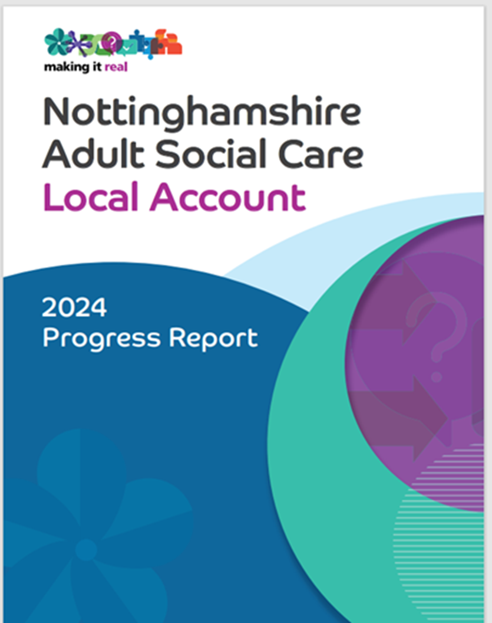

The Local Account is the plan for Adult Social Care services and support 2024/25.

It shows what we’ve done so far and what we still need to do.

To help us find out what is important to people we had the [Big Conversation.](https://www.nottinghamshire.gov.uk/care/adult-social-care/the-big-conversation)

We met with lots of different people who are supported by adult social care who told us what was important to them.



We worked with Our Voice Strategic Co-production group who helped to write the Local Account.



This easy read tells you what we have been doing since 2024.

We focussed on 6 areas and here are some of the things we’ve done:

Find out about the

[Local Account easy read](https://view.officeapps.live.com/op/view.aspx?src=https%3A%2F%2Fwww.nottinghamshire.gov.uk%2Fmedia%2F2sqciktv%2Flocalaccounteasyread.docx&wdOrigin=BROWSELINK)

## Wellbeing and independence

## Living the life you want, feeling safe and well

* 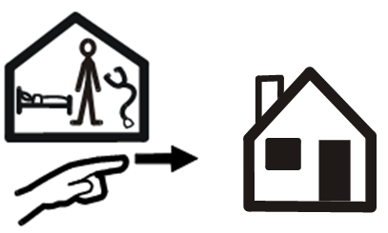More people are going home straight from hospital.



* People are not waiting as long to speak someone.
* In our survey of people using Technology Enabled Care (TEC), most people said they feel more independent and less likely to need residential care.
* More older people are being supported to stay home longer.
* More people have a personal assistant.
* We are working with more homeless people and people who use drugs.



* We are working with our care and support providers to help them work in a more person-centred way.

## Housing options

* Working with district councils to provide more local housing options.
* We have 65 supported living homes being developed.

## Changes to your home to meet your needs.



* We have supported more people to stay at home because of helpful technology and gadgets.
* 165 people were able to stay at home and not move to residential care.

## Information and advice

## Having the information you need when you need it.



*  Fewer carers are asking for a full carers assessment because of better advice and guidance.



* We are trying out 3 Social Care face to face information sessions in Bassetlaw.
* The Carers Hub support service has co-produced a Carers Newsletter with carers



* We are using the Social Care Future [Gloriously Ordinary Language](https://www.gloriouslyordinarylives.co.uk/gloriously-ordinary-language) with people, carers and staff.



It helps us think about the words we use when we have conversations with people.

The council website has British Sign Language (BSL) videos providing information about contacting the Council, services and promoting independence.



* We also have advocacy support including a Deaf advocate, helping people to access independent advocacy in BSL.



* Training of GP carer champions who will find out which patients are carers and give them the support they need.

## Active and supportive communities

## Keeping connections with family, friends and your community.



* More people being supported to access further education, employment or volunteering.
* ‘Let’s Get Active’ in Mansfield supported a sporting event where 52 people took part and a 32 people went along to cheer them on.



* Brooke Farm and I-Work are working together to improve support to people looking for work.

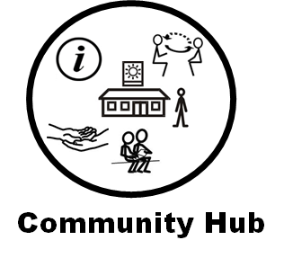

* Day Opportunities includes Community Hubs are offering a ‘One Stop Shop’ for information about local services and a space for carers to support each other .

## Transport

* We use money from the Government to support 110 local bus services which are all wheelchair accessible.
* We have 7 On Demand zones which help people access employment, training, health, and leisure opportunities. The vehicles are all low floor and wheelchair accessible.
* 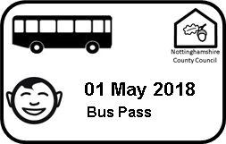There are 154,000 bus pass holders including disabled passes and passes where people can take someone along with them.
* We are also getting ready to offer free bus and tram travel to young carers under 19.

## Flexible and integrated care and support

## My support, my own way.



* We have more adults taking short break stays.
* The Direct Payments team are now doing all new direct payments for people and supporting them to get Personal Assistants.

## Reviews

* We are getting better at listening to what matters to people
* Finding out people strengths and talents

.



* We have a new action plan to improve people’s experience of reviews.
* We are co-producing new review information sheets for people, carers and for staff.
* We are asking some people and carers to tell us about their experience of a review
* Easy Read version of our information sheets is being written.



* A Direct payment working group and support group is being set up.



* We’ve had listening events supported by POhWER, with people who have a direct payment.

## When things need to change

## Staying in control



* We are using more equipment including sensors to support people to be independent and to keep safe.



* Making the time it takes to fix broken equipment quicker.



* We are working on supported accommodation and unplanned support for people who need help in the community.
* We are looking with others including City and County safeguarding partnerships on how we work with young people to keep them safe as they prepare for adulthood.



* More people are being supported by Our Maximising Independence Service (MIS)
*  More staff have been employed in the Preparing for Adulthood team.



* The Preparing for Adulthood team now have enough staff to work with schools.



* New information and guidance for young people is due to be published.

## Workforce

## The people who support you.



* We have more Social Work and Occupational Therapy apprentices.



* We have trained 146 care staff to become mental health first aiders where they work.
* We trained 90 care managers in mental health skills to support their staff.
* We have 29 people who work in social care who will visit schools, colleges, universities, and community job fairs to tell people about working in social care.
* We had our annual Learning and Celebration Event for 600 members of staff and included people with lived experience of social care and partners.

There was an award ceremony for staff recognising their work over the last year. Staff and people with lived experience said the event was very positive.

Date this easy read published June 2025