The Big Conversation Report

Adult Social Care in Nottinghamshire
November 2025

This easy read tells you some of the things people told us in the Big Conversation 2025.

About the Big Conversation

Our Vision

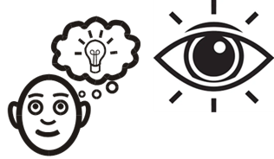
The Adult Social Care vision for Nottinghamshire is for every person in the county to:

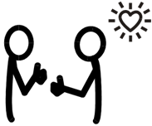
- Live with the people and things that they love.

- Live in the place they call home.
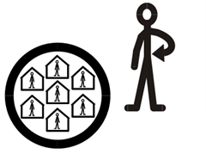
- Live in communities where they look out for one another and do the things that matter to them.


This vision was developed by a group called Social Care Future.

The Big Conversation 2023


In 2023, Adult Social Care had its 1st Big Conversation across Nottinghamshire.

We talked with people, families and carers who draw on care and support.

People told us about:

• What works well

• What could be better

• What needs to change

What happened next


After the 2023 Big Conversation we worked together with Our Voice Strategic Co-Production Group

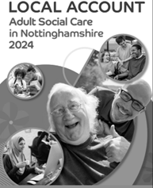
What people said in the Big Conversation was used to make a plan called the Local Account

About the local account


It says what Adult Social Care will do and
uses Think Local Act Personal – Making It Real Themes

Nottinghamshire’s has its own Making It Real Forum, it helps to guide the work that’s needed to help people live better lives.

Making It Real Forum

This group was set up and supported by Adult Social Care.

The forum:

Checks how well Adult Social Care is doing by looking at what is working and what needs to be better.
.

The group includes senior leaders and people with lived experience of care and support.


Last year Adult Social Care
checked if the actions from the Local Account have made things better. They wrote a report.

In 2025 we had another Big Conversation and worked with:

- Think Local Act Personal (TLAP)
- The National Co-Production Advisory Group (NCAG)

- Nottinghamshire’s Our Voice Strategic Co-Production Group

What’s changed for people who draw on care & support and carers since 2023:

People and carers told us about things that have improved and include:


More use of technology and equipment to support people.


More person-centred care and flexible support.


Some of the Council’s website is better, including the Notts Help Yourself.


Direct Payments are positively helping people to live life their way.

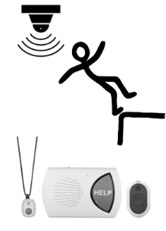
How technology & adaptations are helping people keep safe.

Positive comments about individual staff using person-centred and respectful ways to work with people.

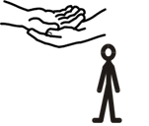
Carers have said they are getting better help from staff to access services and support.

More people want to share their experiences and be involved in improving services.

Wishes for the future

For people who draw on care and support.

People wanted:


Assessments that focus on their life now but include their past where it helps.


To be properly listened to and have enough time to talk about what matters.


To hear about what happened after they have been involved in listening events and surveys.

Everyone to be treated fairly.


Better links between adult and children’s services.

Clear, easy to understand information including:


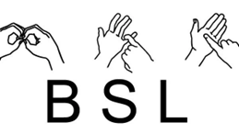
- Easy-read options and British Sign Language (BSL) versions.


- One-stop shops.

- Community hubs offering advice & information.


Regular updates while waiting for services and less online only communication.

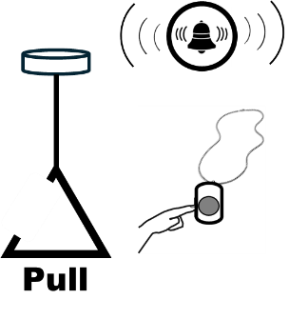
Accessible alarms, websites and equipment that must be accessible to deaf and disabled people.

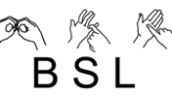
More staff trained in British Sign Language and disability awareness.


More choice and control over care and support.

More control over when and how care and support ends.


Families need better advice about dementia and support in a crisis.


Reliable good quality care providers and clear information when services change or stop.


Simple and clear information about finances and money.



Fair support for people who pay for their own care.


Younger people including blind and partially sighted people need better support to find work or voluntary opportunities.

More chances to get paid work, volunteer, and be part of community life.

For carers (including young carers)
Carers said they wanted:


To be seen as partners and have their own health and wellbeing supported.

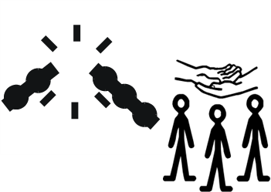
Breaks from caring at times that work for them.

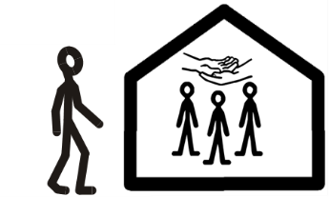
Support groups and carers hubs are essential.

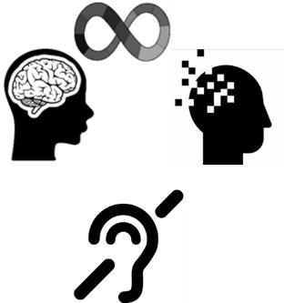
Staff who understand carers’ needs, including hidden disabilities like dementia, autism, and deaf awareness.

To be involved in decision making such as reviews, especially when a service changes or stops.


Support to understand how to get through the difference processes for service, with less paperwork and better guidance.


Clearer information about ways to contact services.


Accessible information for young carers about conditions the person they care for has.

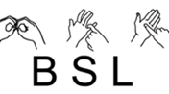
Care staff need more deaf awareness and British Sign Language skills.


More chances to meet other carers.


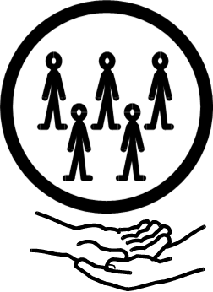
Young carers’ want support groups and free travel cards to continue.

What next?

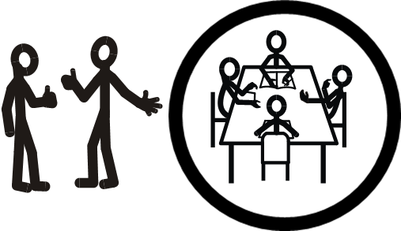
Adult Social Care will work with

co-production groups and use what people said in the Big Conversation report to write plans for 2026 to 2028.

Links in this document
Nottinghamshire County Council Big Conversation Report
https://www.nottinghamshire.gov.uk/care/adult-social-care/the-big-conversation

This easy read was first published 11 February 2026.

This information was last updated 11 February 2026

