

Policy Library Pro Forma

This information will be used to add a policy, strategy, guidance or procedure to the Council’s Policy Library.

Title: Guidance for prison on the provision of equipment to deaf or hard of hearing or visually impaired people.

Aim or Summary: The following information aims to assist Prison staff to understand ways in which equipment can support deaf, hard of hearing or visually impaired people with problems they may be experiencing.

Document Type:

Policy | ☐ | Guidance | ☒
Strategy | ☐ | Procedure | ☐

Approved By: Team Manager Adult Deaf and Visual Impairment Service | Version Number *: 2
Date Approved:  23/02/2023 | Proposed Review Date:  August 2025

Author: Advanced Social Work Practitioner | Responsible Team: Adult Deaf and Visual Impairment Service
Contact Number: 01158040866 | Contact Email: laura.smallwood@nottscc.gov.uk

Publicly Available: | No

Site Link: | Trix

Area on Trix: Adult Social Care Policy, Procedures and Guidance | Subheading: Adult Deaf and Visual Impairment Service

Please Include Any Supporting Documentation:

Guidance for prison on the provision of equipment to deaf, hard of hearing or visually impaired people.
Contents
Introduction 1
1. Deaf or hard of hearing people 1
1.1 Equipment to assist with the television or communication 1
1.2 Alarm clocks to help deaf or hard of hearing people wake 2
2. People with a visual impairment 3
2.1 Anti-Glare Glasses or UV Shades 3
2.2 Reading or Writing Aids 3
2.3 Liquid level indicator 4
2.4 Canes 4
2.5 Dycem 4
2.6 Bumpons 4
2.7 General Advice 4
3. Summary 5

Introduction
The Adult Deaf and Visual Impairment Service (ADVIS) provides rehabilitation support to help Deaf or hard of hearing people and visually impaired people manage daily living. Enablement Officer or Rehabilitation Officers give advice and guidance and provide some specialist environmental equipment to aid independence. In the first instance people experiencing difficulties with their hearing or sight should be referred to audiology or an optician. If people are still experiencing problems, our Rehabilitation team may be able to help.

The following information aims to assist Prison staff to understand ways in which equipment can support Deaf, hard of hearing or visually impaired people with problems they may be experiencing.

Nottinghamshire County Council
Adult Deaf and Visual Impairment Service
Contact us via our Customer Services Centre
Tel: 0300 500 80 80 or online: -
Contact us | Contact us | Nottinghamshire County Council

1. Deaf or hard of hearing people

1.1 Equipment to assist with the television or communication
Deaf or hard of hearing people may struggle to hear the television or radio resulting in loud volume being used which can be a noise nuisance. Subtitles may help but people with a hearing loss can benefit from the provision of a listening device which can be used to increase the sound from a television, radio or other sound source. It can be used with a neck loop or headphones.
A listening device can also be used as a communication aid for 1-1 discussion to amplify the other person’s voice.
There are two options: the Crescendo 60 or the Minitech.
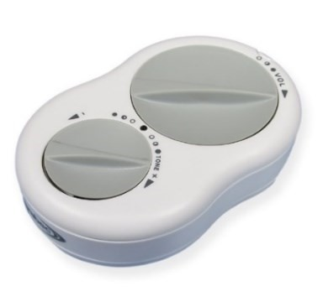
Crescendo 60 The Crescendo 60 can be used as a TV listening device as well as for general conversation. It works by amplifying sound or voices and can be used with either a set of headphones or with a neck loop.
A Crescendo 60 with a neck loop is suitable for people who have hearing aids with the loop setting programmed at audiology. The neck loop will not be suitable for non-hearing aid users or where the hearing aid has not had the loop programme enabled.
Important note: Neck loops cannot be used by people with a pacemaker fitted, headphones are the only alternative in this case.
This equipment is not suitable for people with profound hearing loss.

If the person using the device has a Visual Impairment a Minitech (see below) may be more appropriate than a Crescendo 60.
Full usage instructions, including safety advice, can be found here and in the box:
https://www.sarabec.com/instructions/1101-instructions.pdf
The device requires 2 x AA Alkaline batteries, the first set are supplied with the device. Further replacements are the responsibility of the person using the device.
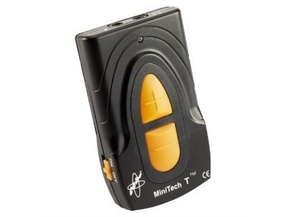
Minitech The Minitech can be used as a TV listening device as well as for general conversation. It works by amplifying sound or voices and can be used with either a set of headphones or with a neck loop.
A Minitech with a neck loop only works for people who have hearing aids with the loop programme enabled. The neck loop will not be suitable for non-hearing aid users or where the hearing aid has not had the loop programme enabled. The loop programme can only be enabled by Audiology or the hearing aid provider.
Important note: Neck loops cannot be used by people with a pacemaker fitted, headphones are the only alternative in this case.
This equipment is not suitable for people with profound hearing loss.
A Minitech may be more suitable for someone who also has a visual impairment due to the large tactile buttons and colour contrast.
Full usage instructions, including safety advice, can be found here and in the box:
https://www.hear4you.com/wp-content/uploads/2014/03/MiniTechT-Instructions-V2.pdf
The device requires 2 x AA Alkaline batteries, the first set are supplied with the device. Further replacements are the responsibility of the person using the device.

1.2 Alarm clocks to help deaf or hard of hearing people wake
People with a hearing loss may need to rely on vibrating or flashing light alarm clocks ton wake up in the morning. If a person with a hearing loss cannot be woken by an audible alarm and needs to be awake at a specific time, we will provide an alarm cock that will meet this need.
There are two options:
- Wake and Shake Vintage Alarm Clock or (2) Travel Tim Alarm Clock
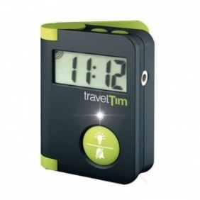
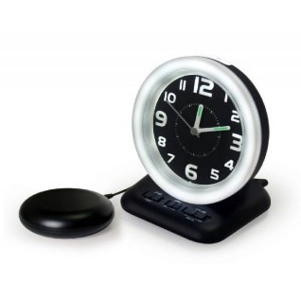
Wake and Shake alarm clocks are powered electrically whereas the Travel Tim is battery powered. Travel Tim is a compact alarm clock that can be placed under the pillow, Wake and Shake is a table stand clock connected to a vibrating pillow pad. People would be responsible for replacing the batteries in the Travel Tim when necessary.

2. People with a visual impairment

2.1 Anti-Glare Glasses or UV Shades
Coloured filters help people minimise eye discomfort and maximise visual resolution. Different filter shades provide varying functions, combining relief from glare, contrast enhancement, and general relief of eye strain.
Amber UV shades - An amber filter provides 100 per cent blue light absorption for reduced glare, UV protection and a high-contrast filter designed for improved definition. For general outdoor use and sunlight.
Green UV Shades - A green filter provides blue and red light absorption for reduced glare and UV protection, particularly for the extremely light sensitive. It can be worn indoors as well as outdoors and is also suitable when other tint colours feel "too bright".
Grey UV Shades - Providing UV protection, a grey filter is for those who prefer not to have contrast as provided by the other filters. Cuts glare and sharpens focus. Designed for general outdoor use and sunlight.
Yellow UV Shades - A yellow filter provides 100 per cent blue light absorption for reduced glare, UV protection and a high-contrast filter for improved definition. Maximum brightness. For indoor use and low intensity sun.
NB Please note the Amber and Grey UV shades are designed for outdoor use only.
Also, one tint will not suit all.

Colour | inside | outside | Sunlight | Glare
Amber |  | x | x | x
Grey |  | x | x | x
Green | x | x | x | x
Yellow | x |  |  | x

2.2 Reading or Writing Aids
Felt pens – in general these enable writing to be made bigger and bolder for reading. There are 2 types we issue, Fine and Broad, please allow both to be tried to suit individual preference and need. Some people may prefer different coloured paper as standard black on white may result in to too much glare. A good alternative is black writing on yellow or buff coloured paper.
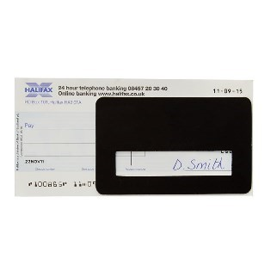
Signature guides – if necessary, please support the visually impaired person by placing the signature guide where they need to sign; ask the person to feel for the gap, finding the far left so they know where to start signing. For some eye conditions, the signature guide can be a good reading aid, particularly for information laid out in columns. As the guide is moved over text it allows greater focus, also cutting out glare from the rest of the page.

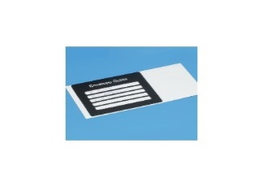
Envelope guides – Space to write up to five lines of an address. If you are partially sighted, the contrast between the thick black frame and the envelope you are writing on will make it easier to write the address. Line up the guide with the edge of your envelope to position and hold in place with your free hand.
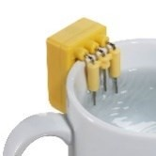
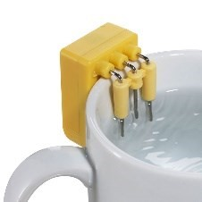
2.3 Liquid level indicator (LLI)
This compact, lightweight device has three metallic probes which indicate two separate liquid levels within a cup or mug by triggering audible and vibratory alerts. The first alert tells you when to stop adding hot water; the second tells you when to stop pouring milk. The device can be used on most cups and mugs, as well as glasses, jugs and (cold) cooking pots.

2.4 Canes
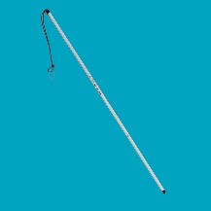
Symbol cane - Increase confidence when you're out and about with a symbol cane, designed to highlight to other people that you are blind or partially sighted. Made from aluminium tubing. Folds up so you can pack it away easily when not in use and small enough to fit easily into a pocket or bag.

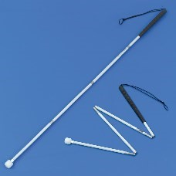
Long Cane - Long canes should only be used by people who have attended a specialist training course to attain a high level of safe and independent travel. Long canes are not to be used for supporting a person's body weight.

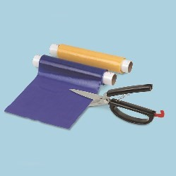
2.5 Dycem

The reel of Dycem allows you to cut pieces to your own sizes. This non-slip material can be used to grip items, as a tray liner to help prevent accidental spillage. It can also increase colour contrast for example at mealtimes.

2.6 Bumpons
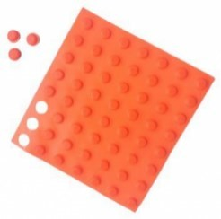

Ideal for marking equipment such as a microwave, buttons on a remote control or important keys on your computer keyboard etc.

2.7 General Advice
Watching TV – obviously people may benefit from sitting closer. Some people prefer to watch TV in a darker environment as this increases contrast. Consider the location of the TV, may cause discomfort or glare if in front of a window. Check TV Settings to see if Audio Description is available. This is a service developed for visually impaired people to enhance enjoyment. Not all programmes are audio described, but if available a ‘Narrator’ will be heard between actors’ dialogue explaining what is happening on the screen.
Colour Contrast – the use of strong bright colours, for example using a white mug for tea or coffee may enhance visibility and contrast for a visually impaired person and could limit accidents and spillages. Similarly placing a white mug on a dark table could increase the likelihood of the mug standing out and again increase visibility and potentially minimising accidents.
Lighting – generally the best source of light to enhance functional vision is daylight. Within a closed environment, angle poise task lamps may be needed in addition to general lighting to improve functional vision when focused on a task. If possible, consider purchasing ‘daylight’ bulbs (designed to emulate daylight) for standard angle poise lamps or purchasing Daylight Lamps available via SW Retail IC VISION LTD (icswretail.co.uk) Tel: 01226 762513 or Edward Marcus UK Premier Supplier of Magnifiers and Low Vision Aids (ic-online.co.uk) Tel: 01302 722979. Catalogues can be ordered by contacting the suppliers direct. Please note that lighting needs are very specific to every individual and the above is just a guide. What can offer increased visual function for one person may result in too much glare for another, even though they may be diagnosed with the same eye condition.

3. Summary
We hope this guide assists you to understand the equipment which can be issued to help Deaf, hard of hearing and visually impaired people with difficulties they may be experiencing as a result of their sensory loss.
Please get in touch with us if you feel we can support a Deaf, hard of hearing or visually impaired person using the contact details on the front page.

