Young People’s Questionnaire:
Post-16 Travel Assistance Consultation

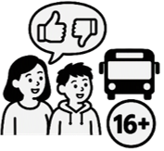
We want to know what you think about travel support for young people aged 16 to 25 with SEND (Special Educational Needs and Disabilities).


Your answers will help us understand what support is important to you and what you think about our ideas for changes in the future.


If you want more information, you can read our Post-16 Travel Assistance Consultation easy read. It tells you about the changes we are thinking about, and why we are changing Post-16 SEND Travel Assistance.

Section A: About you


A1) Where in Nottinghamshire do you live?


☐Ashfield


☐Bassetlaw

☐Broxtowe

☐Gedling

☐Mansfield

☐Newark and Sherwood


☐Rushcliffe


☐Nottingham City


☐Outside Nottinghamshire


☐Prefer not to say

☐Other or not sure


A2) Which school, college or place of learning do you go to?


Please write your school in the box below:


☐Or prefer not to say.


A3) How many days a week do you go to your school, college or place of learning?

☐Less than 1 day
☐1–2 days
☐3–4 days
☐5 days


A4) How do you travel there?


Please tick all the ways you travel.


☐Transport arranged by the council.


☐Lift from a parent or carer.


☐Bus, train or tram.
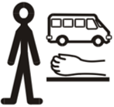
☐Travel with a personal assistant, escort or support worker.


☐Taxi arranged by my family.


☐A mix of different ways.

☐Other, please tell us in the box below.




☐Not sure

☐Prefer not to say


A5) Are you happy with the way you travel?


☐Yes



☐No

☐Not sure


A6) What would make travelling easier for you?


Please tick all the things that would help.

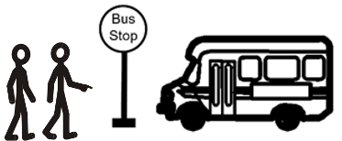
☐Training to help me travel independently.


☐Help planning and practising my journey.


☐Free travel or help paying for buses, trams or trains.


☐Someone to travel with me.

☐A taxi, minibus or specialist vehicle.

☐A passenger assistant or other support on the journey.

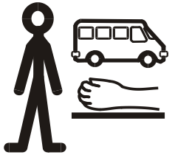

☐Information in a way I can understand.

☐Extra help if my journey changes or is delayed.

☐Other
Please tell us what this is in the box below.

☐Not sure.


A7) Is there anything else you want to tell us?
If there is, please write it in the space below.

Section B: What you think of our ideas for changes


The council is looking at different ways of giving travel support in the future.


Please read each option and tell us what you think.


Option 1 – A contribution for organised transport

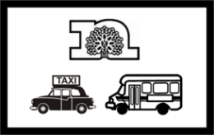
Learners aged 16 – 25 with SEND could still have council-organised transport.

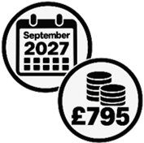
Families of learners aged 16 – 18 (in years 12 and 13) using council-organised transport would pay £795 a year for this from September 2027.

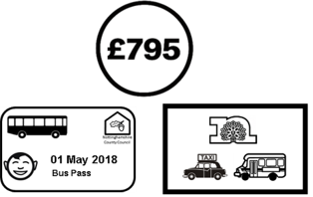
This is 7% of the cost of the transport, and the same amount of money that a council bus pass will cost for pupils using mainstream school transport.


Families with a household income below £7,400 a year would not pay.


This option would save the council about £0.4 million a year.


B1. Do you think the council should make this change from September 2027?

☐Strongly agree
☐Agree
☐Neither agree nor disagree
☐Disagree

☐Strongly disagree


Option 2 - Year 12 enhanced assessment from 2027 plus contributions


Post-16 learners already getting organised transport would keep getting it until they finish their post-16 education.


But from September 2027, learners starting year 12 could only get organised transport in exceptional circumstances.


If someone said they had exceptional circumstances, they would have to do an enhanced assessment (an assessment that is longer and more detailed) as part of their application for travel assistance.


If someone wanted for a DTAP (direct travel assistance payment) or parent mileage, they would not have to do an enhanced assessment.

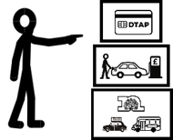
On someone’s application, they would say what sort of travel assistance they wanted.


If the council decides someone does not have exceptional circumstances, they would be offered a DTAP.


Families of learners aged 16- 18 (years 12 and 13) who had organised transport from September 2027 would pay £795 each year towards the cost of the transport.


This could save the council about £1.5 million a year.

B2. Do you think the council should choose this option from September 2027?
☐Strongly agree
☐Agree
☐Neither agree nor disagree
☐Disagree
☐Strongly disagree


Option 3 - Post 16 enhanced assessment from 2028 plus parental contributions


From September 2028, learners aged 16 -25 could only get organised transport in exceptional circumstances.


From September 2028, all learners in or going into post-16 education would need to apply for travel assistance.


If someone wanted to apply for organised transport, they would need to show they had exceptional circumstances.


To show they had exceptional circumstances, they would need to do an enhanced assessment.


An enhanced assessment is an assessment that is longer and more detailed.


If someone said they wanted a DTAP or parent mileage, they would not have to do an enhanced assessment.

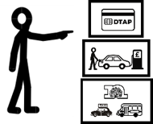
On someone’s application, they would say what sort of travel assistance they wanted.


If the council says someone does not have exceptional circumstances, they would be offered a DTAP instead.


Families of learners aged 16- 18 (years 12 and 13) who had organised transport from September 2027 would pay £795 each year towards the cost.


This option would save the council about £2.3 million a year.


B3. Do you think the council should make this change from September 2028?

☐Strongly agree
☐Agree
☐Neither agree nor disagree
☐Disagree
☐Strongly disagree


Option 4 - All Post 16 learners to have an enhanced assessment from 2027 plus parental contributions


From September 2027, learners aged 16-25 could only have organised transport in exceptional circumstances.

From September 2027 all learners in or going into post-16 education would need to apply for travel assistance.

If someone wanted to apply for organised transport, they would need to show they had exceptional circumstances.

Someone who wanted organised transport would need to do an enhanced assessment (an assessment that is longer and more detailed) as part of their application.

If someone said they wanted a DTAP or parent mileage, they would not have to do an enhanced assessment.

On someone’s application, they would say what kind of travel assistance they wanted.

If the council says someone does not have exceptional circumstances, they would be offered a DTAP instead.

Families of learners aged 16- 18 (years 12 and 13) who had organised transport from September 2027 would pay £795 each year towards the cost.


This option could save the council about £3.1 million a year.

B4. Do you think the council should make this change from September 2027?

☐Strongly agree
☐Agree
☐Neither agree nor disagree
☐Disagree
☐Strongly disagree

B5. Do you have anything else you want to tell us about these options?

Please write your answer in the space below.


Thank you for answering our questions and taking part in our consultation.

Links in this document

Post-16 SEND Travel Assistance Consultation: easy read
https://www.nottinghamshire.gov.uk/global-content/easy-read-library/post-16-send-travel-assistance-consultation-easy-read

For the standard version of this information, go to:

Post-16 SEND travel assistance policy consultation | Nottinghamshire County Council

https://www.nottinghamshire.gov.uk/education/travel-to-schools/post-16-send-travel-assistance-policy-consultation#HowToHaveYourSay

This easy read was first published 20 October 2026
This information was last updated 20 October 2026

