Official headed paper

Mention the athlete by name.
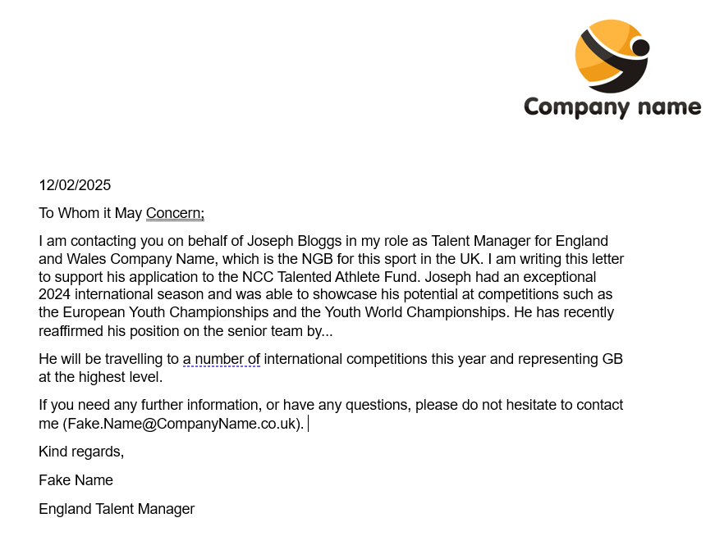
Explain your role.
Discuss recent achievements/rankings
and explain how the athlete meets the eligibility criteria.

Include your contact information


Remember you can always contact the Talented Athletes team at LCF@nottscc.gov.uk if you have any questions or concerns.

