

Workforce Profile Report 2023

|  |  |
| --- | --- |
| **Contents** |  |
| **Foreword** | **2** |
| **Context** | **3** |
| **Data collection and definitions** | **4** |
| **Profile of Nottinghamshire County Council by Protected Characteristics** | **5** |
| **Breakdown of characteristics for Nottinghamshire** | **7** |
| **Nottinghamshire County Council Recruitment Data** | **8** |
| **Summary** | **13** |

# Foreword

The Council is committed to embedding equality, diversity and inclusion (EDI) in the delivery of its services and in the employment of its workforce. We all have a duty to comply with the Public Sector Equality Duty and the Equality Act 2010. The workforce profile information forms part of that.

We are proud of the work we have undertaken so far in striving to ensure our workplace is inclusive and our workplace practices mitigate any disproportionate impact on any staffing groups. By embracing our EDI interventions, we endeavor to develop a working environment free from bullying, harassment, victimisation and unlawful discrimination, promoting dignity and respect for all, where individual differences and the contributions of all staff are recognised and valued. All these qualities in an organisation promote a healthy workplace, with staff that can deliver the best possible services to our communities.

As an organisation we continue to deal with the effects of the pandemic and the disproportionate impacts on certain groups and we continue to look at ways to improve our practices. The workforce profile information plays an important role in helping us to understand where any gaps exist. We use this information to inform our activity and strive to continually improve our systems, practices and processes to suit the needs of our workforce and people within Nottinghamshire.

To show due regard to the aims within the Public Sector Equality Duty we are developing a stronger and clearer Corporate Equalities Action Plan which will build on the successes from the current plan and drive forward the actions across our organisation. Our refreshed EDI activity will be aligned to the themes set out within the People Strategy and the Nottinghamshire Way to promote coherence and consistency within the implementation of our EDI actions.

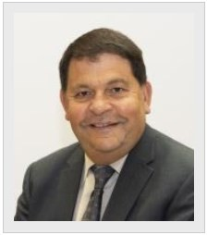

## Councillor Gordon Wheeler

**Cabinet Member for Personnel and Members’ Equality Champion**

# Context

The section details the Equality Act and what relevance it has, the main purpose of this report and a short summary about Nottinghamshire County Council’s (NCC) rates of sharing information across various protected characteristic strands. Nottinghamshire County Council rely on employees and applicants to give us diversity information. This information is given to us on a voluntary basis.

## The Equality Act 2010

This report is underpinned by our duty under the Equality Act. All public sector employers, including local authorities, have a statutory duty under the Equality Act 2010 to publish the equality profile and recruitment data it holds for its directly employed workforce on an annual basis (this does not include school-based employees). The latest workforce and recruitment information for Nottinghamshire County Council (NCC) is based on data 1st April 2022 to 31st March 2023. The snapshot date is 31st March 2023.

This data underpins the Council’s commitment to ensuring that its employment practices and services are free from discrimination and prejudice and fulfil the core statutory duty placed on all public sector employers, including local authorities, to:

* monitor the profile of their workforce by the protected characteristics
* publish the relevant data on a regular basis (annually)
* identify any negative trends or issues and take any necessary action to address these.

## Purpose

The purpose of this report is to provide an annual summary of the profile of the workforce and recruitment data for Nottinghamshire County Council by its protected characteristics as defined under the Equality Act 2010. Further information can be found using this link: Equality Act 2010: guidance - GOV.UK (www.gov.uk).

## Disclosure

Currently, NCC employees can update their own personal data using the Employee Self Service (ESS) facility on the Business Management System (BMS). Disclosure rates for gender and age can be extrapolated from payroll data and are therefore at 100%.

The total number of employees within Nottinghamshire County Council is currently 7331.

# Data collection and definitions: as of August 2022

|  |  |  |
| --- | --- | --- |
| **Topic or Acronym** | **Definitions** | **Notes** |
| Who’s included | Permanent NCC employees | Direct employees of NCC only |
| Temporary NCC Employees |
| Who’s not included | Relief workers |
| Casual workers |
| Agency Workers |
| Protected characteristics analysed | Gender | Data self-validated by employees on an on- going basis |
| Ethnic group |
| Age |
| Disabled status |
| Sexual orientation |
| Religion/belief |
| Heads/headcount | Number of individual employees |  |
| BAME/BME (we aim to avoid the use of this acronym and will be used only where necessary for  data reasons) | All ethnicity categories other than British/English/Scottish/Welsh/N. Irish  BAME/BME refers to individuals from a Black, Asian and Minority Ethnic background. | |
| Disabled | Individuals who consider themselves to be disabled under the Equality Act 2010 | |
| LGBT | Lesbian, Gay, Bisexual, Transexual | |
| NCC | Nottinghamshire County Council | |
| ASCH | Adult Social Care and Health | |
| C&F | Children & Families | |
| **Period/Year** | **Source of workforce profile data** | |
| April 2012 onwards | Business Management System was introduced in 2012 | |

**Profile of NCC Employees by Protected Characteristic**

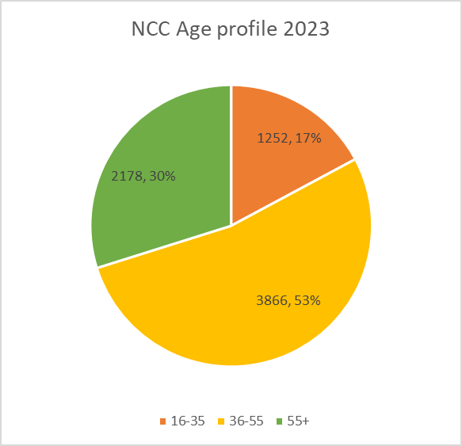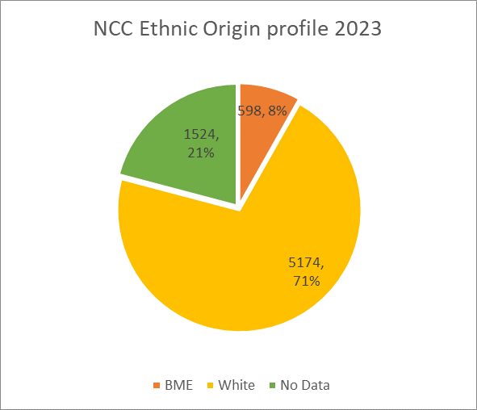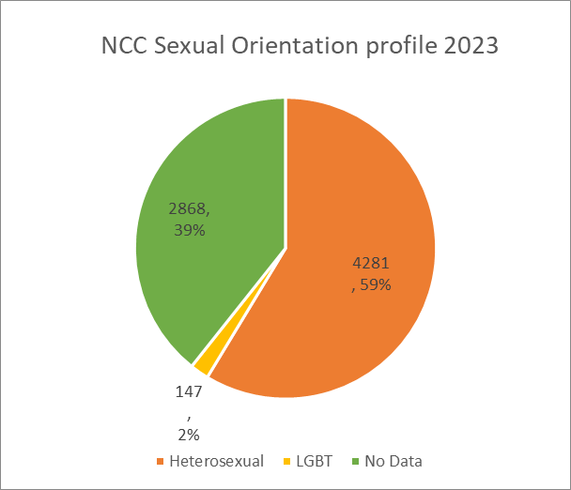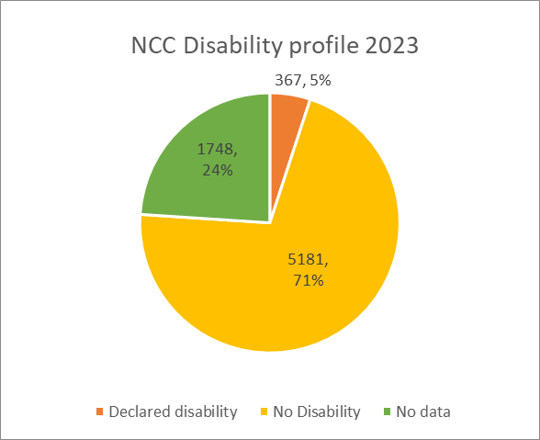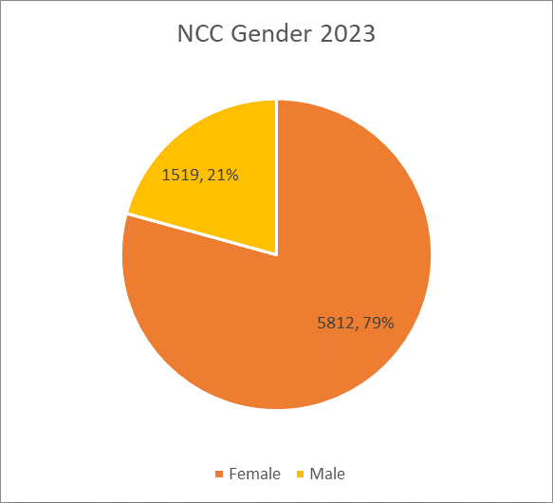

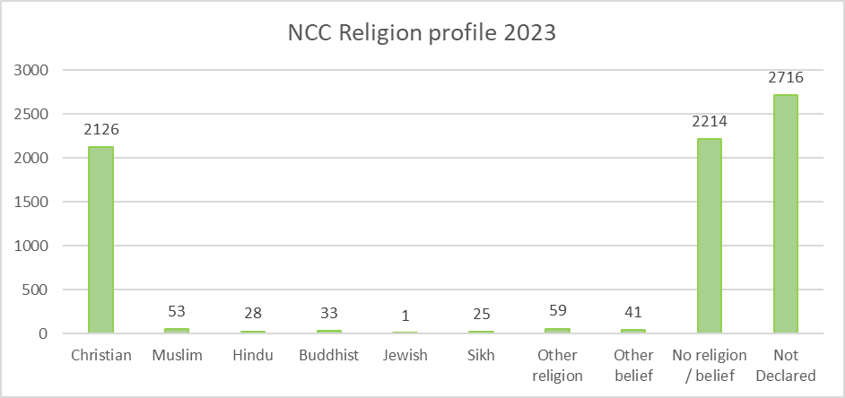

Percentages for religion have been described below:



# Breakdown of characteristics for Nottinghamshire population

Gathered from Office of National Statistics. Further information can be found [here.](https://www.ons.gov.uk/census)

|  |  |  |
| --- | --- | --- |
| **Sex** | **2021** | |
|  | **Number** | **%** |
| **All persons** | 824,822 | 100.0 |
| **Female** | 420,034 | 50.9 |
| **Male** | 404,788 | 49.1 |

|  |  |  |
| --- | --- | --- |
| **Ethnic group (detailed)** | **2021** | |
|  | **number** | **%** |
| **Total: All usual residents** | 824,821 | 100.0 |
| **Asian, Asian British or Asian Welsh** | 24,519 | 3.0 |
| **Black, Black British, Black Welsh of African background** | 5,173 | 0.6 |
| **Black, Black British, Black Welsh or Caribbean background** | 4,757 | 0.6 |
| **Mixed or Multiple ethnic groups** | 17,109 | 2.1 |
| **White** | 767,220 | 93.0 |
| **Other ethnic group** | 6,043 | 0.7 |



# NCC Recruitment data

**From our recruitment database we have provided figures for the application, shortlisting and offer recruitment stages. We have examined these figures across the protected characteristic groups i.e., Gender; Ethnic Origin, Sexuality; Religion or Belief and Disability. Data collection is based on information from 1st April 2022 – 31st March 2023. (Percentages have been rounded up or down therefore totals might equate to just below or over 100%).**

**For each protected characteristic there is a breakdown of information showing the % of candidates at each stage of the process.**

**Gender**

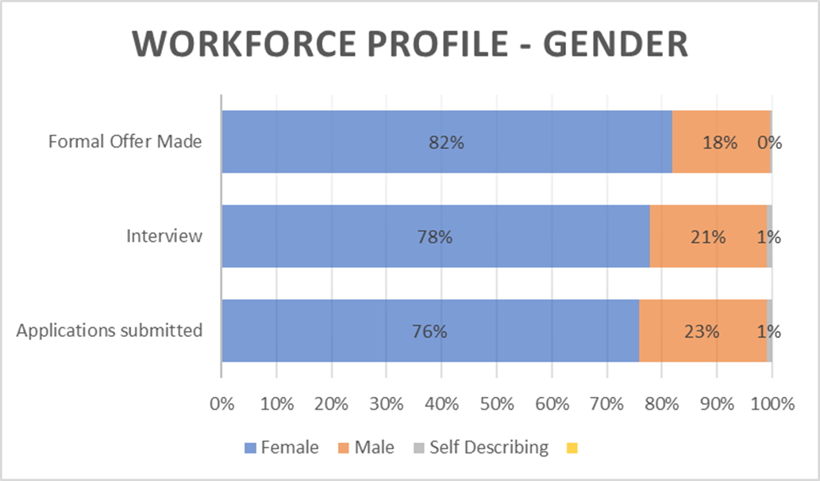

* 76% of applications were from female candidates, 23% were from male candidates and 1% preferred not to share their gender or described their gender as something apart from male or female.
* Out of all those candidates interviewed, 78% were female, 21% were male and 1% preferred not to share their gender or described their gender as something apart from male or female.
* Of all those individuals that we made formal offers to 82% were female and 18% were male.

# Ethnicity

BME refers to individuals from a Black, Asian and Minority Ethnic background as explained on page 3.

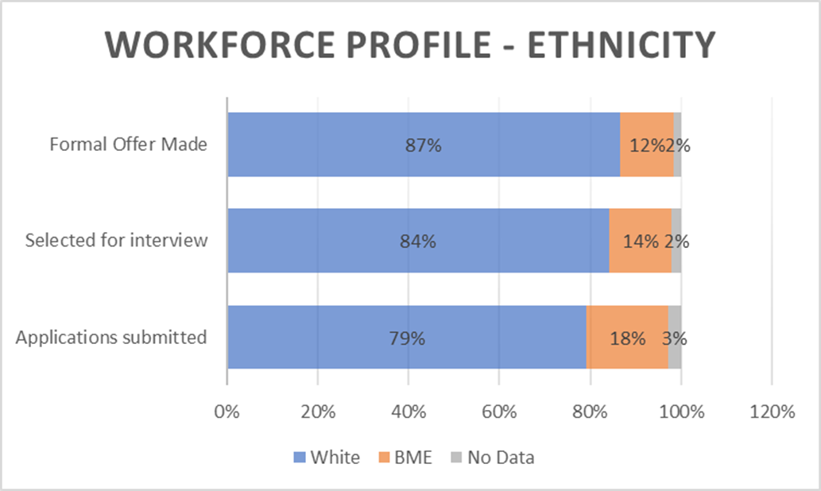

* 79% of applications were from White candidates, 18% were from a Black, Asian and Minority Ethnic background. For 3% of candidates, we had no information on ethnicity.
* Of the candidates selected for interview, 84% were White, 14% were from a Black, Asian and Minority Ethnic background. For 2% we had no information on ethnicity.
* Of those individuals we made formal offers to, 87% were White, 12% had a Black, Asian or Minority Ethnic background. For 2% we had no information on ethnicity.

# Sexuality

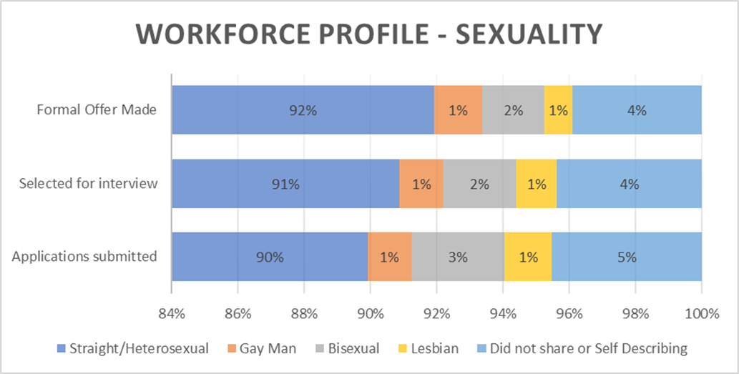

* Out of all the candidates that submitted applications 90% said that they were Straight/Heterosexual. 1% identified as Gay men, 3% said that they were Bisexual and 1% said that they were Lesbian. 5% of those who submitted applications did not share their sexuality or they are self-described.
* 91% of candidates that were selected for interview identified as Straight/Heterosexual. 1% identified as Gay men, 2% said that were Bisexual and 1% identified as being Lesbian. 4% of those selected for interview did not share their sexuality or they are self-described.
* Out of all the candidates we made a formal offer to 92% said that they were Straight/Heterosexual. 1% identified themselves as Gay men, 2% said they were Bisexual and 1% identified as Lesbian. 4% of those who we made formal offers to did not share their sexuality or self-described.

# Religion

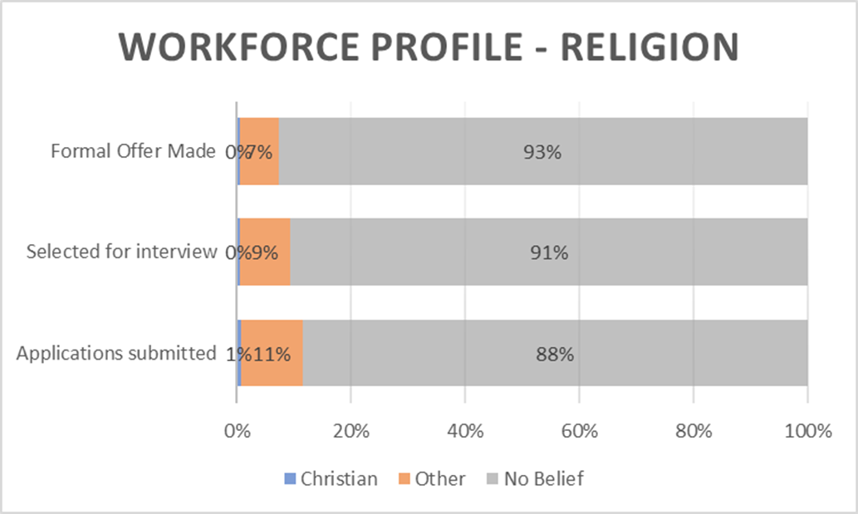

* Out of all the applications submitted, 1% stated they were from the Christian faith. 11% were from faiths other than Christianity and 88% had no belief.
* Out of all the applicants selected for interview, 9% were from faiths other than Christianity and 91% had no belief.
* Out of the candidates that we made a formal offer to, 7% were from faiths other than Christianity and 93% had no belief.
* There is a further breakdown by religion below:



**Disability**

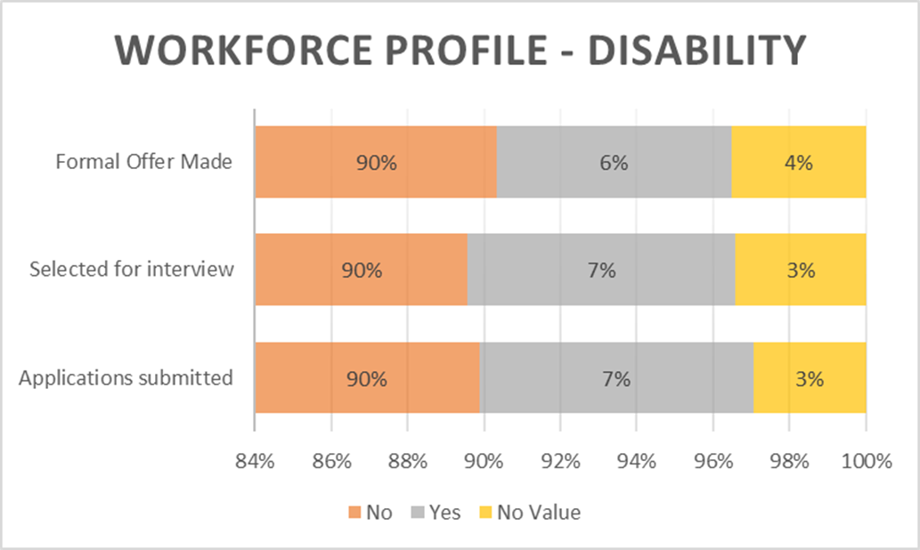

* Out of all the candidates that submitted applications, we had no information in relation to disability for 3% of individuals. 7% of candidates shared that they had a disability and 90% said that they did not have a disability.
* Of all the candidates that were selected for interview, for 3% we had no information in relation to disability. 7% shared that they had a disability and 90% said that they did not have a disability.
* Of candidates we made formal offers to, for 4% of these we had no information in relation to disability. 6% of candidates shared that they have a disability and 90% said that they did not have a disability.

# Summary of workforce profile information and next steps.

The data demonstrates that we have diversity within our workforce, and we are extremely proud of this. We are pleased that our data shows we are representative of our Black, Asian and Ethnic minority community within Nottinghamshire. When the new census data is available across all protected characteristics, we will be able to analyse more widely how our workforce make up reflects its local community.

We appreciate that our workforce data is dependent upon voluntary disclosure of information, and this is something we are currently working to improve on through activity such as “Diversity December”.

Reviewing the recruitment data, there is some minor disproportionate impact from application to offer stage across some of the characteristics and we continue to work on a number of actions we have in place such as anonymous application forms and delivering our “Treating People Fairly” mandatory course which includes fair recruitment practices.

We work closely with our self-managed networks and trade unions across all departments on our equality action plan activity aimed at improving inclusion, equality, and diversity across our workforce and in the community. Some of the activity undertaken this year has included introducing reverse mentoring, continuing to progress our work on employee passports and launching a brand-new learning and development program for our leaders as well as developing our current mandatory EDI offer to all staff. We provide a range of health and wellbeing support initiatives and promote a range of events that support all protected characteristics and beyond. This year we have successfully secured funding to support additional activity, such as increasing our cohort of Mental Health First Aiders and appointing a wellbeing coordinator to map and improve our wellbeing initiatives across the Council. We continue our commitment towards race equality as we work with Skills for Care to deliver the Workforce Race Equality Standard project. Our priority with learning and development has been to improve skills across Nottinghamshire and provide a range of opportunities for all staff, with a focus on supporting young people through apprenticeships, graduate programs, work experience and our Summer Intern Program to support individuals with disabilities.

Our new corporate equality action plan will be informed by data sources such as the workforce profile, and will be underpinned by the Nottinghamshire Plan, People Strategy and link to the values and behaviours embedded in the Nottinghamshire Way. This will enable us to continue to uphold our duty under the Equality Act 2010. Our new corporate equalities action plan work and visions will be captured within Our Commitment to our employees for an equitable, diverse, and inclusive (EDI) workplace at Nottinghamshire County Council, which we will publish by 31st March 2024.