INFORMAL CONSULTATION ON LAUNCH OF A FREE SCHOOL PRESUMPTION COMPETITION

LOCAL AUTHORITY CONSULTATION REGARDING A NEW SPECIAL SCHOOL IN MANSFIELD

This consultation is non-statutory and is an informal means of gathering local views on the proposal outlined below.

Nottinghamshire’s Special Educational Needs and Disabilities (SEND) Place Planning Strategy (2021-2026) states that:

- Despite the planned actions to develop locality working, and the ongoing commitment to inclusion, the analysis of the continuing demand for specialist educational placements … will require the County Council to increase provision over the next five years.

The headline requirements identified in this Strategy are for:

- An additional 275 - 490 places in specialist provision by September 2026, with up to 239 places required for September 2023.

- An additional special school for children and young people with autistic spectrum disorder (ASD)

- A range of provision with most of the additional placements being located either on existing mainstream school sites or new build schools (Satellite Centres), to allow opportunities for integration and access to the national curriculum. This is especially important for the cohort of children and young people with social, emotional and mental health needs.

Context

By law, all new schools in England must be opened as Free Schools, set up and run by Multi-Academy Trusts. The process by which local authorities establish a new Free School, and the Secretary of State appoints a Multi-Academy Trust to run it, is known as the Free School Presumption.

Before embarking on the launch of a Free School Presumption competition, local authorities are encouraged by the Department for Education to conduct local, informal consultation. The aims of this are twofold:

- to publicise the need for a new school among the local stakeholder community and potential sponsors.
- feedback gathered through consultation will be valuable and contribute to formulate and finalise the Local Authority’s specification for a new school before its publication.

Nottinghamshire County Council is therefore conducting a local, informal consultation prior to the initiation of a Free School Presumption. This consultation is in accordance with the Department for Education advice as published in ‘The free school presumption’, guidance for local authorities and new school proposers’, (p.8), DfE, January 2023. See:
https://assets.publishing.service.gov.uk/government/uploads/system/uploads/attachment_data/file/844346/Free_school_presumption_051119.pdf

Please find below information about a proposed new Free Special School in your area. We are seeking the opinion of local stakeholders, including residents, on a proposal to open a new special school in Mansfield.

Background

Location of new special free school at Ravensdale

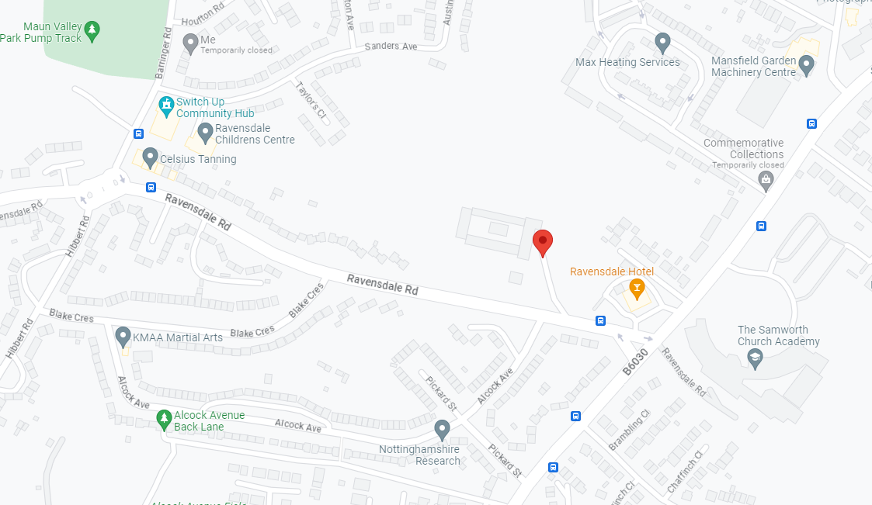

New Special School off Ravensdale Road, Mansfield

The new school will be built on the former Ravensdale Middle School Site. It will be built in accordance with the specifications described by the Department for Education (Building Bulletin 103) and under consultation with Nottinghamshire County Council.

The school will admit pupils from Key Stage 2 to the end of Key Stage 5. Initially the school will be able to offer 144 places with a view to expanding to 160 places.

The allocation of places at the new special school will continue to be managed by the Statutory Education, Health & Care Assessment Team of the Council’s Integrated Children's Disability Service. Places will be allocated to those children with Education, Health and Care Plans specifying specialist provision which can be offered at the new school. The trust that will operate the school will be selected through the Free School Presumption process.

The consultation process and indicative timeline for opening a new special free school

As per the timeline published below, this consultation will run for six weeks from Tuesday 11th July until Tuesday 22nd August 2023.

Nottinghamshire County Council (the Council) will welcome responses to the consultation during this period.

The outcome of this initial consultation will be reported through the Nottinghamshire County Council governance process and a decision will be taken about whether to proceed with a Free School Presumption process. If this option is chosen, the Council would invite Multi-Academy Trusts to apply during Autumn Term 2023 for selection to operate the new special school.

Once proposals are received and have been evaluated, the Council will recommend a sponsor to the Regional Department for Education (DfE) Directors who will make the final decision. The Council will then work with the successful sponsor and the housing developer to open the new school.

Other Options Considered

All existing special school Headteachers were consulted to see if an expansion of their existing site was appropriate. Some of the current maintained schools have reached capacity on their existing sites so a development would not be possible without securing additional land or buildings. Not all special schools offer provision for pupils with autistic spectrum condition or social, emotional and mental health (SEMH) needs and these two areas of need have been identified as a priority. Other sites were considered but are not suitable.

Reason for Recommendation

Additional specialist places are required within the County with the priority being in the specialisms of ASD and SEMH as identified by the Special Educational Needs and Disabilities (SEND) Place Planning Strategy (2021-2026).

Statutory and Policy Implications

This report has been compiled after consideration of implications in respect of crime and disorder, data protection and information governance, finance, human resources, human rights, the NHS Constitution (public health services), the public sector equality duty, safeguarding of children and adults at risk, service users, smarter working, sustainability and the environment and where such implications are material they are described below. Appropriate consultation has been undertaken and advice sought on these issues as required.

Financial implications

The capital costs for this project will come from SEND capital project monies allocated by the DfE.
Revenue costs for the school will be funded through High Needs Block funding. There are no
financial implications arising from this report.

Public Sector Equality Duty Implications

As part of formulating and finalising the Council’s specification for the new school, the Council will
undertake an assessment of the proposals both on existing educational institutions locally and in
terms of the impact on groups of pupils and others from an equalities perspective. This will form
part of the information provided to the DfE.

Implications for Residents

As part of formulating and finalising the Council’s specification, the impact on residents will be
considered and assessed. Should the proposals proceed, the impact on local residents will also
be taken into account through the planning permission process.

Implications for Sustainability and the Environment

The implications for sustainability and the environment of the new free school will be considered
in depth during the construction project’s detailed design stage. Considering both the building
itself and its operation, the new school will be carbon neutral.

At the end of this document there is a Consultation Response Form.

If you wish to respond to the consultation on this proposal, please send written comments to:

- The Corporate Director of Children and Families,
(for the attention of Pupil Place Planning),
Education, Learning and Skills,
County Hall, West Bridgford,
Nottingham, NG2 7QP

or by email to place.planning@nottscc.gov.uk

- Comments may also be submitted online at Nottinghamshire County Council - Citizen Space
(see View our consultations)

To be received no later than 23:59 hrs on Tuesday 22nd August 2023

Consultation Response Form

INFORMAL CONSULTATION ON LAUNCH OF A FREE SCHOOL PRESUMPTION COMPETITION

LOCAL AUTHORITY CONSULTATION REGARDING A NEW SPECIAL SCHOOL IN MANSFIELD

If you wish to respond to the consultation you can share your views by:

- Completing the online survey on Nottinghamshire County Council’s consultation hub
- Emailing Nottinghamshire County Council at place.planning@nottscc.gov.uk
- Requesting a paper copy of this consultation from:
Pupil Place Planning, Education Learning and Skills, Children and Families Services, Nottinghamshire County Council, County Hall, West Bridgford, Nottinghamshire, NG2 7QP - to which your response should be returned.
…………………..………………………………………………………………………………………

Question 1.
Do you think that a new special school with 144 places (with a view to expanding to 160 places) should be built in Mansfield?

Yes
No
Neither agree or disagree

Question 2
Do you have any further comments?

It will help us to analyse responses if we know more about you.
Please complete the following details:
(Please tick and complete all boxes that apply)

I am a:

Parent / Carer | Which school / academy do(es) your child(ren) attend?
Governor | At which school / academy?
Member of Staff | At which school / academy?
Pupil | At which school / academy?
Other | Please specify (e.g. resident)
What is your post code?

Responses should be returned to:

- Nottinghamshire County Council at place.planning@nottscc.gov.uk or
- Pupil Place Planning, Education Learning and Skills, Children and Families Services, Nottinghamshire County Council, County Hall, West Bridgford, Nottinghamshire, NG2 7QP

by 23:59hrs on Tuesday 22nd August 2023

