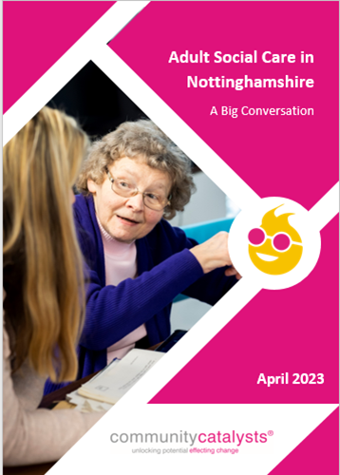 | The Big Conversation  Adult Social Care in Nottinghamshire  Easy Read

 | Community Catalysts are the organisation Nottinghamshire Adult Social Care asked to do the Big Conversation.
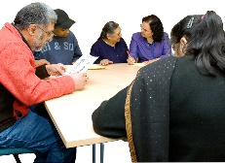 | They wrote a report which was both hard read and easy read.
 | Nottinghamshire Adult Social Care have put all the easy read bits together to make this report

- BACKGROUND – WHAT WE DID

Key points
Community Catalysts were asked to listen to people who draw on social care services and their family carers.
They had to find out what people think about social care in Nottinghamshire.

- The Vision
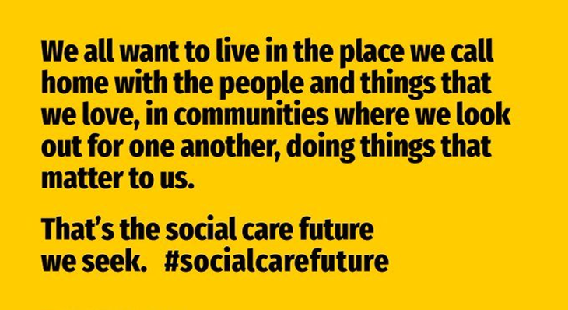
Key points
 | Nottinghamshire wants social care to be like the Social Care Future vision.
Nottinghamshire uses the Making it Real standards.
Click this link for easyread information about Making it Real.
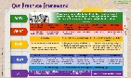 | Nottinghamshire has written a Practice Framework.
 | The Practice Framework says how social care will happen in Nottinghamshire in the future.

- The Big Conversation

Key points

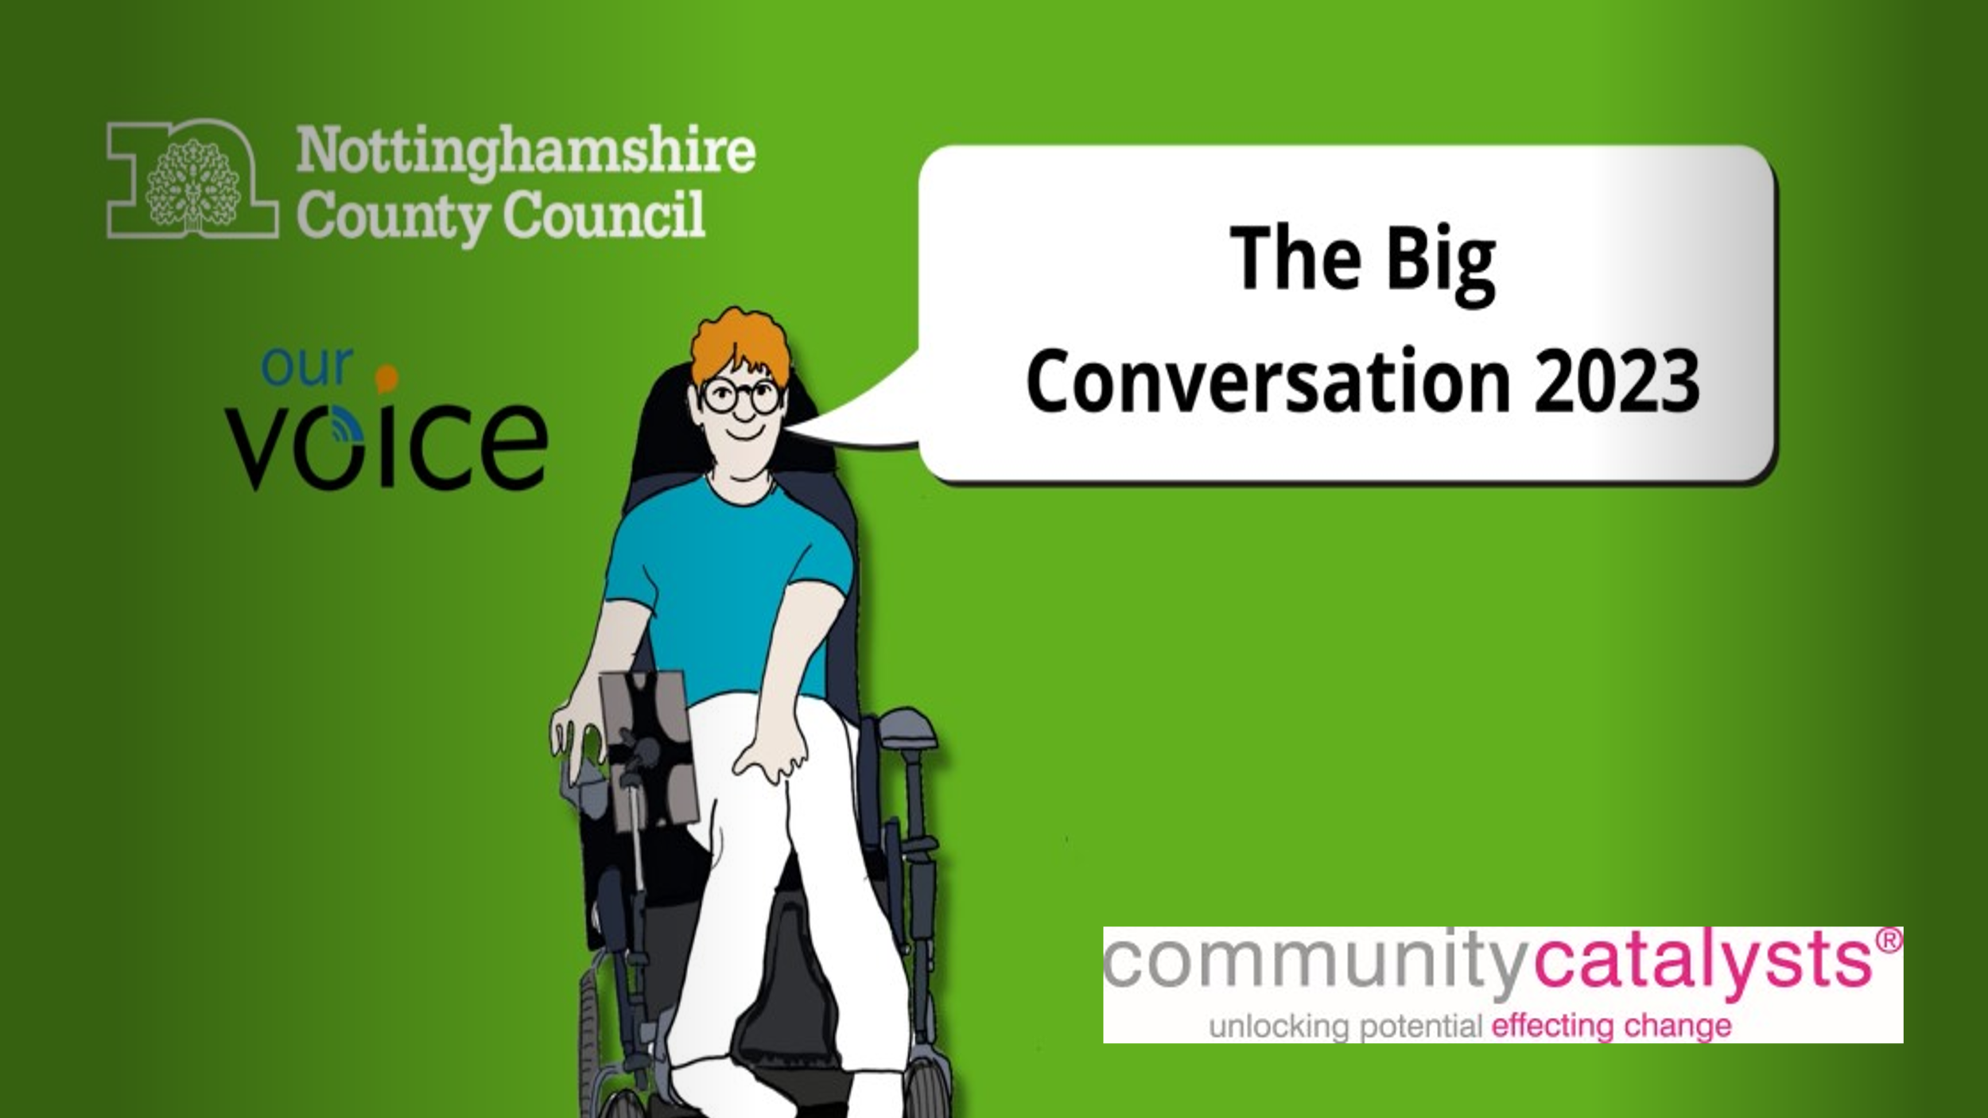 | We called the listening the Big Conversation.
 | We set up a webpage and made a video to tell people about it.
 | Our Voice are Nottinghamshire’s co-production group for social care. They helped make the Big Conversation happen.
 | Together we arranged lots of ways to listen to people.
 | We had events and meetings with people face to face.
 | We did 2 surveys for people who couldn’t come to an event.

- Who did we hear from

Key points

221 people filled out a survey. They lived all over Nottinghamshire.
207 people came to an event.
185 people came to a meeting or group. They were people who used lots of different services.
We heard from 542 people altogether.
277 people were carers.
265 people use social care.

- About the people

Key points

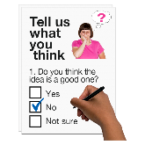 | In the surveys we asked people to tell us about themselves.
 | Most people who use social care say they have an illness or disability.
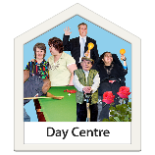 | People who did a survey use lots of different social care services.
 | Some people who use social care are also carers themselves.
 | Some people use social care get help from other organisations like health.
 | Lots of people who use social care get help from family or friends.
- About Carers
Key points
In the surveys, we asked people to tell us about themselves.
Some carers say they have an illness or disability.
Most carers offer care for more than 20 hours a week.
Many carers are older. Most are female.
Most carers don’t get help from anyone else.

Many carers are helped by Carers Hub.
Some are part of a carer support group.
Some have a personal budget.
This helps people live their life their way.

- MEASURING AGAINST THE PRACTICE FRAMEWORK

This is the way adult social care should work with the people they support
Key points

We asked people how well Nottinghamshire does social care.
We used the new Practice Framework to decide what questions to ask.
Some people thought social care was good.
Some people thought social care was bad.
People told us about social workers and the way they work.
Some people said they don’t have the same Social Worker. It can be hard for them to talk to someone they don’t know.
Some people talked about support services being cut.
This makes them worry about review meetings.
Some carers said that that Social Workers were sometimes unsupportive.

- WHAT PEOPLE WHO USE SOCIAL CARE SAID

Key points
Some people said they like living in their own home.
Some people said they feel isolated.
Some people worry about the future and if they can stay in their home.
People told us about support services that do a good job.
They talked about services and staff who are not good.
 | People said that some things stopped for the Covid pandemic. They haven’t started again.
People talked about Direct Payments.
They help people live their life their way.
But they can be hard to manage with lots of paperwork and responsibility.
 | Many people said public transport and buses are important.
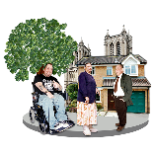 | Many people said that having friends and connections in their community is important.
 | People shared reasons they feel unsafe.
 | People said good information is important. They said lots of information is not accessible and this is not good.
Lots of people talked about money and finances.
People talked about poverty (being very poor).
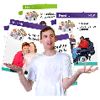 | People want more help and advice with money and benefits.

- WHAT CARERS SAID

Key points

People told us what it is like to live with someone and care for them.
People talked about the difficult things about being a carer.
They told us about carers’ assessments and how these are not always good.
Some people find being a carer very hard.
People said that some care services and staff are good.
Some are not as good.
There are gaps in services.
Some people get good support from family and friends.
People don’t always have time to see friends and family.
Some people feel isolated and alone.
People talked about the effect of caring on their health and wellbeing.
They sometimes feel unsafe.
They worry about the person they care for.
People said it was hard to get the information they need. It is hard to speak to a person.
People said they need more help to understand money and benefits. People said some things are unfair or not right. They gave examples of when this happened.

- PEOPLE’S DIFFERENT EXPERIENCES

Key points

 | People said that some groups of people have a better experience and more choices than other groups.
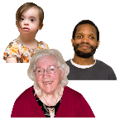 | Younger people get better help than older people.
 | People who fund their own care get more choice than people who have their care paid by the council.
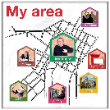 | People who live in different areas of the county have different experiences of social care.
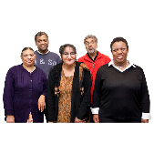 | People from minority groups sometimes have a worse experience of social care.

- WISHES FOR THE FUTURE

Key points

People shared their wishes for the future.
They want services and the council to have more compassion and to help people live their live their way.
People shared ideas and suggestions of things the council and services could do differently.

