|  |  |
| --- | --- |
|  | **The Big Conversation**  **Adult Social Care in Nottinghamshire**  **Community Catalyst.** |

|  |  |
| --- | --- |
|  | **Easy Read** |
|  | **Community Catalyst are the organisation Nottinghamshire Adult Social Care asked to do the Big Conversation.**  **Here is their report on what people told them.** |

|  |  |
| --- | --- |
| 1. **BACKGROUND – WHAT WE DID** | |
| **Key points** | |
|  | Nottinghamshire County Council asked an organisation called Community Catalysts to do a piece of work. |
|  | Community Catalysts were asked to listen to people who use social care services and carers.  They had to find out what people think about social care in Nottinghamshire. |

|  |
| --- |
| 1. **The Vision** |

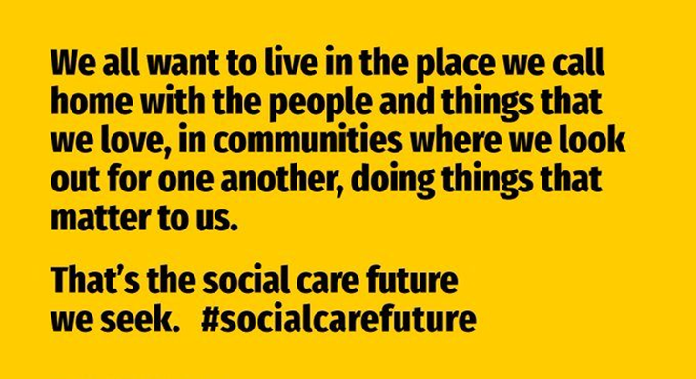

|  |  |
| --- | --- |
| **A person holding a sign  Description automatically generatedKey points** | |
|  | Nottinghamshire believes in the Social Care Future vision. |
|  | Nottinghamshire uses the Making it Real standards.  [Click [this link for easyread information about Making it Real](https://www.thinklocalactpersonal.org.uk/_assets/Resources/MakingItReal/Reports/What-is-Making-it-Real-Easy-Read.pdf).](https://www.thinklocalactpersonal.org.uk/_assets/Resources/MakingItReal/Reports/What-is-Making-it-Real-Easy-Read.pdf) |
|  | Nottinghamshire has written something called the Practice Framework. |
|  | The Practice Framework says how social care will happen in Nottinghamshire in the future. |
|  | In the future social care in Nottinghamshire will be more like the Social Care Future Vision and Making it Real. |

|  |
| --- |
| 1. **The Big Conversation** |

|  |  |
| --- | --- |
| **A person holding a sign  Description automatically generatedKey points** | |
|  | The project was called the Big Conversation. |
|  | We set up a webpage and made a video to tell people about it. |
| The words 'our voice' on a white background | Our Voice are Nottinghamshire’s coproduction group for social care. They helped make the Big Conversation happen. |
|  | Together we organised lots of ways to listen to people. |
|  | We had 8 events and 11 meetings with people face to face. |
|  | We did 2 surveys for people who couldn’t come to an event. |

|  |
| --- |
| 1. **Who did we hear from** |

|  |  |
| --- | --- |
| **A person holding a sign  Description automatically generatedKey points** | |
|  | 221 people filled out a survey. They lived all over Nottinghamshire. |
|  | 207 people came to an event. |
|  | 185 people came to a meeting or group. They were people who used lots of different services. |
|  | We heard from 542 people altogether.  277 people were carers.   1. ople use social care. |

|  |
| --- |
| 1. **About the people** |

|  |  |
| --- | --- |
| **A person holding a sign  Description automatically generatedKey points** | |
|  | In the surveys we asked people to tell us about themselves. |
|  | Most people who use social care say they have an illness or disability. |
|  | People who did a survey use lots of different social care services. |
|  | Some people who use social care are also carers themselves. |
|  | Some people use social care get help from other organisations like health. |
|  | Lots of people who use social care get help from family or friends. |
|  | **About carers** |

|  |  |
| --- | --- |
| **A person holding a sign  Description automatically generatedKey points** | |
|  | In the surveys, we asked people to tell us about themselves. |
|  | Some carers say they have an illness or disability. |
|  | Most carers offer care for more than 20 hours a week. |
|  | Many carers are older. Most are female. |
|  | Most carers don’t get help from anyone else. |
|  | Many carers are helped by Carers Hub. Some are part of a carer support group. |
|  | Some have a personal budget. This helps people live their life their way. |

|  |
| --- |
| 1. **MEASURING AGAINST THE PRACTICE FRAMEWORK** |
| **This is the way adult social care should work with the people they support** |

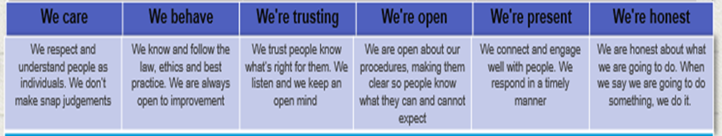

|  |  |
| --- | --- |
| **A person holding a sign  Description automatically generatedKey points** | |
|  | We asked people how well Nottinghamshire does social care. |
|  | We used the new Practice Framework to decide what questions to ask. |
|  | Some people thought social care was good. |
|  | Some people thought social care was bad. |
|  | People told us about social workers and the way they work. |
|  | Some people said they don’t have the same Social Worker. It can be difficult for them to talk to someone they don’t know. |
|  | Some people talked about support services being cut. And this makes them worry about review meetings. |
|  | Some carers said that that Social Workers were sometimes unsupportive. |

|  |  |
| --- | --- |
| 1. **WHAT PEOPLE WHO USE SOCIAL CARE SAID** | |
| **A person holding a sign  Description automatically generatedKey points** | |
|  | Some people said they like living in their own home. Some people said they feel isolated. Some people worry about the future and if they could stay in their home. |
|  | People told us about support services that do a good job. They talked about services and staff who are not good. |
|  | People said that some things stopped for the Covid pandemic. They haven’t started again. |
|  | People talked about Direct Payments. They help people live their life their way. But they can be hard to manage with lots of paperwork and responsibility. |
|  | Many people said public transport and buses are important. |
|  | Many people said that having friends and connections in their community is important. |
|  | People shared reasons they feel unsafe. |
|  | People said good information is important. They said lots of information is not accessible and this is not good. |
|  | Lots of people talked about money and finances. People talked about poverty (being very poor). |
|  | People want more help and advice with money and benefits. |

|  |  |
| --- | --- |
| 1. **WHAT CARERS SAID** | |
| **A person holding a sign  Description automatically generatedKey points** | |
|  | People told us what it is like to live with someone and care for them. |
|  | People talked about the difficult things about being a carer. They told us about carers’ assessments and how these are not always good. Some people find being a carer very hard. |
|  | People said that some care services and staff are good. Some are not as good. There are gaps in services. |
|  | Some people get good support from family and friends. |
|  | People don’t always have time to see friends and family. Some people feel isolated and alone. |
|  | People talked about the effect of caring on their health and wellbeing. They sometimes feel unsafe. They worry about the person they care for. |
|  | People said it was hard to get the information they need. It is hard to speak to a person. |
|  | People said they need more help to understand money and benefits. People said some things are unfair or not right. They gave examples of when this happened. |

|  |  |
| --- | --- |
| 1. **PEOPLE’S DIFFERENT EXPERIENCES** | |
| **A person holding a sign  Description automatically generatedKey points** | |
|  | People said that some groups of people have a better experience and more choices than other groups. |
|  | Younger people get better help than older people. |
|  | People who fund their own care get more choice than people who have their care paid by the council. |
|  | People who live in different areas of the county have different experiences of social care. |
|  | People from minority groups sometimes have a worse experience of social care. |

|  |  |
| --- | --- |
| 1. **WISHES FOR THE FUTURE** | |
| **A person holding a sign  Description automatically generatedKey points** | |
|  | People shared their wishes for the future. |
|  | They want services and the council to have more compassion and to help people live their live their way. |
|  | People shared ideas and suggestions of things the council and services could do differently. |

