Gender Pay Gap Report 2022

Contents
Foreword | 2
Context | 3
Nottingham County Council Gender Pay Gap Information | 4
Findings | 5
Next steps | 6

Foreword
The Council is committed to embedding equality, diversity and inclusion (EDI) in the delivery of its services and in the employment of its workforce. We all have a duty to comply with the Public Sector Equality Duty and the Equality Act 2010. The gender pay gap information forms part of that.
We have a commitment to closing the gender pay gap and are proud of the work done since 2017 which continues to see a decline year on year in the gap. Activity to reduce the pay gap has included work on recruitment, career development and progression and flexible working. The data will be used to inform further work that can be undertaken to close the gap, and the activity will join up with our other equalities work under these themes and sit as part of a comprehensive corporate equality action plan.
Our refreshed EDI activity will be aligned to the themes set out within the People Strategy and the Nottinghamshire Way to promote coherence and consistency for them implementation of our EDI actions.

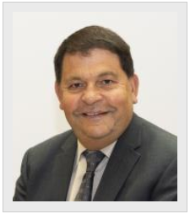

Councillor Gordon Wheeler
Cabinet Member for Personnel and Members’ Equality Champion

Context
The purpose of the report is to publish Nottinghamshire County Council’s Gender Pay Gap (GPG) information as required by the public sector duty under the Equality Act 2010 (Gender Pay Gap Information) Regulations 2016.

Gender Pay Gap Data
The Gender Pay Gap requirements define pay as “ordinary gross pay” which includes payments relating to basic pay, allowances and paid leave. Ordinary pay does not include pay related to overtime, redundancy or termination of employment and pay in lieu of annual leave.

The infographic on page 4 provides information which reflects the organisational structure as at 31 March 2022. The summary information contained as part of the infographic includes the following:

- Mean gender pay gap
- Median gender pay gap
- The proportion of gender in each pay quartile, that is, a breakdown into four equal sections lowest to highest, by their evaluated hourly rate and which shows the number and proportion of female to male employees in each quartile.

The Council has a legal duty to publish its Gender Pay Gap information on the public website. The calculations are prescribed within the legislation and do not allow employers to develop a separate approach.

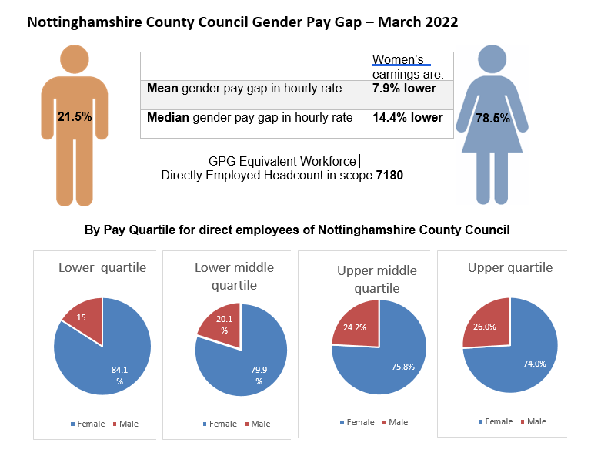

Findings

The overall GPG in Nottinghamshire County Council is a mean gap of 7.9% and a median gap of 14.4%. The table above shows the incremental progress made since 2017 when we were first required to report this information:
One of the main reasons for the Council’s position is the nature of a number of the services we continue to provide and the gender split of our workforce which is 79% female, a significant number of whom work part time.

The Council continues to pay the Living Wage Foundation Living Wage which is greater than the National Living Wage. This is paid as an allowance and increased to £10.90 per hour from 1 November 2022 and has most benefited our frontline part time female workers since the Council implemented payment from 1 April 2014.

Work continues to deliver the actions agreed last year which have supported the reduction in the GPG which include the following:

- Maintenance and application of an equality proofed pay system
- Reviewing our recruitment process and e-learning to remove any gender bias from any part of the process
- Undertaking training for all elected members involved in the senior staffing committee
- Building a refreshed recruitment landing page highlighting the commitments to our equality standards
- Delivering content as part of our learning and development offer which supports staff to develop and build skills, knowledge and confidence to move into management and leadership roles.
- Launch of our Leadership Development Programme with a modular approach – this enables greater engagement for employees, predominately women, to access the programme.
- Our hybrid working strategy continues to assist us to attract and develop the best talent through flexible working and we will continue to explore and maximise all the opportunities presented by flexible working. This is not only through creating flexible physical working environments and opportunities for more flexible working hours, but also to consider how jobs are designed and how work is undertaken where it is appropriate to do so this enable people to work flexibly to incorporate family/caring responsibilities whilst maintaining productivity and performance.

Next steps

Work in all these areas will continue throughout 2023/4 including the renewed focus on leadership development, workforce planning, recruitment and retention and work-based learning opportunities. This approach draws together a range of activities around skills development, career paths, work experience, apprenticeships and graduate training schemes to ensure the issue of addressing the GPG underpins all our activities relating to attracting and retaining people with the right skills and knowledge, to enable us to deliver on key strategic priorities as outlined in the Council Plan.

The action plan which responds to the GPG data will now be incorporated into the wider refreshed corporate equality action plan for 2023/4 and will be aligned to the themes set out within the People Strategy and the Nottinghamshire Way to promote coherence and consistency for them implementation of our EDI actions.

