Nottinghamshire County Council

INFORMAL CONSULTATION ON LAUNCH OF A FREE SCHOOL PRESUMPTION COMPETITION

LOCAL AUTHORITY CONSULTATION REGARDING A NEW PRIMARY SCHOOL IN
THE GATEFORD-SHIREOAKS PLANNING AREA

This consultation is non-statutory and is an informal means of gathering local views on the proposal outlined below.

Context
By law, all new schools in England must be opened as Free Schools, set up and run by Multi-Academy Trusts (MATs). The process by which local authorities (LAs) establish a new Free School, and the Secretary of State appoints a MAT to run it, is known as the Free School Presumption.

Before embarking on the launch of a Free School Presumption competition, Local Authorities are encouraged by the Department for Education to conduct local, informal consultation. The aims of this are twofold:

- to publicise the need for a new school among the local stakeholder community and potential sponsors
- feedback gathered through consultation will be valuable and contribute to formulate and finalise the LA’s specification for a new school before its publication.

Nottinghamshire County Council is therefore conducting a local, informal consultation prior to the initiation of a Free School Presumption. This consultation is in accordance with the DfE advice as published in ‘The free school presumption’, departmental advice for local authorities and new school proposers’, (p.8), DfE, November 2019
See https://assets.publishing.service.gov.uk/government/uploads/system/uploads/attachment_data/file/844346/Free_school_presumption_051119.pdf

Please find below information about a proposed new primary Free School in your area. We are seeking the opinion of local stakeholders, including residents, on a proposal to open a new primary school within the Gateford Park housing development.

Background

In 2015, planning permission was granted by Bassetlaw District Council for a residential development of up to 750 dwellings at Gateford Park, off Ashes Park Avenue, Worksop. There is a Section 106 Agreement* associated with the planning application, which identifies the developer’s commitments to deliver infrastructure for the area. This includes financial contributions and land to be transferred to the County Council to support the delivery of a new primary school within the Gateford Park housing development.

⃰A Section106 agreement is a legal obligation entered into by a housing developer and a local authority, through which a developer contributes financially to reduce the impact of a development proposal by providing local services; in this case, a new school.

Location of Gateford Park development

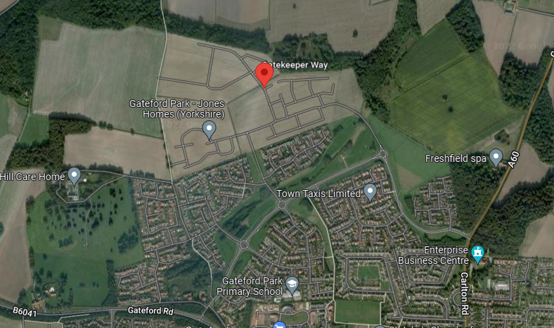

Likely location of new school

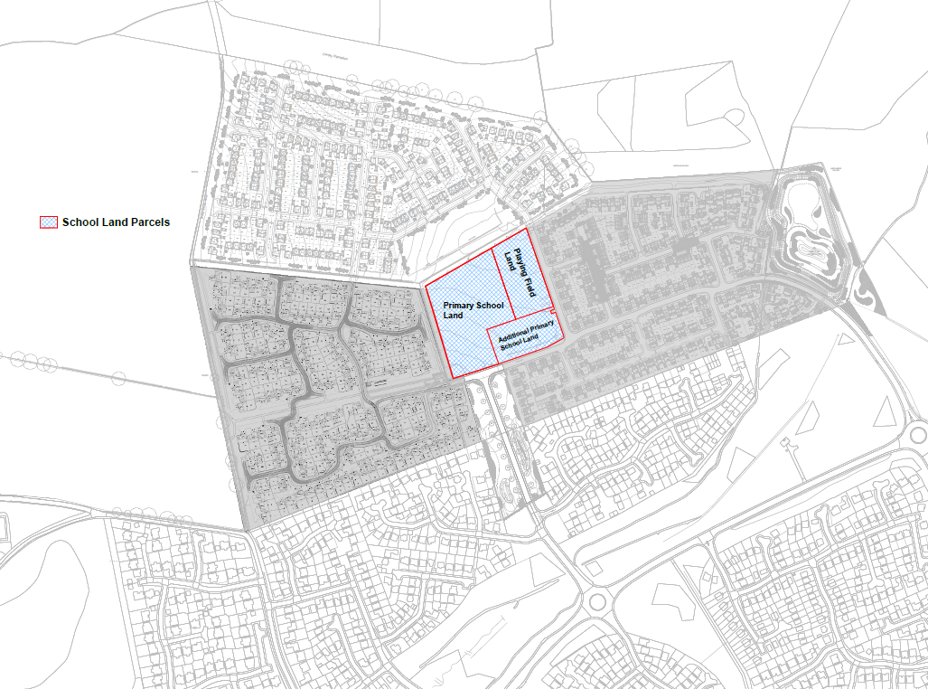

Housing Development at Gateford

It is projected that the 750 dwellings proposed for the Gateford Park site are likely to yield 158 primary-aged pupils who will require school places in the local area. The relevant planning authority, Bassetlaw District Council, has provided the housing trajectory for the development. Prior to 2021/22, there had been 293 houses built on the development site, yielding around 62 pupils. The building trajectory for the next five years (i.e., from 2021/22) is shown in Table 1.

Table 1 | Year of completion
 | 2021-22 | 2022-23 | 2023-24 | 2024-25 | 2025-26
Projected no. houses completed | 75 | 70 | 68 | 40 | 40
Projected primary school places required per year | 16 | 15 | 14 | 8 | 8
Projected primary school places required - cumulative | 16 | 31 | 45 | 53 | 61

The construction of the development is expected to continue for a further three years, as follows:

Table 2 | Year of completion
 | 2026-27 | 2027-28 | 2028-29 | 2029-30 | 2030-31
Projected no. houses completed | 40 | 40 | 31 | 0 | 0
Projected primary school places required per year | 8 | 8 | 7 | 0 | 0
Projected primary school places required - cumulative | 8 | 16 | 22 | 22 | 22

Primary Schools in the Gateford-Shireoaks Planning Area

The map below shows the position of the three existing primary schools in the Gateford-Shireoaks Planning Area, and the location of the Gateford housing development.

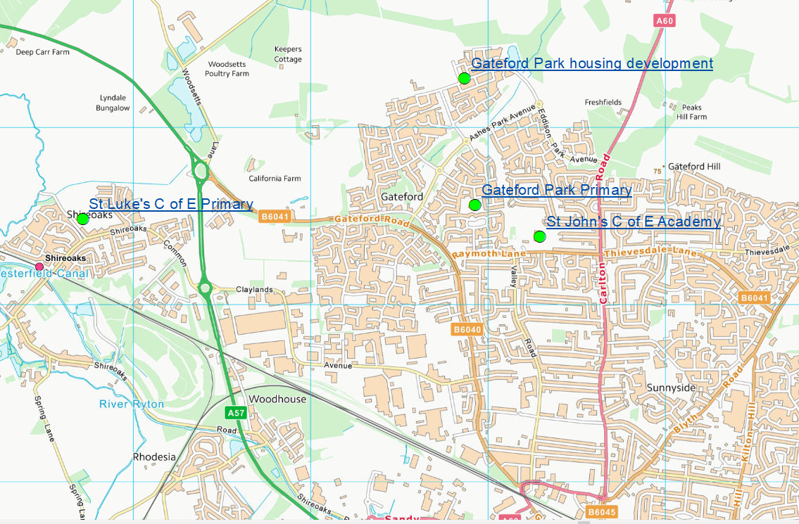

Table 2 Gateford-Shireoaks primary schools – capacity and number of pupils on roll

School | PAN* | Net Capacity** | Number on roll (NoR)  May 2022 | Forecast NoR  Sept. 2024
St John’s C of E Academy | 60 | 420 | 422 | 432
Gateford Park Primary School | 30 | 210 | 214 | 274
St Luke’s C of E (Aided) Primary | 20 | 136 | 161 | 218
*Published Admission Number (PAN): this is the number of places made available each year to applicants
**This is the number of places that a school’s building can reasonably accommodate

New Primary School on the Gateford Park Development

As part of the Section 106 agreement for the development of the Gateford site, developers are committed to deliver supporting infrastructure to the area. The developer has agreed to the allocation of a site of 1.5 hectares for the building of a new, 210-place primary school for children aged 5 to 11.

The new school would be built in accordance with the specifications described by the Department for Education (Building Bulletin 103) and under consultation with Nottinghamshire County Council.

Admission arrangements, which may include a catchment area for the new primary free school, would be decided by the sponsoring Multi-Academy Trust. The trust that will operate the school will be selected through the Free School Presumption process.

The consultation process and Indicative timeline for opening a new primary free school

As per the timeline published below, this consultation will run for 6 weeks from 16 January until 27 February 2023.

Nottinghamshire County Council (NCC) will welcome responses to the consultation during this period.

The outcome of this initial consultation will be reported through the Nottinghamshire County Council governance process and a decision will be taken about whether to proceed with a Free School Presumption process. If this option is chosen, the Council would invite Multi-Academy Trusts to apply during Spring Term 2023 for selection to operate the new primary school, if that is the Local Authority’s decision.

Once proposals are received and have been evaluated, the Council will recommend a sponsor to the Regional Department for Education (DfE) Directors who will make the final decision. The Council will then work with the successful sponsor and the housing developer to open the new school in September 2024.

Other Options Considered

Consideration was given to the expansion of existing sites, but an examination of the nearby Gateford Park School indicated that there was no possibility of it being able to accommodate any expansion. Other schools in the locality were too distant from the housing development.

Reason for Recommendation

Projections evidence that the Gateford Park development is likely to increase the need for primary school places by approximately 158 pupils. Nottinghamshire County Council is committed to supporting children to access education in their own localities wherever possible and consequently would like to consult with interested parties about the possible development of a new school in this planning area.

Statutory and Policy Implications

This report has been compiled after consideration of implications in respect of crime and disorder, data protection and information governance, finance, human resources, human rights, the NHS Constitution (public health services), the public sector equality duty, safeguarding of children and adults at risk, service users, smarter working, sustainability and the environment and where such implications are material they are described below. Appropriate consultation has been undertaken and advice sought on these issues as required.

At the end of this document there is a Consultation Response Form.

If you wish to respond to the consultation on this proposal, please send written comments to:

- The Corporate Director of Children and Families,
(for the attention of Pupil Place Planning),
Education, Learning and Skills,
County Hall, West Bridgford,
Nottingham, NG2 7QP

or by email to place.planning@nottscc.gov.uk

- Comments may also be submitted online at Nottinghamshire County Council - Citizen Space
(see View our consultations)

To be received no later than 23:59 hrs on Monday 27th February 2023

Consultation Response Form

INFORMAL CONSULTATION ON LAUNCH OF A FREE SCHOOL PRESUMPTION COMPETITION

LOCAL AUTHORITY CONSULTATION REGARDING A NEW PRIMARY SCHOOL IN
THE GATEFORD-SHIREOAKS PLANNING AREA

If you wish to respond to the consultation you can share your views by:

- Completing the online survey on Nottinghamshire County Council’s consultation hub https://consult.nottinghamshire.gov.uk
- Emailing Nottinghamshire County Council at place.planning@nottscc.gov.uk
- Requesting a paper copy of this consultation from:
Pupil Place Planning, Education Learning and Skills, Children and Families Services, Nottinghamshire County Council, County Hall, West Bridgford, Nottinghamshire, NG2 7QP - to which your response should be returned.
…………………..……………………………………………………………………………………………….

Question 1.
Do you think that a new primary school with 210 places should be built on the Gateford Park development?
Yes
No
Neither agree or disagree

Question 2
Do you think that a new school should open on the Gateford development in September 2024?

Yes
No
Neither agree or disagree

Question 3
Do you have any further comments?

It will help us to analyse responses if we know more about you.
Please complete the following details:
(Please tick and complete all boxes that apply)
I am a:

Parent / Carer | Which school / academy do(es) your child(ren) attend?
Governor | At which school / academy?
Member of Staff | At which school / academy?
Pupil | At which school / academy?
Other | Please specify (e.g. resident)
What is your post code?

Responses should be returned to:

- Nottinghamshire County Council at place.planning@nottscc.gov.uk or
- Pupil Place Planning, Education Learning and Skills, Children and Families Services, Nottinghamshire County Council, County Hall, West Bridgford, Nottinghamshire, NG2 7QP

by 23:59hrs on Monday 27th February 2023

