Factsheet 3 - pre-paid debit cards

What is a pre-paid debit card?
Using a pre-paid debit card for your direct payment will make managing your finances easier. This card works in just the same way as an ordinary debit card.

Your Direct Payment will be paid onto the pre-paid debit card in line with your Support Plan. You can buy a product or service by using the card in person, over the Internet or using the telephone. You will only be able to make payments with the card as agreed in your Support Plan and where there are sufficient funds on your card. You can’t go overdrawn on this card.

The card is a MasterCard and is issued to you by EML Payments Ltd. This is an example of what the card looks like.

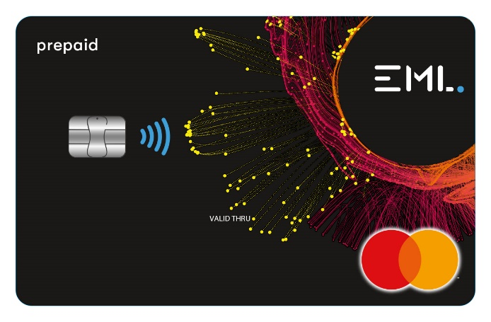

What are the benefits of using a pre-paid card?

- Easy to manage online or over the phone
- No need to open a separate bank account
- No need to send us bank statements when your Direct Payment is audited

How do I use and manage the pre-paid card?
When you receive your card, you will be given instructions on how to use it.

The easiest way to manage your card is online. The Cardholder Control Portal (CCP) is used for all internet banking for the cardholder. The first time you use this you will need to create a username and password. To access the CCP, you will need to go to the following website:

https://clients.prepaidfinancialservices.com/nottinghamshire

Calling the EML IVR numbers
Although you can view and manage your pre- paid card online, there are some things which can only be done by calling EML on an IVR number. IVR stands for Interactive Voice Response and means you can use your telephone to carry out functions by selecting numbers on the telephone keypad or by using simple voice commands.

You will need to phone EML using the IVR number to:

- Report your card lost or stolen
- Check your card balance

The IVR numbers are available 24 hours a day, 7 days a week. There are three numbers you can use:

T: 0203 327 1991
T: 0203 468 4112
T: 0207 183 2248

How will funds be loaded onto the card?
Nottinghamshire County Council will pay your Direct Payment onto your pre-paid card every 4 weeks.

If you have to pay a contribution towards your support, you will need to pay this onto your card every 4 weeks.

Options for paying your contribution onto the card are:

- Standing order - You can set up regular payments for a fixed amount of money to go automatically from your personal bank account to your pre-paid card.

- Debit Card – In your Cardholder Portal, you will first need to register a ‘loading card’ such as a debit card linked to your personal bank account. Select this debit card from the menu and enter the amount of money to be loaded. This will be credited onto your pre-paid card immediately.

- Bank Transfer – Transfer money from your personal bank account to the pre- paid card by using the sort-code and account number given on the card.

When you access your Cardholder Portal, click on Load Funds to see options available to you and more information and instructions.

How do I make payments from my pre-paid card?

When you access your Cardholder Portal online, there are 3 options available to you to make a payment:

- Make a one-off payment (transfer)

- Make a set number of payments and stop after ‘x’ amount of payments (Standing Order)

- Make payments until a specified date
(Standing Order)

You can also make payments by:

Direct Debit – Provide the person or company you are paying with your sort-code and account number from your pre-paid debit card. They should then set up a Direct Debit to automatically take payments from your pre- paid card.

Point of sale payment – Some providers may be able to take a payment by asking you to give the long 16-digit number on the front of your pre-paid card. If you are making the payment over the phone or the Internet, you will also need to give the security number, which is the three last digits on the back of the card. If you are making a payment by machine, you will need to place your card in the card machine and input your PIN number. You should receive a receipt for this.

Will I need to provide bank statements and other documents for auditing?
The Council’s Direct Payments Team will be able to view your pre-paid card account online in order to monitor your Direct Payment spend and help detect and prevent misuse, so you will not have to send us any bank statements. You will still need to keep records, receipts and invoices for payments made from your pre-paid card.

When you access your Cardholder portal, you are able to upload any documents to help explain any transactions you have made. These may be care agency invoices or payslips, for example.

Please refer to the Direct Payments Auditing Factsheet for more information.

Can I withdraw cash using the pre-paid card?
Your pre-paid card cannot be used for ATM withdrawals. If you do require cash withdrawal facilities, you will need to discuss this with your Social Worker. If it is agreed that your card can be used for Cash withdrawal facilities, you will need to activate your card and retrieve the pin by calling one of the IVR numbers listed on page 1. You will need to provide all receipts for anything purchased with the cash to the Council for auditing purposes.

How does a pre-paid card work where there is a Nominated or Authorised Person?
The pre-paid card will be in the name of the ‘beneficiary’ (the person receiving the care and support purchased with the Direct Payment). It is the beneficiary’s date of birth which is used to activate the card. Where an Authorised Person has been detailed on the Direct Payment Agreement, the Authorised Person will receive the card and take full responsibility for the management of the card account. A Nominated Person detailed on the Direct Payment Agreement may provide help and support with the card, but the beneficiary or their Authorised Person, if there is one, will remain responsible.

Please refer to the Direct Payments Factsheet for more information about Authorised and Nominated Person roles and responsibilities.

10. What is the cost of using a pre-paid card?
There are no costs to the cardholder.

11. What if the amount of my purchase is more than my available card balance?
In this case, your payment will be declined, and you must wait until the card has sufficient money on it.

12. Is the pre-paid card safe and secure to use?
Using the card reduces the need to carry or hold large amounts of cash. As with any credit or debit card, you need to keep the card safe and your PIN secure. Care Providers or Personal Assistants should not keep your card or PIN.

Your personal data will be protected as detailed in the Terms & Conditions of the agreement between the cardholder and EML. These can be found online at: www.prepaidfinancialservices.com/nottinghamshire

13. How is my personal information is used
The Council is committed to protecting your privacy and ensuring all personal information is kept confidential and safe. For more details see our general and service specific privacy notices at: https://www.nottinghamshire.gov.uk/global-content/privacy
Useful contact information: For information about your card, terms & conditions and frequently asked questions (FAQs):
Website:
www.prepaidfinancialservices.com/nottinghamshire
Email: nottinghamshire@emlpayments.com

14. For help in activating or using your pre-paid card:
Phone: 0300 500 80 80 - Monday to Friday: 8am to 6pm (Calls cost 3p a minute from a BT landline. Mobile costs may vary).
Enquiries: www.nottinghamshire.gov.uk/contact
Website: www.nottinghamshire.gov.uk
Deaf / hard of hearing:
- Text relay service: Dial 18001 0115 9774050 from your textphone or the Relay UK app.

Download the SignVideo app to communicate with Nottinghamshire County Council in British Sign Language via an interpreter. Visit www.nottinghamshire.gov.uk/contact-us for more information.

Phone 0300 500 80 80 if you need the information in a different language or format.

The Council is committed to protecting your privacy and ensuring all personal information is kept confidential and safe. For more details see our general and service specific privacy notices at:
https://www.nottinghamshire.gov.uk/global-content/privacy

