 | This easy read tells you about the:
 | Nottinghamshire Day Opportunities Strategy (Plan) 2022 to 2027
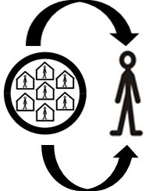 | This is our plan to help people to be part of their communities and to support them to live ordinary lives.  We want leisure, further education and employment to be accessible to everyone including people who access services and support.
 | This plan tells you how we will support people to do different things in different places during the day, evenings and weekends.
 | If you need help to understand this information, please ask someone who supports you to go through it.

 | What are Day Opportunities?
Day Opportunities can be a service or activity in a building or in the community.

It can be about:

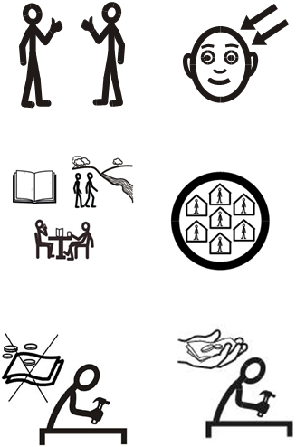 | - Learning new skills  - Making new friendships  - Hobbies and interests  - Being in the community  - Going to college or university  - Voluntary work  - Employment

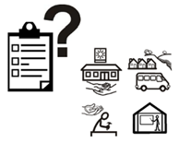 | The Day Service Review  We reviewed day services in 2020 and 2021.
 | The review asked people and carers what they want to see day services doing.
 | People said they want to:
- Meet people and see their friends
- Learn new skills

- Take part in sport and exercise
- Access activities in their communities

- Go out at evenings and weekends

 | Carers said they want:
- To have regular breaks from caring

- To look after their own health and wellbeing

- To maintain their own employment

- To know the person, they care for is safe and well

We asked people where they would like to be supported and join activities. They said:

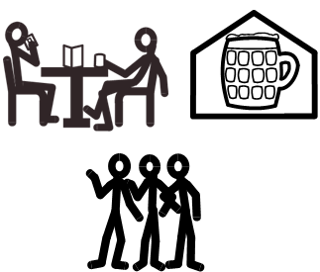 | - In Cafés or the pubs  - In day centres  - In their local area with friends or staff
We looked at everything people told us they wanted from day opportunities.

This is how we will help people to get more from their day opportunities.

 | To help people get the best out of their day opportunities social work teams will begin working with people in a strength-based way.
 | Strength-based means looking at what people can do, their skills and the support they already have and building on this.
 | We will do this through regular reviews so we know what support people need and we can help them choose the best options to meet those needs.
 | For lots of people it will mean using community-based services and activities.
 | If the right support or activity is not there, we will try our best to work with service providers to fill those gaps.
 | We will work with local communities to make sure services and activities are accessible to everyone.
 | This will take time to do so changes will not happen all at once.
 | For some people the services they already have will still be the best ones to meet their needs.
We know change can be worrying.

But working together we can help people understand what we are doing and what options they have.

