Better Together
Working towards co-production across adult social care
April 2022 – March 2025

Introduction
This plan explains how we will work towards more strategic co-production in the Adult Social Care Department in Nottinghamshire County Council.
It has been written and developed with Our Voice, a group of people and carers with lived experience of using adult social care services.
Our vision:
For services, policies and strategies in Adult Social Care to be developed by people and carers with lived experience, our staff and other stakeholders working together as equals from the start to the finish.

What do we mean by co-production?
‘Our Voice’ co-production group have chosen the following definition to explain what we mean by the word co-production
“Co-production is not just a word, it is not just a concept, it is a meeting of minds coming together to find shared solutions. In practice, co-production involves people who use services being consulted, included, and working together from the start to the end of any project that affects them. When co-production works best, people who use services and carers are valued by organisations as equal partners, can share power and have influence over decisions made”. National Co-production advisory group, Think Local Act Personal.
Co-production recognises people and carers with lived experience have skills, knowledge and experience that can help make services better.
Involving everyone from the start leads to diverse conversations and solutions that are much more likely to work the first time around.
Co-production is rewarding. People and carers with lived experience feel valued, empowered and better connected.
Staff report that co-production creates services and processes that work better.
Simply, done well, co-production works for everyone.

“Co-production gives me a great sense of achievement I know I am making a difference.”
Ed: Person with lived experience

“At long last my experience is being recognised and used to improve services.”

Marion: Carer with lived experience

“By co-producing with people, our services and systems work better for more people more of the time.”

Sarah: Commissioner

“It feels like we’ve reached a better outcome more quickly and are less likely to need to change or alter things further down the line.”

Helen: Provider

Where does co-production happen?
Co-production can happen in different places and situations.
It can take place on a one to one basis when a social worker helps a person design their own support.
In a team when a manager asks people with lived experience to help improve the way their team delivers a service in the local area.
Or strategically when people and carers with lived experience work together with staff and other stakeholders to design, develop, deliver or review a policy, strategy or service that will impact upon a larger group of people.

What are the principles of co-production?
Our Voice co-production group developed the following principles for co-production projects in Adult Social Care
- We will all value and work with people’s’ skills, knowledge, and interests to improve services.
- We will let people know what we are learning and achieving through co-production.
- We will make sure that any person or group of people that wants to be involved is included.
- We will use language, written information and other kinds of communication that works for all.
- We will be honest and open to promote mutual trust.
- We will take time to look at how we do things and changing them if we need to.

What are the values of co-production?
There is no one way to ‘do’ co-production but all good co-production shares values that ensure the voices of people and carers with lived experience are heard equally alongside other people.
For strategic co-production to grow adult social care needs a culture where the following values and behaviours are the norm.
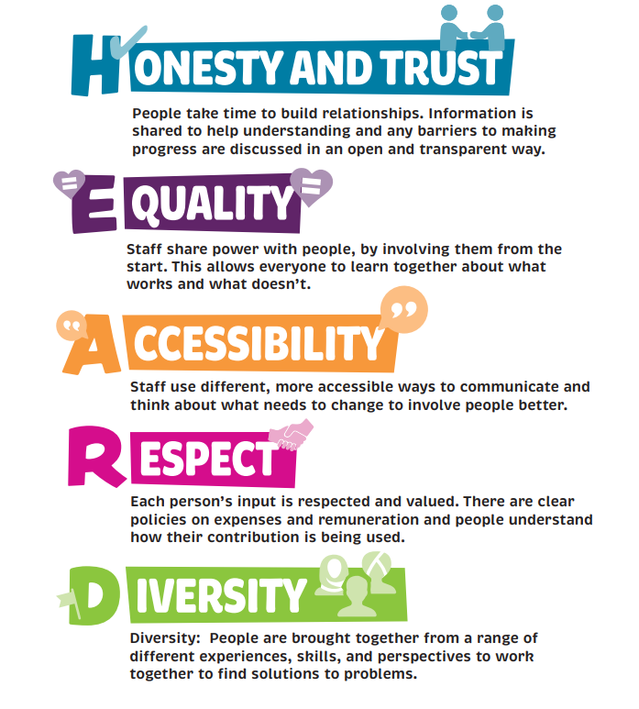

How our strategic co-production plan will be developed?

Where are we now?
The ladder of participation shows the steps that need to be taken to move towards co-production. Our Voice co-production group have said that currently Adult Social Care usually involves people through consultation or engagement rather than co-design or co-production.

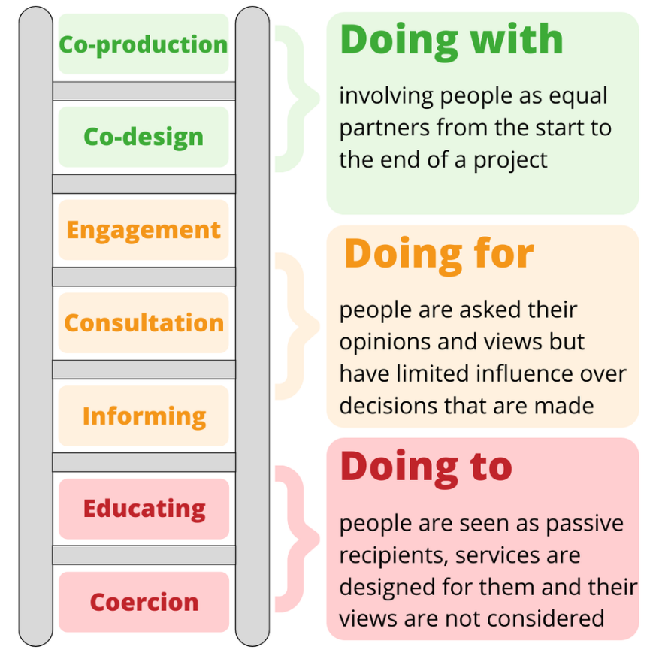

How will we start to do things differently?
The picture shows the work we will do. Each cog is an area of work that we will develop.

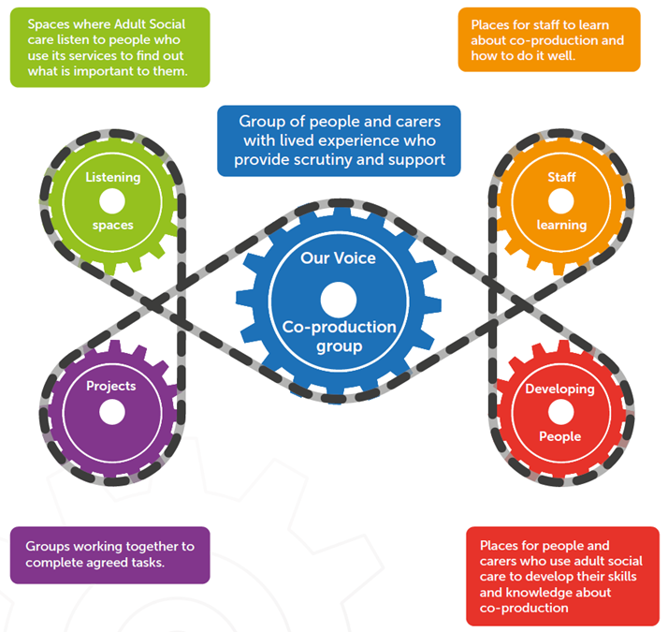

Listening Spaces
A listening Space is an opportunity for people and carers who use adult social care services to say what is important to them. Listening Spaces can be arranged by staff at the start of a new project to help identify what is important to people or can be arranged by senior staff to find out what is working and not working for people who use the services they are responsible for.
“I attended a listening Space with a Service Director after a number of carers had raised concerns over the approach that would be taken to highlight carers issues in the future. We discussed our experience and focused on our ideas for improving things. I then got involved in developing Carers Space Notts, which I hope will mean more carers feel listened to and able to get involved in issues that matter to them, giving them an equal say in shaping how things work in the future.”

Adrian: Carer with lived experience

What we will do
- We will arrange regular listening spaces where our senior staff hear directly from people using the services, they are responsible for.
- We will take a ‘You Said We Will’ approach to these events making sure we tell people who attended what we have heard and what we will do because of this.

Projects
Co-production projects bring people with a diverse mix of experiences together to find the best solutions to problems or issues. Projects are issue based, have clear aims, are time limited and wherever possible co-chaired by a member of staff and a carer or person with lived experience.
“I joined a project to make the councils information about directs payments easier for everyone to understand as it wasn’t. I worked with staff and other people designing new facts sheets and a webpage. I felt my opinions were heard and taken on board and learnt a lot too. Now I feel very empowered and want to do more.”

Ami: Person with lived experience

What we will do
- We will advertise new co-production projects on our webpage so people can find out how they can get involved.
- We will initially start projects in areas where co-production can have the most impact. But as we learn about what works we will build co-production into all the department’s work programmes, so it simply becomes the way we do things within adult social care.

Our Voice Co-production Group
Our Voice is a group of people and carers with lived experience of using adult social care. They have helped develop this strategy and will have a key role in supporting and scrutinising the development of co-production across adult social care in the future.
“I joined Our Voice because co-production is a radical way of working, which is empowering for those who use services. It is the best way of working for everyone.”

Alyson: Carer with lived experience

What we will do
- We will support Our Voice to grow so that it reflects the diverse mix of people who use adult social care services in Nottinghamshire.
- We will support Our Voice members to get the training and support they need
- We will support our voice to share news about the work they are doing to support and scrutinise the development of co-production in Adult Social Care

Staff Learning
Staff need support and training to understand what co-production is and what they can do to help make it happen.
“I attended a training session on how to start a co-production project run by Our Voice. It was so useful to have a chance to ask questions about where to start and what does and doesn’t work”

Michelle: Project Officer

What we will do
- We will provide training and a toolkit on co-production for staff. This will help, Adult Social Care move from a consultation and engagement approach to a co-design and co-production approach.
- We will create an online forum, where our staff have a place to ask questions, share successes and learn together about co-production.
- We will explore how we can use different technology to enable people and carers with lived experiences, colleagues from different organisations and our staff to learn, share ideas and work together.

Developing People
People and carers with lived experience also need an opportunity to learn about co-production and develop their skills, knowledge and confidence so they can work as equals with staff and other stakeholders.
“I have learnt so much about co-production. I feel confident to tell people how it should work now. I know I am making a real difference”

Eddie: Person with lived experience

What we will do
- We will ask the voluntary sector to support us to grow a bank of people and carers with lived experience who want to get involved in co-production projects with us.
- We will offer training and support to people and carers with lived experience, so they have the confidence and knowledge to get involved in projects with us as equals.
- We will co-design a policy for expenses and involvement payments so that people are recognised and rewarded for their contribution in a way that is sustainable.
To find out more about how we are moving towards co-production in adult social care in Nottinghamshire or to see our Action Plans as they develop visit our webpage or email: workingtogether@nottscc.gov.uk

Glossary: What key words mean?

Word | What it means?
Accessibility | Things being adapted to help a group of people or an individual get involved or understand information
Bank | A group of people and carers with lived experience who want to find out about and/or get involved in co-production
Co-design | When people design a service or strategy alongside professionals but may not be involved in helping to implement or review the approach
Consultation | People may be asked to fill in a survey or attend a meeting but may not have any influence or say in decisions that are made as a result of this
Culture | The way that people interact with each other across the Adult Social Care department
Diverse | Varied, lots of different people involved
Engagement | When people can express their views and opinions, for example at a listening event but the influence they have on any decisions will depend on what people who are listening will allow
Guidance | Rules for adult social care staff which explain how to interpret and follow a particular policy
Lived Experience | When a person has experience of using a particular service or process
Policy | A document that says what the department’s approach is. Policies are agreed by councillors at committee meetings on a wide range of topics
Programmes of work | Programmes of work are large work streams that often have lots of individual projects happening underneath them
Stakeholder | Anyone who is affected by a piece of work. Stakeholders can be people who use a service, members of staff or organisations that provide a service
Strategic Co-production | When people and carers with lived experience are involved from the start to the finish in a project that will have an impact on a range of people.
Transparent | Open and honest
Vision | Our aim, where we would like to get to

