This template has been designed to be used alongside Development Matters: Non-Statutory Curriculum Guidance for the Early Years Foundation Stage Development Matters - GOV.UK (www.gov.uk) (Other templates are available if you are not using Development Matters in your setting)

2 year Progress Summary - A Brief Description of This Document
The progress check is a statutory requirement of the EYFS. Providers should seek the consent of parents to share information from the check directly with relevant professionals. Providers must have written policies and procedures in place to safeguard children, in line with the guidance and requirements of the relevant Local Safeguarding Children Partnership (LSCP).
What is this document used for?
When a child is aged between two and three, practitioners must review their progress, and provide parents and/or carers with a short written summary of their child’s development in the prime areas. (EYFS 2021, 2.4)
This progress check will identify the child’s strengths, and any areas where the child’s progress is less than expected. If there are significant emerging concerns, or an identified special educational need or disability, practitioners will develop a targeted plan to support the child’s future learning and development involving other professionals (for example, the provider’s Special Educational Needs Co-ordinator (SENCO) or health professionals) as appropriate.
Beyond the prime areas, it is for practitioners to decide what the written summary should include, reflecting the development level and needs of the individual child. The summary must highlight: areas in which a child is progressing well; areas in which some additional support might be needed; and focus particularly on any areas where there is a concern that a child may have a developmental delay (which may indicate a special educational need or disability). It must describe the activities and strategies the provider intends to adopt to address any issues or concerns. If a child moves settings between the ages of two and three it is expected that the progress check would usually be undertaken by the setting where the child has spent most time. Practitioners must discuss with parents and/or carers how the summary of development can be used to support learning at home.

The following factors may determine the timing of the progress check:
- The child’s entry point
Providers should consider a settling in period for a child to enable their key person and other practitioners to build up good knowledge of that child’s development, abilities and interests before completing the progress check.
- Parental preferences
Practitioners should agree with parents when is the best time to provide the summary.
Where possible, early years providers should consider carrying out the progress check
in time for parents to share it with the health visitor at the two year old health and
development review.

For further guidance on timing please refer to the A Know How Guide: The EYFS progress check at age two (DfE, 2012) If a need for further support is identified, practitioners should complete an action plan and share this with the child, the child’s parents/carers and if relevant other professional (see pages 5 to 6).

Please note: You only need to print pages 3-6 of this document and pages 7 and 8 if you are making a referral.
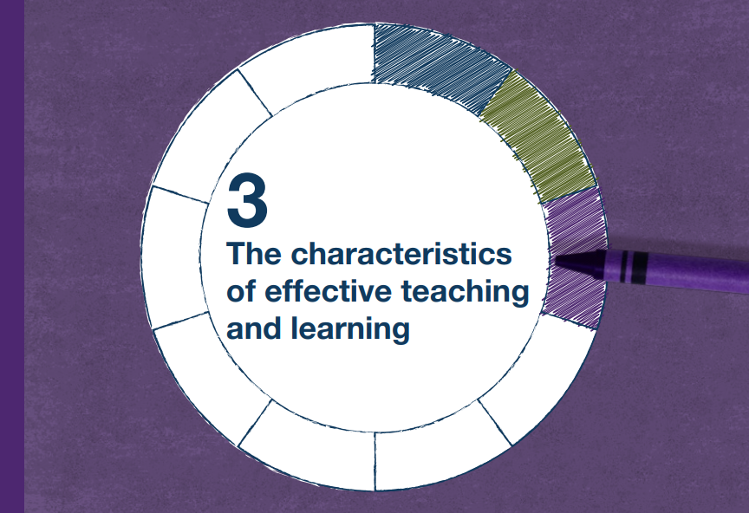
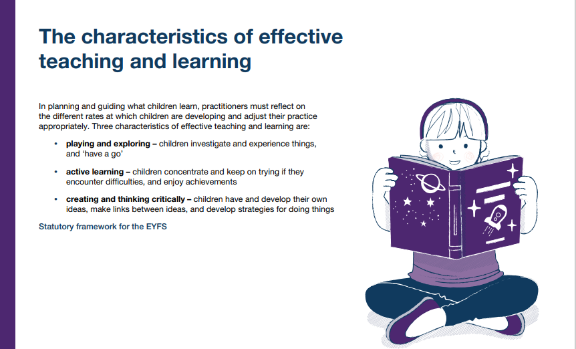

Taken from Development Matters: Non-statutory curriculum guidance for the Early Years Foundation Stage
Development Matters - GOV.UK (www.gov.uk)

Early Childhood Services
Quality and Attainment Team

Name _________________________
D.O.B._________________________

My interests
Early Years Providers and sessions I attend

Attach photo here

My family

Key Person (signature) ___________________________________________________ Date ___________________

Parent/carer (signature) _________________________________________________ Date ______________
Summary of Development

Prime areas of development for:  - - - - - - - - - - - - - - - - - - - - - - - - - | Additional needs?  Y / N |  |  | Date of Birth:  _ _ / _ _ / _ _ _ _ |  | Date of progress review:  _ _ / _ _ / _ _ _ _ |  | Age at progress review:  _______________ months
Personal, Social and Emotional Development  I can ….. |  |  | Physical Development  I can ….. |  |  |  | Communication and Language  I can …..
Emerging/Expected |  |  |  |  |  |  | Emerging/Expected
 |  |  | Emerging/Expected
Key Person signature: Date:

Additional Observations / Annotated Photographs

Child’s Name:

Next Steps to support my learning and development in the setting:

What parents/carers can do to support my learning and development at home:

This is what my key person feels about my progress:

Are there any identified areas where further support is needed? Yes/No

If yes what further support has been agreed?

This is what my family feel about my progress:

Date: Name: Signature:

2 Year Progress Summary Action Document
To Inform an Integrated Review
(ONLY TO BE COMPLETED FOR CHILDREN GIVING A CONCERN)
Providers are encouraged to also use the Prime Areas Progress Tracker Tool, the Language Checklist and the Early Identification Tool Kit for further support in monitoring a child’s development and to more accurately assess a child’s stage of development. Click here to access the link to the NCC Childcare Providers page and scroll down to access the resources.
Child’s Name: |  | Date Assessment Completed:
Child’s Address: |  | Parent’s Phone Number:
Gender: (please circle)  He/She/They | SEN: (please circle)  Yes / No |  | Child’s First Language:
Early Years Practitioner Completing This Form: |  | Provider name, Address and Contact Number:
Children’s Centre Family Support Worker’s Name (if involved): |  | Family Support Worker’s Contact Details:
Healthy families Team Practitioner’s Name: |  | Healthy Families Team Contact Details:
Name of GP: |  | GP Contact Details:
Other Professionals Involved: |  | Contact Details for Other Professionals:
In which area is the child experiencing delay? (please tick all that apply)
- Communication and Language Development
- Personal, Social and Emotional Development
- Physical Development

What action is to be taken?

Plan to be devised in partnership with parents and Healthy Families Team as part of the integrated review process

The Personal Child Health Record
Confirmation that the Early Years Practitioner has added the 2 Year old Progress Summary information on to the Child Health Record (This usually has a red cover and is known as the "Red Book").
Name of practitioner: Date information added to the Red Book: _ _ / _ _ / _ _ _ _

PARENTAL CONSENT
 | Parent/Guardian Permission to Share Information  (*please circle) | Parent/Guardian  Permission to make a referral  (*please circle) | Provider to complete if applicable
Speech and Language Therapy | YES / NO | YES / NO | Who will be completing the referral?  Date of referral made:
Children’s Centre Services | YES / NO | YES / NO | Who will be completing the referral?  Date of referral made:
Schools & Families Specialist Services (SFSS) | YES / NO | YES / NO | Who will be completing the referral?  Date of referral made:
Other Health Professional  (e.g. GP, Paediatrician) | YES / NO | YES / NO | Who will be completing the referral?  Date of referral made:
Home Talk | YES / NO | YES / NO | Who will be completing the referral?  Date of referral made:
Small Steps | YES / NO | YES / NO | Who will be completing the referral?  Date of referral made:
Area SENCo | YES / NO | YES / NO | Who will be completing the referral?  Date of referral made:
Other Professional?  (please state) | YES / NO | YES / NO | Who will be completing the referral?  Date of referral made:

PARENTAL CONSENT

I ………………………………………… [parent/guardian’s name] give consent for
………………………………… [provider’s name] to share information and to make a referral (if necessary) to the professional(s) as indicated above.

Parents/guardian signature: …………………………………… Date: ………………

Please give both the parent and the Healthy Families Team a copy of this form.

