This easy read information tells you about

Disability Related Expenditure

 | What is Disability Related Expenditure (DRE)
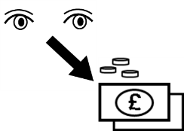 | The Council looks at the money you spend due to your disability or ill health  This is called Disability Related Expenditure or DRE
 | Your social care worker will talk to you about your DRE when they are planning or reviewing your support needs
Things to think about

It can be hard to think about the extra money you spend due to your disability
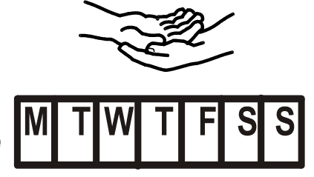 | Try to think about your day-to-day life and what items and services you use.
 | Think about what you spend because of your disability or ill health that someone without a disability does not have to spend.
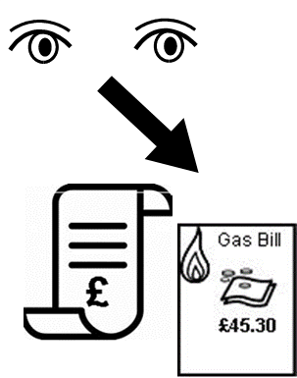 | It may help to look at bills and receipts to see what you spend
 | Ask a family carer, a friend or support worker to help you keep a record of what you spend
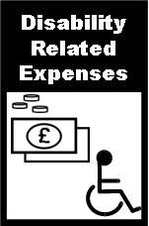 | The person helping you should read the Disability Related Expenditure Guidance  It tells you the items that may be included as a DRE
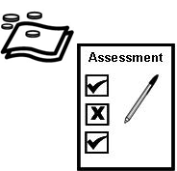 | This will help you prepare for your assessment or review
The Council will look at your DRE when it works out how much you pay for your care and support

This is called a Financial Assessment

The Council wants to make sure you have enough to pay your Disability Related Expenses before you pay towards your support

If you or the person helping you has any questions about DRE talk to your social care worker or get in touch with the

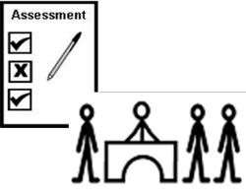 | Community Assessment Team  Phone 0115 9775760 press option 2  or  Email acfs.community-assessments@nottscc.gov.uk

