Adult Social Care Charging Policy

What is this policy about?

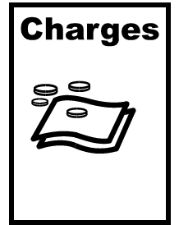
This easy read tells you how Nottinghamshire County Council decides how much people may need to pay for care and support.

Who is this policy for?
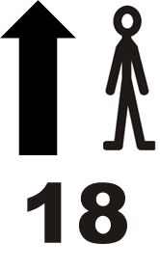
This policy is for adults aged 18 or over who get care arranged or paid for by the Council.

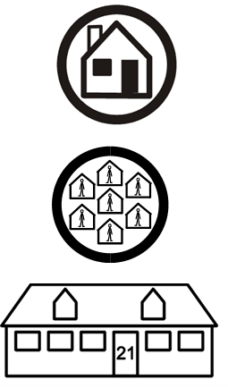
It covers care:
- at home
- in the community
- in care homes.

What services may need to be paid for?


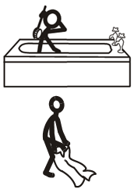
- Help at home (like washing, dressing, cooking)
- Day opportunities (activities outside your home)
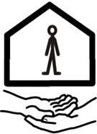
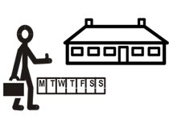
- Supported living or extra care housing
- Short breaks
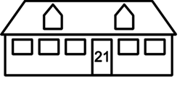
- Care in a care home

What services are free?
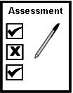
- Having an assessment to find out what care and support you need
- Some mental health aftercare

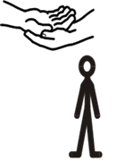
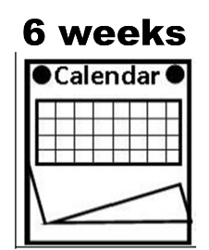
- Up to 6 weeks of help to become independent again after an illness or injury
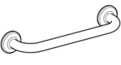
- Equipment and small changes to your home (like grab rails)
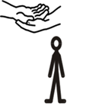
- Support for people who care for someone else

How does the Council work out charges?

The Council will send you a form to fill out asking about your money, savings and spending. This is called a financial assessment.


The Council checks your income, savings, and any extra costs because of a disability.

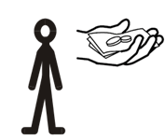
It does this to see how much a person can pay towards their care and support.

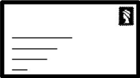
The Council will send you a letter telling you how much you must pay for your care and support.


People with a lot of savings may have to pay the full cost of their care.


People with less money will pay less or may pay nothing.

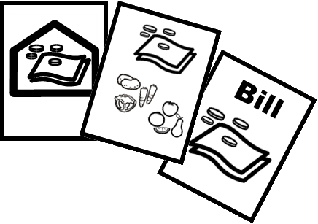
The Council will make sure you have enough money left to pay for things like rent, food and bills. This is known as Minimum Income Guarantee (MIG).

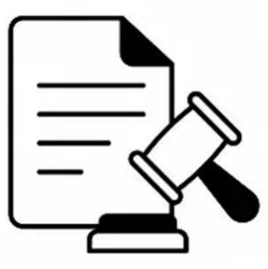
The Council must follow the law to make sure what people are charged is fair.

What if you own your home?


If you need to go into a care home, you might be able to delay paying care home costs until your home is sold. This is known as the Universal Deferred Payment Scheme (UDPS).

What if you want a more expensive service?


If you choose a care home or service that costs more than the Council’s has offered to pay, someone will need to pay the extra amount. This is called a “top-up”.

Short-term care
Short breaks give you and the people who care for you a rest from your usual care and support.

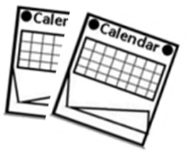
They are usually planned but can be used in an emergency.

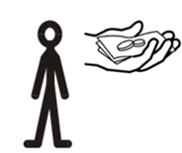
Sometimes short-term care may need to be paid for.

What if your situation changes?


The Council is here to help you.

Please tell the Council if your money changes or your care needs change.

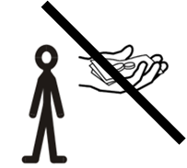
If the person paying your top-up cannot pay anymore, please tell the Council as soon as possible.

What if you disagree with the charges?


You can talk to the Financial Assessment and Assistance Team in Adult Care Financial Services at the council.

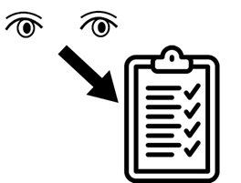
You can ask the Council to check your financial assessment. This is called an appeal.


You can make a complaint if you are still unhappy.


Always talk to us first we are here to help you with your complaint.

What happens if you do not pay?

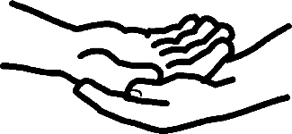
The Council will try to help you pay what you owe.
You can talk to the Councils Debt Recovery Team to set up an affordable payment plan.

If you still do not pay, the Council may take legal action to get the payment from you.

Where to get more help


Contact the Council’s Financial Assessment and Assistance Team in Adult Social Care Financial Services for questions about bills and charges.

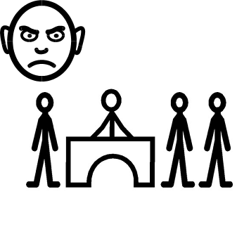
Contact the Complaints and Information Team if you want to give feedback or make a complaint.


If you need help understanding this document talk to someone who supports you.

How to contact us



Adult Care Financial Services - Financial Assessment and Assistance Team
Telephone: 0115 977 5760 (Option 3)
Email: acfs.financialassessments@nottscc.gov.uk

Debt Recovery Team
Telephone: 0115 977 2727 (choose Option 2, then Option 1, then Option 3)
Email: debt.recovery@nottscc.gov.uk

Complaints and Information Team
Telephone: 0300 500 80 80
Email: complaints@nottscc.gov.uk
In writing:
Complaints and Information Team,
County Hall,
West Bridgford,
Nottingham,
NG2 7QP
Online: Comments Compliments and Complaints
www.nottinghamshire.gov.uk/contact-and-complaints/complaints/complaint-comment-compliment

For plain English web page version of this information, go to:
Adult Social Care Charging Policy 2026-2027 | Nottinghamshire County Council

This information was last updated 22nd April 2026.

