Outbreak Investigation Information Sheet.
Nottingham County Council monitors Covid 19 infection data. It is possible that more than 2 people associated with your workplace have tested positive to Covid 19 in the last 10 days. Please provide as much information as possible by completing the form below, so that a decision can be made about how best to support you to manage the risk of further spread of Covid 19 within your work place and workforce. The attached fact sheet explains why we are asking you this information as part of Enhanced Contact Tracing.
WORKPLACE CONTACT DETAILS
Venue/Workplace Name
Manager/Lead Contact Name
Phone Number
Email
Head Office Address  Postcode | Business Address / Location of outbreak
District
Type of Venue/Workplace

INFORMATION ABOUT YOUR WORKFORCE.
Total number of employees
Maximum & minimum of staff in setting at one time
Number of POSITIVE CASES reported
Date of onset in first case
Date of onset in most recent case
Number of symptomatic cases
Number of asymptomatic cases
Number of CONTACTS provided
Complete Tracing Form
DESCRIPTION OF BUSINESS OPERATIONS
Provide a short description of the service your business provides or what it produces / manufactures.
List of activities identifying where close contact occurs
Summary of Risk Assessments
Use separate sheet if necessary
Summary of Control Measures
Use separate sheet if necessary
Description of building size or layout, simple diagram
Remember:
To Report The Workplace Outbreak to your Public Health Team
Tell employees who have a positive Covid 19 test result to Self Isolate Immediately
Collect Information in as much detail as possible, completed this form and send to
NottsTestandTraceInBox@nottscc.gov.uk

Business Fact Sheet:
How is a Covid 19 Outbreak managed?
There are 5 key stages in outbreak management. It tells a story of how the outbreak started and spread as well as looking ahead to ensure that people are kept safe from further infection by making sure they are told to isolate when necessary or by supporting a business to take actions at work to contain an outbreak.
What is the process in Nottinghamshire?
Detecting an outbreak.
The Local Outbreak Cell is a key structure within the Nottinghamshire County Council Outbreak Control process and acts as a forum for different partners in Nottingham and Nottinghamshire to review population data and share local intelligence, which supports coordination of outbreak management activity and facilitates a timely and appropriate response to emerging situations or outbreaks. It oversees the response and is led by the Director of Public Health.
Notifying businesses when cases are detected.
Outbreaks within a workplace may be reported to the Local Outbreak Cell in different ways because different agencies collect different information about Covid 19 infections and outbreaks. PHE look at infection data, Environmental Health Teams regulate business settings, and the Public Health Team proactively monitors outbreaks. This may result in a local investigation as part of the Outbreak Investigation and Rapid Response process or in response to a request to join a formal Outbreak Control Team.
Outbreak Investigation and Contact Tracing
In the majority of cases where an outbreak is associated with a single workplace, a local investigation called an Outbreak Investigation and Rapid Response will be initiated to understand more about possible causes and the potential risk for the outbreak to continue to grow. The key stages on an Outbreak Investigation and Rapid Response are to:
- Work with the business to understand their operation and the dynamics of their workforce. This may include collecting information by phone call, completing, and returning the outbreak information sheet, carrying out contact tracing with your staff, (sheet attached template) or asking Environmental Health Officers to visit your business to give help and advice.
- Look backwards in time to identify risk factors and people who have been exposed.
- Look ahead and contact people who may need to isolate and if necessary, introduce strong control measures at work to manage the outbreak.
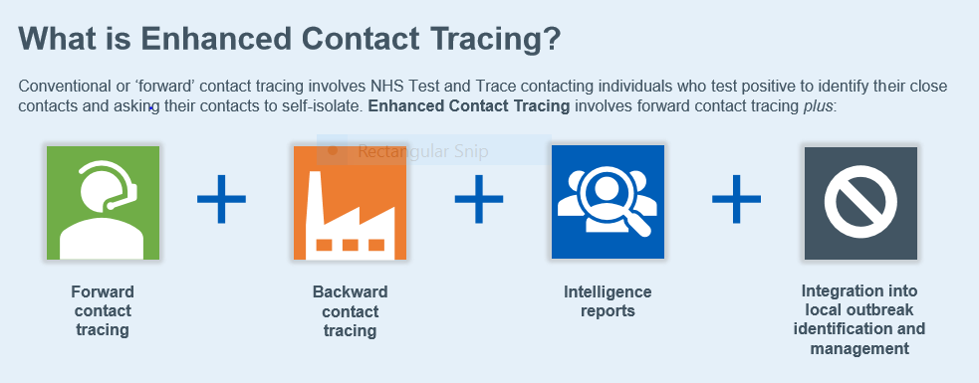
Outbreak Control Teams: Who attends and what is their role?
The role of an outbreak control team is to co-ordinate a formal plan to contain a large or complex outbreak, that has the potential to spread either through the workforce or into the community. It is overseen by the Director of Public Health and the Consultant of Communicable Disease Control for the County. Ultimately, they have the authority to shut a business or require it to take measures to contain an outbreak. The below list provides an indication of the partners that are regularly involved in supporting the management of a workplace outbreak through an OCT and their roles within the meeting.
- The Business is a key Partner and will be involved as the business experiencing the outbreak to inform the OCT of the current situation in terms of case numbers, control measures and other factors that impact the outbreak and to work with relevant partners to agree and implement any identified recommendations or actions.
- Public Health England (PHE) – provide specialist knowledge regarding infectious disease and control measures within the meeting and provide advice regarding additional measures and actions that may be required.
- Public Health (Nottinghamshire County Council) – usually responsible for coordinating and chairing the OCT meeting and will provide Public Health support and advice.
- Testing (joint function across Nottinghamshire County and Nottingham City Council) – provide specialist knowledge on testing and may support coordination of asymptomatic ‘case finding’ testing if required.
- Communications (Nottinghamshire County Council/District Councils) – advise on any comms related actions that may be required, such as external comms messaging or internal messaging the workplace may need to share with staff.
- Public Health Analysts (Nottinghamshire County Council) – will support with epidemiological analysis of the outbreak and provide context regarding local community transmission.
- Environmental Health (District Council) – provide community knowledge and expertise and may support contact tracing. May undertake a site visit if deemed to be appropriate if they are the regulating authority for the setting in question (e.g. warehouses).
- Health and Safety Executive – may undertake a site visit if deemed to be appropriate if they are the regulating authority for the setting in question (e.g. manufacturing).
What is the difference between Forwards and Backwards Contact Tracing
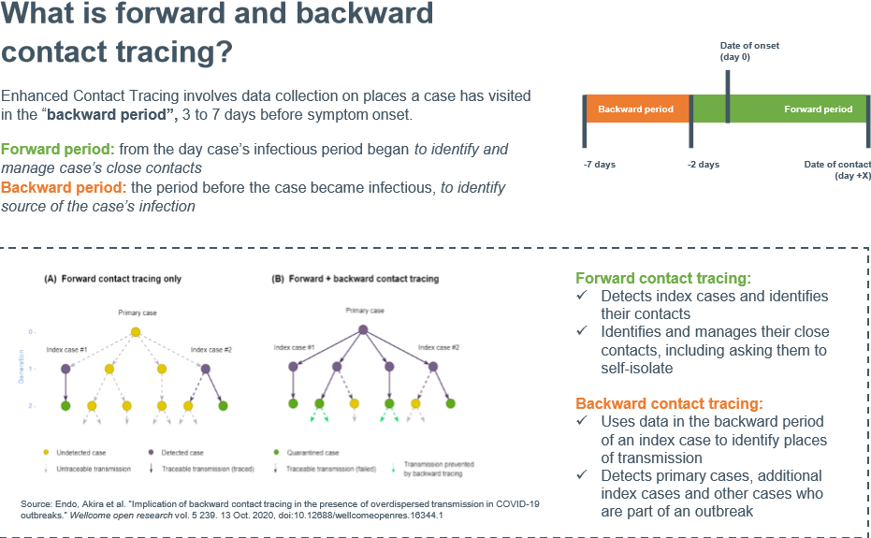
Contact Tracing: You may be asked to complete a contact tracing spread sheet, available on the website.

