This easy read tells you about the Nottinghamshire:

LOCAL ACCOUNT

The Adult Social Care Plan 2024

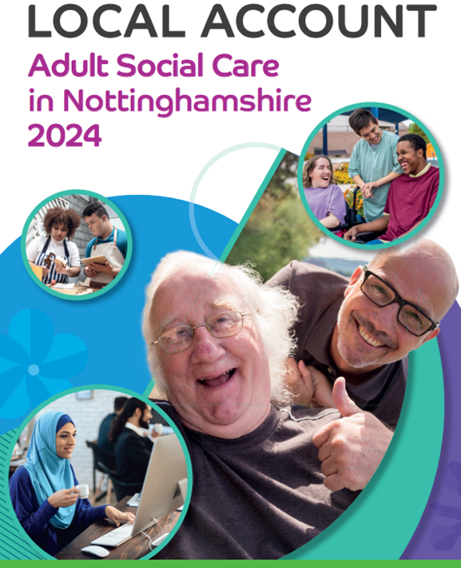

Written by:

People and carers who draw on services and staff

The plan tells you about the things we have agreed are important to focus on in 2024.

These are called our priorities.

- Some of the things we want to do will take longer than 1 year.

- To do some of the things we will need to work with other organisations such as health and housing.
The following page will tell you about the 6 areas we will focus on in 2024.

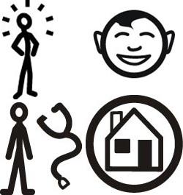 | 1. Wellbeing and independence  Living the life you want, keeping safe and well.

 | Good means:
 | - Doing the things that are important to you as independently as possible.
 | - Being treated with respect and dignity.
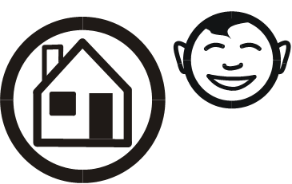 | - Having a place you can call home.
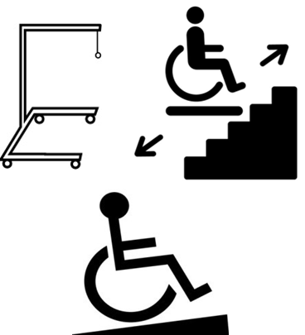 | - Having the equipment or adaptations you need at home.
 | Our priorities in 2024 will be to:
 | - Reduce how long people have to wait for conversations and support.
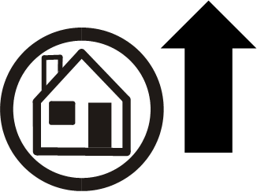 | - Work together with local councils so there is more local housing.  This will help people to have a place to call home.
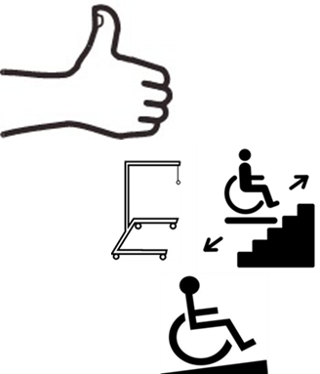 | - Help more people to feel that their home is adapted to work for them.
 | - Work with people from different organisations to improve mental health.

2. Information and Advice.

Having the information you need when you need it.

Good means:
- Giving you better information and advice that helps you think about and plan your life.

Our priorities in 2024 will be to:

- Provide information in different formats like Easy Read.

- Provide better information on finances and money.

- Help you to know how to get in touch with us when you need too.

- Make it easier for you to share information with us in the way that works best for you.

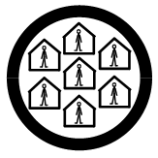 | 3. Active and Supportive Communities  Keeping connections with family, friends and your community.

 | Good means:
 | - Having people who support you, such as family, friends and people in your community.
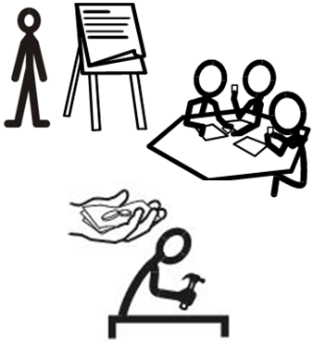 | - Having opportunities to learn, volunteer and work.  - Doing things that are important to you.
 | Our priorities in 2024 will be to:
 | - Having more opportunities for you to take part in further education, employment, or volunteering.
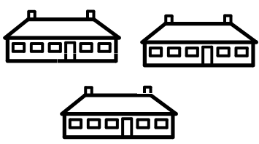 | - Make the best use of our spaces and buildings to support more community activities.
 | - Work with other organisations to improve transport in Nottinghamshire.

4. Flexible and Integrated Care and
Support.

My support, my own way.

 | Good means:
- Care and support that enables you to live the way you want to.

Being seen as an individual with your own skills, strengths, and things you want to achieve.

 | - Knowing how much money you have to meet your care and support needs.
 | - Deciding how money is used to meet your health and care needs.
- Choosing:

Who supports you.

How you are supported

When you are supported

Were your care and support is provided.
 | - Family Carers getting the breaks they need in the way they want them.
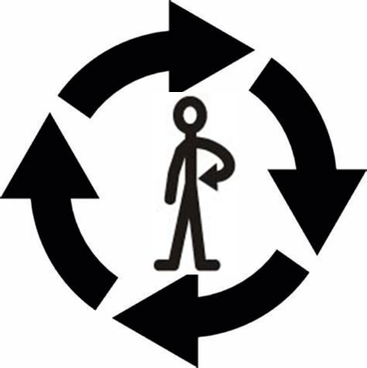 | - Having care and support where everyone works well together and with you.
 | Our priorities in 2024 will be:
 | - Helping more people feel positive about their review and making sure they have a copy of their support plan.
 | - Telling more people about Direct Payments.
 | - Making Direct Payments easier to access and use.
 | - Developing a support network to help everyone who has a direct payment.
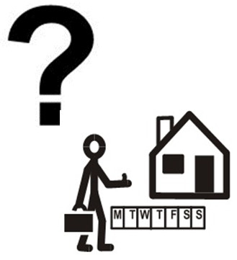 | - Have more choices for short breaks and making sure you and staff understand what the choices are.

5. When things need to change.

Staying in control

 | Good means:
 | - Having support to plan ahead for important changes in your life.
 | Our priorities in 2024 will be:
 | - Being there to support you when you are facing a crisis or a big life change.
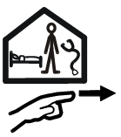 | - Supporting more people to learn new skills or regain their skills after being in hospital.
 | - Having more young people and their parents saying they were supported well.

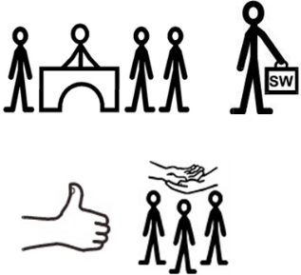 | 6. The Workforce  The people who support you.

Good means:

- Being supported by people who see you as an individual with strengths, abilities and goals.

- Having good and thoughtful support from people who are trained and know what they are doing.

Our priorities in 2024 will be:
- Employing staff who have the right skills, values and behaviours.

- Supporting our staff through good supervision and changing how we work to provide more time for staff to have good conversations with you.

- Supporting our staff to learn new skills
- Helping other organisations that provide services for us to involve you in decisions about your support.

How can you be involved?

Join our Better Together E-Bulletin to get updates sent to your email address.

Or Email us at:

Workingtogether@nottscc.go.uk

If you need help to do this please tell someone who supports you to help.

 |  | What things mean
 | Co-Production |  | Means people working together equally on a problem or issue to come up with the best solutions
 | Direct Payments |  | Payments made by the local authority to people who draw on care and support, or their carers to allow them to arrange their own support and equipment.

