Nottinghamshire’s Guide to
Improving Outcomes for Our Children who are Looked After through the Personal Education Plan (PEP) Process

Contents

- Introduction
- Key Messages
- What is a PEP, what’s the purpose, the aims and statutory expectations?
- Quick guide to who does what
- What is the PEP process?
- A quick glance flow chart of the PEP process
- The PEP process and documentation
- PEP documents for each phase of education
- Completing ‘Strengths and Challenges’ section
- Executive functioning skills
- Preparing for Adulthood (across the age range)
- What if our child is without a school place or not accessing education?
- Understanding our Nottinghamshire Special Educational Needs and Disability processes
- Understanding the Education Health and Care Plan Process with PEP processes
- Checklist for Completing the PEP form and Quality Assurance
- What is the link with Pupil Premium Plus (PP+)
- Ongoing training offer
- Helpful Hints to Education
- What does good look like? An example of an Education Review (PEP)
- References

Introduction
As part of the Care Plan, every child who is looked after must have a Personal Education Plan (PEP). It is statutory for all children and young people aged 3-18 years to have a PEP. This guidance has been constructed by Nottinghamshire Virtual School in partnership with young people, children’s social care teams, school representatives etc. and is informed by the statutory guidance (DfE, 2018) alongside ‘best practice’ in making the PEP a meaningful process for all our children and young people.
At Nottinghamshire County Council, we recognise the importance of the language that is used around children and young people. Whilst the legislative language refers to Looked After Children (LAC) and the Department for Education (DfE) has moved towards using Children Looked After (CLA), where possible, this document will use the term ‘our children’ to identify this group of young people, as the preferred term used by the young people themselves (TACT, Fostering and Adoption, March, 2019). Our young people in Nottinghamshire have stated that they would rather the term ‘Education Review’ is used over ‘Personal Education Plan’ meeting as the legislative literature states. We therefore invite you to use this language with our children when you are referring to the meetings.

Key Messages
- The key mechanism for addressing the educational needs of the child or young person and improving their attainment is the Personal Educational Plan (PEP)
- It is essential that the team around the child invests and plays their role in the PEP process (always the social worker, carers, designated teacher in school, young person and other professionals as necessary)
- It is important that the PEP maintains high expectations for rapid progress and puts in place the additional support the child or young person may need in order to succeed academically
- PEPs are designed to ensure that all important decisions about the education of our children are made jointly by the corporate parents who are the teachers or education staff, social workers, carers and other professionals involved with the child
- PEPs should be ‘living and useful’ documents
What is a PEP, what’s the purpose, the aims and statutory expectations?
The ongoing educational reviews and the documents that are recorded (Personal Education Plan or PEP) is a record of how professionals around the child in care will support their educational outcomes and achievement. The PEP provides the journey and ‘collective memory’ of the child’s education. It is a statutory requirement for children in care to have a PEP from the age of 3 (or when they begin education) until they are 18 and the plan is the joint responsibility of the school/education setting and the local authority, who also have a legal duty to maintain the child’s Care Plan. In Nottinghamshire, the paperwork around the PEP reflects the age of the child (see Early Years, Primary, Secondary, Targeted Curriculum, post 16 EA PEPs and post-18 Pathways: PEP documents personal education plan documents).
The PEP is developed and reviewed termly (this is 3 times a year, the Autumn, Spring and Summer terms) with the designated teacher/education professional, young person, social worker, carer and other agencies where appropriate. A PEP should be started within 10 days of a child becoming ‘looked after’, and their plan must be in place by their first looked after review (20 days).
The PEP documentation contains information about the child and their progress, attainment, outcomes, social and emotional development, and helps schools/settings, carers and social workers to identify any needs and how they can be supported. The plan also celebrates the child’s strengths and all aspects of ‘education.’ The plan should reflect the importance of a personalised approach to learning that meets the child’s identified educational needs, raises aspirations and builds life chances. It should realise short and long term academic progress, goals and aspirations.
The PEP is part of a child in care’s official school record. If the child moves schools/setting, the documentation (PEP) should be forwarded, along with other education records, to their new school or education setting. If a child ceases to be ‘looked after’, the PEP remains an important document to ensure that the child’s educational journey has been documented.
Quick guide to who does what
For transparency and clarity, we have considered the roles and responsibilities of the potential people who will be part of the PEP process. We have also aligned their responsibilities to reflect Nottinghamshire County Council’s processes.
The child/young person is central to the PEP process and it is their educational journey we are supporting. Their voice is key to the process and trusted adults, in school and at home, should ensure if they do not attend the meeting their future hopes/goals, thoughts, feelings or wishes are captured in a form that they are comfortable to use e.g. Mind of My Own app, drawing, writing.
Role | Responsibilities
Managers of Children’s Social Care Teams | - Ensures social workers (SW) are completing Personal Education Plans in statutory timeframes (every term)  - Have Personal Education Plan as part of an ongoing Continuing Professional Development (CPD) training offer and agenda discussion in team meetings  - Support with Quality Assurance (QA) process
Social workers (SW) | - Initiate PEP within 10 days of a child becoming ‘looked after’ (even when child without school place) including those placed in an emergency  - Book in termly PEP meetings (to ensure compliance with statutory timescales), ensuring that the right people are invited (e.g. teachers, carers, in alternative provisions learning mentors and the person in education who knows the child best)  - Ensuring Designated Teachers (DTs) in schools/colleges or staff in early years settings have the current paperwork and guidance around PEPs.  - Ensure that the ‘Essential Information’ is pre-populated and up-to-date  - Ensure PEP contains important relevant education attainment/progress information  - Send pre-populated (section 1) PEPs to schools in advance of meeting  - Attending PEP meetings  - Agree if they, or DT, will chair the PEP meeting (see ‘Agenda’)  - Negotiate with school which staff knows the child best to support them to contribute to their PEP  - Consider evidence based intervention to support the child as guided by the DT (Education Endowment Foundation and Pupil Premium Plus)  - Ensure PEP is effective and available for the first and subsequent statutory review meetings of Care Plan  - Not to make significant decisions about a child’s education without reviewing the plan with child, school, carer, Virtual School, Independent Reviewing Officer (IRO) and, where appropriate, parents  - Alert Independent Reviewing Officer (IRO) to any significant changes to education/documentation (PEP) (e.g. change of education placement)  - Where appropriate, work with school between statutory reviews using the information in the PEP  - Ensure PEPs are up to date before statutory reviews  - Type up documents (PEP) during meeting and circulate to all parties (to ensure timelines are met)
Designated teachers (DTs, early years provision, schools, colleges, education settings) | - Pre-populate the PEP documentation (section 2) with attainment/progress data and other schools based/education information before the meeting  - Lead on how education (PEP) is developed and used within school to make sure the child’s educational progress is effectively monitored  - Lead on SMART target setting with an academic focus  - Ensure that actions agreed in PEP are happening for a child in a cycle of assess-plan-do-review (assessment for learning and how the child learns best)  - Use documentation (PEP) to guide teachers in school to effectively support the child  - Are accountable for the PEP ‘in-school’ actions, working closely with teachers as necessary and removing any barriers to learning  - Ensure evidence-based intervention to support the child  - Ensure PEP is shared with new schools if a child moves  - Use PEP to explore transitions. Particularly starting school; Primary- Secondary and Secondary to post 16
Carers – foster and residential | - Prepare their child for the meeting (talking it through, promoting their voice)  - Attend the PEP meeting and sharing their thoughts and views  - Support extra-curricular learning and opportunities  - Provide ongoing support for the actions in the PEP (e.g. home learning opportunities)
Parents | - Contribute as appropriate (social worker to lead and manage this)
Independent Reviewing Officers (IROs) | - Ensure PEP’s effectiveness is scrutinised to feed into Statutory Review  - Raise any unresolved concerns about PEP or education provision with social workers and/or the Virtual School  - Within the review to ensure the PEP is completed and meets the need of the individual child
Virtual School | - Senior Leadership Team to work in partnership with social care and other partners to quality assure PEP documentation and feed back to schools and social workers  - Annually review effectiveness of PEP documentation and make any necessary changes to reflect updates and current statutory assessment frameworks e.g. GCSE, SATs  - Achievement Officers to contribute to and/or attend PEP meetings where the child is RAG rated red (assessed as requiring AO involvement)  - Deliver training on ‘Making PEPs Meaningful’ in partnership with Children’s Social Care to the Designated Teachers, Children’s Social Care teams and appropriate partners
What is the PEP process?
Whilst the plan (the PEP) is often understood to be the physical document, the plan documents a process of repeating the cycle of assess-plan-do-review. This cycle ensures that our children are receiving positive educational experiences and that these are having an effective educational impact to enable our children to achieve. A PEP review meeting is a meeting between the child, education setting (Designated Teacher and/or other relevant teaching staff), social worker, the child’s carer (foster or residential) and other professionals when there is a need for their input (for example achievement officers from the Virtual School). The meeting allows for discussion and consensus to support the ongoing educational progress of a child/young person. It is important the child/young person is at the centre of this meeting and that the plans reflect their aspirations. Historically, the PEP meeting had everyone physically present, more recently, due to Covid-19 restrictions this is being successfully achieved by having the relevant people connected through ‘virtual’ meeting places, such as ‘Microsoft Teams.’
We believe, for a PEP to be meaningful, it requires preparation, a child centred strength based approach and follow up work between meetings.
- Planning for the PEP meeting
- Date for PEP meeting arranged between school/education setting, carer and social worker. This would initially be made by the social worker but subsequent meetings would be agreed within the PEP review
- Decisions need to be made about who is required to contribute to and/or be at the PEP meeting and the social worker would invite these people
- The child’s voice needs to be sought prior to the meeting (through social workers carers and/or education) and they will be invited to their meeting
-The social worker and school need to decide which PEP document is most suitable (Early Years, Primary, Secondary or Targeted Curriculum)
- The social worker sends the pre-populated section 1 ‘Child/Young Person Information’ PEP document to school
- School/setting to pre-populate section 2 education based information (progress and attainment, exclusions etc) and return to social worker prior to the meeting
- Pre-populated documents is shared with meeting attendees in preparation for the meeting
- The previous PEP must be available to enable ongoing review

- During the Education Review (PEP) meeting
In order to review previous targets, everyone needs sight of the previous PEP actions. These form part of the Action Planning section. The social worker will complete the PEP documents during the meeting as a way of minuting the discussions and actions that have been agreed. We have designed the PEPs to include the statutory requirements (DfE, 2018) and also to map the suggested agenda (which is also embedded into the plan). The PEP documents can therefore be shared with everyone straight away, rather than becoming a ‘paper exercise.’
The social worker and DT will agree who will chair the meeting, but the educational expertise lies with the school/education setting. Therefore, Designated Teachers take a leading role in the meeting including the setting of SMART targets. The PEP meeting is an opportunity to review plans and interventions currently in place and a chance to draw on all the knowledge, commitment and expertise of all those attending the meeting to improve that plan even further.
‘Agenda for PEP meeting’ For a good meeting, everyone will have a copy of the PEP documentation prior to the meeting (or at least 15 mins reading time before) and the documentation will have pre-populated Child/Young Person Information and Education Information. Everyone also needs a copy of the previous plan to look at the actions. The child or young person’s voice is central to the PEP. They may want to be part of the whole meeting, part of it, or contribute to it in some other way. A well prepared PEP meeting should take no longer than an hour for focused discussion, and target setting. Below is a suggested ‘Agenda’ that corresponds to the sections on the PEP documents
Agenda Item
Check in
Warm welcome
Introduction of who is in the meeting
‘What’s worked well recently/since we last met…’
Attainment, progress, strengths & needs
Is the pre-populated education information accurately describing the strengths and needs of our child? What do we need to add in to make sure it provides a better description? What are our child’s current attainment and progress? What else, if anything, needs to happen to support this?
Hopes, dreams and future goals
What are our child’s hopes, dreams and future goals? What aspirations do our trusted adults hold for our child? Short term and long term (think about work experiences and employability skills at beginning of secondary school)
What else does the child want us to know about their education (Mind of my own etc)?
Review targets
Review and reflect on previous target setting. How has our child responded, was it successful? Why? What else needs to be happening to accelerate our child’s progress?
Termly SMART target setting
What areas do we need to focus on to support our child’s development/progress even further? How will we do that? How does this reflect our child’s aspirations? Let’s create SMART targets around this…do they pass the ‘teacher come and see/hear me test’.
Pupil Premium Spending
What areas are we needing to focus our PPP+ spending on to support the SMART targets?
Consideration of Nottinghamshire SEND process
Does our child have additional needs that require Nottinghamshire’s graduated approach to supporting SEND? Does the child need SEN support in school?
Achievement and extra-curricular activities
We know that a sense of belonging and connections are important, what extra-curricular and additional activities is our child/young person engaged in, being invited to or interested in being part of?
Transition Planning
Do we need to plan for any transitions during this Education Review? If yes, what support is needed for a positive transition?
Is the PEP purposeful? Does the documentation reflect this?
Agree next review arrangements
Date and who needs to attend
Sharing with our child/young person
If the child is not at the meeting, decide how and who will share today’s discussion with them. Explore child-friendly ways of doing this
Check out
One thing I know I can do to support this young person

- After the PEP meeting
An effective PEP is a ‘living’ document that should become a tool for supporting the child’s education and development needs on a day to day basis. It is everyone’s responsibility that the actions are followed up and the SMART Action Planning should make it clear who is responsible for what. The DT is responsible for ensuring the school implement what is agreed. It is important to share the PEP with the child, particularly if they have not been at the meeting. Upload documentation to Mosaic (this is where the Virtual School will also access the documentation).
A quick glance Flow Chart of the PEP process
The Statutory Guidance (DfE, 2018) states that PEPs should be reviewed termly. Therefore the following process should happen three times a year, in the Autumn Term, the Summer Term and the Spring Term.
1.Social worker arranges date with foster/residential carers, staff in school/education and other relevant professionals and sends paperwork (PEP) with prepopulated ‘Child/Young Person Information’ (3 weeks prior to meeting)
4.Education Review (PEP) takes place. Previous targets are reviewed, and new SMART Targets are made. Document (PEP) is typed up during the meeting and sent to all participants at the meeting (within a week). Date is set for next meeting (termly)
3.Social worker sends out pre-populated documentation (PEP) with ‘Child and young person’s information’ and ‘Education’ information to foster/residential carer and others invited to review (3 days prior to the review)
2. Education setting pre-populates documentation (PEP) with ‘Education Information’ and shares with Social worker (1 week prior to meeting)
5. Everyone supports the child/young person to achieve their targets throughout the term

The PEP process and documentation
The PEP documents have been developed to cover the full range of the child/young person’s education and development by considering areas of strengths and needs. The documentation is organised into three sections.
- Child/Young Person Information (completed/checked before the PEP meeting by the social worker)
- Education Information and Attainment and Progress (completed before the PEP meeting by the education staff/designated teacher)
- Action Planning (completed in the PEP meeting if possible and emailed out)
The cycle of assess-plan-do-review is key to ongoing progress and to implementing appropriate intervention. SMART target setting is essential to making this work well and recording the steps of progress a child makes. SMART target setting considers some thought to ensure that it appropriate and achievable within the time between review meetings.

Smart Action Planning

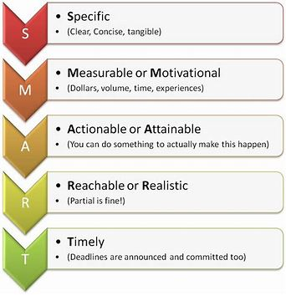

A good test of checking is a target is SMART is ‘hey teacher, come and see/hear/listen to me…….’ if it isn’t clear what you would see/hear, then the target probably isn’t SMART enough.
E.g. Kate needs to improve her reading – NOT SMART
E.g. Kate will be able to read a page of KS1 text and answer a question about what it is about by the next term- SMARTER

Actions and intervention would follow from this (e.g. Action – Kate to read a page and practice oral comprehension questions with Mrs Helpful at 2.30pm every school day)

Specific actions to improve progress and attainment (and attendance, if necessary)
Bring together all the actions discussed today, including any carried forward from discussion of the last PEP’s actions, and record them below.

Autumn term
Area of concern (use assessment data) | SMART targets to address concerns | What will you do?  Specific actions/interventions. Who will be responsible? | How will you (EY)PP+ be spent to support meeting targets? | Review (Achieved/partially achieved/not achieved)
Reading tricky Words | Child is able to read all year 5 and 6 Key Words | Child will access precision teaching 3 x a week for 20 mins with Mrs Helpful | Training for precision teaching and TA time
Times tables | Child will be able to respond to rapid fire questioning to 12 x table | Child will practise times tables daily at home and school with Mr Useful and foster carer | TA time and TT Rockstar App

Our child/young person’s strengths and needs
This section sits within the ‘Education Information’ but can be populated through discussion at the PEP review by the child, social workers, carers etc.
The section is divided into sections to bullet strengths and particular challenges. The first two are more self-explanatory
- The ‘Relationships’ section is about the child’s experiences of all relationships. For example, the child’s family relationships including, carers, siblings etc; relationships at school with teachers and peers and those within the community.
- The ‘Mental health, resilience and emotional health and wellbeing’ section includes the emotional wellbeing of a child, how they are able to express and regulate their emotions with the support of an adult and independently. The strategies they have developed to cope etc. The situations that support their emotional wellbeing best.
- The ‘Communication Skills’ describes how the child or young person is able to communicate their needs to others. Are they able to use speech and language, do they do this through their behaviours?
- The ‘Executive functioning’ section describes the skills we all have to plan and carry out tasks. That may be one at home or self-care or a more school-based task. These skills can be thought of as thinking skills and skills to guide behaviour. Areas to consider are below:
Thinking skills | Skills to guide our behaviour
Planning | Response inhibition
Organisation | Emotional control
Time management | Sustained attention
Working memory | Task initiation
Metacognition | Flexibility
 | Goal directed persistence

- The ‘Preparing for Adulthood’ section describes the four outcomes that we would hope education would support all children in their development over time. A helpful table can be found at the bottom of this guidance document which explains how preparing for adulthood is relevant from early years and into post 16 education.

PEP documentation for each phase of education
The PEP process remains the same for all of our children and young people. This means that the PEP is reviewed every term and new targets are set in a repeating cycle of assess-plan-do-review. As such, the of the documentation has been designed to ensure consistency from early years and school aged children and in to Post 16. The exception is the ‘Attainment and Progress’ section. This section has been developed to be age, development and curriculum appropriate. Our documentation is located on our Virtual School website (add in link). Children accessing a mainstream curriculum and mainstream outcomes (regardless of education setting) complete the Key Stage PEPs. Children/young people who are accessing a targeted, specialist and bespoke curriculum complete the Targeted Curriculum PEP.
Nottinghamshire PEP documents 2020-21
- Early Years Foundation Stage PEP
- Primary Key Stage 1 and 2 PEP
- Secondary Key Stage 3 and 4 PEP
- Targeted Curriculum PEP
The Targeted Curriculum PEP has been devised to be used to support children and young people who are accessing provision and a targeted curriculum that is ‘additional to and different from’ a mainstream curriculum. These children may attend mainstream schools or specialist provisions/schools. This PEP will measure the steps of progress appropriate for that child/young person rather than Key Stage ‘Age Related Expectations.’
- Post 16 Employability Assessment PEPs
The Post 16 PEP has been redesigned as part of a process change resulting from the issuing of new statutory guidance for Virtual Schools in February 2018. The new guidance emphasised the importance of the PEP at Post 16 informing the Pathway Plan. The new Post 16 Employment Assessment (EAPEP) does this by focussing on two key areas, progress in education or training and transition into education, training or employment after the current course of study. The EAPEP has also changed to make the recording of employment and apprenticeship easier and to stimulate and record plans to support young people who are not positively engaged in education training or employment. Detailed guidance for completing EAPEPs can be found on the ‘framework’ tab within the EAPEP document which is in the format of an excel spreadsheet.
Nottinghamshire PEP documents 2020-21

What if our child/young person doesn’t have a school place or is not accessing education?
Every young person’s situation is individual and so it is a challenge to state indefinitely what would happen in every situation. Every young person has a right to their education and therefore social care and the Virtual School will be working hard to ensure that appropriate education for a young person is in place as soon as possible. When appropriate, where the young person is without a school place, the Virtual School will be ensuring interim arrangements are in place.
As with all PEPs, the social worker organises for the PEP to happen in terms of planning a date and time, inviting the relevant people and finding a venue. The PEP process and planning should take place between the social worker, young person, the foster or residential carer and other relevant partner agencies on a termly basis, the same as if a young person was in school.
If tutoring is in place, the tutor may be invited to the PEP meeting but not expected to complete paperwork this would need to be done at the meeting by the social worker – the Virtual School should be alerted to PEP meetings for these pupils as they would be a priority.
Understanding our Nottinghamshire Special Education Needs and Disabilities (SEND) processes
When planning the education around our children in care, we must ensure that we understand the local processes that may also support them. If we have concerns around our children, the schools or education settings must be providing a graduated response to their needs and if necessary, taking for discussion at termly Springboard meetings for consultation with others and if necessary, specialist teacher support (for example cognition and learning and communication and interaction) or Educational Psychologist involvement.

Understanding the EHCP Process with PEP processes
If a child has an Education Health and Care Plan (EHCP), this will be reviewed once a year at an Annual Review. The PEP is reviewed on a termly basis (three times a year with much shorter term targets to set). The content of the PEP must be linked to, and ideally complement, but not duplicate or conflict, with that of the EHCP. It would be reasonable to expect that some of the shorter term targets would be focussing on reaching the EHCP outcomes. It is helpful to have a copy of the EHCP for PEP meetings and combine the Annual Review with one of the PEP meetings so that the processes support one another.
Checklist for Completing the PEP form and Quality Assurance
How do Nottinghamshire Quality Assure the PEP process?
The quality of the PEP process is the joint responsibility of Nottinghamshire local authority and the school or education provider. Social workers, carers, Virtual School, designated teachers and other professionals, as appropriate, need to work together to produce quality PEPs. To be effective and high quality, a PEP should be a ‘living’, evolving, comprehensive and enduring record of the child’s experience, progress and achievement (academic and otherwise), and inform any discussion about education during statutory reviews of the child’s wider care plan,’ (DfE, Promoting the education of looked after children, 2018).
The Quality Assurance process in Nottinghamshire is led by the Virtual School in partnership with colleagues from Children’s Social Care Teams and others.
The Quality Assurance process will ensure the PEP:
- Was initiated within 10 working days of a child becoming ‘looked after’ and completed by the first Looked After review
- Has been reviewed termly
- Is fully completed
- Is using correct paperwork
- Involves the child and their carer/s and has a strong young person voice
- Documents who was invited and who has attended
- Includes school attendance and, if appropriate, behavioural support
- Contains summary of young person’s current attainment and progress and documents any additional needs, Special Educational Needs and Disability (SEND) and mental health
- Is based on accurate assessment that identifies developmental and educational needs and strengths, in relation to skills, knowledge, subject areas and experiences; it is important that critical learning gaps are identified so that these can be tackled.
- Sets out short and long term SMART educational attainment targets agreed in partnership with the child and the carer.
- Records planned actions that the school and others will take to support the child to achieve expected levels of progress for the relevant national curriculum key stage and to complete an appropriate range of approved qualifications. This should be based on an assessment of his or her educational needs; e.g. subject areas, homework, extra tuition, study support, attendance and behaviour.
- Includes information on how the progress of the child is to be rigorously monitored.
- Records details of specific interventions and targeted support that will be used to make sure personal education targets are met, especially at the end of Key Stage 2 in relation to English and mathematics and at Key Stage 4 in achieving success in public examinations particularly in English and maths.
- Says what will happen or is already happening to put in place any additional support which may be required – e.g. possible action to support special educational needs involving the SENCO, educational psychologist, CAMHS or local authority education services.
- Sets out how a child’s aspiration and self-confidence and ambition is being nurtured, especially in consideration of longer term goals towards further and higher education, work experience and career plans.
- Is a record of the child’s academic achievements and participation in the wider activities of the school and other out of school learning activities (e.g. sporting, personal development, community).
- Provides information which helps all who are supporting the child’s educational achievement to understand what works for him or her.
- Has clear accountability in terms of who within the school is responsible for making the actions identified in the plan happen and specifies timescales for action and review - SMART targets.
- Where a child has a statement of special educational needs, or an EHCP, the PEP should include relevant information from these and annual reviews but does not need to duplicate the information in full.
- Identifies developmental needs including any related to unmet attachment needs and trauma and how to support emotional dysregulation
- Identifies support needed around mental health and specialist services
- Includes transition support where needed including when a child has a plan for permanence and may change schools as part of that plan.
- Includes plans and aspirations for post 16, aspirations should be high and discussions should start well before year 9.
- Details out of hours learning activities, study support and leisure interests
- Includes provision of immediate suitable education where a child is not in school (e.g. exclusion, sudden placement move)

What is the link with Pupil Premium Plus (PP+)?
The PEP should include mapping how the PP+ and other additional funding has been used to support the targets in the PEP. This is to ensure that the story of the child’s educational progress is current and continues to meet the child's educational needs.
Ongoing training offer
The Virtual School has worked alongside children’s social care and developed training to support successful PEP meetings and PEP documentation. This training is accessed via the EM-ED website.
Helpful Hints about Education
The Foundation Years (0-5 years)
This is how the Government describe the time in a child’s life between birth and age 5. Every child deserves the best possible start in life and the support that enables them to reach their full potential. Children develop quickly in the early years and their early experiences have a major impact on their future life chances. A secure, safe and happy childhood is important and parenting and high quality early learning together provide the foundation that children need to reach their individual potentials.
Day-nurseries, pre-schools, childminders, nursery and reception classes must meet the standards set out in the Statutory Early Years Foundation Stage (EYFS) Framework (Aged 3-5 years). This is to ensure that children develop and learn and are kept healthy and safe. It promotes learning and teaching to develop ‘school readiness’ and a broad range of knowledge and skills to provide a good foundation for future progress in school and onwards. The Reception class (sometimes called Foundation Two) is included in EYFS.
The EYFSF talks about early learning goals and three characteristics of effective learning (playing and exploring – engagement; active learning – motivation and Creating and thinking critically).
Expected progress in EYFS may look slightly different to expected progress from Key Stage 1. Children in EYFS are expected to make progress across a whole year but progress may be more significant in one term than another, this is particularly relevant when they are settling into a setting.
The National Curriculum
The National Curriculum talks about Key Stages
- Key Stage 1: School Years 1-2 Ages 4-7
- Key Stage 2: School Years 3-6 Ages 7-11
- Key Stage 3: School Years 7-9 Ages 11-14
- Key Stage 4: School Years 10-11 Ages 14-16
- Key Stage 5: School Years 12-13 Ages 16-18
Assessments
Schools should assess children all of the time as part of formative ‘assessment for learning’ However, there are formal summative assessments which take place ‘assessment of learning.’ The government has made a decision that there are National Age-Related Expectations and that there are ‘expected levels’ that children should get to a particular ages. This is how schools report how their children are doing in schools: either ‘working towards’ a particular standard, ‘expected’ or working ‘above expected/greater depth.’ Schools should also measure the progress a child makes each year and this is measured in relation to making expected levels of progress within a year.
End of Key Stages Assessments and Expectations
The table below shows the key points of assessment throughout a child’s education. Once completed, these points are often referred to as prior attainment or historical achievement.
Stages/ages | Assessment | National Age-Related Expectations/Expected levels
Early Years Foundation Stage: preschool – end of reception year (3-5 years old) | EYFS profile (observations etc) | By end of reception ‘good level of development’ if achieved at least expected level in the Early Learning Goals in all aspects of PSE, Physical development, Communication and language, Literacy and Mathematics.
Key Stage 1: Year 1 (5-6 years old) | Phonics Screening | Expected
Key Stage 1: Year 2 (6-7 years old) | SATs tests in English and maths and teacher assessment | Expected
Key Stage 2: Year 6 (10-11 years old) | SATs tests in English and maths and teacher assessment for writing | Expected
Key Stage 3: Year 9 (13-14 years old) | Teacher assessment judgements | Expected
Key Stage 4: Year 11 (15-16 years old) | GCSEs or vocational courses | 5 GCSEs (including maths and English – Grade 4 or above)
Key Stage 5: Year 12+ (usually 16-18 years old) | A Levels or vocational courses

Preparing for Adulthood (PfA) Guidelines
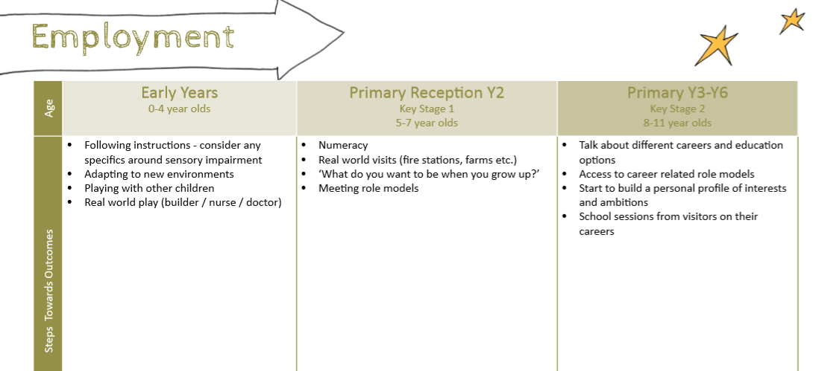
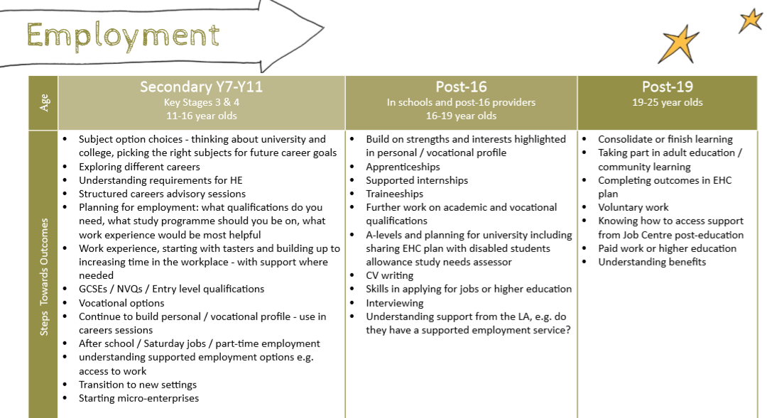
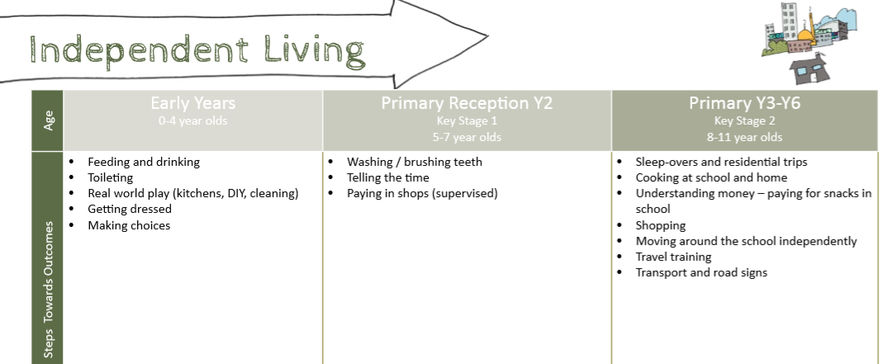
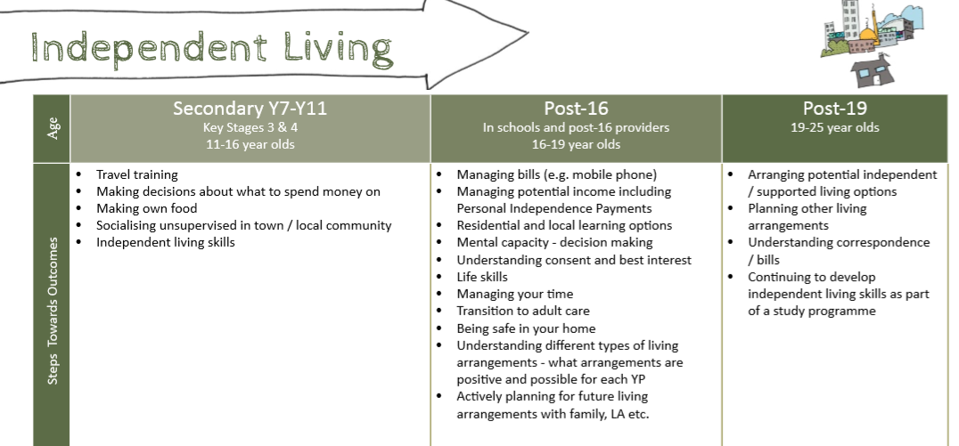

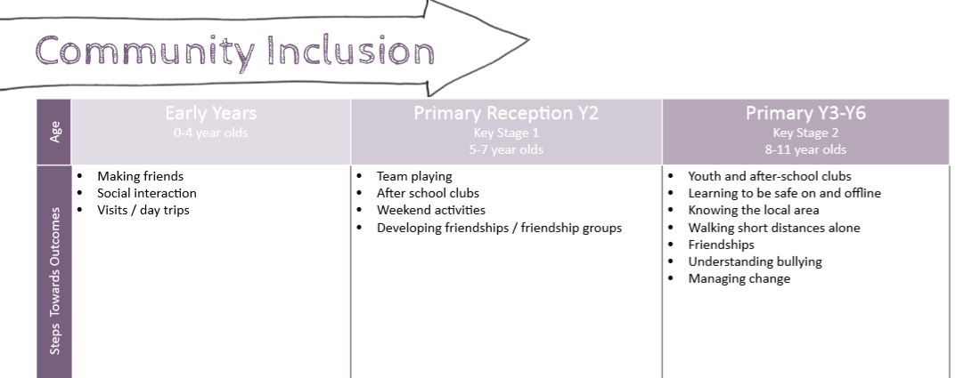

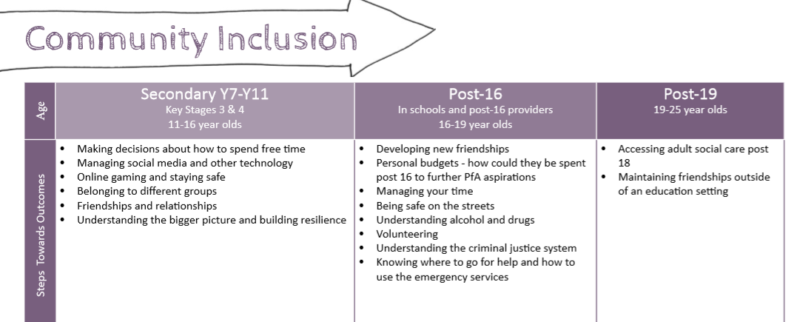
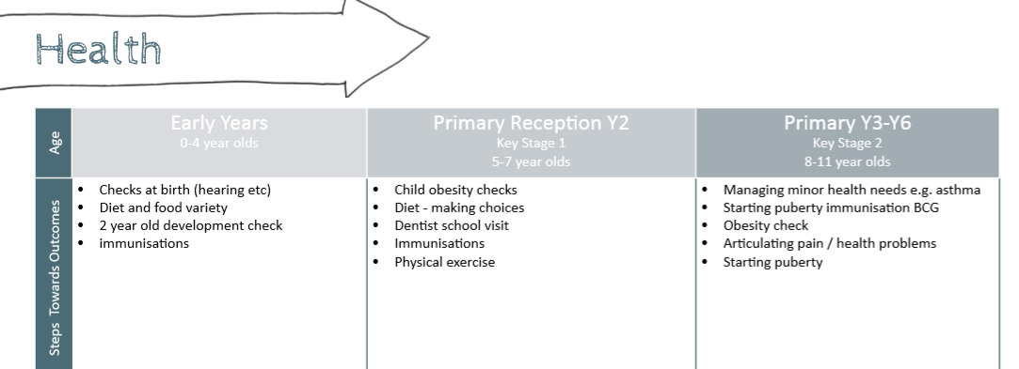
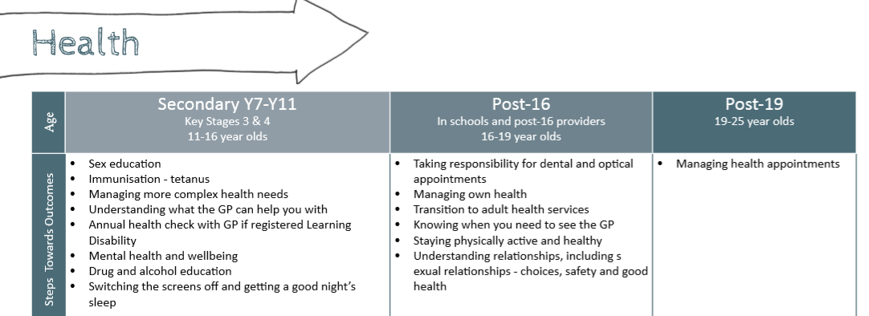
References
DfE (Feb 2018). The role and responsibilities of the designated teacher for looked after and previously looked after children.
DfE (Feb 2018). Promoting the education of looked after children and previously looked after children - statutory guidance for local authorities

