Title:
Assistance with medication policy
for Short Term Assessment & Re-ablement Team (START) re-ablement support workers operating in a service users home
Aim / Summary:
To detail the principles that must be followed by re-ablement support workers in relation to medication.
Document type (please choose one)
Policy |  | X |  |  | Guidance
Strategy |  |  |  |  | Procedure
Approved by: |  |  |  |  | Version number:  3.0
Date approved: |  |  |  |  | Proposed review date:
Subject Areas (choose all relevant)
 | About the Council |  |  |  |  | Older people |  | X
 | Births, Deaths, Marriages |  |  |  |  | Parking
 | Business |  |  |  |  | Recycling and Waste
 | Children and Families |  |  |  |  | Roads
 | Countryside &  Environment |  |  |  |  | Schools
 | History and Heritage |  |  |  |  | Social Care |  | X
 | Jobs |  |  |  |  | Staff
 | Leisure |  |  |  |  | Travel and Transport
 | libraries
Author: Coral Osborn  Senior Prescribing and Governance Adviser |  |  |  |  | Responsible team:  Adult Social Care, Health and Public Protection
Contact number:  01623673028 |  |  |  |  | Contact email:  Cosborn@nhs.net
Please include any supporting documents
1.
Review date |  |  | Amendments
September 2014 |  |  | Addition of Bassetlaw CCG GPs and community  pharmacists contact details
December 2015 |  |  | Addition of updated Medicine Risk Assessment Form
January 2019 |  |  | Review of policy

Nottinghamshire County Council Adult Social Care, Health & Public Protection

ASSISTANCE WITH MEDICATION POLICY FOR START RE-ABLEMENT SUPPORT WORKERS OPERATING IN A SERVICE USER’S HOME

Contents:
- INTRODUCTION 4
  - Consultation 5
  - Working together and taking risks 6
  - Capacity and consent 6
  - Authorisation 7
  - Reporting concerns 7
- AIMS AND PRINCIPLES 8
- ROLES AND RESPONSIBILITIES 9
  - Responsibilities of the re-ablement support worker 9
  - Responsibilities of the peri re-ablement support worker 10
  - Responsibilities of the re-ablement manager 10
  - Responsibilities of the Occupational Therapist & Community Care 11
Officer (Occupational Therapy) …………………………………………...
- ACCOUNTABILITY 11
- ASSESSING LEVELS OF SUPPORT 11
  - First visit. 12
  - First visit outcomes 13
- TRAINING AND COMPETENCY ASSESSMENTS 14
- ORDERING, COLLECTION AND STORAGE OF MEDICATION 14
- MEDICATION SUPPORT TASKS 16
  - Level 1 & 2 medication support tasks for START staff 16
  - Support tasks associated with a higher level of risk 17
  - Tasks that re-ablement staff CAN NOT undertake 19
- ADMINISTRATION OF MEDICATION 19
  - Types of support 19
  - Containers and monitored dosage systems 20
  - Medication Administration Record (MAR) charts 20
  - Administration procedure 22
  - Leaving medication out 24
  - Crushing tablets, opening capsules, splitting tablets 24
  - Imprecise or ambiguous directions 25
  - When required (PRN) medication 25
  - Variable dosages 26
  - Warfarin and newer anticoagulants…………………………………….. 26
  - Food and drink interactions 27
  - Food Supplements and Thickening agents… 27

 | 9.13  9.14  9.15 | Support with TED and Compression stockings…………………………. Application of eye drops and ointment…………………………………… Application of Transdermal patches……………………………………… | 28  29  29
10. | OMISSIONS AND REFUSAL TO TAKE MEDICINES ………………………...... |  | 29
11. | COVERT MEDICATION …………………………………………………………..... |  | 30
12. | RECORD KEEPING ………………………………………………………………… |  | 31
 | 12.1. | Support plan, risk assessments, MAR charts.………………………….. | 31
 | 12.2. | MAR chart codes …………………………………………………………... | 31
 | 12.3. | Recording application of topical products (creams and ointments)…… | 32
 | 12.4. | Discharge from the START service ……………………………………… | 32
13. | DISPOSAL OF MEDICATION ……………………………………………….......... |  | 33
14. | ERROR AND NEAR MISS REPORTING ……………………………………….... |  | 33
15. | GIVING ADVICE TO SERVICE USERS ON MEDICAL ISSUES …………........ |  | 34
16. | CONFIDENTIALITY …………………………………………………………............ |  | 34
17. | DEFINITIONS ………………………………………………………………….......... |  | 35
18. | FORMS TO USE …………………………………………………………………….. |  | 36
 | APPENDICES
 | APPENDIX 1 – Assessment form …….............................................................. |  | 38
 | APPENDIX 2 – MAR chart ………..................................................................... |  | 40
 | APPENDIX 3 – Assistance with application of compression hosiery................, |  | 42
 | APPENDIX 4 – Warfarin Risk Assessment ………………………………………. |  | 44
 | APPENDIX 5 – Guidance on Assessing Capacity and Risk Assessments …… |  | 45
 | APPENDIX 6 – GP Practice details ………………………………………………. |  | 47
 | APPENDIX 7 – Community Pharmacy details……………………………………. |  | 59
 | APPENDIX 8 – Compliance aids …………………………………………………... |  | 73
 | APPENDIX 9 – Supporting with Medication and Health Related Tasks in Service User’s Homes …………………………………………….  APPENDIX 10- Patch Application Record………………………………………… |  | 76  78

1. INTRODUCTION

This document details the policy on the safe and secure handling of medicines by the Short Term Assessment and Re-Ablement Team (START) staff of Nottinghamshire County Council (NCC).

Care providers need to ensure they can respond to the Care Quality Commissions (CQC) 5 key questions for services

    - Are they safe?
    - Are they effective?
    - Are they caring?
    - Are they responsive to people's needs?
    - Are they well-led?

CQC Inspectors will use professional judgement, supported by Key Lines of Enquiry (KLOEs) and evidence, to assess services against these five key questions.

It is important that care providers:

- Handle medicines safely, securely and appropriately
- Ensure that medicines are prescribed and given by people safely
- Follow published guidance about how to use medicines safely

This policy sets out the principles that must be followed throughout the START service of the Council so that the CQC fundamental standards of quality and safety are met. It provides clarity on the medication tasks that can be undertaken by START staff (following training and assessment of competency) and those tasks which should remain the responsibility of healthcare.

All medication is potentially harmful, if not used correctly, and care must be taken with its storage, administration, control and safe disposal. It is important therefore that START employees who provide support are confident about their role in the management of medication.

The responsibilities of health and social care staff in relation to tasks other than medication are set out in the policy on “Responsibilities for Care in the Home’, June 2010, (the Wavy Line document), available via the re-ablement manager and team managers.

There may be occasions where situations are not covered in this policy. Therefore any concerns must be brought to the attention of the workers line manager or person on call.

Independent home care providers who are contracted by Nottinghamshire County Council to provide medication support as part of a package of care may wish to use/adapt this medication policy to reflect their local service.

Consultation

Consultation on previous versions of this document occurred widely within Nottinghamshire County Council, Nottinghamshire Clinical Commissioning Groups (CCGs) and Nottinghamshire Health community groups. The groups listed below were involved in the original consultation process and supported the medication policy as set out in this document.

NHS Nottinghamshire County and Bassetlaw

NHS Nottinghamshire County Medicines Operational Group
NHS Nottinghamshire County Community Pharmacy Development
Group
Nottinghamshire Local Pharmaceutical Committee -
covers Nottinghamshire County, Nottingham City and Bassetlaw CCGs
Nottinghamshire Local Medical Committee, (electronically). Covers Nottinghamshire County, Nottingham City and Bassetlaw CCGs
Nottinghamshire Community Health locality service managers
Bassetlaw PCT Provider Clinical Governance Group
NHS Nottinghamshire County Medicines Management Sub-Committee,
NHS Nottinghamshire County Quality and Risk Sub-Committee
Nottinghamshire Community Health Senior Management Team

Nottinghamshire County Council

START Countywide Operational Managers
Unions
Independent providers of homecare services
Risk Safety Emergency Management Group (RSEMG)
Commissioning Managers (COMMS)
Adult Care Management Team (ACMT)
Safeguarding Adult Mental Capacity Act Team (SAMCAT)

Due to the restructuring of NHS organisations some of the above mentioned groups now cease to exist. The following additional groups/ staff were therefore involved in the consultation and/or the review notification process.

Greater Nottingham CCGs Medicines Optimisation Committee, Mid- Notts CCGs Joint Prescribing Sub group, Sherwood Forest Hospitals NHS Foundation Trust, Nottinghamshire Healthcare NHS Foundation Trust and Nottingham University Hospitals NHS Trust Pharmacy staff.

Feedback was also sought from START and NCC staff on previous policy content and how this translated to patient facing care. Domiciliary care policies were also viewed from councils both locally and nationally to establish that the contents of this policy were in line with local and national thinking.

Working together and taking risks

All members of staff have an important role to play in risk identification, assessment and management of medication. It is important the service learns from events and situations where things have, or could have gone wrong in order that the reasons for the occurrence of the event or situation can be identified and rectified. This is to encourage a culture of openness and willingness to admit mistakes.

Service users may require social care support and health related input. This will necessitate employees from all agencies to work together in partnership to meet individuals’ needs.

Nottinghamshire County Council fully indemnifies START staff against claims for alleged negligence provided they are acting within the scope of their employment and following guidelines set out within this policy.

Capacity and Consent

The majority of service users take responsibility for taking their own medication and their independence should be supported as much as possible.

This part of the policy should be read in conjunction with the Mental Capacity Act 2005 and the Mental Capacity Act Code of Practice.

    - Any professional who prescribes medication has a responsibility to assess that their patient / service user has capacity to consent to treatment with medication at the point of prescribing, or, if the person lacks capacity, that it is in their best interests to take the medication. Any advance decisions to refuse treatment should be taken into account by this professional.

    - Within the START service a peripatetic (peri)-re-ablement support worker or a re-ablement manager will undertake an assessment of the service user’s ability to manage their medication, during their first visit. They will then have a separate responsibility to ensure the person has capacity to consent to medication assistance (if applicable) or, if the person lacks capacity, that it is in their best interests to have medication assistance.

    - Consent must be given by the service user in writing during the first visit with the peri-re-ablement support worker or re-ablement manager, before re- ablement support workers may support with medication related tasks (whether this is reminding, assisting and or administration tasks). If the service user appears to lack capacity to give consent for medication assistance, the peri-

re-ablement support worker or re-ablement manager will undertake a mental capacity assessment.

    - If the service user lacks capacity, the peri-re-ablement support worker or re- ablement manager must check if there is a Lasting Power of Attorney (for health and welfare) who may have authority to make the decision about assistance with medication. If not, when a service user is assessed as lacking capacity a best interests decision must be made by the peri- re-ablement support worker or re-ablement manager on their behalf consulting relevant people based on the best interests checklist and local guidance taking into account any advance statements. A record must be made in the health section of the service users support plan of the reasons and circumstances of the best interest’s decision and who was involved in the process.

    - Confirmation of consent for support with medication will be noted on the service user’s support plan. Unless it has been concluded that the service user lacks capacity to provide authorisation, the service user should sign to confirm authorisation on the support plan.

Authorisation

    - Re-ablement support workers and peri re-ablement support workers must only support with medication related tasks following authorisation by their line manager, and where the authorisation of the service user has been obtained or where a record has been made in the health section of the support plan identifying it is in the best interests of the service user to receive assistance (see 1.3).

    - All re-ablement support workers and peri re-ablement support workers can undertake Level 1 support tasks once they have received induction training and provided conditions described in sections 1.3 and 1.4 apply. Level 2 tasks may only be undertaken following enhanced training and once confirmation of competency has been signed off by their line manager and provided conditions described in section 1.3 and 1.4 apply.

Reporting concerns

    - Re-ablement support workers and peri re-ablement support workers must report any concerns relating to a service user’s medication to their line manager (or if out of hours the person on call).

    - Where a service user has responsibility for their own medicines and the re- ablement support worker is concerned about the service user’s ability to continue to manage their own treatment, the re-ablement or peri re-ablement support worker must report this to their line manager (or if out of hours the person on call). It is the responsibility of the line manager to arrange a further assessment of the service user’s need for assistance with their medication.

    - If the peri or re-ablement support worker has any concerns about any aspects of medication assistance in relation to a service user who lacks capacity, this must be notified at once to the re-ablement manager.
2. AIMS AND PRINCIPLES

The aim of this policy is to provide clear guidance to the re-ablement support worker, service user, and their relatives as to the nature of support that may be given with medication administration by paid carers in the domiciliary setting.

The result of using this policy must be that service users have the,

Right medicine
      - Right dose
      - Right time
      - Right route

and medication is assisted/administered to the Right person.

The recent NICE guideline 67 “Managing medicines for adults receiving social care in the community” also states service users have a Right to decline.

The following principles will also apply:-

      - Independence will be promoted, encouraging service users to manage their own medicines as far as they are able, and for as long as possible
      - The service user’s independence at home will be maintained
      - If the person is assessed as lacking capacity, the principles in the Mental Capacity Act must be applied.
      - Where there is no carer or other responsible adult willing and able to assist service users to take their medicines at home, or where the service user requests that informal carers are not to be involved in administration of their medication, START staff will undertake this task as part of the agreed personal care.
      - Where START staff assist service users to take their medication there must be a formal agreement with the service user and their relatives as to which tasks are the responsibilities of START.
      - Any assistance provided with medication will be by trained competent employees.
      - The START service will not be provided solely for the purpose of administering/assisting with medication however, this may be considered as an interim arrangement on a case by case basis. At point of discharge, where there are medication only needs, ASCH will be unable to provide an ongoing service”.

3. ROLES AND RESPONSIBILITIES

There are three main roles of START staff involved with supporting a service user with their medication, these are a re-ablement support worker, peri re-ablement support worker and the re-ablement manager:-

Responsibilities of the re-ablement support worker

The re-ablement support worker must,

    - Adhere to procedures set out in this policy.
    - Not undertake Level 1 medication support tasks until induction training has been completed
    - Not undertake Level 2 medication support tasks until they have received training and been signed off as competent.
    - Concentrate on support with medication tasks to the exclusion of all other duties and distractions.
    - Talk to the service user about the support they are providing with their medication. The views of the service user should be taken into account and acted upon as appropriate.
    - Ensure the service user’s name and the name of the medication on the container match with the Medication and Administration Record (MAR) chart.
    - Record all provision of support with medication as detailed in section 12 on the MAR chart including any refusal/omission of medication along with reason for the refusal occurring.
    - Ensure they complete the authorised signature sheet in order to identify their signature. The signature sheet will be kept in the office bases.
    - Notify the re-ablement manager (or person on-call) of any changes to a service user’s medication regime so that the support plan can be updated by the peri re-ablement support worker or the re-ablement manager.
    - Refer any observations/concerns about a service user’s condition back to the re-ablement manager (or person on-call).
    - Inform the re-ablement manager (or person on-call) of any risks and potential for error associated with medication in order that risk assessments can be undertaken and safe systems and processes can be implemented. In addition any occurrence of errors should be reported immediately (see section 14).
    - Inform the re-ablement manager (or person on-call) immediately should they become aware of discrepancies in quantities of medicines. Whether the discrepancy is due to medicines being mislaid, stolen or the incorrect quantity being supplied by the pharmacy, a medication incident form should be completed in conjunction with their line manager.
    - Ensure any reported medication changes are updated promptly in the support plan, and ensure arrangements have been made to update the MAR chart in line with procedure by the peri- re-ablement support worker

or re-ablement manager. The support plan must be signed and dated by the service user and appropriate social care staff.

Responsibilities of the peri re-ablement support worker

As for the re-ablement support worker above with the addition of

    - Undertakes the first visit to service users to introduce the service.
    - Completes the service users support plan
    - Carries out all risk assessments needed and mental capacity assessment, if required.
    - Ensures details of current medicines are obtained (including any over-the- counter medicines and creams for personal care) and produces a MAR chart for the service user, which is then checked on a regular basis.
    - Ensures the required medication is available in the service user’s home
    - Provides an on-call function out of hours.

Responsibilities of the re-ablement manager

It is the responsibility of the re-ablement manager to,

    - Ensure that all peripatetic (peri) re-ablement support workers and re- ablement support workers can access/view a copy of this policy along with the summary of tasks that can be undertaken by each group.
    - Provide information to all re-ablement support workers, as part of their induction training, as to what tasks they can and cannot undertake prior to receiving enhanced training and being signed off as competent to assist with Level 2 medication tasks.
    - Ensure that re-ablement support workers and peri re-ablement support workers receive training on assistance with level 2 medication tasks and competency sign off in a timely manner. Records should be kept of the date training is undertaken and the date of competency sign off.
    - Establish that the re-ablement support worker and peri re-ablement support worker is competent in the EPDR each year.
    - Undertake a new competency on each re-ablement support worker and peri re-ablement support worker every year.
    - Ensure a MAR chart and the required medication is available in the service user’s home.
    - Line manage peri re-ablement support workers and re-ablement support workers

Managers must,

    - Not request any staff to undertake Level 2 medication tasks prior to them receiving training and subsequently being signed off as competent.
    - Ensure any reported medication changes are updated promptly on the support plan and ensure arrangements have been made to update the

MAR chart in line with procedure. The support plan should be signed and dated by the service user and appropriate START staff.
    - Ensure an up to date authorised signatories list is maintained in order that signatories on the MAR chart can be easily identified by staff.
    - Provide support to employees who report errors and facilitate a culture of “Fair Blame”. Implement a fair blame culture in which staff are not blamed, criticised or disciplined as a result of a genuine slip or mistake that leads to an incident. Disciplinary action under Nottinghamshire County Council’s Disciplinary Procedure may still follow an incident that occurred as a result of misconduct, gross negligence or an act of deliberate harm.
    - Ensure where an error has been reported, or the re-ablement manager is made aware of potential for an error to occur, a review of systems and processes is undertaken, in conjunction with the team manager to determine appropriate actions.

Responsibilities of the Occupational Therapist & Community Care Officer (Occupational Therapy)

It is the responsibility of the Occupational therapist and Community Care Officer (Occupational Therapy) to:-

    - Participate in appropriate training on the medication policy in order to become familiar with it.
    - Keep up to date with any memos, amendments or changes to the policy.
    - Abide by the procedures set out in the Medication policy
    - Ensure that any START Goal Plans or Support Plans comply with the procedures set out in the Medication Policy.
    - Notify the Re-ablement Manager of any changes to a service users medication regime that they become aware of.
    - Notify the Re-ablement Manager immediately if they become aware of any concerns.
4. ACCOUNTABILITY

All START staff are accountable for ensuring they comply with the Council’s START medication policy. They should only undertake actions for which they have been trained and have been deemed competent to do so. In cases of uncertainty they should refer to their line manager.
5. ASSESSING LEVELS OF SUPPORT

This is key to the whole process to identify what assistance is required. It will also highlight service user’s whose medication needs are beyond the knowledge and competence of the Re-ablement Support Workers.

First visit

Following referral the first visit must be undertaken by a peri re-ablement support worker or a re-ablement manager.

As part of the visit the peri-re-ablement support worker or the re-ablement manager will speak to the potential service user and complete:-

A Support with Medication Risk Assessment form (START/AMP/7)
This will determine the level of support, if required, by the service user.

A support plan
This will detail the level of support to be provided to the service user. It must include an up to date list of prescribed medicines from the service users GP or a hospital discharge letter. Information should also be clarified as to any medicines the service user is taking which they have bought themselves and any creams used for personal care. The service user must sign the relevant sections of the support plan, including the statement of permission to identify that they consent to a level of service support. A first contact form must also be completed, if applicable.

Where START staff support service users to take their medication there must be a formal agreement with the service user and their relatives as to which tasks are the responsibilities of the START staff. This must be clearly documented in the support plan and form START/AMP/1 completed where there may be a necessity to clarify in more detail. For example, where relatives are in dispute over what is provided and by whom or where there is shared responsibility

Even when staff do not routinely give medicines, it is important to document whether the service user has any medicines, what the medicines are and the dosage instructions on the dispensing label.

Warfarin Risk assessment form
This must be completed if it is identified that the service user is prescribed warfarin.

Mental capacity assessment
If the support with medication assessment form identifies a possible issue with capacity then a mental capacity assessment (MCA) must be undertaken and the results documented. The MCA will be completed by the peri re-ablement support worker or re-ablement manager. See section 1.3 for additional information.

Production of a MAR chart
If the assessment form identifies that the service user requires support with their medication by the START team the peri-re-ablement support worker or re-ablement manager will produce a MAR chart for the service user. See

section 9. The MAR chart will then be checked by the peri- re-ablement support worker on the first day of their subsequent shifts.

First visit outcomes:

At the end of the first visit the outcomes will be one of the following:-

    - The service user is able to self-medicate all their prescribed medication. Therefore no further action required with medication from the START service
    - A family member or informal carer assists them with all their prescribed medication.
Therefore no further action required with medication from the START service
    - A family member or informal carer assists with some of the service user’s medication e.g. they may assist with a tea-time dose of medication. Hence support required from START service at other administration times.
    - Service user requires support from the START service. The support can include verbal reminders, the use of compliance aids, preparation, assistance and administration. For example a service user may be able to self-medicate some of their medication but not others, or a service user may require administration support with all their medication.

In all cases where support (including verbal reminders) is to be provided by the START service a MAR chart must be completed and kept at the service user’s home. This will be checked on a regular basis to ensure medication has been documented correctly e.g. no missing administration signatures.

As per above if family members or informal carers assist with a service users medication this must be clearly documented in the support plan and a START/AMP/1 form completed. This ensures that family members or informal carers understand their responsibilities, including signing the MAR chart to document that they have assisted with a dose of medication.

Joint working between health and social care is important to ensure service users receive integrated person-centred support. The START service should notify the service users GP and supplying pharmacy when starting to provide medicines support.

A range of compliance aids are available to help service users administer their medicines independently. START staff should contact the service user’s community pharmacist for advice. (See appendix 7 and 8)

Service users who may need support with medication would include those with:

    - No sight/partial sight
    - Severe mental health problems
    - Complex medicine regimes

    - Dementia
    - Learning difficulties
    - Poor mobility or manual dexterity
    - Stroke
    - Arthritis
    - Multiple Sclerosis /Parkinson’s disease
    - Poor literacy
    - Inability to read or interpret
    - Language barriers

It should be noted that if any START staff notices a change in the service user’s condition, they must contact their line manager to arrange a review of the service user’s support with medication risk assessment.
6. TRAINING AND COMPETENCY ASSESSMENTS

Following induction training all re-ablement support workers will be able to assist with Level 1 medication tasks.

On induction all staff will be expected to successfully complete the following:

    - Attend a medication training session specified by Nottinghamshire County Council
    - Work through the Supporting with Medication workbook
    - Answer a selection of short questions and scenarios as part of the knowledge assessment
    - Demonstrate competency to undertake tasks as specified in this policy by observation or simulation.

Competency will be assessed and signed off by the Re-ablement Manager.

Only trained certificated re-ablement staff who have demonstrated competency are able to undertake Level 2 assistance with medication tasks.

All staff will have refresher medication training and undertake a competency assessment every year.
7. ORDERING, COLLECTION AND STORAGE OF MEDICATION

  - Appropriate arrangements must be taken to ensure there is a continuous supply of medication for the service user.

  - It must be clearly documented how the service user orders their medication how it is obtained (collected) and who is responsible for this.

  - Requests for a supply of medication i.e. ordering from the service user’s GP, should wherever possible remain the responsibility of the service user, or their relatives. In exceptional circumstances where this is not possible a re-

ablement support worker may undertake this task following authorisation from their line manager, and this must be documented in the support plan.

  - Re-ablement staff may collect prescriptions from the surgery and or medicines from a community pharmacy.

  - If re-ablement staff assist with the collection of medication from a community pharmacy or dispensing doctors, this must be collected and returned directly to the service users home. Staff should transport medication out of direct view.

  - Re-ablement staff should ensure that all ordered medication has been received from the community pharmacy. They must check that the name on the medications matches that of the service user and the MAR chart. Staff must contact their line manager (or person on-call) for advice if an item is missing or is owed by the pharmacy. If an item is owed it must be documented in the support plan who and when it will be collected for the service user.

  - Re-ablement staff that collect schedule 2 or 3 controlled drugs from the community pharmacy or dispensing doctor, will be required to show proof of identity and sign the back of the service user’s prescription.

  - Medicines should be stored appropriately in the home environment, e.g. out of reach of children and animals. Medicines should not be exposed to extreme temperatures (hot or cold) or to excessive moisture. As part of the risk assessment process, any specific issues for the safety and storage of medication will be identified in the support plan.

  - Medication should be left in a safe place that is known and accessible to the service user. Where, following risk assessment and in line with the Mental Capacity Act, it has been determined that the service user is unable to take safe control of their medication and re-ablement support staff are responsible for the administration of medicines, medication should be stored safely and appropriately in accordance with instruction documented in the support plan. Other relatives, carers and health professionals should be told where it is stored.

  - When medication is stored away from the service user ( as per 7.9) it may be more appropriate for a family member or re-ablement staff to collect the service users medication rather than arrange for it to be delivered to the service users home by their community pharmacy.

  - Medication safes are available for relatives to purchase for safe storage. Staff should contact their line manager for further details.

  - Medication that has to be stored in the refrigerator should be held in a separate re-sealable container to avoid cross contamination with food. These medicines should not be stored in or adjacent to the ice box/freezer compartment.

  - Whenever new medication is received into the service user’s home expiry dates should be checked and medication stored in such a way that those medicines that expire first are used first.
8. MEDICATION SUPPORT TASKS

START peri and re-ablement support workers may assist a service user to take medication that has been prescribed by the service user’s general practitioner, dental practitioner, non-medical prescriber or hospital doctor responsible for aspects of the service user’s medical care.

Level 1 & 2 medication support tasks for START staff

Following induction training peri and re-ablement support workers may carry out level 1 support tasks. This means they can,

    - Collect prescriptions from surgery or medicines from the pharmacy when there is no alternative means of collection and delivery. Ensuring the name on the medicines matches the name on the MAR chart and that of the service user when delivered to their home.
    - Make sure medicines are stored safely and securely in the service user’s own home
    - Note and record any change in the service user’s ability to manage their medication. Notifying their line manager if there are any concerns.

Following enhanced training and competency sign off, peri and re-ablement support workers may also carry out level 2 support tasks. This means they can,

    - Take tablets/capsules out of pharmacy labelled containers, remove tablets/capsules from foil strips contained within an original pharmacy labelled pack. (NB assistance with medication may not be given for medicines that are not in their original pharmacy labelled containers).
    - Shake bottles of liquid medicines and remove the bottle cap so that the service user can take the required dose.
    - Pour liquid into measuring cups, spoons.
    - Draw up liquid into an oral syringe
    - Mix or dissolve soluble medicines or thickening agents.
    - Insert an eye drop bottle into a compliance aid so that the service user can self-administer their eye drops. Assistance may only be provided for eye drops that have been prescribed by a doctor or non-medical prescriber.
    - Administer eye drops/ointment that have been prescribed by a doctor or non-medical prescriber.
    - Administer ear drops that have been prescribed by the service user’s GP or non-medical prescriber.
    - Administer nasal drops, nasal creams or nasal sprays

    - Apply creams and ointments to clean skin and only to the area it has been prescribed for by a doctor or non-medical prescriber. Only apply to skin that is not broken or inflamed (unless documented as the reason it is being applied). This should only be undertaken when a service user is unable to do this for him or herself and there is no other appropriate person to assist them. Any concerns on the skins condition should be reported to line manager.
    - Apply sun creams, sun blocks, simple body moisturisers without prescription from a doctor or non-medical prescriber, if the service user has used these before. These preparations can be used as part of a personal care routine and are recorded in the personal care plan. Staff should not apply products containing paraffin due to the flammability risk when applying to large areas unless these have been prescribed.
    - Assist with the use of inhaler devices by passing the device to the service user, inserting a capsule into the device or, where necessary, press down the aerosol canister when the inhaler is used in conjunction with a spacer device. Prior to assisting with inhaler devices, the use of a compliance aid should be tried.
    - Apply transdermal patches for the treatment of parkinsons disease e.g. Rotigotine.
    - Support with compression stockings; provided they have been prescribed by a doctor or non-medical prescriber and a shared care agreement is in place with the community nursing team. The agreement ( appendix 3 ) details the reasons for use, responsibilities of healthcare staff and social care staff, including how often stockings need to be changed., in addition form START/AMP/2 should be completed. Compression stockings are generally removed at bedtime and reapplied the following morning, but may be kept on for up to 7 days. Refer to section 9.13 for additional information.
    - Support with Thrombo – Embolic Deterrant (TED) stockings; provided the service has been informed of the treatment duration for these. Refer to section 9.13 for additional information.

Support tasks associated with a higher level of risk

The following tasks are associated with a higher level of risk and must only be undertaken by peri and re-ablement support workers who have been signed off as competent to support with level 2 tasks. Wherever possible these tasks should remain the responsibility of the service user and or their relatives.
However, where this is not possible the following must be undertaken before support from the START team is provided

A risk assessment must be carried out by the re-ablement manager this should be in conjunction with staff from the community nursing service and the service user’s GP practice as applicable.
    - Input should be negotiated on a case by case basis in all cases involving support with the medication listed below.
    - Responsibility will be retained by healthcare professionals with clear documentation, detailing roles and responsibilities.

    - Additional documentation and training may be necessary. This will be agreed by the re-ablement manager and healthcare professionals with input from the NCC prescribing advisor as appropriate.

Tasks include, assisting with the administration (including reminding) of:

    - Warfarin - under no circumstances should social care employees remind/ assist/administer with warfarin that is not in the original container from a community (or hospital) pharmacy or dispensing doctors. The dose should always be checked against written instructions provided by the anticoagulant clinic or GP practice and documented clearly on the service users MAR chart.
    - Controlled drugs – these are administered in exactly the same way as all other forms of medication however their documenting and storage may be different for some service users. This should therefore be determined as part of the service users care plan and a risk assessment completed if applicable. Examples include morphine tablets and solution; buprenorphenine sublingual tablets; oxycodone tablets, capsules and solution. Other controlled drugs may be considered, provided they are not for administration via injection.
    - Cytotoxic oral medicines- these are administered in exactly the same way as all other forms of medication however their documenting and storage may be different for some service users. This should therefore be determined as part of the service users care plan and a risk assessment completed if applicable. Examples include methotrexate tablets, hydroxycarbamide capsules, flurouracil cream, mercaptopurine tablets, fludarabine phosphate tablets. These preparations are usually supplied from a hospital pharmacy.
    - Adrenaline auto-injectors- Brands include Epipen, Jext and Emerade. These devices are prescribed to people with allergies who are at risk of having a severe allergic reaction (anaphylaxis). The devices and dose administered can differ between brands hence an appropriate risk assessment/treatment protocol must be completed and training provided to staff by a healthcare professional prior to support from START being agreed .It must be specified in the assessment that START staff will not make any judgements on the dose required by the service user. Staff are also requested to familiarise themselves with the patient information leaflet for this product, which will be included as part of its packaging.
    - Buccal midazolam- includes Buccolam and Epistatus. Risk assessment and individual treatment protocol must be completed and training provided to staff by a healthcare professional prior to support from START being agreed. Staff are also requested to familiarise themselves with the patient information leaflet for this product, which will be included as part of its packaging.
    - Transdermal patch medication- Patches containing controlled drugs or dementia medication should not routinely be supported by the START service. Managers will assess whether a service user prescribed this type of medication satisfies the criteria for re-ablement.

Tasks that re-ablement staff CAN NOT undertake

These tasks include:
    - Any invasive procedure including:
      - Rectal administration of creams, suppositories or enemas
      - Vaginal administration of creams or pessaries
    - Wound care: including both simple and complex dressings
    - Injection or procedures which break the skin (with the exception of an adrenaline auto injector e.g. epipen )
    - Syringe drivers
    - Any procedure that requires the re-ablement support worker to make medical judgements.
    - Assisting with nebulised medication
    - Assisting or supporting the service user with oxygen therapy
    - Supporting with medication via a PEG tube
    - Assisting or supporting the service user with medication that has not been prescribed by the service user’s GP

A summary of these tasks can be found in Appendix 9.
9. ADMINISTRATION OF MEDICATION

Administration of medication for the purposes of this policy means supporting the service user to take medication. The type of support will vary and will be identified from the support with medication risk assessment form completed with the service user at their first visit.

Types of Support

Support can be:-

Verbal reminder - asking a service user if they have taken their medication or reminding them that it is time that they take it. ( except where this occurs on an occasional basis). A persistent need for reminders may indicate that a person does not have the ability to take responsibility for their own medication. This would be coded as R on the MAR chart.

Reminded and service user observed taking the medication -reminding a service user to take their medication and observing them taking their medication. This would be coded as RO on the MAR chart.

Prepared and service user observed taking their medication- handling the service users medication in some way,i.e. preparing the dose required, either by shaking a bottle of liquid medication, mixing soluble medicines, taking tablets out of containers and putting onto a spoon/saucer or pouring liquids into measuring cups or onto a spoon or squeezing a tube of ointment for use. This would be coded as PO on the MAR chart.

Assisted e.g. pressing an inhaler device Applied e.g. applying a cream to a service user’s skin or Administered- physically giving a service user their medication by either placing it in their hand or mouth. These would all be coded as A on the MAR chart as in all 3 scenarios the support worker is physically ensuring the service user has their medication.

Containers and monitored dosage systems

Re-ablement staff must only support with medication from containers that have been assembled and supplied by a community pharmacy, hospital pharmacy or dispensing doctor practice.

Medication may only be used if the container is clearly labelled with the service user’s name, the name of the drug and the dosage. Most of the containers used today by pharmacists for packaging medication in are the manufacturers foil blister strip packs. Occasionally medication may be placed in brown plastic bottles or brown glass bottles for liquids.

A pharmacy may also supply the medication in a monitored dosage system (sometimes referred to as a blister pack). If so this should be clearly labelled with each medication in it. There should also be a means of identifying each tablet i.e. by description of tablets colour, markings etc.

If a label becomes detached from the container, is illegible, or has been altered, medication must not be used. Advice should be sought through the line manager who should seek further advice where necessary.

Please note: - Re-ablement Staff are trained to support service users from original containers as well as monitored dosage systems.

Community Pharmacists are not obliged to dispense a prescription presented to them in a monitored dosage system and are entitled to charge for this service, if the service user does not satisfy Disability Discrimination Act (DDA) criteria.

Medication Administration Record (MAR) charts

The standard NCC MAR chart (See appendix 2) must be used and maintained for each service user who is receiving support with medication tasks (level 2). A separate patch chart should be used to record administration of patches (see appendix 10). CQC refer to the guidance ‘The handling of medicines in social care’ published by the RPSGB which states that

‘In every social care service where care workers give medicines, they must have a MAR chart to refer to. The MAR chart must detail

    - Which medicines are prescribed for the person
    - When they must be given

    - What the dose is
    - Any special information, such as giving the medicines with food’

The legal direction to administer a medication is as per the medication dispensing label. The MAR chart is a record of medication to be given and taken. Both the dispensing label and MAR chart must be an exact match. If this is not the case, the medication must not be supported with and the re- ablement manager must be contacted.

MAR charts must be completed correctly and in full to ensure a service user’s safety. Handwritten medication details e.g. name of medication and dosage instructions must be in indelible ink, use capital letters and words used instead of numbers. For example a dosage must be written as “Two to be taken in the morning” not “2 to be taken in the morning”. All medications must then be signed by that staff member who entered the information. This must then be countersigned by the next staff member who undertakes a visit to that service user to ensure that the MAR chart has been completed correctly. If the staff member has any concerns they must contact their line manager or person on- call immediately.

Any medications which are labelled “as directed” must be referred back to the service users GP for a specific dose to be defined.

Please note: “As per blister pack “must not be written on the MAR chart as it is not accepted by the CQC. This is because it does not satisfy the requirement of “which medications are prescribed for the person” and hence does not support a clear audit trail for the service user’s care.

It is the staff member’s responsibility who undertakes the first visit to ensure the correct medications are detailed on the MAR chart. This must be done through referring to the service users GP or a hospital discharge letter. On each entry it should be documented if the medication is in a blister pack (MDS) or box.

If the staff member is unsure about the service user’s current medication and it is out of hours they should try to determine the current medication from the service user’s relatives and notify their line manager. Advice may also be sought from the service user’s usual community pharmacy (See appendix 7), NHS 111 telephone service or another community pharmacy, many of whom are now open 100 hours a week. Professionals working in these areas will be able to advise.

The MAR chart must be kept in the service user’s home in an agreed location, and must be examined on each occasion that the re-ablement support worker attends the service user’s home, in order to make themselves aware of any changes in medication.

Re-ablement staff must always check the MAR chart to ensure that the medication has not already been administered and, in addition, check verbally

that the service user has not already taken or been given the medication. Re- ablement staff will also count the tablets in-situ prior to administration to ensure medication has not already been taken and document the number of tablets remaining on the MAR chart after administration. This will be done using gloves (or a counting triangle if available) for those tablets in bottles.
For liquids, including oramorph, a visual check (no need to measure) should be carried out to check that the quantity remaining is approximately what is in the bottle.

Where a service user remains in the service for over six weeks, the MAR chart should be copied and returned at regular intervals to the locality office (at least monthly). A new MAR chart will be written if required by the peri re- ablement support worker. Monitoring and oversight of the MAR chart will be maintained by the re-ablement manager.

Re-ablement support staff must record details of administration on the MAR chart at the time the medication is administered.

Where a service user receives support with medication from re-ablement staff and new medication is received into their home the quantity and date received should be recorded on the MAR chart by the peri-re-ablement manager or re- ablement manager. This also applies if there is discontinuation of medication or a change of dose.

Administration procedure

Medicines must only be supported with in accordance with the prescriber’s specific instructions (Medicines Act 1968). The directions of how the drug must be taken will be detailed on the dispensing label attached to the medication.

Re-ablement staff must adhere to the following administration procedure:-

    - Check that they are giving the right medication to the right service user by asking their name or asking an informal carer if unsure.
    - Check verbally that the service user has not already taken or been given the medication.
    - Check that the service user’s name, the name of the medication on the container and the dosage instructions on the label match with the MAR chart. If there is a discrepancy the line manager must be notified.
    - Check that there have been no recent changes in medication. If there is a discrepancy the line manager must be notified.
    - Check the containers have been assembled by a community/hospital pharmacy or doctors dispensing practice and are clearly labelled.
    - Check that the medication has not exceeded its expiry date. Eye drops should not be used if the date of opening exceeds 28 days. The date of opening should be marked on the eye drop bottle.
    - Check the dosage instructions and any other specific instructions regarding time of administration e.g. before food.

    - Check it is the correct time to administer the medication, paying attention to pain killing medication e.g. paracetamol, that must have at least four hours between doses.
    - Check the label to determine if medication should be dissolved / dispersed in water before administration.
    - Check the way in which the medication is to be administered e.g. eye drops left or right eye, etc.
    - Check that the dose has not already been administered by checking the MAR chart and counting the tablets in-situ (gloves and counting triangle to be used for tablets in bottles) or if in a pharmacy dispensed monitored dosage system that the tablets are not there. If there is a discrepancy the line manager (or person on-call) must be notified to make contact with the pharmacy/GP to find out if a further dose should be given.
    - Measure doses of liquid medication using a 5ml medicine spoon, a graduated medicine measure or an oral syringe supplied by the pharmacist. Where a service user is experiencing difficulties with liquid medicines the re-ablement support worker must contact their line manager.
    - Check old patch has been removed before applying a new one. Ensuring old patch is disposed of safely and gloves are worn.
    - Ensure that if a thickening agent is prescribed this is mixed to the correct consistency.
    - Ensure that compression stockings, if applicable, are applied correctly according to manufacturers instructions.
    - Appropriate hand hygiene must occur before and after any direct handling of medication and before and after the wearing of disposable gloves.
    - Medication must not be handled; solid dose forms e.g. tablets or capsules should be passed to the service user on a spoon or saucer. Disposable gloves must be worn by re-ablement staff where the dose has to be placed in the service user’s mouth.
    - Disposable gloves should be worn when applying skin treatments (e.g. creams, ointments, lotions). Fire Hazard: all paraffin-containing emollients (regardless of paraffin concentration) and paraffin-free emollients, when used in large quantities, pose a fire risk which could result in severe or fatal burns. Service users should be kept away from naked flames, ignited cigarettes or open fires after the use of such preparations.
    - Check the service user has taken their medication and record this on the MAR chart straight away in the correct day and time box, using the appropriate code followed by the support workers initials.
    - Ensure that medication is returned to its safe storage place
    - Report any concerns about the service user experiencing any side effects from their medication.
    - Report any concerns about any aspects of medication support in relation to a service user who lacks capacity at once to the re-ablement manager (or if out of hours the person on call)

When supporting with medication do not:

    - Give medications from unlabelled or illegibly labelled bottles, containers or compliance aids.
    - Give medications via a PEG line
    - Give medications from compliance aids filled by family members
    - Make alterations to the dosage directions on the dispensing label
    - Force a service user to take their medication
    - Transfer medication from their original containers to a different container for later administration by a third party such as a family member. If medication is required to be administered at a different setting e.g. day service or a visit to family – the medication should be sent in its original container and the MAR chart must remain in the service users home.
    - Prepare medicines or drugs in advance of administration.(Except in rare occasions see 9.5 ) Once prepared they must be used immediately or discarded.
    - Handle medication directly when administering, as far as is practicable.
    - Give discoloured solutions, disfigured tablets, substances etc. These must be returned to the community pharmacist.
    - Give medication from containers that have not been assembled by a community pharmacy, hospital pharmacy or dispensing doctor practice.

Leaving medication out

Generally re-ablement support workers should not put medication out for the service user to take themselves at a later (prescribed) time.

There may be rare occasions when leaving medication out to be taken later enables the service user to have greater independence. For example, if Re- ablement staff visit at 7.00pm and the service user is prescribed sleeping tablets, it may be appropriate for these tablets to be put in an agreed accessible place for the service user to take later.

Before medication is put out a risk assessment must be undertaken and agreement obtained from the re-ablement manager. Arrangements agreed must be documented in the support plan and recorded as O = Other on the MAR chart.

No more than one dose of medication must be left out.

Crushing tablets, opening capsules, splitting tablets

Tablets must not routinely be crushed or capsules opened. There may be circumstances however where tablets or capsules may need to be crushed or

opened to enable the service user to take their medication. This should be carried out with the service user’s consent.

In these circumstances the following must apply:-

    - Crushing or opening must be authorized with the prescriber and pharmacist using form START/AMP/4, as the efficacy and legal status of the medicine can be altered.
    - Guidance on how to prepare the medication for administration by re- ablement support workers must be sought from the supplying pharmacy
    - Information and authorisation must be recorded in the support plan.
    - The direction to crush/open should be added to the dispensing label by the GP practice/Pharmacy
    - The correct equipment should be used to crush tablets e.g. a pill crusher, available from community pharmacies.

Occasionally it may be necessary to split a tablet to achieve the required dose. If this is required this should be done by the service user’s community pharmacy or dispensing doctor.

Imprecise or ambiguous directions

Where medication is labelled with imprecise or ambiguous directions e.g. ‘take as directed’, ‘take as before’, ‘apply to the affected part’ the re-ablement support worker must seek clarification through their line manager and/or service user’s GP or community pharmacist. Clarification in writing using form START/AMP/3 may be necessary to gain confirmation of the intended direction of the prescriber and then noted in the support plan and on the MAR chart.

When required (PRN) medication

Medication with a when required (PRN) dose is usually prescribed to treat short term or intermittent conditions. The service user may not need the medication at every dosage time.

Where medication is to be taken on a when required (PRN) basis sufficient information should be available detailing the condition for which the medicine should be given, the interval between doses and the maximum dose in 24 hour period. Where the label does not provide this information, confirmation should be sought from the service user’s GP using form START/AMP/5 and a note of the outcome made in the support plan and on the MAR chart if applicable.

The re-ablement support worker must document the actual dose the service user has received. This should be documented as an O code on the MAR chart with the dose details documented on the RSW medication notes section of the MAR chart.

If the frequency of PRN medication changes by increasing or decreasing then a referral to the service user’s prescriber, via the line manager should be considered for a review of the service user’s medication. This is because their medical condition may have changed and the treatment required may need altering.

Variable dosages

If a variable dose is prescribed e.g. one or two tablets or 5-10mls, the decision regarding the dose to take rests with the service user.

The re-ablement support worker must ask the service user how many they wish to take. If the service user is unable to decide or respond the re- ablement support worker must contact their line manager, who will seek advice from the prescriber. The circumstances in which the variable dose is to be taken must then be documented in the support plan. This should also be documented as an O code on the MAR chart with the dose details documented on the RSW medication notes section of the MAR chart.

Warfarin and new anticoagulants

Warfarin is a high risk drug due to the specific dosing required for each service user. Blood tests (INR) are carried out to determine the dosage of warfarin required. Robust arrangements are required to ensure that re- ablement workers support the administration of warfarin at the correct dose.

The level of support required with warfarin will be identified through completion of the support with medication risk assessment form. In addition the warfarin risk assessment algorithm (see appendix 4) must be followed, with completion of a risk assessment form to identify and control any additional risks.

All service users should have an “oral anti-coagulant therapy pack” commonly known as a “yellow book”. The INR results may be recorded in the yellow book or on an INR chart supplied from a GP surgery or hospital anti-coagulant clinic with the current dosage of warfarin to be taken. If START staff are assisting or administering warfarin to a service user they must check the yellow book or INR chart, which must be kept with the MAR chart, to check the dose of warfarin to be given each day.

The re-ablement manager may consider requesting a community pharmacist
/GP to label the warfarin “to be taken as per INR chart/yellow book” as an additional reminder for START staff member to check that information.

If the yellow book or INR chart is not available START staff must not support the service user until the correct dose has been clarified. They must contact the re-ablement manager (or person on-call) for advice on who to contact.

If START staff support service users to attend healthcare appointments, dentist, hospital etc. they should take the yellow book to the appointment and inform the relevant healthcare professional that the service user is on warfarin.

It must be documented in the support plan how any communication related to changed doses will be addressed.

Staff should be aware that there are newer anticoagulants e.g. dabigatran, rivaroxaban and apixaban. These do not require regular monitoring of INR but due to the risk of blood clots it is extremely important that a dose of these medications is not missed.

Due to the risk of bleeding when receiving anticoagulants if a service user suffers a knock or injury carers should inform their line manager and the service users GP as soon as possible for advice on what action to take.

Food and drink interactions

Some medicines can interact with certain foods and drinks. One of the most common ones is grapefruit juice. Similarly, milk can also affect some medicines by reducing the amount of drug that is absorbed by the body. The pharmacist may add this information onto the label.

Alcohol can interfere with the action of many drugs. Where a known interaction exists between a medicine and alcohol, a warning will appear on the label of the medicine container. If the service user appears to be intoxicated with alcohol or other substances, staff must not administer any medicine until their line manager (or person on-call) has been informed.

Further information on interactions can be found in the patient Information leaflet, in the BNF or by talking to a community pharmacist.

Food supplements and Thickening agents

Both of these items may be administered by the service providing they are prescribed and documented on the MAR chart.

Staff must ensure that they follow the mixing instructions on the label of thickening agents . This will include using the appropriate measuring spoon provided to ensure that the consistency made up is that specified on the dispensing label. If this is not correct, this must be re done to avoid the risk of choking.

Advice must be sought from the prescriber or speech and language therapy service in relation to the other medication prescribed to the service user to ensure this is not a choking risk also.

Support with TED and Compression Stockings

TED stockings
Thrombo- Embolic Deterrant (TED) stockings are recommended for patients who have had surgery or are bed ridden to prevent blood clots. The stockings should be worn all the time including through the night and may be worn for up to 3 weeks after which time they lose their elasticity. They are generally white in colour and are not available on prescription so are supplied normally by a hospital or district nurse.

As the TED stockings should remain in place, support with personal care may need to be adapted by START staff e.g. flannel washes instead of a shower or bath. The service should determine before the service user is supported by the START team the duration that the stockings are required to be kept on for. After this time they may be carefully removed taking care not to damage any fragile skin. Staff must contact their line manager if they are in doubt / concerned about their removal and support from the district nursing team may be required.

Compression stockings

Compression stockings are available on prescription they are generally brown in colour and may be below knee or above knee, closed or open toe styles.
They have a higher compression than TED stockings, are generally only worn during the day and are removed at night. They are used to treat conditions such as varicose veins and so are worn for long periods of time e.g. years.

A shared care agreement Appendix 3 should be completed with district nursing staff to ensure that necessary checks have been undertaken e.g. ruling out of arterial disease and that any venous leg ulcers have healed. The agreement ( appendix 3 ) details the reasons for use, responsibilities of healthcare staff and social care staff, including how often stockings need to be changed, in addition form START/AMP/2 should be completed. Compression stockings are generally removed at bedtime and reapplied the following morning, but may be kept on for up to 7 days. Staff must follow the manufacturers instructions on how to apply the stockings correctly ensuring that no skin is damaged .If worn incorrectly stockings may cause local pressure on toes leading to skin necrosis. Sometimes it may be recommended that a skin emollient is applied while the stocking is off to reduce skin dryness and irritation. Staff must contact their line manager if they are in doubt / concerned about their removal/ application and support from the district nursing team may be required.

As part of the reablement process a stocking aid may be required in order for the service user to apply stockings themselves. These are available from community pharmacies.

Application of eye drops and ointment

Staff must ensure that they follow strict hand hygiene rules when applying eye drops or ointment. Drops or ointments may be prescribed to treat dry eye conditions but also eye infections or prevent eye infections following eye surgery. Staff must ensure that dropper bottles or ointment tubes do not come into contact with the eye surface or lid. If staff observe there is a change in appearance of the eye area e.g. redness, weeping or inflammation they should contact their line manager for advice.

Application of transdermal patches

Patches must be applied to clean, dry, non-irritated skin generally on the torso, upper arm or shoulder area. Staff must record application on the MAR chart as well as the patch application record as per appendix 10, which details where the patch has been applied. Before another patch is applied the old one must be located, carefully removed and disposed of whilst wearing disposable gloves. Staff should refer to the manufacturers leaflet for information on where to apply the patch and any special instructions. The START service will support with those patches that contain medication to treat parkinsons disease. For patches that contain different medication e.g. controlled drugs this must first be agreed with the START manager as to the service users suitability to be supported by the START service.

10. OMISSIONS AND REFUSAL TO TAKE MEDICINES

It is a service user’s choice not to take medication .Administration cannot be forced but some degree of encouragement may be given.

Medicines must not be administered covertly to anyone who is deemed to have capacity on whether or not they take medication.

If a service user refuses their medication or does not take their medication or a dose is omitted for any reason, an entry on the MAR chart must be made.

The reason for refusal/omission should be documented on the reverse of the MAR chart, for example, “following guidance from a health professional, Lactulose has not been given because the service user has diarrhoea”.

If the re-ablement support worker has any concerns about the service user’s medical condition and the appropriateness of a medication they should seek advice from a health professional and inform their line manager.

If a service user refuses their medication or does not take their medication the re-ablement staff should inform their line manager. They will make a judgement about whether to seek further advice.

11. COVERT MEDICATION

Medication must always be administered by consent with the full agreement and understanding of the service user, and, where appropriate, their relatives, wherever possible. Every effort must be made to obtain consent.

Where the service user is deemed to have capacity to make an informed decision, refusal of treatment must be respected. The re-ablement staff should endeavour to make enquiries as to why the service user is refusing their medication and report back to their line manager for notification to the service user’s GP. Actions undertaken must be documented in the service user’s support plan.

All service users must be presumed to have mental capacity to consent to treatment unless proved otherwise. The service user must be able to understand the information relating to the decision, retain and weigh up the information and communicate their decision. If the service user is unable to do any of these they will be classed as lacking capacity to make the decision regarding giving consent.

When a service user is deemed to lack capacity, a best interest decision must be made on their behalf consulting relevant people and taking all relevant circumstances into account. The best interest meeting may include START managers , the service user’s GP (or consultant psychiatrist or psychologist), and relatives. This may include considering the administration of medication covertly, although this should only ever be seen as a last resort.

If it is agreed it is in the service user’s best interests to receive their medication covertly this must be risk assessed, detailed in the support plan and a date specified for when the decision will be reviewed.

Confirmation should be obtained from a pharmacist and included in the risk assessment that the medication can be administered in this way (i.e. medication is suitable to be mixed with food or liquid).

Only medication which is regarded as essential for the service user’s health and well-being, or for the safety of others, should be considered for administration in a covert way.

12. RECORD KEEPING

12.1. Support Plan, Risk Assessments and MAR charts

The support plan will detail the level of support required by the service user from the START team. This will have been assessed through the support with medication risk assessment form and any accompanying specific risk assessments.

All of these must be referred to by START staff prior to supporting with medication. These documents are all confidential records and should only be shared with others on a professional basis and with permission from the service user, referring to the mental capacity act if necessary.

All medication should be recorded on the MAR chart including those prescribed medications that the service user is self-medicating, the latter of which the re-ablement worker should document on the MAR chart.

MAR charts must be retained in the service user’s home whilst in use. They should then be transferred to the re-ablement manager’s offices and stored for 6 years in line with Nottinghamshire County Councils retention policy.

MAR chart codes

The re-ablement staff must record details of assistance with medication on the MAR chart in line with the medicine administration codes described below.

R = Verbal reminder-asking a service user if they have taken their medication or reminding them that it is time that they take it. (except where this occurs on an occasional basis). A persistent need for reminders may indicate that a person does not have the ability to take responsibility for their own medication.

RO = Reminded and service user observed taking the medication - reminding a service user to take their medication and observing them taking their medication. No physical help given.

PO = Prepared and service user observed taking their medication- handling the service users medication in some way ,i.e. preparing the dose required, either by shaking a bottle of liquid medication, mixing soluble medicines, taking tablets out of containers and putting onto a spoon/saucer or pouring liquids into measuring cups or onto a spoon or squeezing a tube of ointment for use.

A = Assisted e.g. pressing an inhaler device Applied e.g. applying a cream to a service user’s skin or Administered- physically giving a service user their medication by either placing it in their hand or mouth. These would all be coded as A on the MAR chart as in all 3 scenarios the support worker is physically ensuring the service user has their medication.

X = Refused, a service user refuses to take their medication

O = Other, document reason on reverse e.g. in hospital, medication left out, variable dose of medication.

If a service user self-medicates their medication this can be written under the drug and dosage description in the medication label box on the MAR chart

Recording application of topical products (creams, ointments, patches)

When emollient creams are prescribed as a soap substitute, moisturiser or barrier cream the support plan should record what the cream is and where it is to be used. This should also apply to prescribed medicated creams/ointments.

A MAR chart must document all prescribed creams/ointments and where they are to be applied.

The application of sun creams, sun blocks and simple body moisturisers purchased by the service user and applied as part of their personal care routine do not need to be recorded on the MAR chart as long as the service user has used these before. They should however be documented in the support plan.

Any products containing paraffin cannot be applied unless they are prescribed and documented on the MAR chart due to their flammability risk when applying to large areas.

It is important that the removal and application of patches is documented accurately see Appendix 10 for record chart. The administration of patches containing controlled drug medication or for dementia is not supported by the START service.

12.4. Discharge from the START service

A social worker will discharge a service user from the START service. They will complete a community care assessment and support plan (CCASP) for the service user and commission an on-going package of care if required.

On discharge the re-ablement support worker must collect the support plan and any other service documentation from the service user’s home. This must then be brought back to the locality offices, scanned and uploaded onto framework.

13. DISPOSAL OF MEDICATION

  - All medication prescribed for the service user is their property and must never be removed by re-ablement support staff from the service user’s home without written consent.

  - The service user or their relatives should be encouraged to return excessive amounts of unused or unwanted medicines to a pharmacy. They should not be encouraged to add them to their household waste or flush them away via the toilet. Empty bottles of liquid medication may be rinsed out and disposed of in the household waste.

  - Return of medication should wherever possible remain the responsibility of the service user and/or their relatives. In exceptional circumstances re-ablement support staff may return medication to a community pharmacy, having obtained written consent from the service user and sought approval from their line manager (START/AMP/8)

  - Details of medication returned for disposal by START staff should be recorded on the MAR chart and countersigned by the community pharmacist, the Peri re-ablement support worker or the re-ablement manager on the appropriate form (START/AMP/8). Information recorded should include the quantity removed and the date of return to the pharmacy.

  - Any medication that is taken out of its original container but is then not taken by the service user (for instance refusal, or medication is dropped on the floor) should be placed in an envelope with identification that it is waste medication. The service user’s family should be requested to return this medication to a community pharmacy for disposal. Dropped tablets can be avoided with good administration technique e.g. preparing doses over a work surface.

  - In the event of a service user’s death all medication should remain in the service user’s home for seven days in case there is a coroner’s inquest.
14. ERROR AND NEAR MISS REPORTING

  - Any instances of error involving medication must be reported to the re- ablement manager immediately (or if out of hours the person on call). Medical advice must be sought via the services user’s GP, NHS 111, or out of hours service (GP telephone service will direct you to the out of hours service) as appropriate. This also applies to errors that staff identify, but have not made themselves e.g. errors made by prescribers, pharmacists and other care workers.

  - In the event of a serious error outside normal office hours NHS 111 or out of hours service and the Emergency Duty Team (0300 456 45 46) must be contacted immediately for further advice and next steps.

  - The re-ablement manager will complete a Medication Incident Report Form (START/AMP/6) with information provided by the re-ablement support worker. A copy of this form will be sent to the Shared Medicines Management Team. The Re-ablement Manager will enter details of the incident onto the Well- Worker system for monitoring and audit purposes.

  - Following report of an error or circumstances where an error could have occurred (a near miss) the Team Manager must investigate systems and processes to identify contributing factors and implement appropriate actions. The re-ablement manager should facilitate shared learning with colleagues to prevent reoccurrence of the error in the START service, and through the appropriate mechanism for independent providers.

  - At all times support must be provided to employees who report errors or near misses in order to encourage an environment of openness and shared learning.
15. GIVING ADVICE TO SERVICE USERS ON MEDICAL ISSUES

  - Advice on medicines is the responsibility of the service user’s GP, pharmacist or clinician who has responsibility for the service user’s medical care. Re- ablement support staff must not advise on medication issues (including over the counter medicines). Any question should be referred to the service user’s GP or pharmacist.

  - It is the responsibility of the prescriber to explain the reason for the treatment and the likely effects (including side effects) of any medication prescribed to the patient.
  - Patient information leaflets are included with prescribed medicines dispensed by a community pharmacist, dispensing doctor or hospital pharmacy. Re- ablement support workers may need to assist service users to access this information e.g. by reading the leaflet to them if required.

  - Re-ablement workers should refer to appendixes 6 and 7 for contact details for GPs and Community pharmacists, including opening hours.

  - Medication advice is available from the CCG medicines management team, via referral through the re-ablement managers and team managers.
16. CONFIDENTIALITY

Re-ablement staff must not discuss or disclose a service user’s medical history or treatment to a relative or lay person. Any questions must be re- directed to the service user, the service user’s medical practitioner or the re- ablement manager.

17. DEFINITIONS

Assessor: Social care professional authorised by Adult Social Care, Health and Public Protection (ASCHPP) to undertake an assessment of a service users need and eligibility under Fair Access to Care Services (FACS) for on-going services e.g. a social worker or a community care officer (CCO)

Container: The packaging in which medication is supplied by the community (or hospital) pharmacy or dispensing doctor. For example: glass or plastic bottle, foil strip or blister packaging, tube containing ointment or cream for external application. Includes monitored dosage system or other compliance aid

Cytotoxic medicines: used in the therapy of various cancers and other conditions. Their effects are produced by interference with some human cell functions. There is a possibility that prolonged; uncontrolled exposure to cytotoxic drugs could produce some type of adverse effect on people who handle these medications.

Disability Discrimination Act (DDA): Community pharmacists will ask service users a series of questions. If the service user satisfies the DDA criteria, they may be eligible to have their prescription dispensed in a compliance aid.

Emollient: Defined as a preparation listed under section 13.2.1 of the British National Formulary (BNF); does not include barrier preparations.

‘Fair Blame’ culture: A culture in which staff are not blamed, criticised or disciplined as a result of a genuine slip or mistake that leads to an incident. Disciplinary action under Nottinghamshire County Council’s Disciplinary Procedure may still follow an incident that occurred as a result of misconduct, gross negligence or an act of deliberate harm.

Framework: An electronic system for recording contact and relevant information regarding a service user’s social care support

Medication Administration Record (MAR) chart: this is a document which gives details of all medicines that a service user is given support to manage. It shows the name of the medicine, the dose to be given, the time it is to be given and the identity of the person supporting with administration

Monitored dosage system/compliance aid: A form of packaging in which all medication required at specific times of the day are grouped together in individual compartments of the container

Non-medical prescriber: A registered healthcare professional, other than a doctor or dentist, who has been accredited as a prescriber by their professional body. At present such professionals include: nurses, midwives, pharmacists, optometrists, physiotherapists or chiropodists/podiatrists who have completed the relevant training programme.

Occupational Therapist: ASCHPP worker who visits all service users to provide equipment or re-ablement goals. May also complete the first visit if needed. Refers to Social Worker for assessment for on-going service.

Perigastric endoscopic tube (PEG): A feeding tube which is surgically inserted directly into the stomach to provide a safe and long term method of obtaining nutrition.

Peripatetic Re-ablement Support Workers: ASCHPP worker who undertakes the first visits to introduce the service and complete the Support Plan. They will also complete a medication risk assessment form as well as other risk assessments.
He/she is also responsible for obtaining the consent of the service user for a re- ablement support worker to assist them with their medication.

Re-ablement Manager: the ASCHPP manager who is responsible for the management of the START and line management and day to day supervision of the re-ablement support workers. He/she undertakes the first visit and completes the risk assessment and support plan only when the Peri Re-ablement Support Workers are not available.

Re-ablement support worker: ASCHPP worker who provides support to service users with a range of personal and practical tasks while enhancing independence. He/she carries out the support plan and monitors and provides feedback.

Remind/prepare/assist/apply/administer: Situations where the service user is not able to take full responsibility for their medication and staff are required to provide varying degrees of assistance through to full administration. This includes selection of medicines by staff from a monitored dosage system or compliance aid.

Team Manager: Has overall responsibility for the service as the Registered Manager with CQC. Has line management responsibility for the Re-ablement Managers.

Transdermal patches: A medicated adhesive patch that is placed on the skin to deliver a specific dose of medication through the skin and into the bloodstream.

18. FORMS TO USE

START/AMP/1 – Information for relatives/friends of service users receiving support with their medication from the START service.

START/AMP/2 – Agreement for assistance with application of compression hosiery. START/AMP/3 – Fax confirmation of prescriber directions.
START/AMP/4 – Confirmation agreement for crushing tablets or opening of capsules.

START/AMP/5 – GP Instructions – prescribed medication (PRN) when required.

START/AMP/6 – Medication incident report form START/AMP/7 – Support with medication risk assessment form START/AMP/8 – Medication Return form

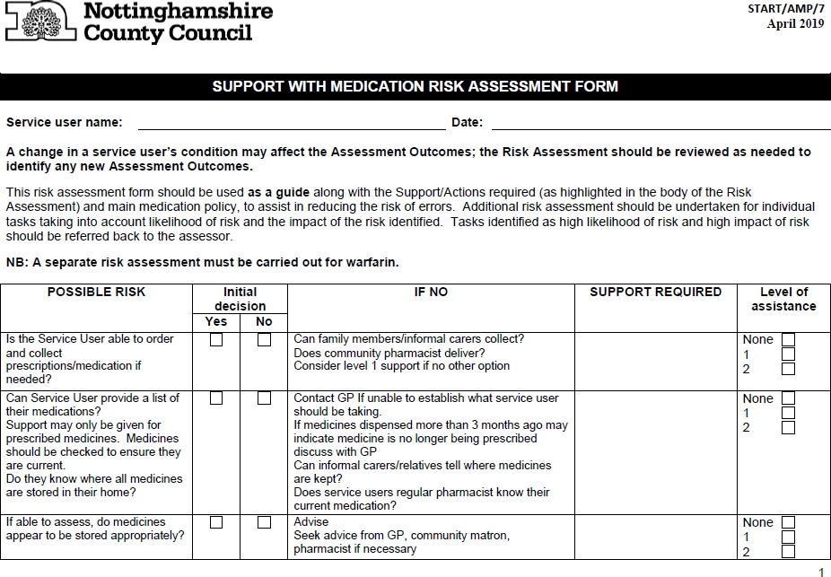
APPENDIX 1 – ASSESSMENT FORM

Page | 34 Version: 2.0
Further information www.nottinghamshire.gov.uk Date: May 2014

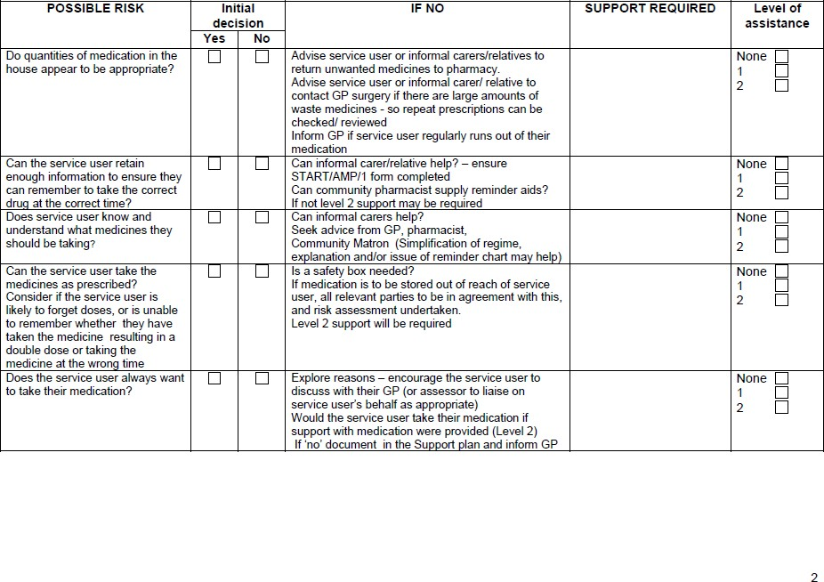

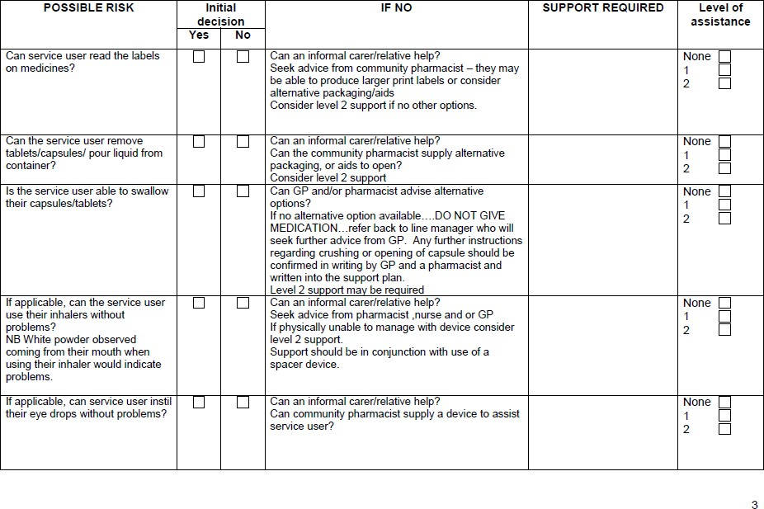

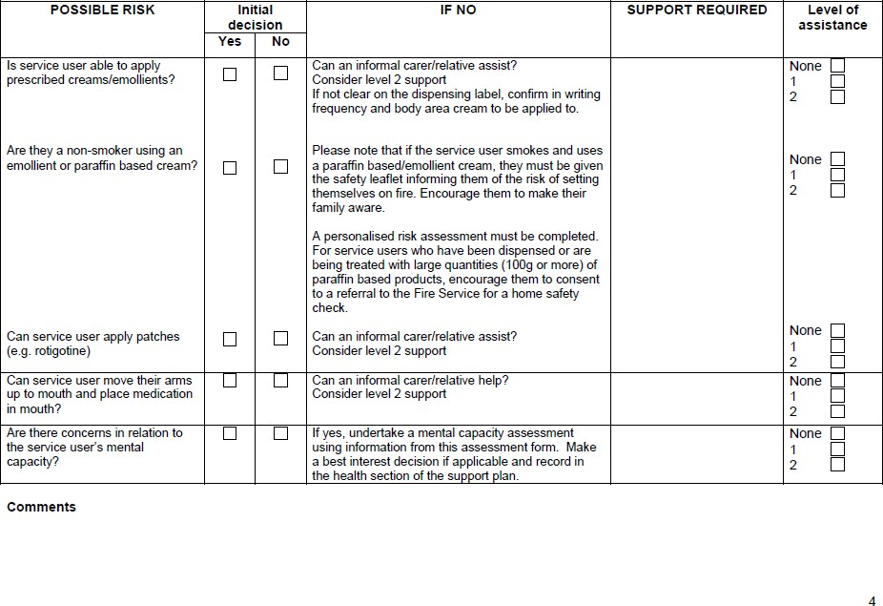

SUPPORT WITH MEDICATION RISK ASSESSMENT FORM

The aim is to promote independence with medicines wherever possible. Informal carers/relatives should be encouraged to help if able to. Always aim to consider the lowest level of support possible to promote Service User independence balancing with lowest possible risk.

ASSESSMENT OUTCOME

Nottinghamshire County Council’s supporting with medication policy in a service user’s home identifies two different levels of supporting with medication. Once staff have received induction training they will be able to undertake tasks identified as Level One support. Only staff that have undergone appropriate training and have been deemed competent will be able to support with Level Two tasks.

If level of assistance is NONE then support from START workers to remind, assist and administer medications is not needed and the service user is deemed self-medicating for all their medication. Hence no further support needed from START staff.

As long as the service user’s condition remains the same, the service user’s ability to self-medicate should remain the same.
If the service user’s ability to self-medicate changes re-assess using the Support with Medication Risk Assessment form (START/AMP/7)

Staff should always assess to the HIGHEST level. If you have any serious concerns discuss with a Re-ablement Manager or on-call manager, you may also wish to DIAL 111 for ADVICE from the ON-CALL GP SERVICE.

Level 1 tasks

Collect prescriptions from surgery or medicines from the pharmacy when there is no alternative means of collection. Make sure medicines are stored safely and securely in the service users own home.
Note and record any change in the service user’s ability to manage their medication, notifying line manager if any concerns.

Level 2 tasks

Take tablets/capsules out of pharmacy labelled containers.
Shake bottles of liquid medicines and remove the bottle cap so that the service user can take the required dose. Pour liquid into measuring cups, spoons.
Mix soluble medicines.
Insert an eye drop bottle into a compliance aid so that the service user can self-administer their eye drops - prescribed eye drops only. Administer eye drops/ointment where the service user requires artificial tears or long term eye drops.

Apply creams and ointments only where the skin is not broken or inflamed (unless documented as the reason for application) which have been prescribed by a doctor or a non-medical prescriber
Remove and apply patches
Can assist with the use of inhaler devices by passing the device to service user, inserting a capsule into a device and where necessary press down the aerosol canister when the inhaler is used in conjunction with a spacer device
Can help to put on compression stocking provided they have been prescribed by a doctor or non-medical prescriber and a shared care agreement is in place with community nursing staff.
See medication policy for additional tasks

Nottinghamshire County Council supporting with medication policy must be followed.

ALL MEDICATION MUST BE IN THEIR ORIGINAL LABELLED CONTAINERS, MUST HAVE SERVICE USERS NAME ON, MUST HAVE INSTRUCTIONS ON AND MUST BE IN DATE.

March 2014
April 2019 amendment - addition of Remove and apply patches for parkinsons disease under Level 2 tasks

APPENDIX 2 – MAR CHART

Medication Log - see notes on how to complete overleaf |  |  |  |  |  |  |  |  |  |  | Prepared by: |  |  |  |  |  |  | Date: |  |  |  |  | Checked by: |  |  |  |  |  |  |  | Date:
Name |  |  | Address |  |  |  |  |  |  |  |  |  |  |  |  |  |  |  | RO = Remind & Observe |  |  |  |  |  |  | R = Remind
Month/Year |  |  | D.O.B |  |  |  |  |  |  |  |  |  |  |  |  |  |  |  | A= Assisted, Applied, Administer |  |  |  |  |  |  | PO = Prepare & Observe
GP Details |  |  | GP. Tel |  |  |  |  |  |  | Allergies |  |  |  |  |  |  |  |  | O = Other Please Log |  |  |  |  |  |  | X = Refused please log
Medication Label |  | Time | Dose | 1 | 2 | 3 | 4 | 5 | 6 | 7 | 8 | 9 | 10 | 11 | 12 | 13 | 14 | 15 | 16 | 17 | 18 | 19 | 20 | 21 | 22 | 23 | 24 | 25 | 26 | 27 | 28 | 29 | 30 | 31
 |  | Breakfast
 |  | remaining
 |  | Lunch
 |  | remaining
 |  | Tea
 |  | remaining
 |  | Bedtime
S t a rt D a t e : | E nd D a t e : | remaining
Signed in by |  | Qty: Carried forward: |  |  |  |  |  |  |  |  |  |  |  |  |  |  |  |  | Total:
Medication Label |  | Time | Dose | 1 | 2 | 3 | 4 | 5 | 6 | 7 | 8 | 9 | 10 | 11 | 12 | 13 | 14 | 15 | 16 | 17 | 18 | 19 | 20 | 21 | 22 | 23 | 24 | 25 | 26 | 27 | 28 | 29 | 30 | 31
 |  | Breakfast
 |  | remaining
 |  | Lunch
 |  | remaining
 |  | Tea
 |  | remaining
 |  | Bedtime
S t a rt D a t e : | E nd D a t e : | remaining
Signed in by |  | Qty: Carried forward: |  |  |  |  |  |  |  |  |  |  |  |  |  |  |  |  | Total:
Medication Label |  | Time | Dose | 1 | 2 | 3 | 4 | 5 | 6 | 7 | 8 | 9 | 10 | 11 | 12 | 13 | 14 | 15 | 16 | 17 | 18 | 19 | 20 | 21 | 22 | 23 | 24 | 25 | 26 | 27 | 28 | 29 | 30 | 31
 |  | Breakfast
 |  | remaining
 |  | Lunch
 |  | remaining
 |  | Tea
 |  | remaining
 |  | Bedtime
S t a rt D a t e : | E nd D a t e : | remaining
Signed in by |  | Qty: Carried forward: |  |  |  |  |  |  |  |  |  |  |  |  |  |  |  |  | Total:

RSW MEDICATION NOTES f f f
DATE | TIME | Initials | REASON FOR O CODE  e.q.variable dose | DOSE | REASON |  |  |  |  | ACTION/ | OUTCOMES
01/11/1974 | 6pm | LR | Refusal of Lactulose | 10ml | Fred has diarrhoea |  |  |  |  | Medicat ion not aiven on this occasion
 |  |  |  |  |  | I
 |  |  |  |  | I |  | I | I
 |  |  |  |  | I |  | I | I
 |  |  |  |  | I |  | I | I
 |  |  |  |  | I |  | I | I
 |  |  |  |  | I |  | I | I
 |  |  |  |  | I |  | I | I
Please ensure you sign medication on the correct date of the month, insert code and your signature Ensure medication label details match those of the medication container label
EVERY time you support with a Service User's medication, REMEMBER to:-

- Wash your hands
- CHECK that you have the RIGHT Service User
- CHECK that you have the RIGHT Service User"s name on the medication, either packets/bottles/creams etc, or CHECK that the RIGHT Service Users's name is on the blister pack
- CHECK you have the RIGHT day/time and CHECK that the Service User has NOT already taken the medication
(Verbally by asking the Service User, by reading the Mar Chart, counting the tablets (if a blister pack is in place, by CHECKING the blister pack)
- CHECK you have the RIGHT dose of the medication if it is in packets/bottles/creams etc, if the medication is in a blister pack CHECK that the medication has not been tampered with
- Support Service User with medication as prescribed in Support Plan
- Sign Mar Chart
- Report any concerns' incidents to your manager

HOSIERY

Working in Partnership Agreement
Nottinghamshire Community Nursing Service and Nottinghamshire County Council’s department for Adult Social Care, Health and Public Protection

Criteria for assistance

START staff (Short Term Assessment and Re-ablement Team) will only assist with the application of compression hosiery where the patient / service user has been correctly assessed for the hosiery this should include a Doppler assessment:

Patients with arterial disease must be distinguished from those with venous disease as management differs.
Compression hosiery should be avoided in patients with arterial disease as it may cause necrosis and further ulceration
Compression hosiery should be used with caution in those with diabetes mellitus or rheumatoid arthritis as these patients are susceptible to small vessel disease.

Objectives

Define responsibilities expected of the community nursing service. Define responsibilities expected of the START staff.
Define circumstances when START staff will be able to assist.

Responsibilities of Community Nursing Staff

Assessment of the patient / service user to confirm compression hosiery is required for either post leg ulcer healing or where the use of graduated hosiery is beneficial in the management of leg oedema
Completion of form “Request for assistance with application of compression hosiery” and ensuring the START staff are in receipt of the form and agree to assist in each individual case
Arrangement for the supply of compression hosiery to the patient / service user Where necessary make arrangements for the GP to prescribe required creams. Provision of compression hosiery information leaflet to the START staff
Six monthly review of patients and the reissue of compression hosiery

Responsibilities of START staff

Observing for any change in skin and reporting back to the community nursing team, Ashfield & Mansfield and Newark & Sherwood CCGs contact telephone number is 0300 024 1111
Rushcliffe, Nottingham West and North & Nottingham East CCGs (Broxtowe, Gedling & Rushcliffe) telephone number is 0115 9287716
Bassetlaw telephone number is 01777 274422
Reporting any concerns regarding the compression hosiery (including fit) to the above number
Following instructions provided on the compression hosiery information leaflet supplied by the community nursing service

Page | 42 Version: 2.0
Further information www.nottinghamshire.gov.uk Date: May 2014

Only re-ablement support workers who have completed the assistance with medication training enabling them to undertake level two tasks will be able to assist with the application of compression hosiery.

Ideally service users should have their compression hosiery removed daily at night time, their legs washed and cream applied, the following morning their hosiery reapplied.

It is recognised some service users may only require twice weekly visits for assistance with personal care for these service users the START staff can only assist with hosiery on these scheduled visits. In these circumstances service users should have their compression hosiery removed and their legs washed with cream and the compression hosiery reapplied on each scheduled twice weekly visit.

April 2010

APPENDIX 4 – WARFARIN RISK ASSESSMENT ALGORITHM (March 2014)
Service user (SU) able to self- medicate and has capacity to understand communication re warfarin doses
Yes
No START support required, but should be documented on MAR chart, support plan, that service user self-medicating Warfarin.

Could the service user take the correct amount of tablets if a relative rings to remind SU to take their medication?
No
Yes
No
Relative needs to make arrangements for communication to be notified direct to themselves regarding dose changes. No support required by START staff but should be documented that SU self- medicating their warfarin on the MAR chart and also in the support plan that relative assisting and responsible for dose communication.

START services (and all other independent providers) must undertake a risk assessment to see if the service can safely support assisting with warfarin administration.

The risk assessment should be carried out by the re-ablement manager in conjunction with community nursing service and the service user’s GP. The following should be considered in the risk assessment:
  - Ability to be able to receive and acceptance of responsibility for receiving communication direct from the clinic that is responsible for making warfarin dose adjustments (currently either GP or hospital anticoagulation clinic)
  - Ability to receive urgent dose adjustments out of office hours (early evening).
  - Being able to ensure that written confirmation of anticoagulation dose is attached to the MAR chart. Plus instruction on the MAR chart that warfarin is to be given in line with attached instruction.
  - Ensuring that assistance with warfarin only occurs from an original labelled container from the pharmacy or dispensing doctor
  - Ensuring agreement with relatives that START will take full responsibility including being the main contact for dose changes for warfarin administration- relatives must sign to say they agree to this.
  - Checking of who takes blood sample for INR test Community nurse, or GP practice?
    - Consider whether START can be informed when the service user has a INR test.
    - If this is not possible need to consider whether risks can be minimised to provide safe support.
  - Ensuring the hospital anticoagulation clinic and or GP practice are informed of specific arrangements as appropriate.
  - Ensuring re-ablement manager is aware of which SUs are receiving support with warfarin.
  - Consideration of alternative medication being prescribed by GP
  - Additional considerations should be history of irregular INR results, previous dosing errors with warfarin, labelling support from community pharmacists.
Prior to assisting with warfarin at each administration time the following should be checked:
- Check the dose required for that day on the attached instructions.
- Check when the next INR test is due, if that test date has already gone then there may be a more up to date test sheet available (check with line manager for further action).
- Check that relatives have signed to state they are NOT supporting with warfarin administration.

APPENDIX 5 – GUIDANCE ON ASSESSING CAPACITY AND RISK ASSESSMENTS

GUIDANCE NOTES

Capacity and Consent

“The professional who prescribed the medication has responsibility to assess that either the person has capacity to consent to treatment with medication at the point of prescribing, or, if the person lacks capacity, that it is in their best interests to take the medication

The staff member who undertakes an assessment of the service user’s ability to manage their medication will then have a separate responsibility to ensure the person has capacity to consent to assistance, or, if the person lacks capacity, that it is in their best interests to have this assistance”

Care Quality Commission (The Mental Capacity Act 2005 – Guidance for providers) extracts:
“As a service provider, you assess people’s capacity to make decisions as part of their normal assessment and care planning arrangements.
A person’s capacity to make decisions can be affected by many factors. Some have long-term or permanent effects, others have only a short-term effect and some will be intermittent”

“Having an illness such as Alzheimer’s disease, mental health difficulties, or a learning disability does not necessarily mean that a person lacks capacity to make all decisions.
A person may have the capacity to choose what to have for lunch or what to wear, but not whether to take vital medication. Capacity can vary over time, even over the course of a day”

The code of practice does not require care services and workers to undertake formal, recorded assessments for minor day to day decisions about giving routine care but there needs to be evidence of overall consideration of capacity- especially maximising capacity- in the support plan.

START
The staff member undertaking the first visit will need to exercise judgement as to whether an individual situation is significant enough to need a formal, written assessment of capacity. Staff will need to remind themselves of the five key principles of the Mental Capacity Act in line with their previous training.

Procedure for Staff carrying out First Visits and START Support Planning
Where assistance with medication is identified as a necessary task, documentation needs to be completed in line with the Medication Policy including the Support with Medication Risk Assessment (START/AMP/7) (Appendix 1)

Where staff have serious concerns with regard to the Service User’s ability to consent to this assistance then the following action should be taken.

A mental capacity risk assessment must be undertaken by the peri re-ablement support worker or re-ablement manager.
Concerns should be recorded in the health section of the START Support Plan clearly identifying what the concerns are
The information on which the concerns are based
The action taken (i.e. situation checked with GP, family etc., referral for further assessment)
Instructions and guidance for staff to follow

It is vital that service users continue to take vital medicines therefore staff should provide the necessary assistance, clearly following the requirements of the medication policy pending the further assessment.

Procedure for START staff delivering support

The START Support Plan should be clearly followed
Assistance identified should be provided in accordance with the Medication Training and competency level
Where a member of staff becomes concerned at the service user’s capacity to consent then START staff should alert their line manager immediately (or on-call person) to arrange for a re-ablement manager or peri-re-ablement support worker to undertake a mental capacity assessment and best interest’s decision on the service user.

It is vital that service users continue to take their medicines therefore staff should provide the necessary assistance, clearly following the requirements of the medication policy pending the further assessment.

APPENDIX 6 – GP PRACTICE DETAILS
Practice | Lead GP | Tel No. | Practice Manager
Abbey Medical Centre 63 Central Avenue Beeston  Nottingham NG9 2QP | Dr N Browne | 0115 9255323 | Debs Smith
Acorn Medical Practice 11-13 Wood Street Mansfield Nottinghamshire  NG18 1QA | Dr A Rahman | 01623 428412 | Alison Bailey
Ashfield House Surgery 194 Forest Road Annesley Woodhouse Nottinghamshire  NG17 9JB | Dr G Place | 01623 752295 | Mrs D Partlow
Kings Medical Centre  King Street Sutton in Ashfield Nottinghamshire  NG17 1AT | Dr Chakraborty | 01623 559992 | Louise New
Balderton Surgery  Balderton Primary Care Centre Lowfield Lane  Balderton, Newark Nottinghamshire NG24 3HJ | Dr Kerri Sallis | 01636 705826 | Frances Chater
Barnby Gate Surgery 50 Barnby Gate Newark Nottinghamshire NG24 1QD | Dr Julie Barker | 01636 704225 | Sally Dixon
Bawtry & Blyth Medical Bawtry Health Centre Station Road  Bawtry Doncaster DN10 6RQ  Blyth Surgery 1 High Street Blyth  Worksop  S81 8EQ | Dr A Perkins | 01302 710210  01909 591254 | Daniel Blakey

Belvoir Health Group Cropwell Bishop Surgery Fern Road  Cropwell Bishop Nottinghamshire NG12 3BU  Bingham Surgery Newgate Street Bingham Nottinghamshire NG13 8FD  Cotgrave Surgery Candleby Lane Cotgrave Nottingham  NG12 3JG | Dr R Britton  Dr M Lowden  Dr M Lewis | 0115 8969991  then press 1  0115 8969991  then press 3  0115 8969991  then press 2 | Jon Hermon
Bilsthorpe Surgery 35 Mickledale Lane Bilsthorpe  Newark Nottinghamshire  NG22 8QB | Dr Robinson | 01623 870230 | Lynn Alsop
Abbey Medical Group Blidworth Surgery  59 Mansfield Road Blidworth Nottinghamshire NG21 0RB  Ravenshead Surgery 30 Longdale Avenue Ravenshead Nottinghamshire  NG15 9EA | Dr M Dalton | 01623 795461 | Rick Gooch
Bramcote Surgery 2a Hanley Avenue Bramcote Nottingham  NG9 3HF | Dr E Jordan | 0115 9224960 | Pam Husband
Brierley Park Medical Centre  127 Sutton Road Huthwaite Nottinghamshire  NG17 2NF | Dr H Lovelock | 01623 550254 | Liz Griffin
Bull Farm Surgery  Bull Farm Health & Social Care Centre  Concorde Way, Millennium Business Park  Mansfield Nottinghamshire  NG19 7JZ | Dr S Patel | 01623 621059 | Denise Mcphee

Calverton Practice 2a St. Wilfrids Square Calverton Nottinghamshire NG14 6FP | Dr P Rayner | 0115 9657801 | Bridget Hall
Castle Health Care 50-60 Wilford Lane West Bridgford Nottingham  NG2 7SD | Dr J Ashton | 0115 8832626 | Susan Green
Chilwell Valley & Meadows Medical Practice  Valley Surgery 81 Bramcote Lane Chilwell Nottingham  NG9 4ET  Chilwell Meadows Surgery  Ranson road Chilwell Nottingham  NG9 6DX | Dr T Avery  Dr R Churchill | 0115 9430530  0115 9462767 | Linda Allum
Churchside Medical Practice  Wood Street Mansfield Nottinghamshire  NG18 1QB | Dr V Pearce | 01623 664877 | Sharon Atherton
Collingham Medical Centre  High Street Collingham, Newark Nottinghamshire NG23 7LB | Dr K Fearn | 01636 892156 | Julie Reid
Crown House Surgery Retford Primary Care Centre Retford Hospital  North Road Retford  DN22 7XF | Dr J Roberts | 01777 703672 | Jessica Cliff
Daybrook Medical Practice  Salop Street Daybrook  Nottingham NG5 6HP | Dr G Gallagher | 0115 9267628 | Debi Rattray
East Bridgford Medical Centre  2 Butt Lane East Bridgford  Nottinghamshire NG13 8NY | Dr R Scaffardi | 01949 20216 | Andrew Whincup

East Leake Medical Group East Leake Health Centre Gotham Road  East Leake Leicestershire LE12 6JG  Church House Surgery  Shaw Street Ruddington Nottingham NG11 6HF  Sutton Bonington 45 Orchard Close Sutton Bonington Loughborough  Leicestershire LE12 5NF | Dr T Kelly | 01509 852181  0115 9847101  01509 672229 | Practice Manager of ELM Group: Nicky Grant  Surgery Manager: Angela Butchart  Surgery Manager: Hilary Jones
Eastwood Primary Care Centre Church Street Site  11b Church Street Eastwood Nottingham  NG16 3BS  Church Walk Site Church Walk Eastwood Nottingham  NG16 3BH | Lim K | 01773 304700 | Alison Rounce
Family Medical Centre 56A Low Moor Road Kirkby in Ashfield Nottinghamshire  NG17 7BG | Dr J Dar | 01623 757219 | Sue Jackson
Forest Medical  Oak Tree Lane Surgery Jubilee Way South Mansfield Nottinghamshire  NG18 3SF  Rosemary Street Health Centre  Mansfield Nottinghamshire NG19 6AB | Dr R Park | 01623 649991  01623 623600 | Nicola Ryan
Fountain Medical Centre Sherwood Avenue Newark  Nottinghamshire NG24 1QH | Dr M Jefford | 01636 704378 | Lisa Sandland-Taylor

Gamston Medical Centre Gamston District Centre Gamston  Nottingham  NG2 6PS | Dr L Kandola | 0115 9455946 | Kathryn West
Giltbrook Surgery 492 Nottingham Road Giltbrook  Nottingham  NG16 2GE | Dr J Ransford | 0115 9383191 | Julie Wright
Hama Medical Centre 11A Nottingham Road Kimberley  Nottingham NG16 2NB | Dr T Hama | 0115 9382101 | Julie Thurlby
Skegby Family Medical Centre  Mansfield Road Skegby Nottinghamshire  NG17 3EE | Dr R Hook | 01623 440144 | Nicole Keeling
Health Care Complex 52 Low Moor Road Kirkby in Ashfield Nottinghamshire  NG17 7BG | Dr P Oza | 01623 752312 | Mel Yorke
Kirkby Health Centre Low Moor Road Kirkby in Ashfield Nottinghamshire  NG17 7LG | Dr R Prabu | 01623 752454 | Tracy Dudley
Hickings Lane Medical Centre  120 Ryecroft Street Stapleford Nottingham  NG9 8PN | Dr J Doddy | 0115 9395555 | Tracey Colman
Highcroft Surgery Highcroft Medical Centre High Street  Arnold Nottingham NG5 7BQ | Dr J McKeating | 0115 8832330 | Emma Rowe
Hill View Surgery Kirklington Road Rainworth Nottinghamshire NG21 0JP | Dr I Jairam | 01623 795562 | Amanda Brown
Hounsfield Surgery Hounsfield Way Sutton on Trent Newark Nottinghamshire NG23 6PX | Dr K Moloney | 01636 821023 | Gillian Wainwright

Ivy Medical Group Lambley Lane Surgery 6 Lambley Lane Burton Joyce Nottinghamshire NG14 5BG  Apple Tree Surgery 4 Wheatsheaf Court Burton Joyce Nottinghamshire NG14 5EA  Lowdham Medical Centre  Franklin Road Lowdham Nottingham  NG14 7BG | Dr P Panesar | 0115 9312500  0115 9312929  0115 9664120 | Susanne Croll
Jacksdale Medical Centre  Main Road Jacksdale Nottinghamshire  NG16 5JW | Dr K Brown | 01773 608760 | Mel Lindley
Jubilee Practice Lowdham Medical Centre Francklin Road Lowdham Nottinghamshire  NG14 7BG | Dr C Hatton | 0115 9663633 | Rachel White
Keyworth Medical Practice Keyworth Primary Care Centre Bunny Lane  Keyworth Nottinghamshire NG12 5JU | Dr J Langridge | 0115 9373527 | Lindsey
Keyworth & Gotham Surgery Orchard Surgery  The Dragwell Kegworth Derbyshire DE74 2EL  Gotham Surgery Village Hall Surgery Nottingham Road Gotham Nottinghamshire  NG11 0HE | Dr Foster | 01509 674919  0115 9830011 | Sue Sharp
Kingfisher Family Practice Retford Primary Care Centre Retford Hospital  North Road Retford DN22 7XF | Dr A Weenink | 01777 702381 | Jackie Lockton

Kirkby Community Primary Care Centre  Portland Street Ashfield Health Village Kirkby in Ashfield Nottinghamshire NG17 7AE | Dr A Miah | 01623 434600 | Donna Revill
Larwood Health Partnership Larwood Surgery  56 Larwood Worksop S81 0HH  Village Surgery Long Lane Carlton-in Lindrick Worksop  S81 9AR  Lakeside Surgery Church Street Langold  Worksop S81 9NW  Oakleaf Surgery Harworth PCC Scrooby Road Harworth  DN11 8JT  Westwood Surgery Pelham Street Worksop  S80 2TR | Dr C Stanley | 01909 500233  01909 732933  01909 732933  01302 243230  01909 509010 | Sarah Dale
Linden Medical Group Stapleford Care Centre Church Street Stapleford Nottinghamshire  NG9 8DB | Dr S Adl | 0115 8752000 | Fares Msaiei
Lombard Medical Centre  2 Portland Street Newark Nottinghamshire  NG24 4XG | Dr D Wathen | 01636 702363 | Debbie Swain
Lowmoor Road Surgery  Low Moor Road Kirkby in Ashfield  Nottinghamshire NG17 7BG | Dr S Barish | 01623 759447 | Jane Wardle
Major Oak Medical Practice  High Street Edwinstowe Nottinghamshire  NG21 9QS | Dr W Mikhail | 01623 822303 | Jacquie Mikhail

Manor Surgery Middle Street Beeston Nottingham  NG9 1GA | Dr D Charles | 0115 9076960 | Adrian Taylor
Meden Medical Services  Church Street Warsop Mansfield Nottinghamshire  NG20 0BP | Dr S Allen | 01623 843521 | Jackie Jones
Middleton Lodge Practice  New Ollerton Newark Nottinghamshire NG22 9SZ | Dr W Effingham | 01623 703266 | Jonathan Cummins
Mill View Surgery 1A Goldsmith Street Mansfield Nottinghamshire NG18 5PF | Dr H Field | 01623 649528 | Kerry Dowson
Misterton Group Practice Misterton Surgery  Marsh Lane Misterton Doncaster DN10 4DL  Gringley Surgery Leys Lane Gringley on the Hill Doncaster  DN10 4QU | Dr N Ahmed | 01427 890206 | Clare Marfleet
Musters Medical Practice  50-60 Wilford Lane West Bridgford Nottingham  NG2 7SD | Dr Libby Smith | 0115 9814124 | Christine Jones
Newgate Medical Group  Health Centre Newgate Street Worksop  S80 1HP | Dr S Warner | 01909 500266 | Sheila Smith
Newthorpe Medical Centre  Harvest Road Eastwood Nottingham NG16 3HU | Dr S Bamford | 01773 535511
North Leverton Surgery  Sturton Road North Leverton Retford  DN22 0AB | Dr G Brownson | 01427 880223 | Jacqui Dickenson

Oakenhall Medical Practice  Bolsover Street Hucknall  Nottingham NG15 7UA | Dr N Gilmore | 0115 9633511 | Lisa Ellison
Oaks Medical Centre 20 Villa Street Beeston  Nottingham  NG9 2NY | Dr G Mansford | 0115 9254566 | Andrea Swanson
Oakwood Surgery Church Street Mansfield Woodhouse  Nottinghamshire NG19 8BL | Dr K Butt | 01623 435555 | Ros Reavill
OM Surgery  112 Watnall Road Hucknall Nottingham  NG15 7JP | Dr S Mohindra | 0115 9632184 | Reeta Mohindra
Orchard Medical Practice  Stockwell Gate Mansfield  Nottinghamshire NG18 5GG | Dr D Temple | 01623 400100 | Rebecca Tate
Park House Medical Centre  61 Burton Road Carlton Nottingham  NG4 3DQ | Dr I Campbell | 0115 9404333 | Michelle Turpin
Peacock Healthcare 428 Carlton Hill Nottingham  NG4 1HQ | Dr A Subramanian | 0115 9580415 | Michael Orozco
Plains View Surgery 57 Plains Road Mapperley Nottingham  NG3 5LB | Dr A Pillai | 0115 9621717 | Ann Pillai
Pleasley Surgery Chesterfield Road Pleasley Nottinghamshire  NG19 7PE | Dr S Patel | 01623 810249 | Denise Mcphee
Radcliffe on Trent Health Centre  Main Road Radcliffe on Trent Nottinghamshire  NG12 2GD | Dr R Patel | 0115 9333737 | Ken Johnson
Rainworth Surgery Warsop Lane Rainworth  Nottinghamshire NG21 0AD | Dr S Huggard | 01623 794293 | Leigh Nash

Riverbank Medical Services  Church Street Warsop Nottinghamshire NG20 0BP | Dr A Kaistha | 01623 844421 | Philippa Hutchinson
Riverside  Riverside Health Centre  Riverside Walk Retford  DN22 6FB  Riverside Harworth Harworth PCC Scrooby Road Harworth  DN11 8JT | Dr M Ho | 01777 713330  01302 741840 | Emma James
Roundwood Surgery Wood Street Surgery Wood Street Mansfield Nottinghamshire NG18 1QQ  Forest Town Surgery 47 Ellesmere Road Forest Town Mansfield  NG19 0EG | Dr S Cappin | 01623 648880 | Gillian Slack
Ruddington Medical Centre  Church Street Ruddington Nottingham  NG11 6HD | Dr J Rai | 0115 9211144 | Liz Yeatman
Sandy Lane Surgery 77 Sandy Lane Mansfield  Nottinghamshire NG18 2LT | Dr H Masud | 01623 656055 | Jill Towns
Saxon Cross Surgery Stapleford Care Centre Church Street Stapleford Nottinghamshire  NG9 8DA | Dr H O'Neil | 0115 939 2444 | Tony Oram
Selston Surgery  139 Nottingham Road Selston Nottinghamshire NG16 6BT | Dr S Bassi | 01773 810226 | Dawn Rose

Sherwood Medical Partnership Farnsfield Surgery  Station Lane Farnsfield, Newark Nottinghamshire NG22 8LA  Crown Medical Centre Crown Farm Way Forest Town  Mansfield NG19 0FW | Dr J Smith | 01623 882289  01623 626132 | Michelle Barksby
Southwell Medical Centre  The Ropewalk Southwell Nottinghamshire  NG25 0EW | Dr S Reeves | 01636 813561 | Nigel Kenward
St George's Medical Practice  93 Musters Road West Bridgford Nottingham  NG2 7PG | Dr M Jelpke | 0115 9143200 | Carol Wilson
St Peter's Medical Practice  Chaucer House Commercial Street Mansfield Nottinghamshire  NG18 1EE | Dr R Sharma | 01623 422355 | Sandra Chatwin
Stenhouse Medical Centre  66 Furlong Street Arnold Nottingham  NG5 7BP | Dr A Cockburn | 0115 9673777 | Martin Rowlatt
Torkard Hill Medical Centre  Farleys Lane Hucknall Nottingham  NG15 6DY | Dr M Dalton | 0115 9633676 | Joanne Hicken
Trentside Medical Group Netherfield Medical Centre 2a Forester Street Netherfield  Nottingham NG4 2NJ | Dr C Kennedy | 0115 9614583 | Vicky Wall
Tuxford Medical Centre  Faraday Avenue Tuxford  Newark NG22 0HT | Dr C Shearstone- Walker | 01777 870203 | Oliver Lord
Unity Surgery  318 Westdale Lane Mapperley Nottingham  NG3 6EU | Dr A Khan | 0115 9877604 | Ruth Cutler

West Bridgford Medical Centre  97 Musters Road West Bridgford Nottingham  NG2 7PX | Dr D Ottey | 0115 8837380 | Trevor Woolley
West Oak Surgery 319 Westdale Lane Mapperley Nottingham  NG3 6EW | Dr M Karpha | 0115 9525320 | Alisa White
Westdale Lane Surgery 20-22 Westdale Lane Gedling  Nottingham  NG4 3JA | Dr U Khaliq | 0115 9613968 | Paula Watts
Whyburn Medical Practice  The Health Centre Curtis Street Hucknall Nottingham  NG15 7JE | Dr A Ndirika | 0115 8832150 | Sarah Fines (Reception Manager)
Willowbrook Medical Practice  Brook Street Sutton in Ashfield Nottinghamshire  NG17 1ES | Dr J Jenkins | 01623 440018 | Dr M Islam
Woodlands Medical Practice  Bluebell Wood Way Sutton in Ashfield  Nottinghamshire NG17 1JW | Dr N Pound | 01623 528748 | Patricia Brown

APPENDIX 7 – COMMUNITY PHARMACY DETAILS
Name of Pharmacy | Address | Tel No. | Core Hours
Abbey Pharmacy | 63 Central Avenue Beeston Nottingham  NG9 2QP | 0115  9254522 | Mon-Wed: 8.30am-6.30pm Thu: 8.30am-1pm  Fri: 8.30am-6.30pm
Acorn Pharmacy | 8-10 Main Road Jacksdale Nottinghamshire  NG16 5JW | 01773  602759 | Mon-Fri: 9am-6pm Sat: 9am-2pm
Asda Pharmacy | 111-127 Front Street Arnold  Nottinghamshire NG5 7ED | 0115  9649110 | Mon- Fri: 7am-11pm Sat: 7am-9pm  Sun: 10am-4pm
Asda Pharmacy | 184 Loughborough Road West Bridgford Nottingham  NG2 7JA | 0115  9694210 | Mon-Sat: 8am–10pm Sun: 10am-4pm
Asda Pharmacy | Lombard Street Newark Nottinghamshire NG24 1XG | 01132  152531 | Mon: 8am-11pm Tue-Fri: 7am-11pm Sat: 7am-10pm Sun: 10am-4pm
Asda Pharmacy | Old Mill Lane  Forest Town, Mansfield Nottinghamshire  NG19 8QT | 01623  676710 | Mon: 8am-11pm Tue-Fri: 7am-11pm Sat: 7am-10pm Sun:10am-4pm
Asda Pharmacy | Priestsic Road Sutton in Ashfield Nottinghamshire  NG17 2AH | 01623  516222 | Mon: 8am-11pm Tue-Fri: 7am-11pm Sat: 7am-10pm  Sun: 10am-4pm
Bingham Pharmacy | 23 Eaton Place Bingham Nottinghamshire  NG13 8BD | 01949  839978 | Mon - Fri: 9am–6pm Sat: 9am–2pm
Blidworth Pharmacy (Dudley Taylor Limited) | 57 Mansfield Road Blidworth Nottinghamshire NG21 0RB | 01623  792485 | Mon-Fri: 9am - 6pm Sat: 9am – 1pm
Boots UK Limited | Northgate Retail Park Newark  Nottinghamshire NG24 1GA | 01636  605405 | Mon-Sat: 8.30am-midnight Sun: 10am-5pm
Boots UK Limited | 205 Nottingham Road Hill Top  Eastwood Nottingham NG16 3GS | 01773  713064 | Mon-Fri: 8.30am-6.30pm Sat: 9am-5pm
Boots UK Limited | 110-116 Nottingham Road Eastwood Nottinghamshire  NG16 3NP | 01773  713260 | Mon-Fri: 8.30am–6.30pm Sat: 8.30am–5.30pm Sun: 10am–4pm

Boots UK Limited | 14-15 Stodman Street Newark Nottinghamshire NG24 1AT | 01636  703489 | Mon-Sat: 8.30am-5.30pm Sun: 10am–4pm
Boots UK Limited | 14-16 Eaton Place Bingham Nottinghamshire NG13 8BD | 01949  837857 | Mon-Fri: 8.30am-6.30pm Sat: 8.30am–5.30pm
Boots UK Limited | 17-19 Kings Street Southwell Nottinghamshire NG25 0EH | 01636  813318 | Mon-Fri: 8am-Midnight Sun: 11am-3pm
Boots UK Limited | 24 Central Avenue West Bridgford Nottinghamshire NG2 5GR | 0115  9811015 | Mon-Fri: 8.30am-6pm Sat: 8.30am-5.30pm Sun: 10am-4pm
Boots UK Limited | 31 High Road Beeston Nottingham NG9 2JQ | 0115  9255602 | Mon-Sat: 8.30am-5.30pm Sun: 10.30am-4.30pm
Boots UK Limited | 35 Idlewells Shopping Centre Sutton in Ashfield Nottinghamshire  NG17 1BN | 01623  554094 | Mon, Thu & Sat: 8.30am- 5.30pm  Fri: 8.45am-5.30pm
Boots UK Limited | 39 Four Seasons Shopping Centre  Mansfield Nottinghamshire NG18 1SU | 01623  623089 | Mon-Sat: 8.30am-5.30pm Sun: 10am-4pm
Boots UK Limited | 41 Forest Road New Ollerton Nottinghamshire NG22 9PR | 01623  860256 | Mon-Fri: 9am-6pm Sat: 9am-5pm
Boots UK Limited | 48 Lowmoor Road Kirkby in Ashfield  Nottinghamshire NG17 7BG | 01623  753616 | Mon-Fri: 8.30am-6pm Sat: 8.30am-5.30pm
Boots UK Limited | 52-54 High Street Hucknall Nottingham  NG15 7AX | 0115  9633505 | Mon-Sat: 8.30am-5.30pm
Boots UK Limited | 55 High Street Hucknall Nottingham  NG15 7AW | 0115  9632434 | Mon-Fri: 9am-6pm Sat: 9am-5pm
Boots UK Limited | 85 Front Street Arnold Nottingham  NG5 7EB | 0115  9262397 | Mon-Sat: 8.30am-5.30pm Sun:10am-4pm

Boots UK Limited | 944 Woodborough Road Mapperley  Nottingham NG3 5QS | 0115  9623564 | Mon-Sat: 8.30am-5.30pm
Boots UK Limited | Curtis Street Health Centre Curtis Street  Hucknall Nottingham NG15 7JE | 0115  9633387 | Mon-Fri: 8am-5pm
Boots UK Limited | Giltbrook Retail Park Ikea Way  Giltbrook Nottinghamshire NG16 2RP | 0115  9386050 | Mon-Sat: 8am-8pm Sun: 11am-5pm
Boots UK Limited | 80 Main Road Nether Langwith Mansfield  Nottinghamshire NG20 9BH | 01623  742486 | Mon-Fri: 9am-5.30pm Sat: 9am-12pm
Boots UK Limited | 164 Bramcote Lane Bramcote Nottingham  NG8 2QP | 0115  9281048 | Mon-Fri: 8am-6.30pm Sat: 9am-5pm
Boots UK Limited | St Peters Retail Park Mansfield  Nottinghamshire NG18 1BE | 01623  653926 | Mon-Sat: 8am-midnight Sun: 10.30am-4.30pm
Boots UK Limited | Victoria Retail Park Netherfield Nottingham  NG4 2PE | 0115  9878943 | Mon-Fri: 9am-8pm Sat: 9am-7pm Sun: 10.30-4.30pm
Boots UK Limited | Larwood Health Centres 56 Larwood Avenue Worksop  S81 0HH | 01909  500292 | Mon-Thurs: 8am-8pm Fri: 8am-6.30pm  Sat: 9am-12.30pm
Boots UK Limited | 24-26 Bridge Street Worksop  S80 1JQ | 01909  472144 | Mon-Sat 8.30am-5.30pm
Boots UK Limited | 46-48 Carolgate Retford  DN22 6DY | 01777  703812 | Mon-Sat 8.30am-5.30pm
Boots UK Limited | 107 Harworth Health Centre Doncaster  DN11 8JT | 01302  742331 | Mon-Fri: 8.30am-6.30pm Sat: 9am-1pm
Boots UK Limited | 49 Main Street Burton Joyce Nottingham  NG14 5DX | 0115  9312096 | Mon, Tue, Wed & Fri: 8.30am- 6.30pm  Thu: 8.30am-5.30pm Sat: 9am-1pm

Boots UK Limited | 45b Green Lane Kimberley Nottingham  NG16 2PB | 0115  9262397 | Mon-Fri: 8am-7pm Sat: 9am-5pm
Boots UK Limited | 3-5 St Wilfrids Square Calverton  Nottingham NG14 6FP | 0115  9652377 | Mon-Fri: 8.30am-6.30pm Sat: 9am-5pm
Boots UK Limited | 19 Carlton Square Carlton Nottingham  NG4 3BP | 0115  9870480 | Mon-Fri: 8.30-6pm Sat: 9am-5pm
Boots UK Limited | Manor Surgery Middle Street Beeston  NG9 1GA | 0115  9228291 | Mon: 8am-8pm Tues: 7am-6.30pm  Wed & Thu: 8am-6.30pm Fri: 7am-6.30pm
Boots UK Limited | 2 Church Street Stapleford Nottingham  NG9 8GA | 0115  9391589 | Mon-Fri: 8.45am-6pm Sat:9am-5pm
Boots Midnight Pharmacy | North Road Retford  DN22 7XF | 01777  708277 | Mon-Fri 8am-midnight Sat 8am-10pm  Sun 10am-4pm
Bridgegate Chemist | 54 Bridgegate Retford  DN22 7UZ | 01777  703299 | Mon-Fri 8am-7pm Sat 8am-4pm
Brinsley Pharmacy | 1 Brynsmoor Road Brinsley Nottinghamshire  NG16 5DD | 01773  714150 | Mon-Fri: 9am-6pm Sat: 9am-12pm
Brisco's Chemists | 1-3 Kingsway Kirkby in Ashfield Nottinghamshire  NG17 7BB | 01623  753242 | Mon-Fri: 9am-5pm
Carlton Hill Pharmacy | 359 Carlton Hill Carlton Nottingham  NG4 1HW | 0115  9873660 | Mon, Tue, Wed & Fri: 9am- 6.30pm  Thurs: 9am-1pm Sat: 9am-5.30pm
Celtic Point Pharmacy | 6 Celtic Point Worksop  S81 7AZ | 01909  482566 | Mon-Fri 9am-6pm Sat 9am-1pm
Collingham Pharmacy | High Street Collingham Nr Newark Nottinghamshire  NG23 7LB | 01636  893038 | Mon: 8.45am-1pm & 2pm- 6.30pm  Tue-Fri: 8.45-1pm & 2pm-6pm Sat: 9am-12.30pm
Dudley Taylor Limited | 25 High Street Edwinstowe Nottinghamshire  NG21 9QP | 01623  822207 | Mon-Fri: 9am-6pm Sat: 9am-1pm
Dudley Taylor Limited | Doncaster Road Langold  S81 9QG | 01909  730300 | Mon-Weds & Fri 8.45am-1pm & 2pm-6.15pm  Thurs & Sat 8.45am-1pm

Dudley Taylor Limited | 3 The Arcade Long Lane Carlton-in-Lindrick  S81 9AN | 01909  730340 | Mon-Fri 8.45am-1pm & 2pm- 6.30pm
Edwalton Pharmacy | 40 Earlswood Drive Edwalton Nottingham  NG12 4AZ | 0115  9452657 | Mon-Fri: 9am-6pm Sat: 9am-1pm
Evans Pharmacy | 33 Kirkgate Newark  Nottinghamshire NG24 1AD | 01636  703722 | Mon-Fri: 9am-5.30pm Sat: 9am-5pm
Evans Pharmacy | 12-14 Gotham Lane East Leake Leicestershire  LE12 6JG | 01509  852810 | Mon-Fri: 8.30am-6.30pm Sat: 9am-12pm
Evans Pharmacy | 12 High Street Ruddington  Nottinghamshire NG11 6EH | 0115  9211086 | Mon-Fri: 8.30am-6pm Sat: 9am-1pm
Evans Pharmacy | 48a Barnby Gate Newark Nottinghamshire  NG24 1QD | 01636  701824 | Mon-Fri: 9am-1pm & 1.30pm- 6pm  Sat: 9am-12pm
Farnsfield Pharmacy | The Old Surgery Station Lane Farnsfield Nottinghamshire  NG22 8LA | 01623  882310 | Mon-Fri: 9am-6pm Sat: 9am-1pm
Gilbody Pharmacy | Mansfield Road  Skegby, Sutton in Ashfield Nottinghamshire  NG17 3EE | 01623  552383 | Mon-Fri: 8am-7pm Sat: 9am-1pm
Green Cross Pharmacy | 95 Musters Road West Bridgford Nottingham  NG2 7PX | 0115  9816604 | Mon, Weds, Thurs & Fri: 8.30am-6.30pm  Tues: 8.30am-7.30pm Sat: 9am-12.30pm
Grewal Pharmacy | 38-40 Chilwell Road Beeston Nottingham  NG9 1EJ | 0115  9253034 | Mon-Fri: 9am-7pm Sat:9am-4pm Sun: 11am-12pm
Harts Chemist | 106-110 Watnall Road Hucknall  Nottingham NG15 7JW | 0115  9637612 | Mon, Tues, Thurs & Fri: 9am- 6pm  Weds: 9am-5.30pm Sat: 9am-1pm
Imaan Pharmacy | 77 Eaton Avenue Newark  Nottinghamshire NG24 4JH | 01636  701274 | Mon-Fri: 9am-6pm  Sat: 9am-1pm

Jardines Chemist | Unit 9, Sainsburys Precinct Stoney Street  Beeston  Nottingham NG9 2LA | 0115  9430487 | Mon, Tues, Weds & Fri: 8.45am- 6.30pm  Thurs: 8.45am-5.30pm Sat: 9am-2pm
Jhoots Pharmacy | Hicklings Lane Medical Centre Ryecroft Street  Stapleford Nottingham NG9 8PN | 0115  9397352 | Mon-Fri: 9am-6pm Thurs: 9am-2pm
Jhoots Pharmacy | 1 Robin Hood Walk Newark Nottinghamshire  NG24 1XH | 01636  703709 | Mon-Fri: 8am-6.30pm Sat: 9am-5.30pm
Keyworth Pharmacy | 5 The Square Keyworth Nottingham  NG12 5JT | 0115  9377477 | Mon-Fri: 8.30am-6.30pm Sat: 9am-1pm
KMP Pharmacy | Keyworth Primary Care Centre Bunny Lane  Keyworth  NG12 5JU | 0115  9371536 | Mon-Sat: 8am-11pm Sun: 10am-8pm
Knights Pharmacy | 46 Church Street Bilsthorpe, Newark  Nottinghamshire NG22 8QR | 01623  870243 | Mon-Thurs: 8.30am-1pm & 2pm- 6pm  Fri: 9am-1pm & 2pm-6pm Sat: 9am-1pm
Ladybay Pharmacy | 145 Trent Boulevard West Bridgford Nottingham  NG2 5BX | 0115  9455412 | Mon-Fri: 9am-6pm Sat: 9am-12pm
Ladybrook Pharmacy | 18 Ladybrook Place Mansfield  NG18 5JP | 01623  626182 | Mon-Fri: 9am-5.30pm Sat: 9am-1pm
Lloyds Pharmacy | 12 High Street Mansfield Woodhouse Nottinghamshire  NG19 8AN | 01623  636391 | Mon-Fri: 9am-6.30pm Sat: 9am-5.30pm
Lloyds Pharmacy | 2-4 King Street Southwell Nottinghamshire  NG25 0EN | 01636  812241 | Mon-Fri: 8.30am-6pm Sat: 8.30am-5.30pm
Lloyds Pharmacy | 4 Sherwood Parade Kirklington Road Rainworth Nottinghamshire  NG21 0JP | 01623  797060 | Mon-Fri: 8.30am-6pm Sat: 9am-12pm
Lloyds Pharmacy (Sainsbury’s) | Nottingham Road Mansfield Nottinghamshire  NG18 1BN | 01623  421057 | Mon-Sat: 8am-10pm Sun: 10am-4pm

Lloyds Pharmacy | Unit 1, Farleys Lane Hucknall Nottingham  NG15 6DY | 0115  9632421 | Mon-Fri: 8.30am-6.45pm Sat: 9am-1pm
Lloyds Pharmacy | 6 Newgate Street Worksop  S80 2HD | 01909  472024 | Mon-Fri 8.30am-6.30pm Sat 9am-1pm
Lloyds Pharmacy (Sainsbury’s) | Sir Robinson Way Arnold Nottingham  NG5 6BN | 0115  9661166 | Mon-Sat: 8am-10pm Sun: 10am-4pm
Lowdham Pharmacy | 47-49 Main Street Lowdham Nottinghamshire NG14 7AB | 0115  9663228 | Mon-Fri: 9am-6pm Sat: 9am-1pm
Lowmoor Pharmacy | 58 Lowmoor Road Kirkby in Ashfield  Nottinghamshire NG17 7BG | 01623  756791 | Mon, Tue, Thu & Fri: 9am- 5.30pm  Wed: 9am-12pm
LP Pharmacy | Unit 3, Shopping Centre Compton Acres  West Bridgford Nottingham NG2 7RS | 0115  9455256 | Mon-Fri: 9am-6pm Sat: 9am-1pm
M & R Pharmacy | Unit B, 67 Scrooby Road Harworth  Doncaster DN11 8JN | 01302  744785 | Mon-Sat 7am-11pm Sun 9am-1pm
Mann's Pharmacy | 271 Westdale Lane Carlton  Nottingham NG4 4FG | 0115  9870491 | Mon-Fri: 9am-6.30pm
Mann's Pharmacy | 852a Woodborough Road Mapperley  Nottingham NG3 5QQ | 0115  9607826 | Mon, Wed, Thurs & Fri: 9am- 6.30pm  Tues: 9am-5.30pm
Mann's Pharmacy | 13-15 Portland Road Hucknall Nottingham  NG15 7SL | 0115  9638338 | Mon-Fri: 8.30am-1pm Mon, Tue, Thu & Fri: 2pm- 6.30pm  Wed: 2pm-5.30pm
Manor Pharmacy | 1 Milton Court Ravenshead Nottinghamshire  NG15 9BD | 01623  792584 | Mon-Fri: 8.45am-1pm & 1.30pm- 6pm  Sat: 9am-1pm
Manor Pharmacy | Arnold Health Centre High Street  Arnold Nottingham  NG5 7BQ | 0115  9266406 | Mon-Fri: 8.45am-6pm Sat: 9am-1pm

Manor Pharmacy | 185 Loughborough Road West Bridgford Nottinghamshire  NG2 7JR | 0115  9812257 | Mon-Fri: 9am-1pm & 1.30pm- 5.30pm
Manor Pharmacy | 1a Forrester Street Netherfield Nottingham  NG4 2LJ | 0115  9615987 | Mon-Fri: 9am-6pm Sat: 9am-12pm
Manor Pharmacy | 24 Chilwell Road Beeston Nottingham  NG9 1EJ | 0115  9255584 | Mon-Fri: 9am-1pm & 1.30- 5.30pm
Manor Pharmacy | 27 Greens Lane Kimberley Nottingham NG16 2PB | 0115  9383327 | Mon-Fri: 8.30am-1pm & 1.30- 6pm  Sat: 9am-1pm
Manor Pharmacy | 49 Brook Street Sutton in Ashfield Nottinghamshire  NG17 1ES | 01623  511303 | Mon-Fri: 8.45am-6pm Sat: 9am-12pm
Manor Pharmacy | 97a Melton Road West Bridgford Nottingham  NG2 6EN | 0115  9813229 | Mon-Fri: 9am-1pm & 1.30pm- 6pm
Manor Pharmacy | Blue Bell Wood Way Ashfield Park  Sutton in Ashfield Nottinghamshire NG17 1JW | 01623  553781 | Mon-Fri: 8.30am-1pm & 1.30pm- 6pm
Manor Pharmacy | Harwood Close Skegby Road Sutton in Ashfield Nottinghamshire NG17 4PD | 01623  555282 | Mon-Fri: 9am-1pm & 1.30pm- 6pm
Manor Pharmacy | Park House  61 Burton Road Carlton Nottingham NG4 3DQ | 0115  9401822 | Mon-Fri: 8.30am-1pm & 1.30pm-6.30pm
Mansfield Delivery Chemist  (Bahia Pharmacy) | 1 Wood Street Mansfield Nottinghamshire  NG18 1QB | 01623  625973 | Mon-Fri: 8.30am-6.30pm Sat: 9am-1pm
Manton Pharmacy | 1 Richmond Road Manton  Worksop S80 2TP | 01909  477772 | Mon-Fri: 830am-6.30pm Sat: 9am-1pm
Medina Chemist | 89 Victoria Road Netherfield Nottingham NG4 2NN | 0115  9875760 | Mon-Sat: 8am-11pm Sun: 10am-8pm

Misterton Pharmacy | The Retort House Marsh Lane Misterton Doncaster  DN10 4DL | 01427  892117 | Mon-Fri 8.30am-6.30pm
Morrisons Pharmacy | Lings Bar Road Gamston Nottingham  NG2 6PS | 0115  9818530 | Mon-Fri: 8.30am-8pm Sat: 8am-7pm  Sun: 10am-4pm
My Local Chemist | 50/60 Wilford Lane West Bridgford Nottingham  NG2 7RL | 0115  7140006 | Mon-Fri: 8am-10.30pm Sat & Sun: 8am-9.45pm
Nabbs Lane Pharmacy | 63 Nabbs Lane Hucknall Nottingham NG15 6NT | 0115  9641625 | Mon-Fri: 9am-6pm Sat: 9am-1pm
Nuthall Pharmacy | Unit 1, 2 Upminster Drive Nuthall  Nottingham NG16 1PT | 0115  9756504 | Mon-Fri: 9am-6pm Sat: 9am-12pm
Oakwood Pharmacy | 14 Church Street Mansfield Woodhouse  Nottinghamshire NG19 8AH | 01623  423670 | Mon-Sat: 7am-10.30pm Sun: 8.30am-3.30pm
Orchard Pharmacy | Orchard Medical Stockwell Gate Mansfield Nottinghamshire  NG18 5GG | 01623  656586 | Mon-Sat: 7am-11pm Sun: 10am-4pm
Ordsall Pharmacy | 1A Welbeck Road Ordsall  Retford DN22 7RP | 01777  869707 | Mon-Fri 9am-1pm & 2pm-6pm  Sat 9am-1pm
Oza Pharmacy Ltd | 50 Lowmoor Road Kirkby in Ashfield  Nottinghamshire NG17 7BG | 01623  750678 | Mon-Fri: 9am-6.30pm
Peak Pharmacy | 127 Sutton Road Huthwaite  Sutton in Ashfield Nottinghamshire NG17 2NF | 01623  554370 | Mon-Fri: 9am-1pm & 1.45pm- 6.30pm  Sat: 9am-12pm
Peak Pharmacy | Kings Medical Centre King Street  Sutton in Ashfield Nottinghamshire NG17 1AT | 01623  554017 | Mon-Fri: 8.30am-6pm Sat: 9am-1pm
Peak Pharmacy | 18 Westdale Lane Gedling Nottingham  NG4 3JA | 0115  9878602 | Mon-Fri: 9am-6pm  Mon-Fri: 9am-1pm & 1.30pm- 5.30pm

Peak Pharmacy | 40 Derby Road Stapleford Nottingham  NG9 7AA | 0115  9392125 | Mon-Fri: 9am-5.30pm
Peak Pharmacy | 40 Rosemary Street Mansfield  Nottinghamshire NG18 1QL | 01623  623785 | Mon-Fri: 9am-1.30pm & 2pm-6pm Sat: 9am-12pm
Peak Pharmacy | 35 Plains Road Mapperley  Nottingham NG3 5JU | 0115  9606125 | Mon-Fri: 9am-1pm & 1.30pm- 5.30pm  Sat: 9am-12pm
Peak Pharmacy | 93-97 Westgate Mansfield Nottinghamshire  NG18 1RT | 01623  645005 | Mon-Fri: 9am-6pm
Pleasley Pharmacy | 6 Poplar Drive Mansfield Nottinghamshire  NG19 7TA | 01623  811171 | Mon-Fri: 9am-1pm & 2pm-6pm Sat: 9am-1pm
Radcliffe Day & Night Pharmacy | 1 Shelford Road Radcliffe on Trent Nottinghamshire  NG12 2AE | 0115  9335220 | Mon-Fri: 7am-11pm Sat: 8am-10pm Sun: 11am-5pm
Rosemary Street Pharmacy | Rosemary Street Mansfield Nottinghamshire  NG19 6AB | 01623  622413 | Mon-Fri: 7.30am-10pm Sat: 8am-10pm  Sun: 8.30am-10pm
Rowlands Pharmacy | 112 Chesterfield Road North Mansfield  Nottinghamshire NG19 7HZ | 01623  621820 | Mon-Fri: 9am-1pm & 2pm-6 Sat: 9am-1pm
Rowlands Pharmacy | 123 Newgate Lane Mansfield Nottinghamshire  NG18 2LG | 01623  623304 | Mon, Tue, Thu & Fri: 9am-6pm Wed: 9am-5.30pm  Sat: 9am-1pm
Rowlands Pharmacy | 29a-29b Church Street Warsop  Nottinghamshire NG20 0AU | 01623  842432 | Mon-Fri: 9am-1pm & 2pm-6pm
Rowlands Pharmacy | 6 Sherwood Street Warsop Nottinghamshire  NG20 0JN | 01623  842430 | Mon-Fri: 9am-5.30pm Sat: 9am-5pm
Rowlands Pharmacy | Salop Street Daybrook Arnold Nottingham  NG5 6HP | 0115  9266697 | Mon-Fri: 9am-1pm & 1.20pm- 6.30pm

Rowlands Pharmacy | 36 High Street Mansfield Woodhouse Nottinghamshire  NG19 8AN | 01623  623511 | Mon, Tues, Thur & Fri: 9am-6pm Wed & Sat: 9am-5.30pm
Rowlands Pharmacy | Shop 3, Ossington Close Meden Vale Nottinghamshire  NG20 9PZ | 01623  846331 | Mon, Tues, Thur & Fri: 9am-6pm Wed: 9am-5pm
Sainsbury’s Pharmacy | Highground Farm Road Worksop  S80 3AT | 01909  487071 | Mon-Fri 7am-11pm Sat 7am-10pm Sun 10am-4pm
Singh S | Unit 6, Tudor Square West Bridgford Nottingham  NG2 6BT | 0115  9813048 | Mon-Fri: 9am-5.30pm Sat: 9am-12pm
Singhs Pharmacy | 77 High Street Arnold Nottingham  NG5 7DJ | 0115  9262208 | Mon-Fri: 9am-1pm & 2pm- 6.30pm
Superdrug Instore Pharmacy | 14-18 Stockwell Gate Mansfield Nottinghamshire  NG18 1LE | 01623  623315 | Mon-Fri: 8.30am-5.30pm Sat: 9am-5.30pm
Superdrug Instore Pharmacy | 36 Stodman Street Newark Nottinghamshire  NG24 1AW | 01636  610694 | Mon-Fri: 8.30am-5.30pm Sat: 9am-5.30pm
Superdrug Instore Pharmacy | 37 Idlewells Shopping Centre Sutton in Ashfield Nottinghamshire  NG17 1BP | 01623  557144 | Mon-Fri: 8.30am-5.30pm Sat:9am-5.30pm
Superdrug | 11-15 Carolgate Retford  DN22 6BZ | 01777  703505 | Mon-Fri: 8.30am-5.30pm Sat: 9am-5.30pm
Tesco Pharmacy | Gateford Road Worksop  S81 7AP | 01909  711011 | Mon-Sat 8am-8pm Sun 10am-4pm
Tesco Pharmacy | Ashgate Road Hucknall Nottingham  NG15 7UQ | 0115  8271090 | Mon: 8am-10.30pm  Tue-Fri: 6.30am-10.30pm Sat: 6.30am-10pm  Sun: 10am-4pm
Tesco Pharmacy | Chesterfield Road South Mansfield Nottinghamshire  NG19 7BQ | 01623  328122 | Mon: 8am-10.30pm  Tue-Fri: 6.30am-10.30pm Sat: 6.30am-10pm  Sun: 10am-4pm
Tesco Pharmacy | Forest Road  New Ollerton, Newark Nottinghamshire NG22 9PL | 0345  6779525 | Mon: 8am-10.30pm  Tue-Fri: 6.30am-10.30pm Sat: 6.30am-10pm  Sun: 10am-4pm

Tesco Pharmacy | 1 Station Road Beeston Nottingham  NG9 2AR | 0115  8271293 | Mon-Sat: 6.30am-10.30pm Sun: 11am-5pm
Tesco Pharmacy | Jubilee Way South Mansfield Nottinghamshire  NG18 3RT | 01623  328789 | Mon-Sat: 8am-8pm Sun: 10am-4pm
Tesco Pharmacy | Swiney Way Toton  Nottingham NG9 6GZ | 0345  6779804 | Mon-Sat: 8am-8pm Sun:10am-4pm
Tuxford Pharmacy | 5 Newcastle Street Tuxford  NG22 0RN | 01777  872609 | Mon-Fri 9am-6.30pm
Vantage Vale Pharmacy | 66 Vale Road Colwick Nottingham  NG4 2EB | 0115  9404044 | Mon, Tues, Thur: 8.30am-5.30pm Wed: 8.30am-12.45pm  Fri: 8.30-6.30
Weldricks Pharmacy | 67 Scrooby Road Harworth  DN11 8JN | 01302  744373 | Mon-Fri 9am-6pm Sat 9am-1pm
Weldricks Pharmacy | High Street Bawtry Doncastor  DN10 6JE | 01302  710442 | Mon-Fri: 8.30-6.30  Sat: 91m-5pm
Well Pharmacy | 113 Clipstone Road West Forest Town, Mansfield Nottinghamshire  NG19 0BT | 01623  643801 | Mon-Fri: 9am-6pm Sat: 9am-1pm
Well Pharmacy | 130-132 Forest Road Annesley Woodhouse  Nottinghamshire NG17 9HH | 01623  751410 | Mon-Fri: 8.30am-6.15pm Sat: 9am-1pm
Well Pharmacy | 137 Nottingham Road Selston Nottinghamshire  NG16 6BT | 017732  810522 | Mon-Fri: 8.30am-6.30pm Sat: 9am-1pm
Well Pharmacy | Crown Medical Centre Crown Farm Way Forest Town  Nottinghamshire NG19 0FW | 01623  623222 | Mon-Fri: 8.30am-7pm Sat: 9am-1pm
Well Pharmacy | 2 The Square Keyworth Nottinghamshire  NG12 5JT | 0115  9376565 | Mon-Fri: 8.30am-6.30pm Sat: 8.30am-1pm
Well Pharmacy | 22a Main Road Radcliffe on Trent Nottinghamshire  NG12 2FH | 0115  9333184 | Mon-Fri: 8.15am-6.30pm Sat: 9am-2pm
Well Pharmacy | 23 Lawrence Avenue Awsworth Nottinghamshire  NG16 2SN | 0115  9322233 | Mon-Fri: 8.30am-1pm & 2pm- 5.30pm

Well Pharmacy | 2a Church Walk Eastwood Nottinghamshire  NG16 3BG | 01773  713283 | Mon-Fri: 8.15am-7pm
Well Pharmacy | 31 Main Street Balderton, Newark Nottinghamshire NG24 3LG | 01636  705860 | Mon-Fri: 8.30am-5.30pm Sat:9am-1pm
Well Pharmacy | 47 Sherwood Avenue Newark  Nottinghamshire NG24 1QH | 01636  674052 | Mon-Fri: 8.30am-6pm Sat: 9am-1pm
Well Pharmacy | 48a Lowmoor Road Kirkby in Ashfield Nottinghamshire NG17 7BG | 01623  757597 | Mon-Fri: 8.30am-6pm Sat:9am-1pm
Well Pharmacy | 81 Bramcote Lane Chilwell Nottingham  NG9 4ET | 0115  9256607 | Mon-Fri: 9am-6.30pm
Well Pharmacy | Forest Road New Ollerton Nottinghamshire  NG22 9PL | 01623  860384 | Mon-Fri: 8.30am-6pm Sat: 9am-1pm
Well Pharmacy | Primary Care Centre Lowfield Lane Balderton, Newark  Nottinghamshire NG24 3HJ | 01636  704450 | Mon-Fri: 8.30am-6pm
Well Pharmacy | Rainworth Primary Care Centre Warsop Lane  Rainworth  Nottinghamshire NG21 0AD | 01623  795250 | Mon-Fri: 8.30am-6pm Sat: 9am-12pm
Well Pharmacy | Stapleford Care Centre Church Street Stapleford  Nottingham NG9 8DB | 0115  9490905 | Mon-Fri: 7am-11pm Sat: 7am-10pm Sun: 10am-3pm
Well Pharmacy | The Ropewalk Southwell  Nottinghamshire NG25 0AL | 01636  819396 | Mon-Fri: 7am-11pm Sat: 8am-10pm Sun: 10am-4pm
Well Pharmacy | Unit 4b, Candleby Lane Cotgrave Nottinghamshire  NG12 3JG | 0115  9892436 | Mon- Fri: 8.30-6.30pm Sat: 9am-4pm
Well Pharmacy | The Health Centre Newgate Street Worksop  S80 1HP | 01909  482813 | Mon-Fri 8.30am-6.30pm Sat 8.30am-12.30pm
Westdale Pharmacy | 354-356 Westdale Lane Mapperley  Nottingham NG3 6ET | 0115  9606836 | Mon-Fri: 8am-11.30pm Sat: 9am-10pm  Sun: 10am-7.30pm

West Point Pharmacy | Unit 5, West Point Shopping Centre  Ransom Road Chilwell  Nottingham NG9 6DX | 0115  9736620 | Mon-Thur: 8am-10.30pm Fri: 8am-1pm & 2pm-5.30pm Sat: 8am-10.30pm  Sun 8am-10pm
Whistlers Pharmacy | Beaumond Chambers London Road  Newark Nottinghamshire NG24 1TN | 01636  703756 | Mon-Fri: 8am-5.30pm Sat: 9am-1pm
Worksop Pharmacy | 95-97 Bridge Street Worksop  S80 1DL | 01909  483542 | Mon –Fri 7.30am-10.30pm Sat 8.30am-10.30pm  Sun 10am-9pm
Worksop Pharmacy  (Prospect) | Unit 4, Prospect Precinct Worksop  S81 0RS | 01909  474344 | Mon-Fri 8am-11pm Sat 9am-11pm  Sun 10am-9pm
Worsley Pharmacy | 435 High Road Chilwell  Nottingham NG9 5EA | 0115  9257661 | Mon-Fri: 9am-7.30pm Sat: 9am-5pm  Sun: 11am-12pm

APPENDIX 8 – COMPLIANCE AIDS
Compliance Aids

A guide to what is available to support service users with medicines?

Medication compliance aids are devices designed to help service users to maintain their independence. Some are available free of charge, some are available on prescription whilst others would have to be purchased by the service user. The community pharmacist can offer advice on this.

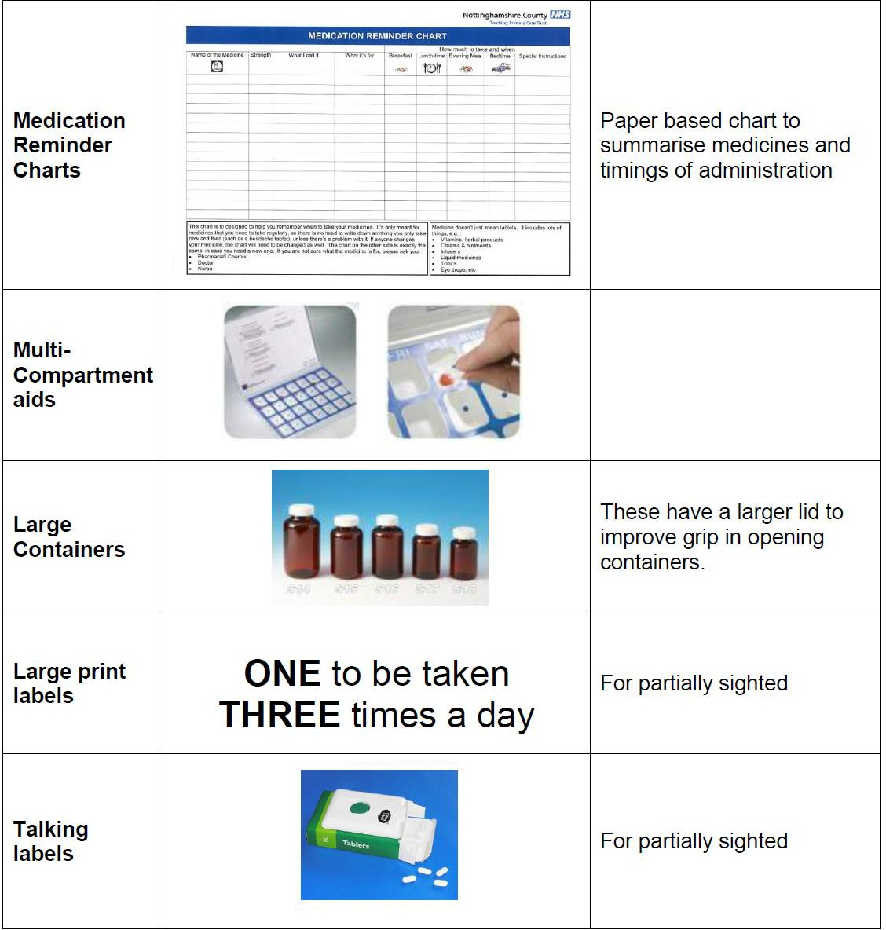

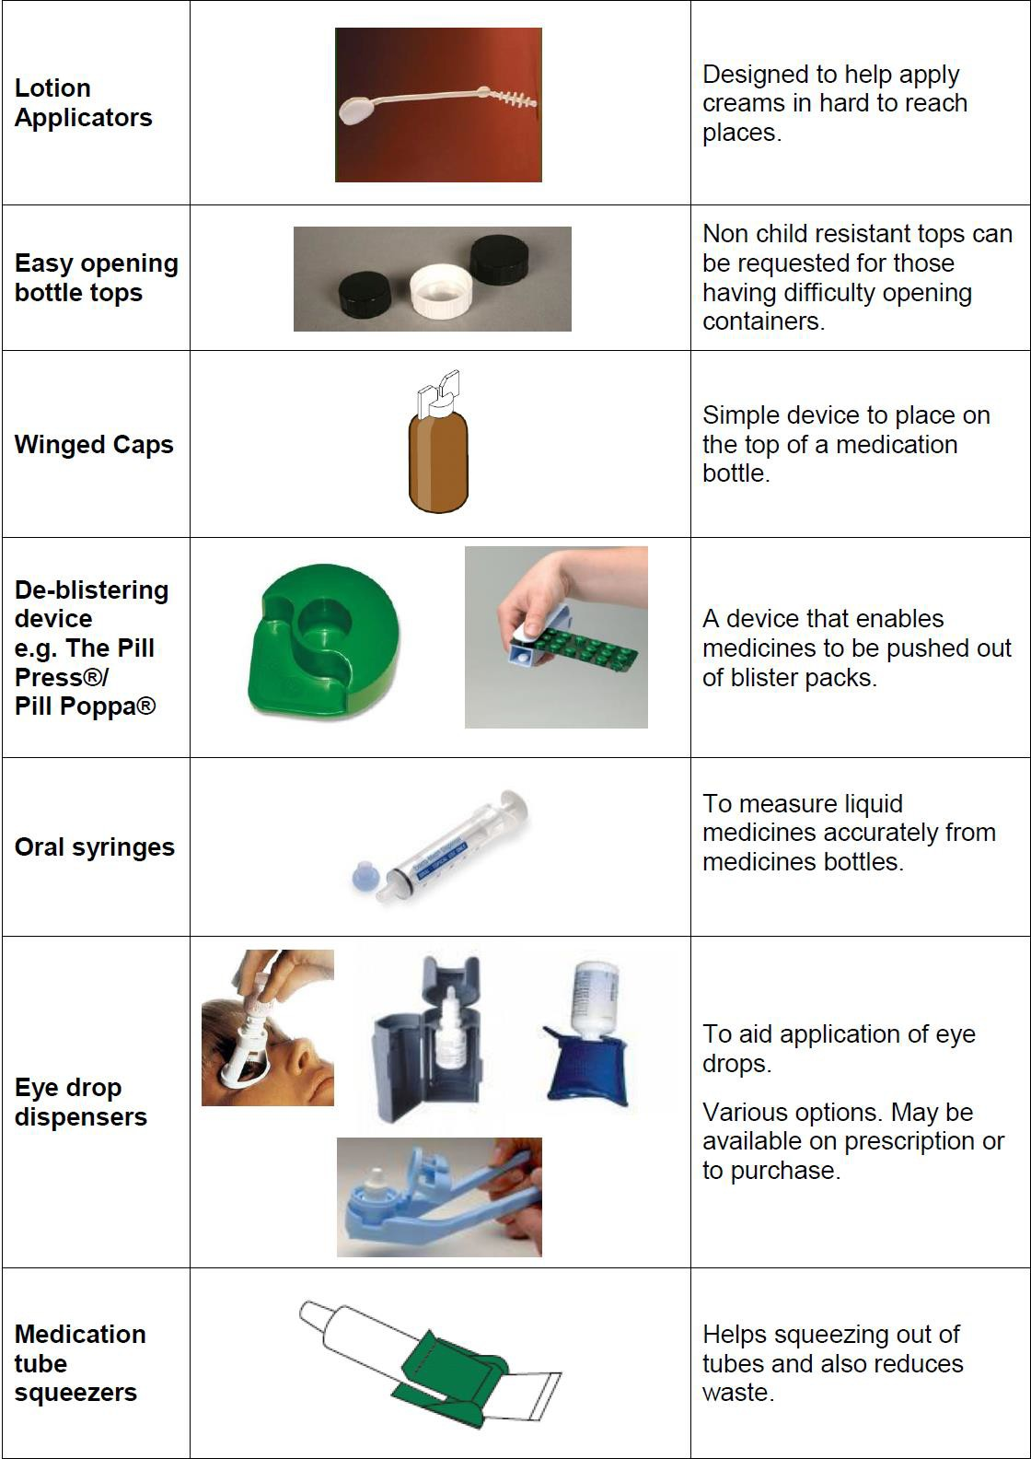

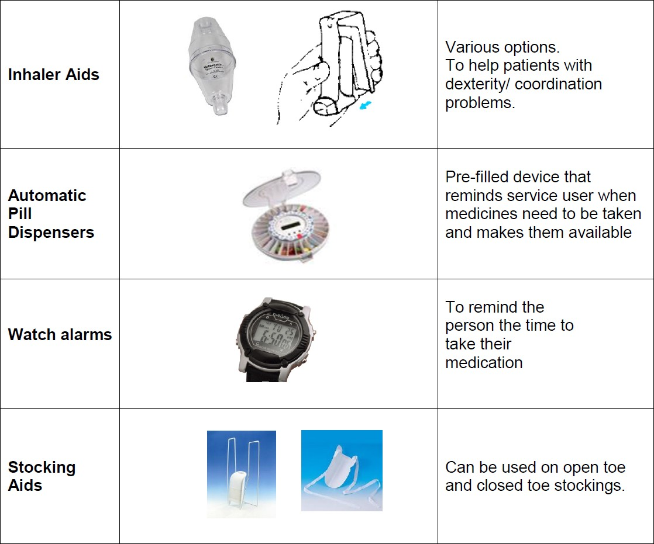

APPENDIX 9 – SUPPORTING WITH MEDICATION AND HEALTH RELATED TASKS IN SERVICE USER’S HOMES

ADULT SOCIAL CARE, HEALTH AND PUBLIC PROTECTION SHORT TERM ASSESSMENT AND RE-ABLEMENT TEAM

Supporting with Medication and Health Related Tasks in Service User’s Homes

The following table is an aid to those staff members authorised to deliver level 2 support tasks.

Can assist with | Cannot assist with
- Only social care tasks that are in the Support Plan and have been risk assessed  - Support (prepare/remind/assist/apply/admini ster as written in the plan) with medication from the original packaging, as supplied by the pharmacy  - Tablets and capsules  - Liquid medications including liquid food supplements  - Dietary food thickeners  - Eye drops/ointment, Ear drops  - Nasal drops, cream and Sprays  - Patches for parkinsons disease  - Prescribed creams and ointments: but not on broken skin (unless documented as the reason it is being applied)  - Emollients , moisturisers and sun cream as part of personal care  - Inhalers  - Epipens and buccal midazolam ( in exceptional circumstances) as part of a care plan  - Prescribed compression stockings with oversight from health  - TED stockings  - Leaving medication out for later- as long as supported by risk assessment, to promote independence | - Transferring medication from their original containers  - Preparing medication in advance of administration, except in rare circumstances supported by risk assessment  - Give medications covertly (without the service users knowledge) unless there has been a Mental Capacity Act Best Interest decision made and recorded in the Plan  - Injections and syringe drivers  - Non prescribed medication  - Rectal medicines  - Vaginal preparations  - Wound care  - Nebulisers  - Oxygen  - Patches for controlled drugs or dementia medication  - Administering medication via a PEG  - Supporting from an unlabelled or illegibly labelled container

In addition, you must remember to record all support provided with medication by completing the MAR chart, Support Plan and running records.

Please remember that any member of staff undertaking a health care task is at risk of being disciplined for gross misconduct.

If you have a problem with carrying out the instructions contained in this document, please speak to your line manager in the first instance.

Appendix 10

Patch Application Record

Name of Service User
Name of patch |  | Strength
Frequency of change
The patch should be checked on a daily basis to make sure it is still in place and recorded in the support plan.
The site of application should be rotated in accordance with the manufacturer guidance.
The old patch must be folded in half and stuck together before disposal
Please indicate where the patch has been applied using a cross (x). If more than one patch is in use please indicate with a separate symbol, e.g. o
Remember to complete the MAR chart
If the old patch cannot be found, do not put on another patch. Report this to line manager/person on call.

 | Old patch removal date |  | Time
 | Removed by
 | New patch applied date |  | Time
 | Applied by
 | Old patch removal date |  | Time
 | Removed by
 | New patch applied date |  | Time
 | Applied by
 | Old patch removal date |  | Time
 | Removed by
 | New patch applied date |  | Time
 | Applied by
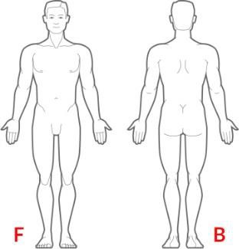 | Old patch removal date |  | Time
 | Removed by
 | New patch applied date |  | Time
 | Applied by

