Nottinghamshire Health and Wellbeing Board Stakeholder Network
9 June 2014

This event was held at the Summit Centre, Kirkby in Ashfield and was attended by around 100 people from across the voluntary and community sector as well as Clinical Commissioning Groups (CCG), the County and borough/district councils, Nottinghamshire Police and healthcare providers.
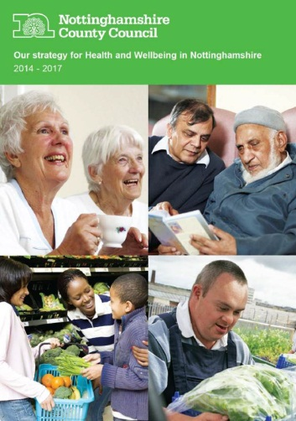
Councillor Joyce Bosnjak opened the event and gave an overview of the Health and Wellbeing Board and gave an overview of the Board and its progress to date. She stressed that integration was a key priority for the Board and that the voluntary and community sector were vital to achieving that.
Chris Kenny, Director of Public Health and Kristina McCormick gave an overview of the Joint Strategic Needs Assessment (JSNA) which identifies the health needs in Nottinghamshire and is a core responsibility of the Health and Wellbeing Board. Cathy Quinn then launched the Health and Wellbeing Strategy for Nottinghamshire which the Board has agreed to address those needs identified by the JSNA.

Val Gardiner and Penny Spice gave an overview of current partnership arrangements supporting carers in Nottinghamshire.

The Group then split to discuss how the Health and Wellbeing Board and the voluntary and community sector (VCS) could work together in the future. Points raised included:

- The VCS are very keen to be involved and to support the Board to improve Health and Wellbeing in Nottinghamshire.

- There were numerous opportunities to get involved and to influence health and wellbeing policy in Nottinghamshire. The Stakeholder Network being a key opportunity to speak to Board members directly.

- The VCS could have a direct involvement in the JSNA process and had a lot of information which could feed into that.

- A joined up approach would help – ‘coordinated listening’ from the Board, CCGS, the County Council and Healthwatch and coordinated consultations so that people were only asked for information once.

- Organisations needed to feel that they were being listened to and that action was being taken as a result of their views.

- The VCS could get messages out from the Health and Wellbeing Board into local communities.

- Communications from the Board could be improved including developing the website, utilising networking groups, ebulletins and using social media.

- A variety of methods of engagement were necessary as ‘one size doesn’t fit all’ and plain language and accessibility were key.

- It would help to map local VCS services to form a directory to help professionals and the public. There were good examples of how this had been achieved for individual Clinical Commissioning Groups and it was agreed that this should be shared across other areas.

- The voluntary and community sector is a large part of the local health and wellbeing system but many organisations work in isolation and there needs to be some coordination across the sector using existing networks like NAVO and the Community and Voluntary Services (CVS’s) where possible.

- The scope and capability of the third sector isn’t well understood and commissioners need to consider their work when scoping services.

- Some of the smaller organisations found it difficult to be heard and had limited capacity for development but could also support the work of the Board.

- There are existing networks which would be used for communications and engagement including NAVO and the CVS’s across the county – these networks should be used wherever possible to circulate information and involve VCS organisations.

- Since the changes within health and social care it was difficult to know who was responsible for what.

- The Health and Wellbeing Strategy was the cornerstone which would bind everyone together and the Delivery Plan would under pin that and identify leads for each priority action.

Next steps

A report will be presented to the Health and Wellbeing Board at the meeting to be held on 3 September 2014 and will include feedback from this event.

The next Stakeholder Network event will take place on Monday 10 November 2014 and will focus on Homelessness.

There would be an annual Stakeholder Network event for the voluntary and community sector and the Health and Wellbeing Board.

Useful links

Nottinghamshire Insight – Joint Strategic Needs Assessment
http://jsna.nottinghamcity.gov.uk/insight/Strategic-Framework/Nottinghamshire-JSNA.aspx

Nottinghamshire Health & Wellbeing Strategy 2014-17
http://www.nottinghamshire.gov.uk/caring/yourhealth/developing-health-services/health-and-wellbeing-board/strategy/

Presentations from the event on 9 June 2014
http://www.nottinghamshire.gov.uk/caring/yourhealth/developing-health-services/health-and-wellbeing-board/stakeholdernetwork/?entryid282=410962

Nottinghamshire Health and Wellbeing Board
http://www.nottinghamshire.gov.uk/caring/yourhealth/developing-health-services/health-and-wellbeing-board/

Nottinghamshire Stakeholder Network updates & information
http://www.nottinghamshire.gov.uk/caring/yourhealth/developing-health-services/health-and-wellbeing-board/stakeholdernetwork/

