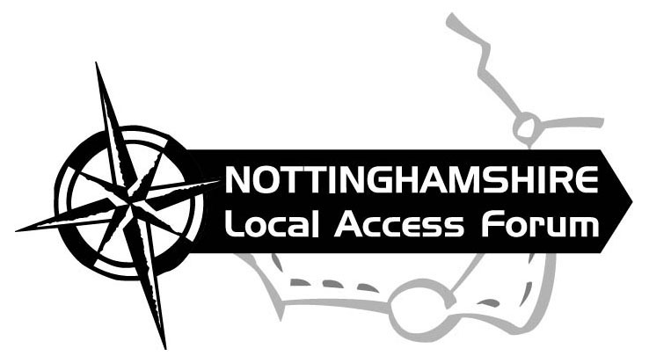

Minutes of the November 2017 Meeting of
Nottinghamshire Local Access Forum

Date: Tuesday 7th November at 7.15pm
Venue: County Hall, West Bridgford.

Forum Members: Alex Staniforth (Chair), Penny Lymn Rose (Vice Chair), Dennis Reeson, Alan Hudson, Alison Pritchard, and Mary Mills.

Officers and Guests: Neil Lewis (NCC), David Shorrocks (Network Rail), Victoria Young and Neil Coleman (HS2 Project Team).

1. Apologies: Hilary Limb, Cathy Charles-Jones, Simon Wilson and Sue Guy.

2. Minutes of the last Meeting: The minutes for the 25th July 2017 meeting were accepted as a true record.

3. Matters arising not covered elsewhere in the agenda:

Countryside Stewardship Scheme – members agreed that this is still an important issue which we should pursue, Mary to send a standard letter to parish councils with Stewardship paths advising them of the end of the scheme as they are probably the best people to approach and negotiate with landowners. The County Council will assist with landowner declarations where an agreement can be reached to retain permissive access after the end of the scheme.

Miner2Major Project – No communication or update received from the project since our July meeting.

Papplewick Strategy for Cycling and Walking 2017-2028 – Copies were available to members, this strategy is well written and comprehensive and shows a parish with good aspirations for future access.

Access for All – Alex and Mary to attend meeting with the Forestry Commission to discuss barriers to disabled access, identified by Mr Pilling.

4. HS2 Presentation and Update – Victoria Young and Neil Coleman

Victoria and Neil C gave an interesting presentation which reassuringly covered protecting existing public rights of way, and also an assurance that any paths diverted by the scheme would be diverted onto good quality alternative routes. Apparently no paths were extinguished on phase 1 of the route.
There are still hurdles to this section of the route going ahead and the proposal is for the actual works to begin in 2026 and the line to open in 2033. HS2 are already looking at buying up land and properties in the proposed HS2 corridor.
Neil Lewis asked about future liabilities for structures on the public rights of way, and Dennis asked about historic paths yet to be researched and recorded, HS2 have agreed to look into both these issues.

It is proposed at the January LAF meeting (or a separate extra meeting in the new year), we go through the route in detail identifying all existing and claimed public rights of way and at all other access routes and open land, and start to look at best options for improving and maintaining access both during and after the railways construction.

5. Network Rail Update – David Shorrocks

Whitehouse Lane – An application for Extinguishment (HA 118A – Rail Safety) has been sent to NCC, this will be a straight extinguishment with a promise of some improvement works through the trading estate, as it has been impossible to negotiate the link along the riverside which NCC and Network Rail were hoping for.
Kings Mill Crossing – A bridleway bridge is to be installed (hopefully in the spring) once paperwork for Transport and Works Act Order are complete.
Cross Lane Collingham – Network Rail wish to close Cross Lane Level Crossing and provide an alternative new road link onto Swinderby Road. This proposal also includes the extinguishment of one foot crossing and improvements to another. The LAF have identified acceptable footpath changes around Cross Lane which protect public safety and preserve a decent, safe path network. David informed us that negotiations with affected landowners so far suggest they have slightly less ambitious plans for public access. Network Rail are meeting with Collingham Parish Council next week and then there will be a resident’s consultation on the plans.
Dykes End, Collingham – Network Rail would like to close Dykes End Crossing, South Collingham and retain Butts Crossing, with some alterations to the footpaths, there is no timescale for this at the moment.
Attenborough Crossings – Network Rail will not close Nature Reserve Crossing (unless or until a bridge is installed). As a temporary measure they plan to install miniature stop lights. Penny is attending a meeting on site shortly with Suzanne Bedford to look at possible stopping up/diversion of equestrian rights over the crossing.
Long Lane and Barratt Lane No.1 Crossing are still being considered by Network Rail for possible closure.

David informed us that March 2019 is the end of Network Rails current Control period, within which they have a specific budget to spend on level crossing safety such as bridges, closures and diversions.

6. Trent Vale Trail – Alan Hudson

Sustrans have agreed to manage the project. Some landowners along the route are still to be tracked down. Letters of support for the project have been received from many organisations, including the LAF, more are sought.
Funding for the project is yet to be applied for.

7. Rights of Way Management Plan (ROWMP)- Consultation

A report is to go before the Community and Place Committee on the 7th December asking for consent to go out to public consultation on the new Rights of Way Management Plan. Assuming consent is given the plan will go on deposit for 12 weeks in the New Year, comments received will then be collated, and changes made. The Plan will then go to the Planning and Licensing Committee for approval and will be valid until 2026.

8. Priority scheme for Definitive Map Modification Orders (DMMOs)

All Authorities are required to deal with applications for DMMO within a reasonable time scale. If an applicant is dissatisfied they can seek a direction from the Planning Inspectorate. The PI are required to take into account any statement of priority which the authority has in place when deciding whether to direct the Council to determine the Application within a timescale.
The LAF are an advisory body to the County Council and therefore it is appropriate that an opinion be sort on priorities by members.
Due to lack of time this item was only discussed briefly and no conclusion was reached.

9. Gating Orders / Public Spaces Protection Orders
None

10. NCC Planning and Licensing Committee update
Village Greens and Public Rights of Way reports will now be considered by this one committee.
A report on a footpath claim at Staythorpe was considered at the September Committee - 3 supporters of the Order turned up and no objectors, the committee approved the making of the Order.
On 12th December a report will be considered by the Committee on an application at Widmerpool based solely on Enclosure Award Evidence.

11. Town and Village Greens and Common Land
None

12. PPOs and DMMOs

Langar cum Barnstone – pre consultation to partially divert bridleway 4 off the busy works access road, for part of its length.
Caunton – pre consultation for a minor diversion at Beesthorpe Hall (of Auf Wiedersehen Pet fame).

13. AOB/ Members Update

Barton in Fabis – Proposed sand and gravel quarry – Penny raised concerns about this, particularly regarding bridleways which run through the proposed quarry site. It was agreed that the LAF would send a formal letter of objection to the proposals.

Restoring the Record Training – Training in researching unrecorded paths is taking place in Coalville on 2nd December if any members are interested.

14. Future Dates and Venues

Neil to book Committee Room B at County Hall for next meeting on 23rd January 2018.
7pm for a 7.15pm start.

The Chair concluded the meeting, thanked all those present for attending and closed the meeting.
Close of Meeting

