ADMISSION POLICY

2019-2020

ADMISSION POLICY

2019-2020

The Suthers School belongs to the Nova Education Trust and first opened to Year 7 on 4 September 2017.

The Trust Board have a responsibility to ensure that this admissions policy is implemented and delegates this responsibility to the school.

The Suthers School participates in the Nottinghamshire County Council’s coordinated scheme for the September Year 7 intake and applications should be made direct to them. For those children who live outside of Nottinghamshire County, parents/carers should apply on a common application form through theiappealr ‘home’ County. The closing date for the coordinated admission scheme is 31 October preceding admission to secondary school. Places are allocated on National Offer Day (1 March).

The published admissions number for Year 7 in September 2019 is 120.

The Suthers School also participates in the Nottinghamshire County Council’s In-Year Co-ordinated scheme for in-year applications and such applications should therefore be made to directly to NCC.
The Suthers School does not believe in any form of selection, either on the basis of the school’s specification or on any other criterion.

If more applications are received than places available, applications will be ranked against the following over-subscription criteria for the school.The criteria will be applied in the priority order indicated below.

Admission oversubscription criteria for Year 7

The school will admit a child with a Statement of Special Educational Need or Education Health and Care Plan (EHCP) if the Statement or Plan names The Suthers School, before any of the following criteria are applied:

- Children looked after by a local authority or previously looked after children.

- Children who live in the catchment area and who, at the time of admission, will have an older sibling attending the school.

- Other children who live in the catchment area.

- Children who live outside the catchment area and who, at the time of admission, will have a brother or sister attending the school.

- Children whose parent is an employee of The Suthers School and has been employed for two or more years at the time at which the application for admission to the school is made, or the member of staff is recruited to fill a vacant post for which there is a demonstrable skill shortage.

- Children who live outside the catchment area but who are attending a linked primary phase school on the closing date for applications preceding admission to secondary school and who will have a brother or sister at the school at the time of admission.

- Children who live outside the catchment area but who are attending a linked primary phase school on the closing date for applications preceding admission to secondary school.

- Other children who live outside the catchment area.

In the event of oversubscription, within any criterion, preference will be given to children who live nearest to the school as the crow flies. Distances are measured from the entrance to the child’s home to the principal entrance building of the school by using Nottinghamshire County Council’s computerised measuring system.

Distance Tie Breaker

In the event of needing to discriminate between pupils living an equal distance from the school, names will be drawn randomly from a hat and independently verified.

Twins and Multiple Births

Where one child of a multiple birth can be admitted, the other child/children will also be admitted.

Key Terms and Definitions

Home address

The child’s place of residence is taken to be the parental home, other than in the case of children fostered by a local authority, where either the parental address or the foster parent’s address may be used. Where a child spends part of the week in different homes, one of which is not a parental address, their place of residence will be taken to be their parent or parents’ address. If a child’s parents live at separate addresses, where the child permanently spends at least three ‘school’ nights, i.e. Sunday, Monday, Tuesday, Wednesday or Thursday will be taken to be the place of residence. Addresses of other relatives or friends will not be considered as the place of residence, even when the child stays there for all or part of the week.

Evidence that a child’s place of residence is permanent may also be sought. Such evidence should demonstrate that a child lived at the address at the time of the application, and will continue to live there after the time of admission. Informal arrangements, even between parents, will not be taken into consideration. The Governors Admissions Committee may also seek proof of residence from the courts regarding parental responsibilities in these matters.

Looked After Child and previously looked after children

A looked after child is a child who is (a) in the care of a local authority, or (b) being provided with accommodation by a local authority in the exercise of their social services functions in accordance with section 22(1) of the Children Act 1989 at the time of making an application to a school.

Previously looked after children are children who were looked after, but ceased to be so because they were adopted (or became subject to a child arrangements order or special guardianship order). This includes children who were adopted under the Adoption Act 1976 and children who were adopted under section 46 of the Adoption and Children Act 2002.

Child arrangements orders are defined in section 8 of the Children Act 1989, as amended by section 12 of the Children and Families Act 2014. Child arrangements orders replace residence orders and any residence order in force prior to 22 April 2014 is deemed to be a child arrangements order. Section 14A of the Children Act 1989 defines a ‘special guardianship order’ as an order appointing one or more individuals to be a child’s special guardian (or special guardians).

Parents

For school admissions the governors will consider the following as parents:

- The mother of the child
- An adoptive parent
- The father of the child where he was married to the mother either when the child was born or at a later date
- The father of the child if (since 1 December 2003) he was registered as the father on the birth certificate
- Any other person who has acquired ‘parental responsibility’ through the courts.

Siblings

For school admissions the governors will consider the following as sibling:
- A brother or sister who shares the same parents
- A half-brother or half-sister or legally adopted child living at the same address to the child
- A child looked after by a local authority placed in a foster family with other school age children
- Stepchildren or children who are not related but live as a family unit, where parents both live at the same address as the child.

Children of UK service personnel (UK Armed Forces)

For families of service personnel with a confirmed posting to an admission authority area, or crown servants returning to live in that area, admission authorities must allocate a place [2.18 Admissions Code 2014].

Admission of children outside the normal age group

Parents may seek a place for their child outside of the normal age group. Children should only be educated outside of the normal age group in very limited circumstances.

Parents should submit a request in writing to The Suthers School’s admissions team as early as possible. School Governors and the Head of School will make decisions based on the circumstances of each case and in the best interests of the child concerned. When informing a parent of the decision on the year group to which the child should be admitted, the parent will be notified of the reasons for the decision.

The parent has a statutory right to appeal against the refusal of a place at a school for which they have applied. This right does not apply if they are offered a place at the school but it is not in their preferred age group.

Transfer to Secondary School—Where a child has been educated out of the normal age group it is the parent’s responsibility to again request admission out of the normal age group when they transfer to junior secondary school. It will be for The Suthers School to decide whether to admit the child out of the normal age group. The admission authority must make a decision on the basis of the circumstances of each case and in the child’s best interests, and will need to bear in mind the age group the child has been educated in up to that point.

Waiting lists

The school will operate a waiting list until the end of the summer term in the year of entry and applications will be ranked against the oversubscription criteria in the order set out above. If the school is over-subscribed, parents may request that their child be placed on the waiting list.

Late applications

Late applications are those submitted after the closing date for the co-ordinated admissions scheme and will be dealt with in accordance with that scheme. Late applications will be considered up to 2nd December 2018, the date specified in the Nottinghamshire County Council coordinated scheme, providing the applicant can provide evidence that they have moved into the area after the closing date for applications or can establish at the time of completing the form that there were exceptional reasons for missing the closing date. Examples include family bereavement, hospitalisation, and family trauma. Supporting evidence may be required.

Linked primary phase schools

- Barnby Road Academy
- Bishop Alexander LEAD Academy
- Chuter Ede Primary School
- Coddington C of E Primary School
- Elston All Saints Primary School
- Holy Trinity Catholic Academy
- John Hunt Primary School
- Lovers Lane Primary School
- Manners Sutton Primary School
- Marston Thorold C of E Primary School
- Mount C of E Primary School
- The Sir Donald Bailey Academy
- William Gladstone C of E Primary School

Independent appeals

Places in Year 7 at The Suthers School for September 2019 will be allocated on 1st March 2019 and advised thereafter. Parents have the right to an independent appeals panel if you are not happy with the outcome of your application. Repeat applications in the same academic year will not be considered unless there is a significant and material change in circumstances. Parents wishing to appeal should do so in writing to the Head of School and the Chair of Governors. Notification of the appeals date will be given with at least 10 school days’ notice and the deadline for submission of written case will normally be six working days in advance of the hearing date. In the event of oversubscription and applications being refused, applicants have the right to an independent appeal. Applicants wishing to appeal should contact the school within 20 school days of the refusal letter to obtain the necessary forms.

In-year admissions

Admissions in year will be processed by Nottinghamshire County Council and applications should be made directly to them. The Application Form and details of how to apply are available by contacting the Admissions Team at Nottinghamshire County Council. Applications received in year will be dealt with in accordance with our published criteria. Distance measurements to be made ‘as the crow flies’ from the home address to the main administrative building of the school using Google Maps. If a place is available in the appropriate year group, then that will be offered. If no places are available, the child’s name will be added to the waiting list. The position on that waiting list is determined by the School’s oversubscription criteria, not in the date order by which they are received. Parents of pupils who have been unable to secure a place in any year group have the right to appeal.

Catchment area

Details of the catchment area school for your address can be obtained from the Nottinghamshire County Council website: http://www.nottinghamshire.gov.uk/findmynearest

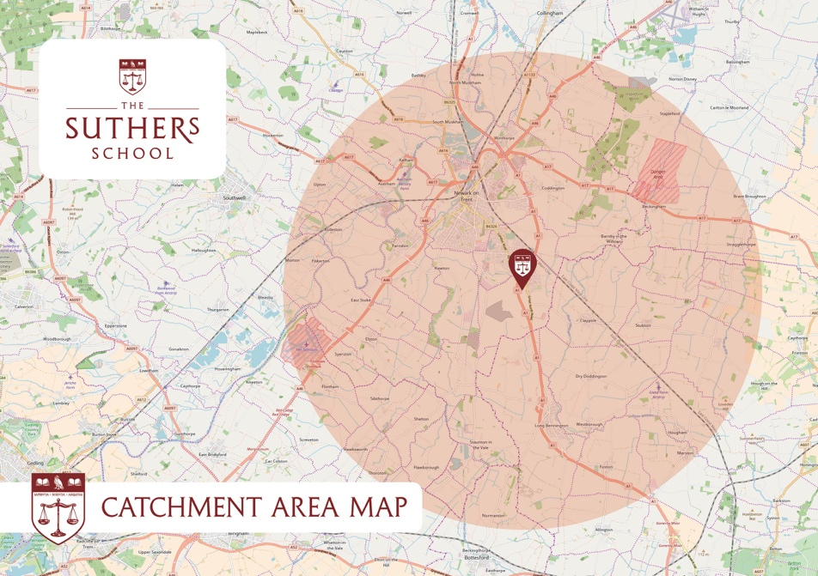

Fair Access Protocol

The Suthers School observes the Fair Access Protocol and governors may accept vulnerable children outside the normal admissions round.

