Pedestrians

During September 2012, the road safety team are running a pedestrian safety campaign. If you pass a secondary school you may see some of the posters and artwork that go with this campaign.
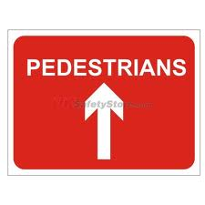
We would like our JRSOs to join in this campaign by promoting pedestrian safety in your school. There are some presentations and worksheets on the JRSO website for you to use if you want, or you can use your own ideas. Let us know what you’re up to though, as we love to hear your fabulous ideas.

Below are a few random facts about pedestrians; see if you can find anything else out about pedestrians. You could create a display on your notice board about pedestrians and add in the green cross code, to remind everyone how to stay safe when they are out and about

Here are a few facts about pedestrians:-

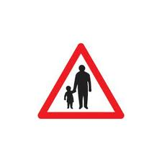
During the 18th and 19th century Pedestrianism (or walking) was a popular spectator sport.

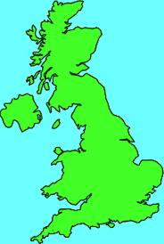
One of the most famous walkers was Captain Robert Barclay Allardice. He was also known as “The Celebrated Pedestrian” of Stonehaven in Scotland. He walked one mile every hour for 1000 miles.

Walking is still an Olympic sport.

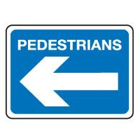
Many people have walked from John O’Groats to Land’s End, to raise money for charity. John O’Groats is at the very top of Scotland and Land’s End is at the very bottom of Cornwall, 838 miles apart.

Dave Kunst was the first person to walk around the world. It took him 4 years and 4 months; he set off in June 1970 and walked back into his home town in October 1974. Do you know of anyone who has walked a long way or an unusual way to raise money for charity?

In town and city centres many roads have been pedestrianised –
meaning that vehicles are not allowed on those streets, they are only for pedestrians.

Can you find out any other facts about pedestrians?

