EARLY HELP ASSESSMENT FORM (EHAF)

This assessment is about: (LIST CHILD(RENS)/YOUNG PEOPLE/S and Significant Adults NAMES)

Written by: (assessors name)

Date: (completion date)

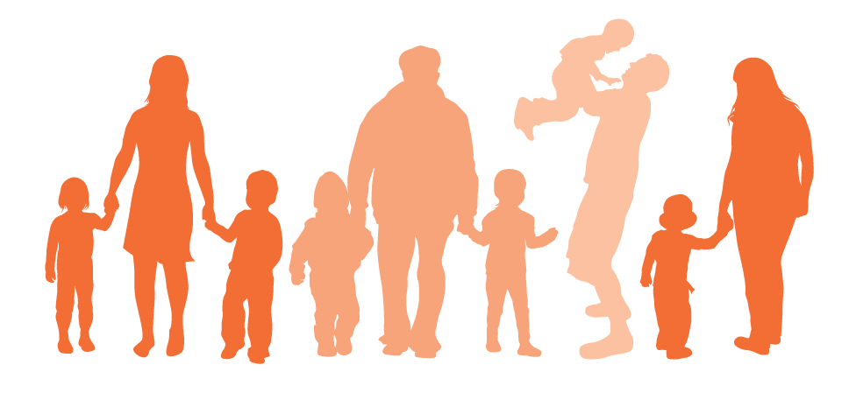

Early Help Assessment Framework (EHAF)
This form should be used alongside the guidance within the Pathway to Provision
www.nottinghamshire.gov.uk/pathwaytoprovision

Why are you completing the EHAF? | Please Tick | Which sections to complete
To undertake an assessment that will lead to a TAF (for families at tier 2 of the pathway to provision) |  | Complete sections 1 to 5 and 8
To record a TAF and Action Plan (for families at tier 2 of the pathway to provision) |  | Complete section 6
To make a referral via the EHU with family consent where you are not sure which service you require and need advice and signposting |  | Complete sections 1 to 5 and 8
To make a referral with family consent to The Family Service Case Management Service (for families at tier 3 of the pathway to provision) |  | Complete sections 1 to 5, 7 and 8
To make a referral without family consent to The Family Service for Education Enforcement Only |  | Complete sections 1, 5, 7 and 9
Please note that when completed, form can also be sent to CAMHS SPA or Healthy Families Teams provided information relevant to those services is included and you have consent from the family to refer.
If the family does not meet the threshold for The Family Service then the Early Help Unit may be able to advise as to what services available at tier 2 or 3 of the Pathway to Provision

Section 1 – PRACTITIONER AND FAMILY INFORMATION
Details of the person completing this form:
Name: |  | Telephone number:
Job title: |  | Service / organisation:
Email: |  | Date:
Relationship to child/family

Family Address
Main Address:

Secondary Address (list which family members live here):

Main contact numbers and names:

Information about the Children and Youth People in the family: (If child is an unborn baby, specify name as 'unborn baby' and mother's name and use expected delivery date)
Name | DOB | Gender | Ethnicity | School Year | School | Subject to the assessment?
Do any of the children in the family have a disability or communication difficulty (please give details):

Information about the adults in the family:
Name | DOB | Gender | Ethnicity | Relationship to child
Do any of the adults in the family have a disability or communication difficulty (please give details):

Section 2 – THE CHILDREN / YOUNG PEOPLE (you can compete this section for one child, or all children in the family depending on the information you have access to and your role with the family)

Describe the strengths and areas for development of the child/children in this family

You may wish to consider the following prompts for children under the age of 5:  Are they meeting developmental milestones?  (Physical, Intellectual, Language, Emotional and Social)  Do they have additional health needs?  Are they in nursery? |  | You may wish to consider the following prompts for school age children:  Do they have additional health needs?  How do they behave at home and at school?  How is their school attendance and punctuality? Have they been excluded?  Are they achieving academically?  Comment on speech, language and communication skills.  How would you describe their ability to form relationships?  How is their emotional wellbeing? (stress, anxiety self-esteem)  Do you have any concerns about emerging threats such as radicalisation or CSE?
Behaviours of concern (leave blank if not relevant)
What is the behaviour | Where and When do they happen | Triggers | What helps?
 | (classroom, break times, home, community)

Section 3 – FAMILY AND ENVIRONMENT

Describe the family and their environment
You may wish to consider the following prompts:

Who lives in the household?
What significant life events have there been? (e.g. death of a family member, house move, parent gets a new partner)?
Is there a history of agency involvement with the family (Social Care, Children Centre, CAMHS or Health)?
Have you been able to visit the home and if so what were your impressions?
What support networks are in place for the family (friends, relatives, neighbours and/or community resources)

Section 4 – PARENTS AND CARERS

Describe the Parent/Carers and their parenting style

You may wish to consider the following prompts:

Does the child/children present as clean and hygienic, well fed and with health needs met?

Describe the relationship the child and parent carer has? Are the child’s emotional needs met?

Guidance and boundaries – is the young person is sanctioned when they behave badly or rewarded when they behave well? Does the child gets away with their poor behaviour? Does the parent engage well with your service (for example on issues with behaviour and attendance if you are a school?)

Are there any issues such as parental mental-health, substance misuse, physical health problems or domestic violence?

Section 5 – WHAT NEEDS TO CHANGE?

What do the family/ parents / carers think needs to change? Record here the parent’s opinion of the current situation and their feelings about any referral if you are making one.

What does the child / young person think needs to change? Record here the child’s opinion of the current situation and their feelings about any referral if you are making one.
What do you think needs to change? What underlying issues do you feel need to be addressed in order to reduce the barriers to progress?
If your referral is for a poor school attendance case where there is no consent from the family please can you include in this section any additional information you know about the family and the reasons for the poor attendance that you think may be relevant to our involvement.

Section 6 – TEAM AROUND THE FAMILY AND ACTION PLAN

Date:

Attendees:
Apologies:

Summary of the Team Around the Family meeting

Agreed Actions | Who is responsible? | By When? | Progress so far (complete when you do a review)

Section 7 – REFERRAL FOR FAMILY SERVICES

Please explain what support has already been offered to the family – Have there been regular TAF meetings? What referrals have been made and has the young person/ family engaged? What interventions or strategies have been put in place and what were the outcomes?
Refer reader to the family plan if you feel this holds all the relevant information.

What are the unmet needs that require referral to services?

Section 8 – CONSENT (complete to log EHAF or to refer for services)
If not physically signed by the parent, consent can be shown with an electronic signature and a comment to say verbal consent obtained. For a referral we would like to know that main care giver and the subject child are aware of and in consent with the referral – please provide us with additional information to explain the situation if there is consent from the carer but not the child or the child but not the carer.

I am a child / young person/parent/carer named in this form:
I understand the information recorded in this form. I know that it will be used to provide services to me and may be stored electronically. A copy will be held securely with Nottinghamshire County Council's Children, Families and Cultural Services Department and may be used for monitoring purposes, where all identifying information will be removed.

The reasons for information sharing have been explained to me. I understand those reasons. I agree to this referral being made and for the sharing of information between the services that will contribute to the assessment for and delivery of an agreed plan of work.

I agree to the sharing of agreed information with members of my family if necessary except:

Signed: |  | Name: |  | Date:
Signed: |  | Name: |  | Date:
Signed: |  | Name: |  | Date:

Section 9 – EDUCATION ENFORCEMENT (referral without consent)

What is the current unauthorised absence level for the child over the past 6 weeks? (must be 15% or more)
How many unauthorised absences in the past 6 weeks? (must be 6 or more)
Have you attached a copy of the attendance certificate and any other relevant evidence e.g. letters? (referral will be declined without this)
Have you attached evidence of informing the family of the absences and of this referral? (referral will be declined without this)

- MAKING A REFEFFRAL TO EARLY HELP SERVICES

Please send the completed assessment to the Early Help Unit or to the local Children’s Centre (if known).

Early Help Unit
Tel: 0115 8041248
Email: early.help@secure.nottscc.gov.uk (if from a secure e-mail address), or please use early.help@nottscc.gov.uk and password protect any confidential information
Address: Early Help Unit, Piazza Building, Little Oak Drive, Sherwood Business Park, Annesley, Nottinghamshire, NG15 0EB

SAFEGUARDING CONCERNS
If you have safeguarding concerns regarding a child or young person (in line with the Pathway to Provision level 4 guidance) please contact your designated safeguarding lead.

