 | Report to Children’s Trust  Board  Insert name of Council Body (eg County Council) or Decision Maker (eg Cabinet Member for Finance and Property).
18 December 2015
Insert the date the report is to be considered (eg the date of County Council or Portfolio Meeting). Must be in the format “dd MMMM yyyy” (e.g. 10 August 2011).
Agenda Item: 2
Please leave this blank.
Children’s Trust Board Sponsor: Derek Higton, Service Director, Youth, Families and Cultural Services

Review of the Children’s Trust arrangements in Nottinghamshire

Purpose of the Report

- To provide the Children’s Trust Board with further details to support the consideration of the proposed changes to the Children’s Trust arrangements which were discussed at the Board’s October and November meetings.

Information and Advice

- This report builds upon the earlier report on the review of the Children’s Trust which was discussed at October’s Board meeting. It also takes into account the subsequent discussions held over the last couple of months regarding the proposed changes to the Children’s Trust arrangements in Nottinghamshire.

- The main change to the original report’s recommendations is the proposal to have a single Children’s Trust Executive rather than two separate executive groups (Help and Protection and Health and Well-being Executives) to be responsible for the delivery of the priorities of the Children, Young People and Families Plan.

- Reducing the number of executive groups to a single one will minimise the risk duplicating business and membership at a time of reducing resources across the partnership in Nottinghamshire.

- This report sets out the roles and responsibilities of the proposed Board and Executive. Appendix A provides a governance chart for the proposed arrangements and Appendix B lists the proposed membership of the Board and Executive.

- If these revised proposals are accepted by the Children’s Trust Board, implementation will be from 1 April 2016.

Children’s Trust Board 2016

- The Children’s Trust Board will champion the interests of children, young people and their families in Nottinghamshire and will be responsible for the overall strategic direction of children and young people’s services in Nottinghamshire. It will provide a forum for the discussion of shared priorities for partnership working and the integration of the delivery of services.

- The Children’s Trust Board will meet three times per year and will be chaired by the Chair of the County Council’s Children and Young People’s Committee.

- The Board will also be responsible for:

  - The Children, Young People and Families (CYPF) Plan
  - The approval of the Children’s Trust Executive’s Improvement Plan
  - The partnership’s participation strategy
  - The partnership’s workforce development activities
  - The communication with partners and the workforce

- The membership of the Children’s Trust Board will include the County Council’s Lead Elected Members for Children and Young People, and tier 2 and / or 3 senior officers.

- The Children’s Trust Board will be able to task the Children’s Trust Executive with specific pieces of work requiring a partnership response and will receive regular reports on its work.

Children’s Trust Executive 2016

- Reporting to the Children’s Trust Board, the Children’s Trust Executive will meet seven times per year, and will develop a focused improvement plan based upon the priorities of the Children, Young People and Families (CYPF) Plan:

- Children and young people are safe in Nottinghamshire
- Children and young people are happy and healthy in Nottinghamshire
- Children and young people achieve their potential in Nottinghamshire
- Children, young people and families receive support when needed in Nottinghamshire

- The Executive will provide regular reports on its work to the Children’s Trust Board.

- The Executive’s purpose will be to ensure the effective delivery of high quality services for children, young people and families in Nottinghamshire.

- The membership of the Executive will reflect the priorities of the CYPF Plan and will be drawn from across the partnership, consisting of tier 3 and / or 4 senior officers including commissioners and providers.

- Specific responsibilities for the Children’s Trust Executive will include:

- The identification of delivery priorities for partnership activity (joint operational priorities) required to improve children’s services and meet statutory and regulatory requirements.
- The commissioning/establishing where necessary cross-partnership working groups to deliver such activity,
- The monitoring of the progress and impact of its improvement plan,
- The monitoring of risks and issues and ensuring appropriate mitigation,
- The provision of a mechanism to ensure service improvement through the coherence of multi-agency delivery,
- The response to recommendations made by the Nottinghamshire Safeguarding Children Board (NSCB) in its role to co-ordinate local work to safeguard and promote the welfare of children and to ensure the effectiveness of that work.
- The approval of the topics for the children and young people’s section of the Joint Strategic Needs Assessment.
- The effective implementation of the Trust’s Participation Strategy for children, young people and families.

- The Executive will receive regular reports from the various commissioning and delivery groups as listed in Appendix A to inform its business and improvement plan.

RECOMMENDATION/S

- That the Children’s Trust Board notes this report and agrees to implement the proposed changes to the Children’s Trust arrangements in Nottinghamshire for 1 April 2016.

Chris Jones
Senior Practitioner, Strategy and Planning
Christopher.1.jones@nottscc.gov.uk

Appendix A – Children’s Governance Structure 1 April 2016 (as at 30.11.2015)

Appendix B – Proposed membership of the Children’s Trust Board and Executive Group

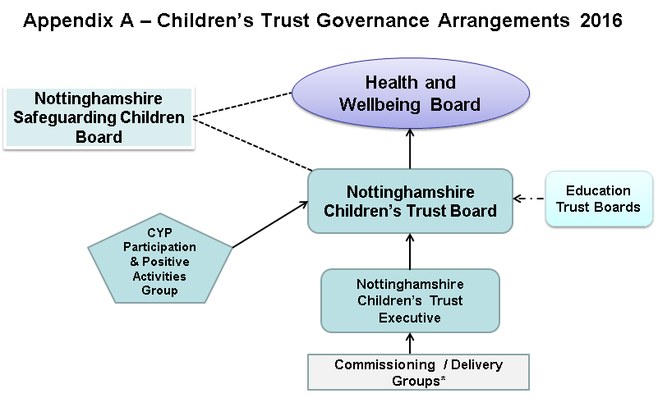

* Commissioning / Delivery Groups include:

- Closing the Gap Performance Group
- MASH Governance Group
- Looked after Children and Care Leavers Strategy Group
- Parenting Strategy Group
- Young Person’s Health Strategy Group
- Disability & SEN Integrated Commissioning Group
- Early Childhood and Healthy Child Programme Integrated Commissioning Group
- Local Management Groups

Appendix B – Proposed membership of the Children’s Trust Board and Executive Group

Nottinghamshire Children’s Trust Board Membership
Organisation | Representative
Nottinghamshire County Council | NCC Children and Young People’s Committee Chair (Chair of the Board)
Nottinghamshire County Council | NCC Children and Young People’s Committee Vice-Chair
Nottinghamshire County Council | NCC Children and Young People’s Committee Chair – Lead responsibility for Children’s Social Care
Nottinghamshire County Council | Corporate Director for Children, Families and Cultural Services
Nottinghamshire Police | Assistant Chief Constable
Nottinghamshire Safeguarding Children Board (NSCB) | Independent Chair
Clinical Commissioning Groups | Chief Officer & Clinical Lead for Children and Young People (County plus Bassetlaw)
Representative from the Education Trust Boards | Primary & Parent Governors
District Council Representative | Chief Executive or equivalent

Nottinghamshire Children’s Trust Executive Membership
Organisation | Representative
Nottinghamshire County Council | Corporate Director for Children, Families and Cultural Services (Chair)
Nottinghamshire County Council | Service Director, Children’s Social Care
Nottinghamshire County Council | Service Director, Youth, Families and Culture
Nottinghamshire County Council | Service Director, Education Standards and Inclusion
Nottinghamshire County Council | Consultant in Public Health, Children and Young People
Nottinghamshire Police | Appropriate Chief Inspector
Nottinghamshire Safeguarding Children Board (NSCB) | Independent Chair / other NSCB Executive Member
Clinical Commissioning Groups | Appropriate representatives (County plus Bassetlaw)
Nottinghamshire Healthcare NHS Foundation Trust | Divisional General Manager, Health Partnerships
NHS Acute Hospital Trusts | Appropriate CYP Lead (Safeguarding)
Representative of schools in Nottinghamshire | Primary & Secondary Head Teacher

