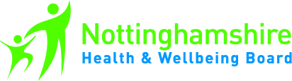

Nottinghamshire Health and Wellbeing Board
Stakeholder Network Event
22 September 2015

We’re in it together – how the voluntary sector & the Health & Wellbeing Board can work together to improve health & wellbeing in Nottinghamshire

At the Stakeholder Network event on 22 September 2015 we would like to hear about successful partnership projects from across Nottinghamshire. We would like to have a ‘speed dating’ event of small tables where a project is presented by one of the partners with an opportunity for people to ask questions before moving on. Everyone will get an opportunity to hear about 3 or 4 projects & hopefully find some inspiration for something in new their own area, make useful contacts or it could plant a seed of an idea which could potentially lead to something exciting!

If you have been involved in a project involving partners and would be prepared to tell other people about it we would love to hear from you. Tables will be small & friendly so you won’t have to worry about speaking to lots of people – just talk about your project for 5 – 10 minutes and answer any questions before the table moves on.

Please complete the form below and return it to Julia Thornborough (Julia.thornborough@nottscc.gov.uk ) by 7 September 2015 and we will be in touch.

What is your project?
Who is the project lead?
From which organisation?
Which organisations were involved in the project?
Where was the project based & what area did it cover?
How did it improve health & wellbeing?
Who would be attending the event?
Contact details (email & phone number)
What stage is it at? Has it finished or been evaluated?

