 | Equality  Impact Assessment

- Contact details
1.1. Contact Details & Project/piece of work/improvement details
Author of this EqIA
Name of Author | Iris Peel
Job Title | Group Manager
Department/Team Name/division | Adult Support Services - Improving Lives  Adult Social Care and Health
Email | Iris.Peel@nottscc.gov.uk
Lead Contact (or senior manager/line manager)
Name | Ainsley McDonnell
Job Title | Service Director
Department/Team Name/division | Adult Support Services  Adult Social Care and Health
Email | Ainsley.McDonnell@nottscc.gov.uk

- Project / Initiative details
2.1. About the project / initiative
Executive summary and the general potential impacts of the proposal? Has any initial engagement informed the identification of impacts?
Basis of reporting:
In Phase 1 of the ASC redesign, specific mental health and learning disability and autism (LDA) services, focused on inpatient admission and discharge, prisons and forensic work, were brought together to strengthen strategic leadership, consistency, partnership and closer working for teams who work with the people with the highest levels of risk and acuity.
The Improving Lives portfolio consists of the 24-hour AMHP service (Approved Mental Health Professional service), the Transforming Lives team, the Making Every Adult Matter (MEAM) project, prison support and forensic social work. It also incorporates the Think Ahead fast-track master’s degree in mental health social work programme.
Within acute hospitals there have been discharge hubs for many years however the same parity of esteem has not applied to Mental Health or LDA, prisons or forensic work. People’s length of stay in psychiatric hospitals has been high and Nottinghamshire is an outlier in terms of length of stay and the use of out of area beds. There is enhanced scrutiny by National Health Service England (NHSE) for people’s outcomes to be improved and to cease the use of out of area beds. As a result, there is an additional escalation process in place to oversee the discharge of all people who are clinically ready for discharge (CRFD) and look at ways of unblocking the system.
Impact and Analysis:
Work in the Improving Lives portfolio is governed by a wealth of legislation, policy, and guidance, much of which is being reviewed and which will likely bring new duties for the Local Authority (LA) e.g. Mental Health Act (MHA) reforms, Social Supervision standards for Forensic Social Work, national guidance on MEAM etc.
The Council has a statutory duty to carry out assessments under the Mental Health Act 1983 (revised 2007) and is currently awaiting implementation of the Mental Health Act (MHA) Reform Bill which will bring with it new duties for the health and care system.
The new Mental Health Bill which was introduced in the House of Lords on 6 November 2024, contains measures to amend the Mental Health Act 1983 (MHA) and will make subsequent amendments to the Mental Health Act Code of Practice.
The key elements of the Bill that will impact on the delivery of adult social care services are shortened detention periods, statutory care and treatment plans, change to nearest relative arrangements, more regular Tribunal reviews, increased access to Independent Mental Health Advocates (IMHAs) and the introduction of Advance Choice Documents.
The Bill will also give greater focus to unnecessary detentions for people with a learning disability or autism and will set new expectations on local systems to discharge people from acute settings in a timely way and will limit the length of time that they can be detained.
There is currently a national Learning Disability and Autism programme, overseen by NHS England, which sets expectations for local health and care partnerships to support people to leave hospital and live in the community, with the right support, and close to home.

2.1.5. Estimated ‘go live’ date for the project / initiative | 01/04/2025
2.1.7. Has this project been proposed to / approved through a formal decision-making route (e.g. been approved by committee / challenge panel?  The recommendations fall within the remit of the Cabinet Member for Adult Social Care through that Cabinet Member’s terms of reference. |  | Yes ☒ | No ☐
2.1.8. Please provide details including date(s) below: If the answer is yes or no please explain further.
18th December 2024 SLT approval to proceed with proposal
17th February 2025 Informal Briefing with Cabinet Member– approval given to proceed with proposal
24th March 2025 – Final Cabinet Member Approval

- Who are the main internal and external stakeholder groups that will be affected? This question is to help you think about the potential groups that your decision/piece of work/policy might affect.

3.2.? Please indicate who will be affected by this project (Tick below all that apply)
Young Service Users / clients | ☐ | Employees | ☒ | People with disabilities | ☒
Suppliers | ☐ | Advisors/consultants | ☐ | Residents | ☒
Parents | ☐ | Benefits recipients | ☒ | People who use BSL, who those whom English is not their first language | ☒
Families | ☒ | Unpaid Carers | ☒ | Other, please state  People living with poor Mental Health | ☒
Students/pupils | ☐ | Care experienced individuals | ☐ | Other, please state | ☐
People over 60+ | ☒ | Schools | ☐ | Other, please state | ☐

- Protected Characteristic Groups. Based on your understanding so far, how will your policy, process or change affect the following groups of people.

Protected Characteristic or group - Age
Positive impact, tick if applicable and describe below
Having a dedicated all age Mental Health Discharge Hub, will improve people’s experience and time that it takes to discharge from hospital back to community. ☒
Negative impact, tick if applicable and describe below ☐
Neutral impact/non applicable, tick if applicable and describe below ☐
Mitigations (please add how you will address the negative impact or explain why it is not possible to do so):

Protected Characteristic or group - Disability
Positive impact, tick if applicable and describe below
A dedicated Team will develop expertise in Mental Health and related disabilities, which will result in better outcomes for people. ☒
Negative impact, tick if applicable and describe below ☐
Neutral impact/non applicable, tick if applicable and describe below ☒
Mitigations (please add how you will address the negative impact or explain why it is not possible to do so):
Protected Characteristic or group – Gender Reassignment
Positive impact, tick if applicable and describe below ☐
Negative impact, tick if applicable and describe below ☐
Neutral impact/non applicable, tick if applicable and describe below ☒

Mitigations (please add how you will address the negative impact or explain why it is not possible to do so):

Protected Characteristic or group – Marriage and Civil Partnership
Positive impact, tick if applicable and describe below ☐
Negative impact, tick if applicable and describe below ☐
Neutral impact/non applicable, tick if applicable and describe below ☒
Mitigations (please add how you will address the negative impact or explain why it is not possible to do so):

Protected Characteristic or group – Pregnancy and Maternity
Positive impact, tick if applicable and describe below ☐
Negative impact, tick if applicable and describe below ☐
Neutral impact/non applicable, tick if applicable and describe below ☒
Mitigations (please add how you will address the negative impact or explain why it is not possible to do so):

Protected Characteristic or group - Religion
Positive impact, tick if applicable and describe below ☐
Negative impact, tick if applicable and describe below ☐

Neutral impact/non applicable, tick if applicable and describe below ☒
Mitigations (please add how you will address the negative impact or explain why it is not possible to do so):

Protected Characteristic or group - Sex
Positive impact, tick if applicable and describe below

MH Discharge Hub staff will receive relevant training and support to ensure that their practice does not discriminate on grounds of sex resulting in better outcomes for people. ☒
Negative impact, tick if applicable and describe below ☐
Neutral impact/non applicable, tick if applicable and describe below ☒
Mitigations (please add how you will address the negative impact or explain why it is not possible to do so):

Protected Characteristic or group – Sexual Orientation
Positive impact, tick if applicable and describe below
MH Discharge Hub staff will receive relevant training and support to ensure that their practice does not discriminate on grounds of sexual orientation resulting in better outcomes for people ☒
Negative impact, tick if applicable and describe below ☐
Neutral impact/non applicable, tick if applicable and describe below ☒
Mitigations (please add how you will address the negative impact or explain why it is not possible to do so):

Protected Characteristic or group - Race
Positive impact, tick if applicable and describe below
People from racialised communities are three to four times likely to be detained, improving training to all staff will provide better outcomes. ☒
Negative impact, tick if applicable and describe below ☐
Neutral impact/non applicable, tick if applicable and describe below ☒
Mitigations (please add how you will address the negative impact or explain why it is not possible to do so):

Protected Characteristic or group – Care Experience*
Positive impact, tick if applicable and describe below ☐

Negative impact, tick if applicable and describe below ☐
Neutral impact/non applicable, tick if applicable and describe below ☒
Mitigations (please add how you will address the negative impact or explain why it is not possible to do so):

*Definition of a Care Experienced: anyone who, at any stage in their life, for any length of time (no matter for how short a time period):
- Has been in care; or
- Is currently in care; or
- Is from a looked-after background, including adopted children who were previously looked-after. This could be looked after in the UK or Overseas.
For further details please follow this link: NCC County Council meeting notes

Protected Characteristic or group – Any other group such as People who use different languages, including British Sign Language (please add here)
Positive impact, tick if applicable and describe below ☐
Negative impact, tick if applicable and describe below ☐
Neutral impact/non applicable, tick if applicable and describe below ☒
Mitigations (please add how you will address the negative impact or explain why it is not possible to do so):

- Further information

Yes ☒ | No ☐
Does this policy/activity rely on, relate to, or mention any other policy
Mental Health Act 1983-2007
Mental Health Act Reform (currently going through approval)
Mental Capacity Act 2005
Mental Health Code of Practice 2015
Care Act 2014
Equality Act 2010
Human Rights Act 1998
Local Government Association (LGA) Framework for Achieving Excellence in Mental Health Discharge
Learning Disability and Autism (LDA) programme
Discharge to Access (D2D) Model within the acute settings
NHS 10 years Plan
3 Year Mental Health Strategic Plan

Listening and Engagement: Where there are potential negative impacts for protected characteristics? These should be detailed including consideration of the equality duty, proposals for how they could be mitigated (where possible) and meaningfully engaged with groups?
A session will be arranged with people with lived experience to discuss the Mental Health Discharge Hub and to support with recruitment.

Knowing your community/area/demographic: evidence and data:
Rates of mental illness in England have been steadily rising over a number of years. COVID-19 has accelerated this trend, driving an increase in the number of people who are in contact with secondary mental health services. Mental health services in England received a record 5 million referrals during 2023 (up 33% from 2019), with the number of people in contact with mental health services continuing to rise.

The number of people in contact with mental health services, April 2016 - September 2024
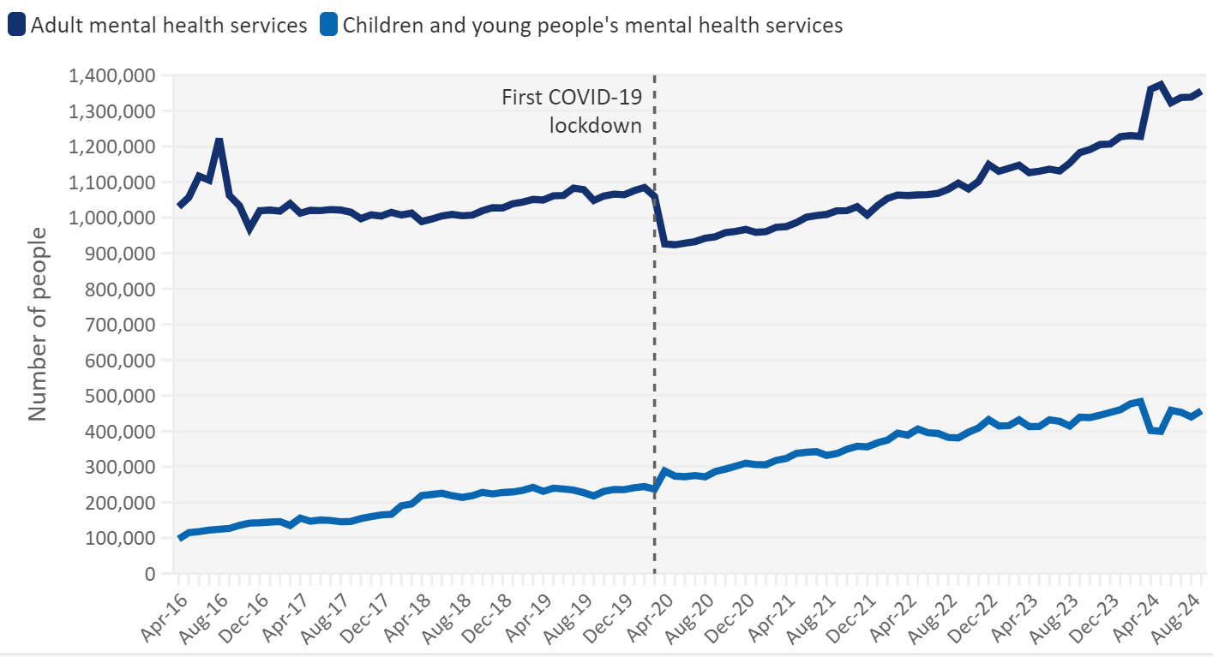
Between 01 April 2023 and the 31 March 2024, Nottinghamshire County Council received 2,355 contacts where the primary support reason was mental health.

Ongoing Monitoring: Please detail when you would like to revisit this policy/project/piece of work for review of equality impact.
This MH Discharge Hub new way of working will be monitored on an annual basis to ensure its continued relevance and effectiveness. Should there be any relevant policies or changes in Mental Health Legislation Policy/Practice, the MH Discharge Hub new way of working will be promptly reviewed and updated to reflect these changes. Currently, the MH Discharge Hub new way of working is owned by Adult Support Services - Improving Lives, which is responsible for overseeing its implementation and ensuring adherence to it.

Please indicate when this form will be reviewed and by who (usually 12 months from today’s date, if you would like to propose another date, please do so)
09/03/2026 | Group Manager for Improving Lives

Publishing, tick the boxes if you agree
I intend to publish this EqIA | ☒
I intend to attach this EqIA to a report | ☒
If you do not intend to publish this report, please explain why:

Next steps and extra information:

Completed EqIAs should be sent to equalities@nottscc.gov.uk.They will be stored centrally by Adult Support Services – Improving Lives. You are also welcome to store them locally.

EqIA’s should be published on the Nottinghamshire County Council website here, Completed Equality Impact Assessments (EqiAs) | Nottinghamshire County Council unless there is a good reason not to make this document available to the public. To get your EQIA published you should use this form, Request a website content change or addition | Nottinghamshire County Council Intranet (nottscc.gov.uk)

EqIA’s should be attached to reports for decision makers to consider: Report writing | Nottinghamshire County Council Intranet (nottscc.gov.uk)

Useful links:

When you can provide a separate or single-sex service | Equality and Human Rights Commission (equalityhumanrights.com)

Health & Safety Management System | Nottinghamshire County Council Intranet (nottscc.gov.uk)

LGBTQ+ Staff Network | Nottinghamshire County Council Intranet (nottscc.gov.uk)

Black Workers Network | Nottinghamshire County Council Intranet (nottscc.gov.uk)

Disabled Employees Support Network | Nottinghamshire County Council Intranet (nottscc.gov.uk)

Corporate and departmental equalities groups | Nottinghamshire County Council Intranet (nottscc.gov.uk) Please contact your departmental equality group chair for further support.

Version 1.0 Last updated October 2024 HR Equalities

