

|  |
| --- |
| **Policy Library Pro Forma**  This information will be used to add a policy, strategy, guidance, or procedure to the Council’s Policy Library. |

|  |
| --- |
| **Title:** Day Care Portal External Provider User Guide |
|  |

|  |
| --- |
| **Aim / Summary:** Guidance for day care providers to follow so that they get paid for services they deliver on behalf of Nottinghamshire County Council. |
|  |

|  |  |  |  |
| --- | --- | --- | --- |
| **Document Type:** | | | |
| Policy |  | Guidance |  |
| Strategy |  | Procedure |  |
| **Approved By:** Service Lead Digital Data System Process | | **Version Number *:** 7 | |
| **Date Approved:**  09/09/2019 | | **Proposed Review Date:**  30/04/2026 | |

|  |  |
| --- | --- |
| **Author:** Mosaic Technical Specialist | **Responsible Team:** Mosaic Development Team - Adults |
| **Contact Number:** 0300 500 8080 | **Contact Email:** [mosaicdevelopmentteam@nottscc.gov.uk](mailto:mosaicdevelopmentteam@nottscc.gov.uk) |

|  |  |
| --- | --- |
| **Publicly Available:** | No |

|  |  |
| --- | --- |
| **Site Link:** | Trix |

|  |  |
| --- | --- |
| **Area on Trix:** Day Care and Transport | **Subheading:** N/A |

|  |  |
| --- | --- |
| **Review date** | **Amendments** |
| 09/03/2017 | Clarification statement added |
| 21/03/2018 | Reviewed |
| 14/03/2019 | Reviewed |
| 06/04/2020 | Reviewed |
| 29/06/2021 | Reviewed |
| 24/04/2023 | Reviewed |
| 05/04/2024 | Reviewed |
| 31/05/2024 | Reviewed |
| 12/05/2025 | Minor amendments to dates and screenshots |
| 11/06/2025 | References to service user replaced |

|  |
| --- |
| NCC-l-head-black |

Nottinghamshire Day Care Portal User Guide

Contents

1. What the portal is for 1

2. Log in 1

2.1 Who can use the system 1

2.2 Where it will be available 1

2.3 When it will be available 1

3. DCP Home screen 2

3.1 Main Menu 2

3.2 Message 2

3.3 My care suppliers 3

3.4 Links 3

4. Choose care supplier 3

4.1 Multiple care providers 3

4.2 Dates that are available for enquiry and updating 3

4.3 How the register is created 3

4.4 Non-Payment weeks 4

5. Description of screen layout, symbols and their meanings 4

5.1 Screen Layout 4

5.2 Symbols and their meanings 5

6. Update appropriate records 6

6.1 What needs amending 6

6.2 Rules governing amendments 6

6.3 What to do if wrong service details appear on the register 6

7. Save 7

7.1 How the save function works 7

8. Submit 7

8.1 Submitting a register 7

8.2 What happens to submitted registers 8

8.3 What happens to the information sent back to Mosaic. 8

9. Log out 8

## **What the portal is for**

The Day Care Portal (DCP) is the system used by Nottinghamshire County Council to collect the details of attendance at day services for people who have had day care commissioned as part of their care package. It is only used for those people for whom Nottinghamshire County Council (NCC) has financial responsibility – there may be other people attending the day service that are paid for privately or by other authorities.

The portal displays the expected pattern of attendance for each person, and providers confirm that pattern or update it to show any changes. Each weekly register must be checked for accuracy by the service provider and submitted for importing into the NCC social care system. The data will then be used to create peoples’ bills and for paying suppliers of services.

## **Log in**

Use this URL to get to the log in page: <https://www.nottinghamshire.gov.uk/daycareportal/>

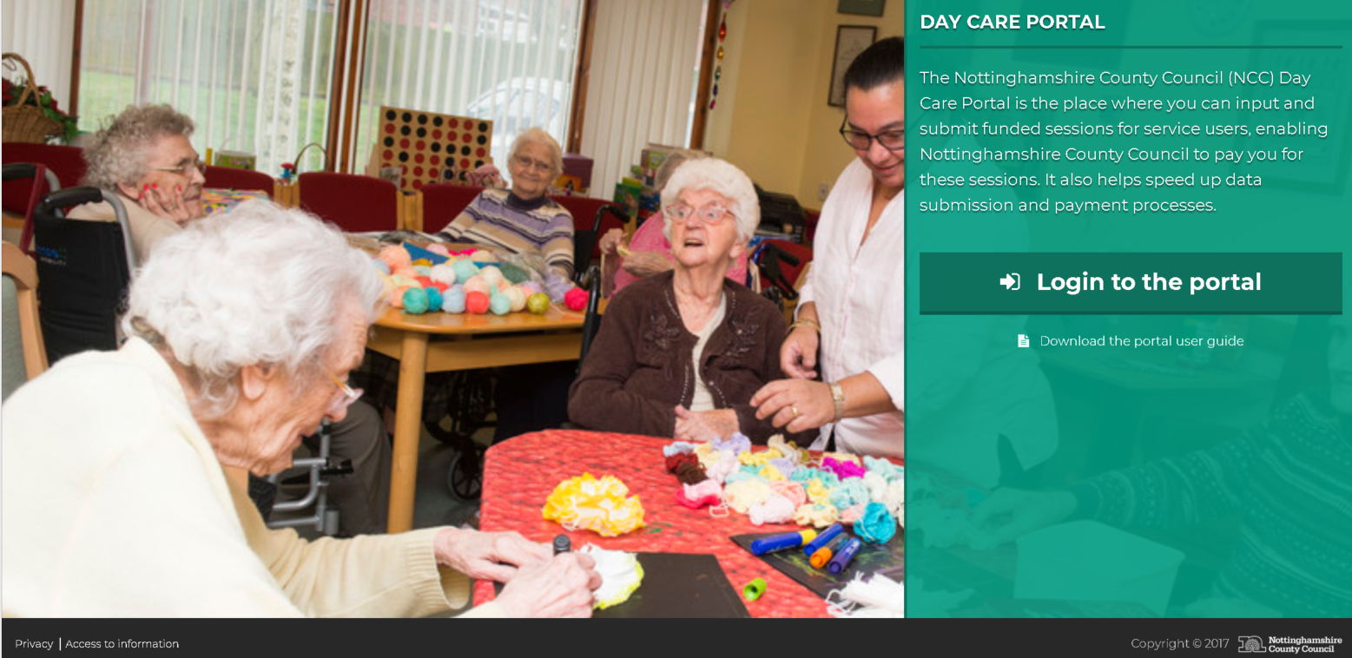

### **2.1 Who can use the system**

Access is arranged through Adult Care Financial Services (ACFS) in Adult Social Care and Health department. Access will be based on an approved email address.

### **2.2 Where it will be available**

Access will be available from any computer with internet access. Two level authentications will be used. Users will have to provide a phone number and receive a verification code when logging in for the first time using their registered email address.

### **2.3 When it will be available**

24 hours a day, 7 days a week, but support will only be available during normal office hours

## **Day Care Portal (DCP) Home screen**

Having logged in you will see your day service:

The progress bar shows you how many registers for previous weeks have been submitted (coloured Green), how many are in progress (coloured Amber) and how many future registers there will be in the financial year.

### **3.1 Main Menu**

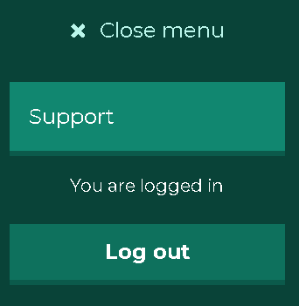

There are two options on the menu:

* Support: This will allow you to request support if there is a technical problem with the day care portal. A blank email will be created and addressed to the Day Care Support team at the Council. You will need to describe the nature of the problem and the steps leading up to it happening. This is for technical problems with the portal itself, not for problems with the data showing – there’s a separate option for that described below (3.4).
* Log out – when you have finished working with the portal

### **3.2 Message**

There is a simple facility to allow ACFS to display messages on the home screen – these messages are for all users of the portal, not directed at individual day service providers.

Some examples are shown below.

* The standard welcome message



* Warning message



* Error message



### **3.3 My care suppliers**

The service providers that you are responsible for updating will be listed on the home screen under ‘My care suppliers’.

### **3.4 Links**

At the bottom of the home screen there are some useful links.

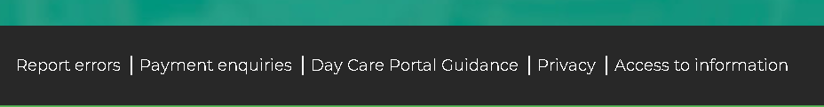

* **Report errors**. Use this for errors that are shown in care packages, or to report errors in past registers that have already been submitted. This link opens an email addressed to the appropriate team in ACFS.
* **Payment enquiries**. Use this for queries about payments that have been received.
* **Day Care Portal Guidance**. Allows you to download a copy of the User Guide.
* **Privacy**. Takes you to the NCC privacy statement.
* **Access to information.** Takes you to the NCC website.

## **Choose care supplier**

### **4.1 Multiple care providers**

If you have been given the ability to amend records for multiple providers, the list will be displayed. Choose the one you want by clicking on ‘Edit register’.



### **4.2 Dates that are available for enquiry and updating**

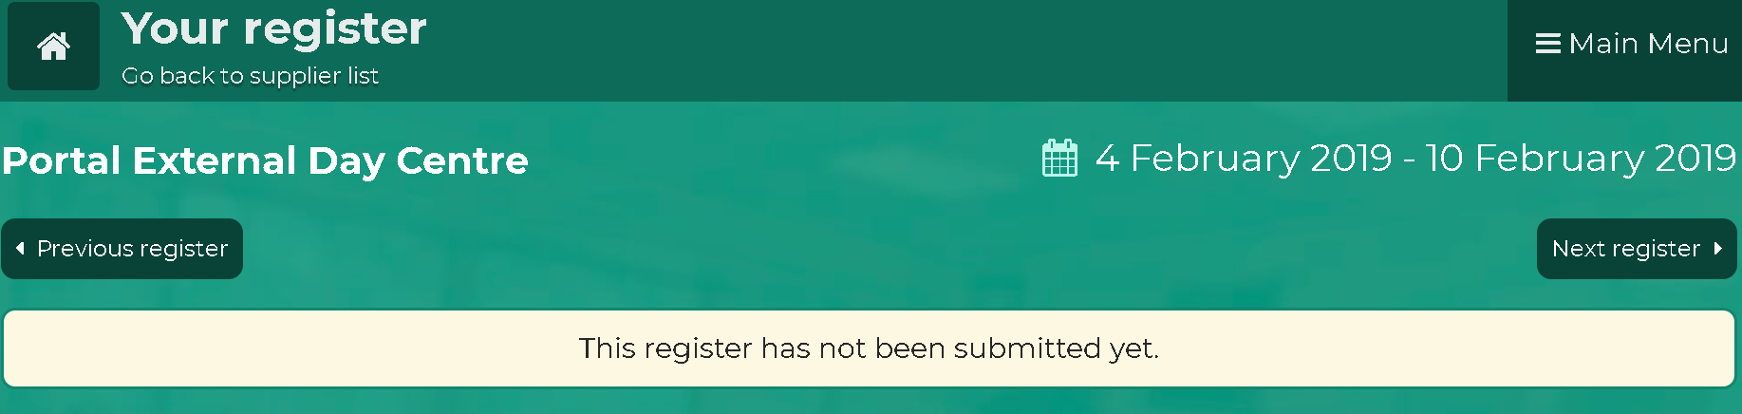

The current year, plus all of last year will be held on the portal. You will be able to go back to previous weeks to look at past details. You will be able to download any register that has been submitted. To download a register click the “download register as .csv” button located under the previous register button.

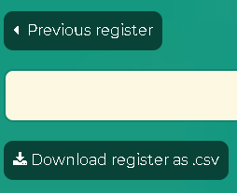

### **4.3 How the register is created**

The day care portal is linked to the NCC social care system called Mosaic. Mosaic is used by care planners to have care plans authorised and purchased. Each night the details of all current day service provisions are exported from Mosaic and the current week register is created from these details. Because this is done daily, the register will always show the most up to date information. Any new people or changes to the level of provision authorised on Mosaic will be reflected in the day care portal within 24 hours.

### **4.4 Non-Payment weeks**

**Rules**. The contract with Notts CC stipulates that payment will be made for 50 weeks of each financial year. Each provider chooses which 2 weeks are classed as their “non-payment weeks”. Ideally, these weeks would be when the service was planning to close anyway.

This means that, for at least two weeks of the year, providers are not paid for their services by the Council. These two weeks are classed as “non-payment weeks”.

The two weeks of specified non-payment **cannot** be spread out over more than two weeks (e.g. you cannot pick two days from one week and three days from another week to make up a full week). The non-payment weeks can be any two weeks of your choice, but for auditing purposes, they have to be two full weeks (Monday to Sunday).

You will be asked to nominate your non-payment weeks, and these will be recorded in the day care portal. If you do not specify your non-payments weeks, ACFS will close the register down for two weeks over Christmas and the New Year.

For each of the non-payment weeks there will be no register produced in the day care portal. Instead, you will see the following message, and there will be no changes to record, or submission needed for that week.



## **Description of screen layout, symbols and their meanings**

### **5.1 Screen Layout**

The layout of the register is like a spreadsheet, with the columns representing the days of the week and then a row for every person who attends at least one session per week. People are listed in surname order. You can scroll down the list and see everyone listed. There’s also a search facility at the top of the list if you have a long list of people attending and you want to go straight to a particular individual.

Column 1 – Person name, purchase order number, reference number and the amount payable per week for their planned day care.

The reference number is the unique identifier used by NCCs social care system for this person.

The amount payable is the number of sessions for the week multiplied by the session rate (also known as the matrix rate). If the person has additional support hours these are added at the standard hourly rate.

Columns 2 to 8 – One column for each day. If the service isn’t available at the weekend (as in the example above) only Monday to Friday will be shown. If there is a weekend service both Saturday and Sunday will be shown (even if there is not a Sunday service).

Column 9 – A shortcut to marking a person as absent all week. If you click on the ‘**x’** all sessions and support hours will be marked as unattended.

### **5.2 Symbols and their meanings**

For each person the number and type of symbols appearing for a day will be based on the care package that has been purchased for them. Each day will, as a minimum, show the AM and PM sessions. There may also be an evening session, 1:1 or 2:2 support hours or transport.





In addition, colour coding is used to show the planned attendance pattern and any variations to it. The default colours are:

* Grey: A session that the person is not expected to attend
* Pale Green: A session that is part of the care plan and has been attended. Also used for showing that the planned additional support hours have been provided
* Orange: A session, or additional support, that is part of the care package but has not been attended
* Dark Green: A session that was not on the care plan but was attended by the person. (See below for rules governing changes allowed to planned services)

The handshake symbol appears beneath any session that has been marked as not attended. By default, this appears coloured green – indicating that notice was given of the absence. When you click on the handshake a range of options will be shown:

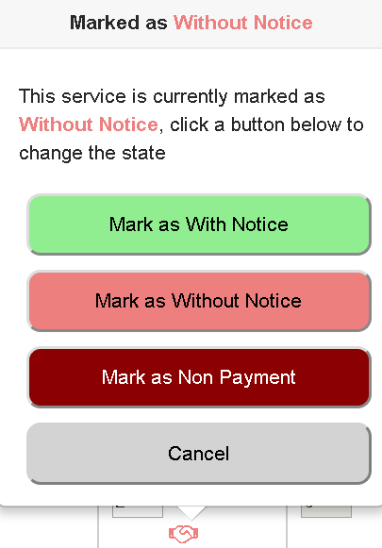

These are used to calculate service user bills and provider payments.

Providers mark the register appropriately – if an absence is marked as ‘without notice’ or ‘with notice’ there will be no reduction to the payment. If ‘non-payment’ is chosen, there will be no payment made for those sessions.

## **Update appropriate records**

### **6.1 What needs amending**

The main principle used by the portal is that you only have to update records where the service received is different to the expected pattern. If everyone receives all of their service as planned, you do not have to make any changes – just submit the register and you will be paid as planned.

Life is not that simple though, and there will be variations that need to be recorded. These can be done whenever it suits you but please remember that registers need to be updated and submitted before you can receive your payment. Payments are made in accordance with the Payment Calendar which is supplied by ACFS.

### **6.2 Rules governing amendments**

You cannot add people. The portal is updated daily and when a new service is commissioned the new person will appear on the register the next day. Previous registers will not be changed as the new person will appear from the current day forward. The Mosaic system will hold the original start date for the service and will backdate payments to the start date even though the register did not include them.

**Permitted changes.** Changes to sessions, support hours and transport if the total for the week does not exceed the amount commissioned. For example, you can record an absence one day and swap to a day when the person does not usually attend.

**Prohibited changes.** Exceeding the number of sessions, support hours or transport journeys for a week. An error message will show where there is a problem, and you won’t be able to submit the register until it is corrected

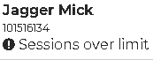

### **6.3 What to do if wrong service details appear on the register**

* **Changes to pattern of attendance** – the total number of sessions and or support hours being shown is correct, but the days are wrong. If the change is a temporary one you should simply update the register each week to show the changed pattern. If it is a permanent change, it can be re-commissioned without the involvement of a social care worker. Use the ‘Report Errors’ email link to notify ACFS and they will arrange for the adjustment to be made.
* **Decreases in service level.** These should be accompanied by a changed support plan and a reduction in the personal budget commitment. If someone is regularly not attending the sessions that have been commissioned, then a social care worker needs to be involved to investigate and, if necessary, adjust the support plan. If there is no social care worker currently involved, please contact the Customer Service Centre (0300 500 80 80) who have a procedure for directing enquiries to the appropriate duty social care worker.
* **Increased level of service**. Contact the social care worker allocated to the person. If there is no social care worker currently involved, please contact the Customer Service Centre who have a procedure for directing enquiries to the appropriate duty social care worker.

## **Save**

### **7.1 How the save function works**

If you make changes to the register the system will automatically save them five seconds after the change is made. There is no need to select ‘Save’ button – simply make the changes and you will periodically see a message confirming that they have been saved:

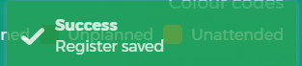

## **Submit**

**Please note that you cannot submit a register until the week ending (w/e) date has passed. For example, register for w/e Sunday 11/05/25 cannot be submitted until Monday 12/05/25.**

### **8.1 Submitting a register**

Each week’s register must be submitted. When this is done no further changes to the register for the week will be possible.

To submit your register, you must select the ‘When you are done’ checkbox at the bottom of the screen.

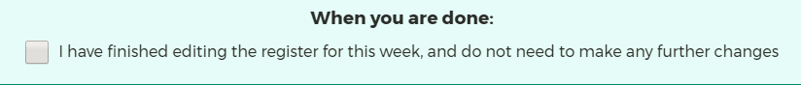

As soon as the checkbox is ticked the ‘Save, Confirm and Lock the Register’ button appears. To submit the register, select this button.

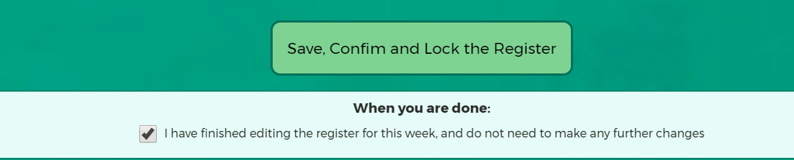

Once a register has been submitted, the status of the register (at the top of the screen) will be updated.



**Please note** - you are not permitted to make any further changes once a register has been submitted. If you have submitted a register in error, or wish to make a further update please contact the ACFS team by clicking on **Report Errors** on the Provider page or the Register page:



### **8.2 What happens to submitted registers**

As soon as a register is submitted an automatic process will send the updated records back to Mosaic. It will still be possible to view submitted registers, but no further updating will be allowed.

### **8.3 What happens to the information sent back to Mosaic.**

Mosaic will use the submitted records for calculating your payment and for compiling service user bills.

## **Log out**

Use the link from the main menu on the home screen – or simply close the browser.