Co-production Group Biographies
Find out more about the members of Our Voice

Alyson Fisk
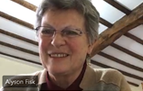
I originally come from Waltham Cross in Hertfordshire and went to university in Swansea to study Zoology, gaining a degree way back in 1975. My first job was as a lab technician in Cambridge where I met my husband. We moved to the East Midlands because of his work, eventually living in Collingham near Newark for the past 37 years. I have three sons, the eldest of whom was born with Down’s Syndrome, having a severe learning disability and a severe language disorder. Ben is beautiful, challenging, fun and loving and I am his primary carer. He still lives at home with me and his youngest brother. Being Ben’s advocate and unpaid carer has been challenging for me over the years, but also fulfilling in many ways. I have been involved in the fight for inclusive schooling, fighting against prejudice and for equal rights. I have been a part of many different organisations as a volunteer and as a representative of other parent/carers. In these roles I have tried to come up with solutions for Ben and others to be truly included in mainstream schools and further education. As a volunteer for Parent Partnership I was also able to help other parents in their particular challenges within education. Similarly, within Adult Social Care I have fought to maintain sufficient support hours and have flexible use of Direct Payments to be able to provide my son with a good life. Along the way I have also achieved 2 City and Guild Certificates in Ceramics, have taught pottery to adults with learning disabilities and set up my own business as a Potter and Pottery Tutor, teaching from home - which has been interrupted by Covid - but hope to start again eventually.

Why did I want to be involved in Our Voice co-production?
I wanted to be able to change the systems which were causing the problems for many people and carers. Although I have been a member of different groups within education and social services I always felt professionals took the lead and to a greater or lesser extent did not treat me as an equal. Co-production is a radical system which, when done well, can produce positive outcomes for both people who use services and also for the staff who are tasked to manage and provide those services. We share power and then learn to trust each other resulting in a culture change within the organisation. It means that people and carers will in future be ‘done with’ rather than ‘done to’. That is such an empowering statement. This model of working will take time and will be more difficult for some individuals and organisations which have long been working in a completely different way. But I am convinced that this is a much better way to manage a service for people.

Dean Thomas

A Bit About Me
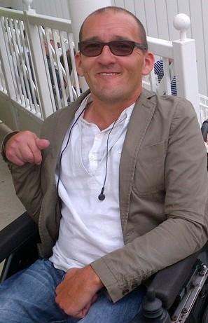
Hi, I am Dean Thomas now living in Beeston, Notts, originally from South Wales. I am in my late 40s and am married to my 2nd wife Ami, and we live “independently” with the personal and practical support from a team of Personal Assistants (PAs) who we directly and “jointly” employ funded through Direct Payments. We both have Cerebral Palsy which is our primary medical condition. I have a son called Joe from my previous marriage now aged 21 and who has just graduated from Manchester Met University. Most of my education took place at boarding Schools, boarding Sixth Form College, culminating at Coventry University where I graduated with a 2:1 in Communication Studies in 1994. Finally one of my other significant achievements, was to compete at International level for over a decade in a sport called Boccia (akin to bowls), where I took part in 3 Paralympic Games and several European and World Games winning a handful of medals along the way.

Why I have Joined Our Voice
Firstly I have over 30 years personal experience of directly employing PAs, first through the Independent Living Fund and then through Direct Payments as we currently know them. This has in no uncertain terms facilitated me to live an active and empowering life, including going to Uni, have a sports career, be in a few paid jobs, be an active citizen / volunteer / campaigner, get married (twice) and bring up my son.
In the mid to late 90s I worked as a Disability Sports Development Officer firstly for Sheffield City Council and later with the Charity Scope.
More relevantly I have both worked with a 3rd sector organisation providing a Support Service to Direct Payment recipients in Cumbria, then as a Direct Payments Officer for Rotherham City Council. Both these jobs taught me a great deal about Direct Payments from many different perspectives.
Throughout the 2000s I was heavily involved as a volunteer and Committee member of another national 3rd sector organisation called Disabled Parents Network, providing information, advice and support to disabled parents which in many cases included peer support, advocacy and sometimes facilitating Direct Payment and other Benefits Assessments with them.
So It goes without saying I would like to put these experiences to good use, to try and improve how Direct Payments and other things are delivered here in Notts now and in the future.
Thanks Dean

Ed Lowe
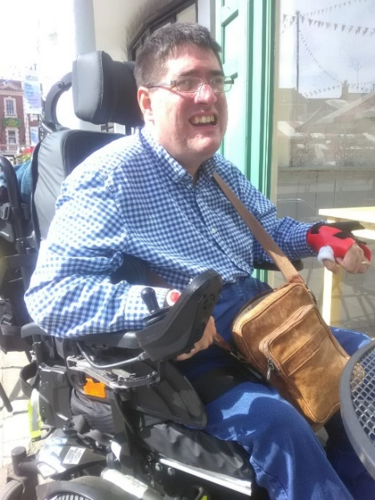
My name is Ed Lowe and I am 38 years of age. I live in Newark with my fiancé Mark and I have been a direct payment recipient since 2004. I use my direct payment to employ a team of personal assistants (PAs) to support me to live my day-to-day life.
I have Cerebral Palsy and am a full-time electric wheelchair user. My parents fought for me to attend mainstream school and I’m so glad they did, as it’s given me the life and skills that I have today. I went to Coventry University and graduated in 2007 with a 2:2 in Communication, Culture and Media, which I’m very proud of and I am also now a trained Counsellor for the LGBTQ+ community.
My parents always wanted the best for me, and I am proud to say that I have achieved everything I have set out to achieve so far!

Why I Have Joined Our Voice?
I have worked in different voluntary roles throughout the years, from working in various charity shops to being on a board of directors for Newark and Sherwood Homes.
I have helped children with additional educational needs and their families to get the support they need at home or at school and I have even produced, presented and worked at a local BBC Radio station, helping to produce programmes and content.
My work with Nottinghamshire County Council began in 2009 when I became a member of what was then the Disability Advisory Group alongside my late friend and colleague Veronica Price-Job. I joined as I wanted to make things better for disabled people. Although I started off as a member of the group I voiced to Veronica that I would like to Chair it and she enabled me to do just that.
When Our Voice was mentioned I knew I wanted to be a part of it. I co-chair the group alongside one of the Service Directors for Adult Social Care. I am passionate about using my experience to help others and to make social care better for all those who use it now and in the future. I want to help others who don’t have a voice.

Eddie Morecroft
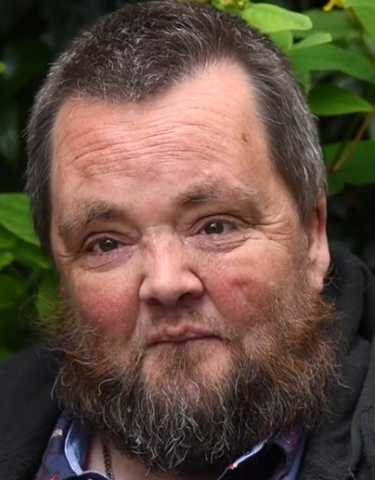
Hi, I am Eddie Morecroft from Lowdham. I live in my own flat and love it here. I have been part of the village panto since I was 12. I am a massive Harry Potter fan. I have read all the books seen all the films and bought all the merchandise. I even called my dog Dobby! I love heavy metal and punk and usually go with my mates to Download festival.
I was a member of the parish council in the village for a few years as wanted to make life better for everyone. I helped get some new benches in the bus shelters as saw older people rushing to cross the main road to catch a bus as there was only a seat on one side of the road for them. I was really worried about people. getting knocked.
I have a learning disability and after I left school, I went to a day centre for people with a learning disability. At the time this helped me learn how to be more independent and get control of things BUT I grew out of it and just wanted to do more so got a direct payment instead to help me keep healthy.

Why am I involved with Our Voice?
I have done loads of stuff in the past to try to make things better for everyone with a learning disability. I was co-chair of a learning disability board. I quality checked different services in Notts for people with a learning disability. I set up a training company We Can Do It with some friends with a learning disability so we could tell different organisations about what a good life meant and to ask everyone to ‘stop wrapping people with a learning disability in bubble wrap’.
Sadly the pandemic meant lots of things I has been involved in had to stop. But I wanted to still make a difference so joined Our Voice so I could use all of my experience. Since joining I have learnt what working together with different people can do. I have learnt from other group members about how different things work and they have learnt from me. Together we share ideas and work with staff to try to make things better for everyone.

Marion Wardill
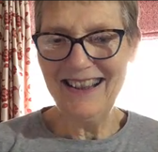
Hi, I am Marion Wardill, married to John who has MS and whose care needs over the past 20 years have been the reason for my involvement in any work which seeks to improve home care.
We met at Nottingham College of Education in 1968, graduating and marrying in 1972. Our daughter was born in 1979. She followed us into the teaching profession! We both taught in primary schools in Nottingham and Nottinghamshire, however at the age of 32 John was diagnosed with MS and had to take early retirement in 1994. I continued until 2005 when managing John’s care and frequent relapses meant I could not invest in my paid(!) job as much as I wanted to. It was a job that I absolutely loved and I missed it. Needing something to fill the gap and also flexible enough to manage John’s needs, I became a link tutor at Nottingham Trent University and went from teaching 5-7 year olds to working with 18+ students in their teaching practice placements.

As John’s condition deteriorated, I had to acknowledge that it just wasn’t possible to carry on and so my career in volunteering began. I helped at a local advice centre every Wednesday, meeting such a variety of people and dealing with the bureaucracy that blighted their lives! I had by this time become adept at form filling: applying for Disability Living Allowance and then Personal Independence Payment for John. The most frustrating part of managing his care was getting the care right.

Why did I join Our Voice?

A random opportunity presented itself when I attended a meeting. I was one of only two carers to turn up and the floor was mine! As a result, I was approached to join a new group of Experts by Experience. This group supported the work of Adult Social Care, particularly around home care. We were listened to and asked for our opinions as the experts. It was a brilliantly productive time, actually it was a brilliantly co-productive time. And now the drive to improve adult social care is embodied in Our Voice. We are working with those who are responsible for the delivery of care to ensure that the people who are dependent upon it are listened to and equally involved in shaping adult social care in Nottinghamshire. Exciting times!

Sarah

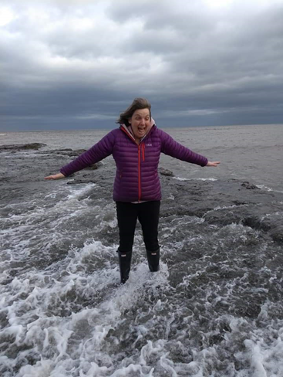
What I bring?
A passion for involving people in things that are important to them. I have experience of working alongside different groups of people, supporting them to work together and solve problems to improve services. I see myself as someone the group can call on for help if you need it.
Who I am and what is important to me?
I live in Nottingham with my partner and two sons Josh aged 17 (and don’t I know it!) and Nic who is 13. Life tends to revolve around supporting the boys and so I like nothing more than an empty house and time for a coffee and a bit of quiet! When I can (get the boys away from the X box) family time, going out for a walk, a cycle or trip away is important to me.
I was born in Nottingham but moved away as a teenager when I went to college in Hertfordshire. I qualified as a social worker and stayed in the south working first as a residential social worker, before dabbling in research for a bit at Southampton University. But this experience reinforced for me how much I needed to work with people, and I left and went to work as an advocate for 4 years.
I returned to Nottingham around 20 years ago and have had different jobs working in adult social care since then, as a Social Worker, Supported Living Coordinator and a Person-Centred Planning Manager. I am excited that my new role is allowing me to focus on co-production and supporting everyone to work together so we improve services for all. I am passionate about people with lived experience being involved equally in designing, delivering and reviewing services as recognise that it is only by including lots of different voices that we can really make social care better.

