Social media plan – spring HAF messages

Channel | Message | Image/asset | Alt text
Twitter | 🐥 Holiday activities and food this spring school holiday!  This school spring/Easter holiday we’re excited to bring fun activities to eligible families, with a free meal provided for each session!  Find out more and book on from next week #HAF2023 ⬇️  www.nottinghamshire.gov.uk/hafprogramme | 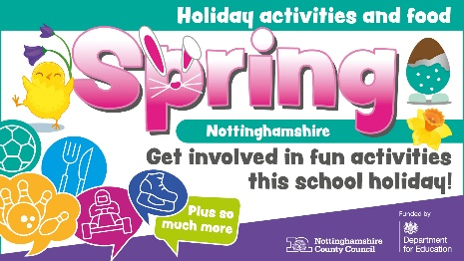 | Colourful graphic image with text. The text is surrounded by icons representing activities such as bowling, sport and food. The text reads: “holiday activities and food, spring, Nottinghamshire. Get involved in fun activities this school holiday!”
Facebook | 🌷 Holiday activities and food this spring school holiday! 🐥  This school spring/Easter holiday we’re excited to bring fun activities and food to eligible families.  There will be plenty of free activities for children and young people to enjoy over the holiday, and there will be a meal provided for each activity session!  If your child qualifies for benefits-related free school meals, you can find out more and book your place here #HAF2023 ⬇️  www.nottinghamshire.gov.uk/hafprogramme |  | Colourful graphic image with text. The text is surrounded by icons representing activities such as bowling, sport and food. The text reads: “holiday activities and food, spring, Nottinghamshire. Get involved in fun activities this school holiday!”
Facebook | ⚽🌳🥗 HAF is here! 🖌️🎭🍝  The holiday activities and food (HAF) programme is for children and young people aged 5-16 who are in receipt of for benefits-related free school meals, offering them free meals and activities in the spring school holidays.  Find out more #HAF2023 ⬇️  www.nottinghamshire.gov.uk/hafprogramme  Book activities ⬇️  https://www.nottshelpyourself.org.uk/kb5/nottinghamshire/directory/results.page?term=&sorttype=relevance&servicepartnership=1 |  | Colourful graphic image with text. The text is surrounded by icons representing activities such as bowling, sport and food. The text reads: “holiday activities and food, spring, Nottinghamshire. Get involved in fun activities this school holiday!”
Twitter | ⚽🌳🥗 #HAF2023 is here!  The holiday activities and food (HAF) programme is for 5-16 year olds receiving benefits-related free school meals, offering food & activities in the school holidays.  Find out more ⬇️  www.nottinghamshire.gov.uk/hafprogramme  Book activities ⬇️  https://www.nottshelpyourself.org.uk/kb5/nottinghamshire/directory/results.page?term=&sorttype=relevance&servicepartnership=1 |  | Colourful graphic image with text. The text is surrounded by icons representing activities such as bowling, sport and food. The text reads: “holiday activities and food, spring, Nottinghamshire. Get involved in fun activities this school holiday!”
Facebook | 🌷 There’s still time to get involved with HAF! 🐇  The holiday activities and food programme is in full swing! HAF offers eligible children and young people free activities and meals over the spring school holiday.  The programme is eligible for children who are in receipt of benefits-related free school meals. Find out more or book #HAF2023 ⬇️  www.nottinghamshire.gov.uk/hafprogramme |  | Colourful graphic image with text. The text is surrounded by icons representing activities such as bowling, sport and food. The text reads: “holiday activities and food, spring, Nottinghamshire. Get involved in fun activities this school holiday!”
Twitter | 🌷 There’s still time to get involved with HAF!  The holiday activities and food programme offers eligible children and young people free activities and meals over the upcoming school holiday.  Find out more or book #HAF2023 ⬇️  www.nottinghamshire.gov.uk/hafprogramme |  | Colourful graphic image with text. The text is surrounded by icons representing activities such as bowling, sport and food. The text reads: “holiday activities and food, spring, Nottinghamshire. Get involved in fun activities this school holiday!”

