**Introduction**

The effective management of health and safety is an important factor in delivering corporate objectives and is consistent with the County Council’s core values. This policy describes how Nottinghamshire County Council is committed to the management of health and safety and has three sections;

* A1: Statement of corporate commitment
* A2: Definition of roles and responsibilities
* A3: Health and safety management system arrangements

Effective health and safety management enables service delivery by preventing ill health and injury to employees and service users and by maintaining a healthy workforce. Developing and maintaining the commitment to good health and safety standards is an important corporate objective and all employees are expected to adopt a positive attitude towards these arrangements and be active in implementing them.

Nottinghamshire County Council commits to preventing ill health and injuries related to psychosocial risk and providing initiatives promoting well-being at work.

 This will be achieved by working to the principles of the health and safety management standard ISO 45003

This policy statement

* sets out the County Council’s commitment to high standards of health and safety management and explains the arrangements in place to establish an effective and robust health and safety management system;
* requires the establishment of a health and safety management system designed to eliminate or minimise risks to employees and others who could be exposed to health and safety hazards associated with its activities;
* aims to ensure that all staff and members are clear about who does what, when and how in order to effectively control the risk of harm and other related business losses; and
* is supported by a series of guidance documents intended to assist employees to fulfil the objectives and requirements of the policy

The County Council’s policy applies to all County Council employees, activities, equipment and properties that operate under the control of the County Council.

Further details on the policy and arrangements that support it are available on the intranet. A hard copy is available to staff who do not have access to a computer.

**Statement of General Policy**

**The County Council is committed to taking all reasonable steps to prevent accidents and cases of work-related ill-health and provide adequate control of health and safety risks arising from work activities by ensuring the provision of:**

* Safe and healthy workplaces and conditions;
* Safe and well-maintained plant, equipment and machinery;
* Safe storage and use of hazardous substances and materials;
* Safe systems and methods of work; and
* Information, instruction, training and supervision.

**The County Council is committed to maintaining effective management systems to enable compliance with legal and good practice requirements on health, safety and welfare and to enable sensible risk management with pragmatic solutions, through:**

* Assessment and control of significant risks to all those who may be affected;
* Effective planning, with clear objectives, monitoring and review of compliance with policy and legal requirements with the aim of continually improving performance;
* Integration of health and safety with other business functions;
* Worker involvement, participation and consultation; and
* Provision of sufficient resources to meet the commitments outlined in this policy.

The County Council makes a commitment to ensure that employees understand their roles, responsibilities and accountabilities. Employees are required to actively support the Council’s efforts by working with due regard for the safety of themselves and others who may be affected by their actions. The County Council will require compliance in this from contractors, partners, volunteers and co-operation from clients and other visitors who use facilities and premises. This policy will be reviewed on an annual basis and changes will be brought to the attention of employees. This Policy has the support of Corporate Directors and their Leadership Teams and will be implemented within their Departments.

Signed by:

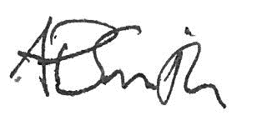

Adrian Smith

Chief Executive

 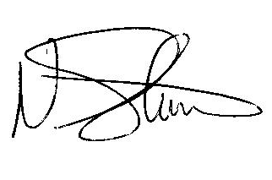

Melanie Williams Nigel Stevenson

Corporate DirectorService Director

Adult Social Care and Health Chief Executives

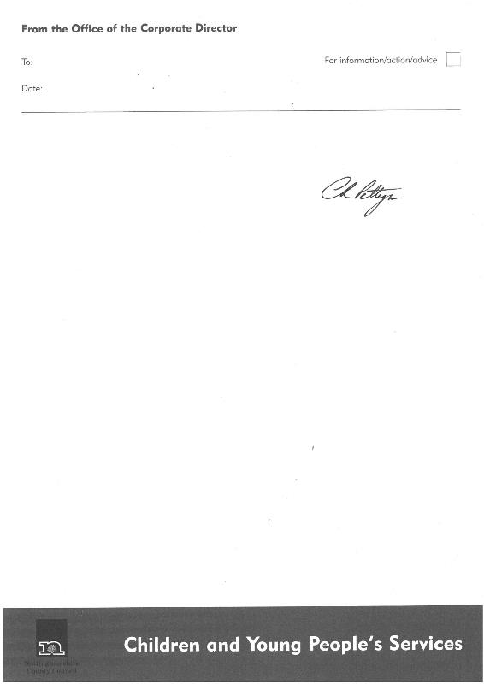 

Colin Pettigrew Marjorie Toward

Corporate Director Service Director

Children and Family Services Chief Executives

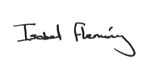

Isobel Fleming Derek Higton

Service Director Interim Service Director

Chief Executives Place

**Supporting Documents**

* [Health and Safety Policy poster](http://home.nottscc.gov.uk/working/hr/health-safety/safety-manual/section-a1)
* [Health and Safety Documents](http://home.nottscc.gov.uk/working/hr/health-safety)
* BS ISO 45001:2018 - Occupational health and safety management systems
* BS 45002 - General guidelines for the application of ISO 45001