PUBLIC CONSULTATION

Better Broadband for Nottinghamshire
Phase 3 Better Broadband for Nottinghamshire Contract

Update to existing project to further extend coverage of Next Generation Access (NGA) Broadband across Nottinghamshire.

1. INTRODUCTION AND BACKGROUND

Through three separate contracts with British Telecom (BT) and Openreach, Nottinghamshire County Council has taken the superfast digital infrastructure (speeds greater than 24Mbps) across Nottinghamshire from a baseline of 86% to 98.7%. The intention is to invest further to extend the availability of NGA broadband infrastructure to 100%, and to support the Government’s ambition for gigabit-capable broadband (capable of delivering download speeds of at least 1Gbps) network to reach every corner of the UK.

Geographically, Better Broadband for Nottinghamshire covers all County within seven borough and district council area (Ashfield District, Bassetlaw District, Broxtowe District, Gedling Borough, Mansfield District, Newark and Sherwood District, Rushcliffe Borough). Nottinghamshire County Council completed its original public consultation under the National Broadband Scheme for the United Kingdom (referred to hereafter as the 2016 NBS) in July 2017.

Following completion of the public consultation, Nottinghamshire County Council completed an open procurement in respect of the remaining area without NGA broadband infrastructure (known as “white NGA”), which comprised around 17,700 premises. It awarded contract to Openreach.

As set out under paragraph 89 of the 2016 NBS, Nottinghamshire County Council wishes to include further coverage within the scope of the existing intervention area. The Nottinghamshire County Council needs to ensure that the further coverage proposed continues to target NGA white areas. Therefore, it is required to run a new mapping and public consultation exercise for the area concerned as more than three years have lapsed since the public consultation for the whole intervention area identified in the tender.

2. MARKET ENGAGEMENT AND ANALYSIS OF EXISTING COVERAGE

Nottinghamshire County Council conducted an OMR between January - February 2017 to establish existing and planned (within the 3 years) coverage of broadband infrastructure across the Better Broadband for Nottinghamshire Area. This included both commercial coverage by existing and prospective NGA broadband infrastructure providers and coverage procured under Nottinghamshire County Council’s existing contracts with BT and Open Reach. A public consultation was subsequently published to determine the intervention area and enable Nottinghamshire County Council to target NGA white areas with public funds. The public consultation closed on February 2017 and enabled targeting of public funds for 3 years from closure.

Nottinghamshire County Council contacted all known broadband infrastructure operators within the Programme Area and other providers known to have (or potentially having) plans to deploy new networks across the UK with a formal request for information. The OMR and public consultation were publicized through the Nottinghamshire County Council website. Operators were requested to provide information on their existing and planned NGA broadband infrastructure (capable of delivering download speeds of at least 30 Mbps), and to provide detail of their coverage at a premise level so as to enable greater granularity of mapping.

This information, together with Nottinghamshire County Council's own data sources, was used to define the existing intervention area for the existing project.

This further public consultation sets out the existing intervention area, so as to enable all interested stakeholders (including the public, businesses, internet service providers and broadband infrastructure operators) to comment on the proposals. In particular, this provides an opportunity for broadband infrastructure operators to review Nottinghamshire County Council’s mapping to ensure that it correctly represents the information provided by them in the course of the original OMR and public consultation completed in 2017.

All responses to the public consultation will be carefully considered and where necessary will be incorporated into the final map of the intervention area. The final intervention area maps and a summary report confirming details of the changes made to the existing intervention area will be published on the Nottinghamshire County Council website shortly after the close of the consultation period. Where responses to the consultation are received, Nottinghamshire County Council will respond to these and provide an explanation of how the information submitted has been treated. The finalized intervention area will then be submitted to BDUK’s National Competence Centre (NCC) for approval against the State aid Framework.

3. STATE AID FRAMEWORK AND RULES

This section provides a brief introduction to the State aid Framework for the purpose of informing responses to the public consultation. Respondents may wish to obtain their own professional/legal advice on the application of the State aid Framework and rules that relate to this proposal.

The European Commission has published ‘EU Guidelines for the application of State aid rules in relation to the rapid deployment of broadband networks’ (2013/C 25/01’.These guidelines summarise the principles of the Commission’s policy in applying the State aid rules of the Treaty to measures that support the deployment of broadband networks, and seek to ensure that State aid schemes for broadband are well-designed so that they target market failures and minimise negative effects on competition.

The guidelines require public interventions to be targeted so as to limit the risk of crowding out private investments, of altering commercial investment incentives and ultimately of distorting competition.

Planned public interventions can seek State aid approval directly from the Commission, or (as is the case with this proposal) seek clearance under a national scheme which has been pre-approved by the Commission.

Projects under the 2016 NBS will need to demonstrate their State aid compliance (in accordance with the terms of the scheme) in order to receive clearance from BDUK’s National Competence Centre.

The Commission’s guidelines distinguish between two types of broadband networks, namely basic broadband and NGA networks.

Basic broadband networks are generally those based on currently widely deployed technologies such as fixed wired telephony networks (using ADSL/ADSL2+ technologies), non-enhanced cable TV networks (e.g. DOCSIS 2.0), mobile networks (2G/3G (UMTS)), some fixed wireless access (FWA) networks, and satellite networks.

NGA networks rely wholly or partly on optical elements (optical fibre) and are capable of delivering an enhanced broadband capability compared to existing basic broadband networks. Current qualifying NGA technologies are fibre-based networks (FTTx), advanced upgraded cable networks (DOCSIS 3.0) and certain advanced wireless access networks capable of delivering reliable high speeds.

Guidance on the characteristics of qualifying NGA technologies is available from BDUK.

The Commission’s guidelines also require that public intervention should be able to ensure a ‘step change’ in broadband availability. This is demonstrated by:

- Significant new investments in the broadband network;
- The new infrastructure brings significant new capabilities to the market in terms of broadband service availability and capacity, speeds and competition;

The ‘step change’ in broadband availability shall be compared to that of existing as well as concretely planned networks.

The Commission’s guidelines also distinguish between geographic areas on the basis of their existing or planned broadband infrastructure:

- ‘White’ areas are those in which there is no qualifying broadband infrastructure, and none is likely to be developed within 3 years;
- ‘Grey’ areas are those where only one network is present or is to be deployed within the coming 3 years; and
- ‘Black’ areas are those where at least two networks of different operators exist or will be deployed in the coming 3 years.

NGA networks are mapped on the basis that, amongst other things, they have substantially higher upload speeds (compared to basic broadband networks) and are able to deliver broadband services at an access (download) speed of more than 30Mbps.

Public intervention can only take place in white NGA areas under the 2016 NBS. White NGA areas are those in which there are no NGA networks, and none is likely to be developed within the next 3 years.

- EXISTING INTERVENTION

For NGA, In the absence of premise level data from some broadband infrastructure operators Nottinghamshire County Council has mapped areas as white, grey or black at a postcode level, using the following criteria:

- A postcode is turned grey if all premises in the postcode have access to NGA services (with speeds greater than 30Mbps) from one broadband infrastructure operator.

- A postcode is turned black if there are at least two broadband infrastructure operators providing NGA services (with speeds greater than 30Mbps) to all premises in that postcode.

- All other postcodes remain white i.e. all postcodes with at least 1 confirmed white premise remain white and eligible for intervention.

In addition, the proposed intervention area includes a number of “under review” areas where premise level NGA coverage has not been clarified (colored blue on the map). These areas have previously been indicated to have planned commercial coverage for NGA broadband (i.e. mapped as grey or black NGA), but those plans have been reported through the OMR as being ‘at risk’ of not being completed. Areas that potentially have NGA white premises but where individual premises cannot yet be identified have also been marked “under review”. These areas will be subject to continued monitoring and verification of supplier plans within the next 3 year period by Nottinghamshire County Council and in the event that these commercial plans fall away these premises will be mapped as white NGA and form part of the proposed intervention area and eligible for intervention via this aid measure.

The mapping analysis of existing and concretely planned coverage (within the next 3 years) has identified significant remaining ‘white NGA’ areas. The outcome of the OMR is summarised in terms of NGA White, Grey, Black and ‘Under Review’ premises below:

Postcode NGA classification | Number of Postcodes | Number of Black Premises | Number of Grey Premises | Number of White Premises | Number of Under Review Premises
White | 2,229 | 0 | 18,172 | 32,060 | 60
‘Under Review’ | 1,966 | 0 | 31,856 | 0 | 48,522

Nottinghamshire County Council intends to extend coverage to target the remaining ‘white NGA’ areas using its existing contract with Openreach under the 2016 NBS (and in accordance with the Public Contracts Regulations 2015)

As noted above, if commercial plans fall away in the ‘under review’ areas then these will be considered as eligible for intervention and considered as ‘white NGA’ areas.

- Timescales

This consultation will be open until 21/02/2021.

Once the consultation is closed and Nottinghamshire County Council has finalised the intervention areas, additional NGA broadband coverage will be targeted to the premises set out in the public consultation via its existing contract. The related extended deployment plans for broadband infrastructure should begin by the end of this year.

- State Aid Public Consultation

The EU Guidelines (at paragraph 78) and the 2016 NBS set out the requirements to hold a public consultation in order to validate the intervention area mapping by allowing all interested stakeholders an opportunity to comment on the planned aid measure.

The purpose of this document is to fulfil those requirements by publishing a description of the existing aid measure and seeking feedback from all interested stakeholders. The mapping for NGA broadband is shown in the attached map.

The attached map of the NGA broadband Intervention Areas relies on the definitions of white, grey and black areas, as set out in the EU Guidelines (and as summarised above). Nottinghamshire County Council will only target the areas identified as White on the map.

This State aid public consultation and the existing NGA broadband Intervention Area map are available to all stakeholders on the Nottinghamshire County Council website and will also be available via BDUK’s website at BDUK Table of local broadband projects.

- Responding to this State Aid Public Consultation

Nottinghamshire County Council is requesting information and supporting evidence in relation to basic and NGA broadband infrastructure within the project area and wish to hear from all relevant stakeholders (including residents, businesses as well as broadband infrastructure operators), particularly in relation to areas to be targeted as part of the NGA intervention area at Annex [A].

For the avoidance of doubt, there is no need to respond to this public consultation if you have no comment to make.

For residents and businesses, where this relates to the ability to receive an NGA service, any information provided in response to this State Aid public consultation should as a minimum include (but need not be limited to) the address of the property or area that the submission relates to and the nature of the concern.

If the response is from an infrastructure provider and comments on the white, grey and/or black or under review classifications within the attached maps or data, or on the wholesale products to offered via the subsidised network, then the submission should also include the specific information set out in Section 8.

For all submissions, Nottinghamshire County Council would be grateful if you would contact Nottinghamshire County Council to register your intention to submit a response and could confirm in your submission the following:

- Your organisation’s name (if applicable)
- Your organisation’s address (if applicable)
- Your name
- Position
- Contact telephone number
- Email Address

Nottinghamshire County Council will then arrange access to the Response Template (or subset thereof if you are reporting on a specific area).

Nottinghamshire County Council also requests confirmation from an authorised signatory that the information provided is suitably accurate and up to date.

Please send your responses no later than 21/02/2021 to:

Jess Tomlinson

C/O: enquiries.broadband@nottscc.gov.uk

Please note that the data you provide in your response will be treated as commercially confidential to your organisation. However, it may be necessary to share/some all of your response data with our professional advisers and/or DCMS/BDUK, Ofcom, the National Competence Centre and the European Commission in the course of seeking State aid approval.

It should also be noted that it is a State aid requirement to use this information to produce State aid maps to define white, grey and black areas for basic and NGA broadband. However, the published maps will show the aggregated White/Grey/Black NGA areas, not the data provided on a per-operator basis. The final maps that will be used for procurement purposes will be published shortly after the conclusion of this State aid public consultation and once approved by the National Competence Centre.

If you have any questions about any of the above, please contact the Nottinghamshire County Council by email as above.

- Information Requested

This section specifies the information you are requested to provide in response to this State aid public consultation in relation to the presence of broadband infrastructure.

Nottinghamshire County Council is requesting information on, and supporting evidence for, any current or planned (within the next 3 years) investment in broadband infrastructure in the Better Broadband for Nottinghamshire Area, where this may not be already included within the existing NGA intervention area map attached.

For any current or planned coverage not included within the existing State aid intervention areas shown on the attached map, Nottinghamshire County Council is requesting information at premise level, using the template issued by Nottinghamshire County Council upon receipt of a signed contractor license to show existing or planned coverage by your broadband infrastructure investment. By ‘covered’ (or ‘passed’) Nottinghamshire County Council means that fixed network infrastructure is or will be available to the premises, potentially subject to a final drop connection, or that the premises are able to receive a suitable quality radio signal over the air interface, potentially subject to the installation of a suitable antenna.

Any information provided in response to this State aid public consultation should include, but need not be limited to:

- Detailed maps for NGA broadband showing existing and planned coverage, for at least the next 3 years.
- Details of premises covered or passed that fixed network infrastructure is or will be available to the premises within the next 3 years, potentially subject to a final drop connection, or that the premises are able to receive a suitable quality radio signal over the air interface, potentially subject to the installation of a suitable antenna.
- A detailed description of the technology solution(s) deployed (or to be deployed) in your broadband infrastructure, demonstrating how they meet the minimum standards as set out in the BDUK NGA Technology Guidelines.
- A description of the services/products currently offered, and separately those services/products to be offered within the next 3 years.
- Installation, annual/monthly subscription, and additional volume or per-service tariffs for those services/products (identifying whether such tariffs are inclusive or exclusive of VAT).
- Upload and download speeds typically experienced by end-users, and how these may vary by factors such as distance, increased take-up or demand, contention, etc.
- Appropriate indicators of the quality of services (e.g. contention ratios, bandwidth allocation per user, etc), including any characteristics (e.g. latency, jitter) that are required to support advanced services such as video conferencing or HD video streaming.
- Evidence to substantiate actual or planned coverage claims, including business cases and evidence of available funding to enable plans to be fulfilled.
- Details and planned timing of roll-out of any future investments, including further investments required to cope with future increases in take-up or demand.

Please supplement the required information above with any supporting evidence as you consider appropriate (e.g. links to public websites).

Nottinghamshire County Council would also be interested to hear from operators their views as to the types of wholesale access products they would like to see offered on any newly created subsidised NGA network infrastructure. This information may inform the intervention design. Please note that we are not obliged to include these products in the invitation to tender (unless already required under any State aid Decision).

8. Next Steps

Following any responses received to this State Aid public consultation by the closing date of 21/02/2021 Nottinghamshire County Council plans to publish the final Intervention Area maps shortly after the close of the consultation period.

Information about the Better Broadband for Nottinghamshire can be found at:

https://www.nottinghamshire.gov.uk/business-community/better-broadband-for-nottinghamshire-programme/about-the-programme

Annex A

NGA Map

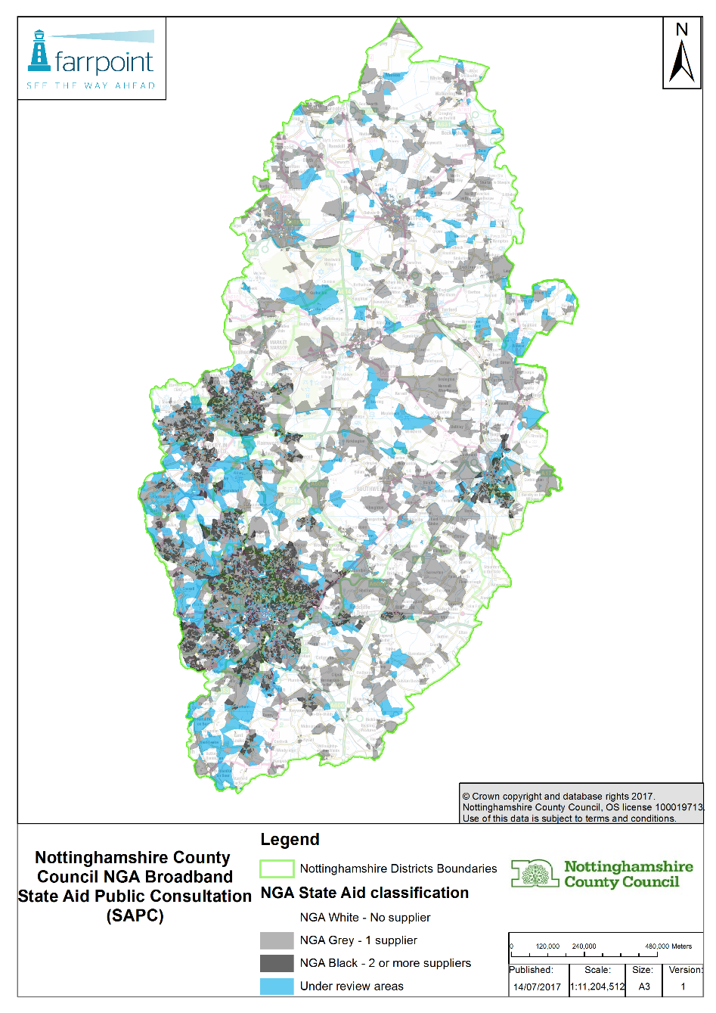

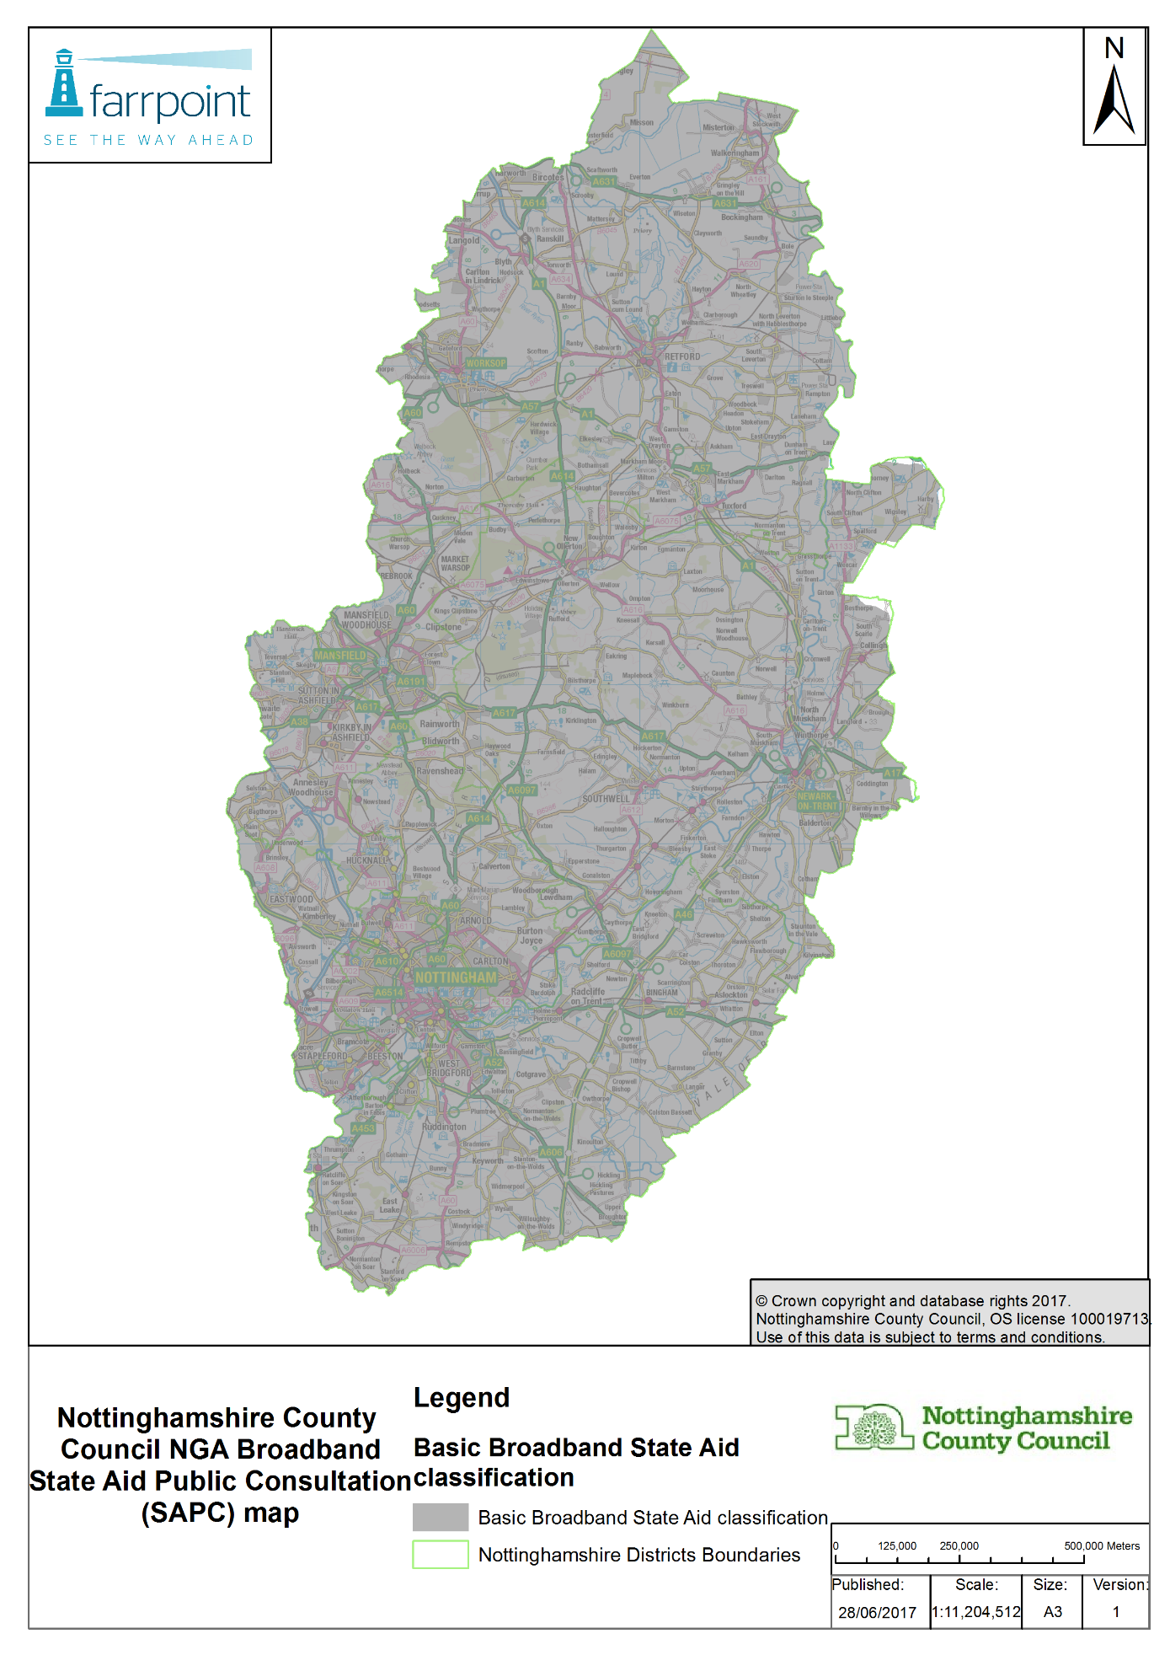

Postcode classification for the project

http://eur-lex.europa.eu/LexUriServ/LexUriServ.do?uri=OJ:C:2013:025:0001:0026.EN.PDF *Delete if procurement portal not used.
https://www.gov.uk/government/publications/2016-nbs-tech-guidelines
See Footnote 66 of the Commission’s Guidelines - this sets out that the subsidised network should be pro-competitive (i.e. allow for effective access at different levels of the infrastructure).
Substantially higher upload speeds means at least a doubling of the maximum upload speed available on current generation access network(s) for given ‘up to’ packages available on basic broadband networks in the relevant intervention area. * Delete as appropriate if premises level data provided.
See paragraph 65 of the Commission’s guidelines.
Operators will still be able to request new forms of access products on the subsidised NGA network infrastructure through the formal general access provisions under the terms of a future State aid Decision.

