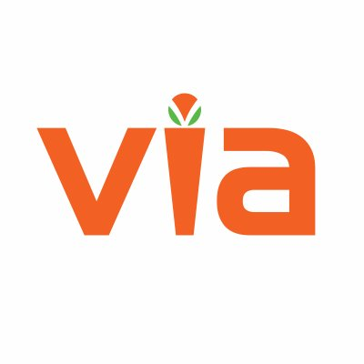

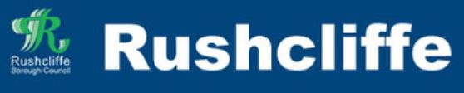
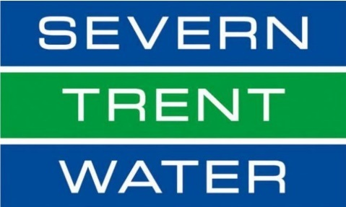

Gotham Flood Update

Overview and Update

In November 2019 and February 2020, the community of Gotham suffered the impacts of devastating flood events where several homes and businesses were internally flooded.

Nottinghamshire County Council, Via East Midlands, Rushcliffe Borough Council and Severn Trent Water are committed to investigating the causes of the flooding. All parties have contributed to the significant work that has already taken place in Gotham to reduce the future risk of repeat flooding. They are also committed to considering potential solutions in future to reduce that risk further.
The following information may offer some insight to questions you have about the flooding:

General Information – I have information I would like to share or would like information because I am concerned – who do I contact?

You can contact each of the partners involved in reducing the future risk of flooding in Gotham using the following details:

Nottinghamshire County Councils Flood Team – flood.team@nottscc.gov.uk - 0300 500 80 80

Via East Midlands - https://www.nottinghamshire.gov.uk/contact-and-complaints/contact-us/contact-us – 0300 500 80 80

Rushcliffe Borough Council - customerservices@rushcliffe.gov.uk – 0115 981 99 11

Severn Trent Water - https://www.stwater.co.uk/help-and-contact/contact-us/ – 0800 783 4444

I have concerns about the condition of a watercourse, the Foul sewer or the Highway gullies/grates – who do I contact?

A watercourse or ditch - contact Nottinghamshire County Councils Flood Team – flood.team@nottscc.gov.uk - 0300 500 80 80

Highway Gullies/Grates – online at https://www.nottinghamshire.gov.uk/transport/roads/report-a-flooding-or-drainage-problem - 0300 500 80 80

Foul sewer – contact Severn Trent Water - https://www.stwater.co.uk/help-and-contact/contact-us/ - 0800 783 4444

I have concerns about the impact that new development in Gotham is having on my risk of flooding?

There is now a focus on ensuring that all new development does not increase flood risk to both those houses being built and those existing neighbouring properties. Indeed, in most cases new development can if designed effectively reduce the risk of flooding to neighbouring communities. Nottinghamshire County Council as Lead Local Flood Authority are statutory consultees to planning process, we assess surface water drainage designs for new developments advising the Local Planning Authorities, enabling them to grant or not permission to build. Should you wish to discuss a development in Gotham please contact:

Your Local Planning Authority is Rushcliffe Borough Council, contact them at customerservices@rushcliffe.gov.uk - 0115 981 99 11

Nottinghamshire County Councils Flood Team – flood.team@nottscc.gov.uk - 0300 500 80 80

I have previously flooded by water from the road, would it be possible to close some of the roads in Gotham during flooding?

This is something that we are working towards. The Environment Agency working with Nottinghamshire County Councils Emergency Planning Team are currently looking to recruit volunteers to become Flood Wardens who amongst other tasks will be trained to put out signs and close the highway on specific roads when required. If you are interested in volunteering or would like more information, please contact:

Nottinghamshire County Councils Emergency Planning Team - emergency.planning@nottscc.gov.uk – 0300 500 80 80

The Environment Agency - enquiries@environment-agency.gov.uk - 03708 506 506

I have heard that I can apply to have my property protected against being flooded again, who do I contact?

Following the November and February flooding the Government made the Flood Protection Grant available to residents in Gotham who were flooded in their houses. This Grant pays for a contractor to survey and then protect your house from being flooded again. Rushcliffe Borough Council are administering this Grant and if you flooded inside your house in November 2019 or February 2020 and have not yet done so, please contact Rushcliffe Borough Council: customerservices@rushcliffe.gov.uk

Contact information:
In the unfortunate event that further flooding occurs and impacts you, more information on what to do is available on the Nottinghamshire County Councils website:

Website: www.nottinghamshire.gov.uk/planning-and-environment/flooding/the-councils-role

For all other enquiries:
Phone: 0300 500 80 80
Monday to Friday: 8am to 8pm
Saturday: 8am to 12 noon

Out of Hours Phone: 01253 502776

Email: enquiries@nottscc.gov.uk
Website: www.nottinghamshire.gov.uk

Minicom: 01623 434993
Calls cost 3p/min from BT landlines. Mobile costs may vary.
Phone 0300 500 80 80 if you need the information in a different language or format.

