Nottinghamshire’s Guide to
Improving Outcomes for Our Children who are Looked After through the Personal Education Plan (PEP) Process

Contents

- Introduction
- Key Messages
- What is a PEP, what’s the purpose, the aims and statutory expectations?
- Quick guide to who does what
- What is the PEP process?
- A quick glance flow chart of the PEP process
- The PEP process and documentation
- PEP modules on ASSET and phases of education
- Completing SMART targets and ‘Strengths and Needs’ section
- Executive functioning skills
- Preparing for Adulthood (across the age range)
- What if our child is without a school place or not accessing education?
- Understanding our Nottinghamshire Special Educational Needs and Disability processes
- Understanding the Education Health and Care Plan Process with PEP processes
- Checklist for Completing the PEP form and Quality Assurance
- What is the link with Pupil Premium Plus (PP+)
- Ongoing training offer
- Helpful Hints to Education
- What does good look like? An example of an Education Review (PEP)
- References

Introduction
As part of the Care Plan, every child who is looked after must have a Personal Education Plan (PEP). It is statutory for all children and young people aged 3-18 years to have a PEP. This guidance has been constructed by Nottinghamshire Virtual School in partnership with young people, children’s social care teams, school/education representatives etc. and is informed by the statutory guidance (DfE, 2018) alongside ‘best practice’ in making the PEP a meaningful process for all our children and young people.
At Nottinghamshire County Council, we recognise the importance of the language that is used around children and young people. Whilst the legislative language refers to Looked After Children (LAC) and the Department for Education (DfE) has moved towards using Children Looked After (CLA), where possible, this document will use the term ‘our children’ to identify this group of young people, as the preferred term used by the young people themselves (TACT, Fostering and Adoption, March, 2019). Our young people in Nottinghamshire have stated that they would rather the term ‘Education Review’ is used over ‘Personal Education Plan’ meeting as the legislative literature states. We therefore invite you to use this language with our children when you are referring to the meetings.

Key Messages
- The key mechanism for addressing the educational needs of the child or young person and improving their attainment is the Personal Educational Plan (PEP)
- It is essential that the team around the child invests and plays their role in the PEP process (always the social worker, carers, designated teacher in school, young person and other professionals as necessary)
- It is important that the PEP maintains high expectations for rapid progress and puts in place the additional support the child or young person may need in order to succeed academically
- PEPs are designed to ensure that all important decisions about the education of our children are made jointly by the corporate parents who are the teachers or education staff, social workers, carers and other professionals involved with the child
- PEPs should be ‘living and useful’ documents
What is a PEP, what’s the purpose, the aims and statutory expectations?
The ongoing educational reviews and the documents that are recorded (Personal Education Plan or PEP) is a record of how professionals around the child in care will support their educational outcomes and achievement. The PEP provides the journey and ‘collective memory’ of the child’s education. It is a statutory requirement for children in care to have a PEP from the age of 3 (or when they begin education) until they are 18 and the plan is the joint responsibility of the school/education setting and the local authority, who also have a legal duty to maintain the child’s Care Plan. In Nottinghamshire, the PEP reflects the age of the child (Early Years, Primary, Secondary, Targeted Curriculum, post 16 PEPs and post-18 Pathways) on the PEP platform ASSET PEP for Success.
The PEP is developed and reviewed termly (this is 3 times a year, the autumn, spring and summer terms) with the designated teacher/education professional, young person, social worker, carer and other agencies where appropriate. A PEP should be started within 10 days of a child becoming ‘looked after’, and their plan must be in place by their first looked after review (20 days).
The PEP documentation contains information about the child and their progress, attainment, outcomes, social and emotional development, and helps schools/settings, carers and social workers to identify any needs and how they can be supported. The plan also celebrates the child’s strengths and all aspects of ‘education.’ The plan should reflect the importance of a personalised approach to learning that meets the child’s identified educational needs, raises aspirations and builds life chances. It should realise short and long term academic progress, goals and aspirations.
The PEP is part of a child in care’s official school record. If the child moves schools/setting, the documentation (PEP) should be forwarded, along with other education records, to their new school or education setting. If a child ceases to be ‘looked after’, the PEP remains an important document to ensure that the child’s educational journey has been documented.
Quick guide to who does what
For transparency and clarity, we have considered the roles and responsibilities of the potential people who will be part of the PEP process. We have also aligned their responsibilities to reflect Nottinghamshire County Council’s processes.
The child/young person is central to the PEP process and it is their educational journey we are supporting. Their voice is key to the process and trusted adults, in school and at home, should ensure if they do not attend the meeting their future hopes/goals, thoughts, feelings or wishes are captured in a form that they are comfortable to use e.g. Mind of My Own app, drawing, writing.
Role | Responsibilities
Managers of Children’s Social Care Teams | - Ensures social workers (SW) are completing Personal Education Plans in statutory timeframes (every term)  - Have Personal Education Plan as part of an ongoing Continuing Professional Development (CPD) training offer and agenda discussion in team meetings  - Support with Quality Assurance (QA) process
Social workers (SW) | - Initiate PEP within 10 days of a child becoming ‘looked after’ (even when child without school place) including those placed in an emergency  - Book in termly PEP meetings (to ensure compliance with statutory timescales), ensuring that the right people are invited (e.g., teachers, carers, in alternative provisions learning mentors and the person in education who knows the child best)  - Ensuring Designated Teachers (DTs) in schools/colleges or staff in early years settings have logins to ASSET PEP for Success platform and guidance around PEPs.  - Ensure that the ‘Essential Information’ is pre-populated and up to date  - Ensure the PEP contains important relevant education attainment/progress information  - Check and complete the PEP ‘Personal Info’ module and ‘start PEP’ if one has not already been started  - Inform schools/education settings to start pre-populating ‘data’, ‘strengths and needs’, ‘targets and actions’ modules in advance of meeting  - Attending PEP meetings  - Agree if they, or DT/education representative, will chair the PEP meeting (see ‘Agenda’)  - Negotiate with school/setting which staff member knows the child best to support them to contribute to their PEP  - Consider evidence-based intervention to support the child as guided by the DT (Education Endowment Foundation and Pupil Premium Plus)  - Ensure the PEP is effective and available for the first and subsequent statutory review meetings of Care Plan  - Not to make significant decisions about a child’s education without reviewing the plan with child, school /setting, carer, Virtual School, Independent Reviewing Officer (IRO) and, where appropriate, parents  - Alert Independent Reviewing Officer (IRO) to any significant changes to education/documentation (PEP) (e.g., change of education placement)  - Where appropriate, work with school between statutory reviews using the information in the PEP  - Ensure PEPs are up to date before statutory reviews  - Type in ‘meeting’ module (PEP) during meeting and circulate to all parties (to ensure timelines are met)
Designated teachers (DTs, early years provision, schools, colleges, education settings) | - Pre-populate the ‘data’, ‘strengths & needs’, and ‘targets and actions’ modules with attainment/progress data and other schools based/education information before the meeting  - Lead on how education (PEP) is developed and used within school/setting/FE/EET to make sure the child/young person’s educational progress is effectively monitored  - Lead on SMART target setting with an academic focus including actions for adults  - Ensure that actions agreed in PEP are happening for a child /young person in a cycle of assess-plan-do-review (assessment for learning and how the child /young person learns best)  - Use documentation (PEP) to guide teachers in school/educational professionals to effectively support the child /young person  - Are accountable for the PEP ‘in-school’ /education or training/setting actions, working closely with teachers/educational professionals as necessary and removing any barriers to learning  - Ensure evidence-based intervention to support the child /young person  - Ensure PEP is shared with new schools/settings if a child /young person moves  - Use PEP to explore transitions. Particularly starting school; Primary- Secondary and Secondary to post 16, FE to HE
Carers – foster and residential | - Prepare their child /young person for the meeting (talking it through, promoting their voice)  - Attend the PEP meeting and sharing their thoughts and views  - Support extra-curricular learning and opportunities  - Provide ongoing support for the actions in the PEP (e.g., home learning opportunities)
Parents | - Contribute as appropriate (social worker to lead and manage this)
Independent Reviewing Officers (IROs) | - Ensure PEPs effectiveness is scrutinised to feed into Statutory Review including QA questions  - Raise any unresolved concerns about PEP or education provision with social workers and/or the Virtual School  - Within the review to ensure the PEP is completed and meets the need of the individual child /young person
Virtual School | - Senior Leadership Team to work in partnership with social care and other partners to quality assure PEP s and feed back to schools and social workers  - Annually review effectiveness of PEP modules and make any necessary changes to reflect updates and current statutory assessment frameworks e.g., GCSE, SATs  - Achievement Officers to contribute to and/or attend PEP meetings where the child /young person is RAG rated red (assessed as requiring AO involvement)  - Deliver training on ‘Making PEPs Meaningful’ in partnership with Children’s Social Care to the Designated Teachers, Children’s Social Care teams and appropriate partners
What is the PEP process?
Whilst the plan (the PEP) is often understood to be the physical document, the plan documents a process of repeating the cycle of assess-plan-do-review. This cycle ensures that our children/young people are receiving positive educational experiences and that these are having an effective educational impact to enable our children to achieve. A PEP review meeting is a meeting between the child /young person, education setting (Designated Teacher and/or other relevant teaching staff), social worker, the child’s carer (foster or residential) and other professionals when there is a need for their input (for example achievement officers from the Virtual School). The meeting allows for discussion and consensus to support the ongoing educational progress of a child/young person. It is important the child/young person is at the centre of this meeting and that the plans reflect their aspirations. Historically, the PEP meeting had everyone physically present, more recently, due to Covid-19 restrictions this is being successfully achieved by having the relevant people connected through ‘virtual’ meeting places, such as ‘Microsoft Teams.’
We believe, for a PEP to be meaningful, it requires preparation, a child centred strength-based approach and follow up work between meetings.
- Planning for the PEP meeting
- Date for PEP meeting arranged between school/education setting, carer and social worker. This would initially be made by the social worker but subsequent meetings would be agreed within the PEP review
- Decisions need to be made about who is required to contribute to and/or be at the PEP meeting and the social worker would invite these people
- The child’s voice needs to be sought prior to the meeting (through social workers carers and/or education) and they will be invited to their meeting
- The social worker checks, edits as appropriate and completes the ‘Personal Info’ module three weeks before the meeting, and checks school has access to the system
- School/setting to pre-populate ‘data’, ‘pupil voice’, ‘strengths & needs’ and ‘targets and actions’ modules prior to the meeting

- During the Education Review (PEP) meeting
- The social worker will complete the PEP ‘meeting’ module during the meeting as a way of minuting the discussions and actions that have been agreed. All modules need to be checked and ‘completed’ which is shown by a blue tick by the end of the meeting. We have designed the PEPs to include the statutory requirements (DfE, 2018) and also to map the suggested agenda (which is also embedded into the plan). The completed PEP document can therefore be accessed by school and shared with everyone (by downloading a pdf) straight away, rather than becoming a ‘paper exercise.’

The social worker and DT/educational professional will agree who will chair the meeting, but the educational expertise lies with the school/education setting. Therefore, Designated Teachers/educational professional take a leading role in the meeting including the setting of SMART targets. The PEP meeting is an opportunity to review plans and interventions currently in place and a chance to draw on all the knowledge, commitment and expertise of all those attending the meeting to improve that plan even further.
‘Agenda for PEP meeting’ For a good meeting, social worker or education professional will need to share their screen showing the current PEP on ASSET PEP for Success platform. The first 4 modules of the PEP will have been pre-populated and will need checking and completing in the meeting. The child or young person’s voice is central to the PEP. They may want to be part of the whole meeting, part of it, or contribute to it in some other way. A well-prepared PEP meeting should take no longer than an hour for focused discussion, and target setting. Below is a suggested ‘Agenda’ that corresponds to the sections on the PEP.
Agenda Item
Check in
Warm welcome
Introduction of who is in the meeting
‘What’s worked well recently/since we last met…’
Hopes, dreams and future goals
What are our child/young person’s hopes, dreams and future goals? What aspirations do our trusted adults hold for our child/young person? Short term and long term (think about work experiences and employability skills at beginning of secondary school)
What else does the child/young person want us to know about their education (Mind of my own etc)?
Attainment, progress, strengths & needs
Is the pre-populated education information accurately describing the strengths and needs of our child/young person? What do we need to add in to make sure it provides a better description? What are our child/young person’s current attainment and progress? What else, if anything, needs to happen to support this?
Achievement and extra-curricular activities
We know that a sense of belonging and connections are important, what extra-curricular and additional activities is our child/young person engaged in, being invited to or interested in being part of?
Review targets
Review and reflect on previous target setting. How has our child/young person responded, was it successful? Why? What else needs to be happening to accelerate our child/young person’s progress?
Termly SMART target setting
What areas do we need to focus on to support our child/young person’s development/progress even further? How will we do that? How does this reflect our child/young person’s aspirations? Let’s create SMART targets around this…do they pass the ‘teacher/adult come and see/hear me test’.
Pupil Premium Spending (statutory school age)
What areas are we needing to focus our PP+ spending on to support the SMART targets?
Consideration of Nottinghamshire SEND process
Does our child/young person have additional needs that require Nottinghamshire’s graduated approach to supporting SEND? Does the child need SEN support in school?
Transition Planning
Do we need to plan for any transitions during this Education Review? If yes, what support is needed for a positive transition?
Is the PEP purposeful?
Does the documentation reflect this?
Agree next review arrangements
Date and who needs to attend
Sharing with our child/young person
If the child/young person is not at the meeting, decide how and who will share today’s discussion with them. Explore child-friendly ways of doing this
Check out
One thing I know I can do to support this young person

- After the PEP meeting
An effective PEP is a ‘living’ document that should become a tool for supporting the child child/young person’s education and development needs on a day-to-day basis. It is everyone’s responsibility that the actions are followed up and the SMART Action Planning should make it clear who is responsible for what. The DT/education professional is responsible for ensuring the school/setting implement what is agreed. It is important to share the PEP with the child/young person, particularly if they have not been at the meeting. Download the completed PEP from ASSET PEP for Success and upload to Mosaic.

A quick glance Flow Chart of the PEP process
The Statutory Guidance (DfE, 2018) states that PEPs should be reviewed termly. Therefore the following process should happen three times a year, in the Autumn Term, Spring Term and the Summer Term.
1.Social worker arranges date with carers, staff in school/education and other relevant professionals. Social worker checks PEP has been started on ASSET and that education setting have access to the system, and completes ‘Personal Info’ module (3 weeks prior to meeting)
4. Everyone supports the child/young person to achieve their targets throughout the term.
3. Education Review (PEP) takes place – ‘meeting’ module is populated on ASSET during the meeting and all modules are ‘completed’. Previous targets are reviewed, and new SMART Targets are made. Date is set for next meeting (termly). Completed version of PEP is sent to foster carers and other professionals who do not have access to ASSET platform (within a week). PEP is downloaded from ASSET and uploaded to Mosaic.
2. Education setting pre-populates ‘data’, ‘pupil voice’, ‘strengths & needs’, and ‘targets & actions’ modules (1 week prior to meeting)

The PEP process and platform
The PEP has been developed to cover the full range of the child/young person’s education and development by considering areas of strengths and needs. The documentation is organised into six modules.
- Child/Young Person Information (completed/checked before the PEP meeting by the social worker)
- Data - Attainment and Progress (completed before the PEP meeting by the designated teacher/education staff)
- Pupil voice (started before the PEP meeting by the designated teacher/education staff)
- Strengths & Needs (started before the PEP meeting by the designated teacher/education staff)
- Targets & Actions (started before the meeting by the designated teacher/education staff)
- Meeting (completed during the meeting by the social worker)

PEP modules on ASSET & phases of education
The PEP process remains the same for all our children and young people. This means that the PEP is reviewed every term and new targets are set in a repeating cycle of assess-plan-do-review.
The PEP platform is accessed through Advanced Statistical System Evaluation Tool (assetforschools.com)
Logging in
- You should have been sent an Egress email called ‘Login Credentials’ from ASSET for Schools
- Click ‘login’ on top right of page using the username and password sent to you by email from ASSET for Schools. It will then ask you to enter a token which is a 6-digit number sent to your email (check junk mail)
- If you do not have a login or you know a child has changed school or social worker, contact virtual.school@nottscc.gov.uk or 0115 977 4747
Starting a PEP
- Once logged in, you should be able to see the children you are the allocated worker for. Click on the name of the child/young person you wish to start a PEP for
- Click ‘All PEPs’ in the top right-hand corner of the screen and select the date of the PEP you wish to look at or edit.
  - If our child/young person has not had a PEP before or the next PEP date hasn’t been arranged, you will need to click ‘start new PEP’. Edit the meeting date and time, click save.
Personal Info
- Click the ‘personal info’ icon on the left side of the screen. Social worker should check the pupil information is correct (including school name) and make any changes before clicking save and submit - 3 weeks prior to the PEP
- Click ‘contacts’ tab at the top to check the right education/school professional is recorded. If changes need to be made contact virtual.school@nottscc.gov.uk or 0115 977 4747
- If our young person is NEET, accessing alternative provision/tutoring or is UASC, please edit the tabs and click ‘save’
- Click ‘submit’ once complete
Data
- Click ‘data’ on the left-hand side of the screen. School or education professional pre-populates this module with attendance, exclusion, attainment and progress data
  - If this is not the first PEP, historical data should pull through. Schools should be able to find historical achievement data on Keys to Success
  - To enter attendance, click ‘bulk entry’ in the top right-hand corner and enter present code for all. Then edit the individual days the child/young person was absent
- Click ‘save’
- Click ‘complete’ once agreed in the PEP meeting
Pupil Voice
- Click ‘pupil voice’ on the left-hand side of the screen. School/education professional or social worker pre-populates this module during or after a conversation with our child/young person, prior to the PEP meeting
- Click ‘save’
- Click ‘complete’ once agreed in the PEP meeting
Strengths & Needs
- Click ‘Strengths & Needs’ on the left-hand side of the screen. School/education professional starts to pre-populate this module prior to the meeting.
  - Record strengths for all areas, and needs where necessary. Actions to support needs are for named adults to carry out.
- Click ‘save’
- Click ‘complete’ once agreed in the PEP meeting
Targets & Actions
- Click ‘Targets & Actions’ on the left-hand side of the screen. School/education professional pre-populate this module prior to the meeting.
  - Record actions and interventions to be carried out by named adults to support our young person to achieve the target
  - Record where pupil premium will be spent – it will be approved and allocated through the PEP
  - See SMART target section of guidance below
- Click ‘save’
- Click ‘complete’ once agreed in the PEP meeting
Meeting
- Click ‘Meeting’ on the left-hand side of the screen. During the PEP meeting, social worker (or education professional if agreed otherwise) will record in this module.
- Click ‘save’ and ‘complete/
The PEP is complete when all 6 modules show as purple with a blue tick.
To download the complete PEP, click ‘Export PEP’, on the right-hand side of the page. Click ‘Full PEP’. The PEP can now be distributed and uploaded to Mosaic.
Targeted Curriculums
For children and young people who are accessing provision and a targeted curriculum that is ‘additional to and different from’ a mainstream curriculum, there is a section in the ‘data’ module to record attainment and progress in free text boxes. This will measure the steps of progress appropriate for that child/young person rather than Key Stage ‘Age Related Expectations.’ Children/young people accessing a targeted curriculum may attend mainstream schools or specialist provisions/schools.
Post 16 PEPs
The Post 16 PEP has been redesigned as part of a process change resulting from the issuing of new statutory guidance for Virtual Schools in February 2018. The guidance emphasised the importance of the PEP at Post 16 informing the Pathway Plan.
The Post-16 PEP uses a framework scoring system in the ‘strengths & needs’ module to support measuring progress in educational outcomes and employability skills such as time management, problem solving and team working. The scores range between 0-5 and enable our young people to see and measure small steps of progress.
The cycle of assess-plan-do-review is key to ongoing progress and to implementing appropriate intervention. SMART target setting is essential to making this work well and recording the steps of progress a child/young person makes. SMART target setting considers some thought to ensure that it is appropriate and achievable within the time between review meetings.
Smart Action Planning
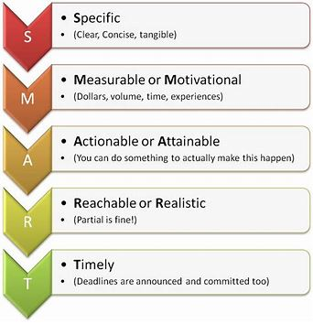

A good test of checking if a target is SMART is ‘hey teacher, come and see/hear/listen to me…….’ if it isn’t clear what you would see/hear, then the target probably isn’t SMART enough.
E.g., Kate needs to improve her reading – NOT SMART
E.g., Kate will be able to read a page of KS1 text and answer a question about what it is about by the next term- SMARTER

Actions and intervention would follow from this (e.g., Action – Kate to read a page and practice oral comprehension questions with Mrs Helpful at 2.30pm every school day)

Specific actions to improve progress and attainment (and attendance, if necessary)
Bring together all the actions discussed today, including any carried forward from discussion of the last PEP’s actions, and record them below.

Autumn term
SMART Target 1
Child will be able to read all year 5 and 6 key words
Act/Int | What | Who | By When | PP £
Int | Child will access precision teaching 3 x a week for 20 mins with Mrs Helpful | Mrs Helpful | 14.1.23 | £300

SMART Target 2
Child will be able to respond to rapid fire questioning to 12 x table
Act/Int | What | Who | By When | PP £
Int | Child will practise times tables in school during registration twice a week | Mr Useful | 14.1.23 | £300
Act | Download times table app to class iPads | Mrs Teacher | 20.10.22 | £10
Act | Practise times tables at home three times a week | Mr Carer | 14.1.23

Our child/young person’s strengths and needs
This section sits within the ‘Strengths & Needs’ module but can be populated through discussion at the PEP review by the child/young person, social workers, carers etc.
The module is divided into sections to bullet strengths and particular challenges. For 16-18 PEPs there are additional skill areas to focus on too. The first three are more self-explanatory
- The ‘Relationships’ section is about the child/young person’s experiences of all relationships. For example, the child/young person’s family relationships including, carers, siblings etc; relationships at school/setting/college with teachers, education professionals and peers and those within the community.
- The ‘Communication Skills’ describes how the child or young person is able to communicate their needs to others. Are they able to use speech and language, do they do this through their behaviours?
- The ‘Mental health, resilience and emotional health and wellbeing’ section includes the emotional wellbeing and emotional regulation of a child /young person, how they are able to express and regulate their emotions with the support of an adult and independently. The strategies they have developed to cope etc. The situations that support their emotional wellbeing best.
- The ‘Executive functioning’ section describes the skills we all have to plan and carry out tasks. That may be one at home or self-care or a more school/education-based task. These skills can be thought of as thinking skills and skills to guide behaviour. Areas to consider are below:
Thinking skills | Skills to guide our behaviour
Planning | Response inhibition
Organisation | Emotional control
Time management | Sustained attention
Working memory | Task initiation
Metacognition | Flexibility
 | Goal directed persistence

- The ‘Preparing for Adulthood’ section describes the four outcomes that we would hope education would support all children/young people in their development over time. A helpful table can be found at the bottom of this guidance document which explains how preparing for adulthood is relevant from early years and into post 16 education.

What if our child/young person doesn’t have a school place or is not accessing education?
Every child/young person’s situation is individual and so it is a challenge to state indefinitely what would happen in every situation. Every child/young person has a right to their education and therefore social care and the Virtual School will be working hard to ensure that appropriate education for a child/young person is in place as soon as possible. When appropriate, where the child/young person is without a school place, the Virtual School will be ensuring interim arrangements are in place.
As with all PEPs, the social worker organises for the PEP to happen in terms of planning a date and time, inviting the relevant people and finding a venue or through virtual means. The PEP process and planning should take place between the social worker, young person, the foster or residential carer and other relevant partner agencies on a termly basis, the same as if a child/young person was in school.
If tutoring is in place, the tutor may be invited to the PEP meeting but not expected to complete paperwork this would need to be done at the meeting by the social worker – the Virtual School should be alerted to PEP meetings for these pupils as they would be a priority.
In the ‘Personal Info’ module, the tab ‘Alt Ed – NEET’ should be completed to record current provision and plans to increase.
Understanding our Nottinghamshire Special Education Needs and Disabilities (SEND) processes
When planning the education around our children in care, we must ensure that we understand the local processes that may also support them. If we have concerns around our children, the schools or education settings must be providing a graduated response to their needs and if necessary, taking for discussion at termly Springboard meetings for consultation with others and if necessary, specialist teacher support (for example cognition and learning and communication and interaction) or Educational Psychologist involvement.
Understanding the EHCP Process with PEP processes
If a child has an Education Health and Care Plan (EHCP), this will be reviewed once a year at an Annual Review. The PEP is reviewed on a termly basis (three times a year with much shorter-term targets to set). The content of the PEP must be linked to, and ideally complement, but not duplicate or conflict, with that of the EHCP. It would be reasonable to expect that some of the shorter-term targets would be focussing on reaching the EHCP outcomes. It is helpful to have a copy of the EHCP for PEP meetings and combine the Annual Review with one of the PEP meetings so that the processes support one another.
Checklist for Completing the PEP form and Quality Assurance
How do Nottinghamshire Quality Assure the PEP process?
The quality of the PEP process is the joint responsibility of Nottinghamshire local authority and the school or education provider. Social workers, carers, Virtual School, designated teachers and other professionals, as appropriate, need to work together to produce quality PEPs. To be effective and high quality, a PEP should be a ‘living’, evolving, comprehensive and enduring record of the child’s experience, progress and achievement (academic and otherwise), and inform any discussion about education during statutory reviews of the child’s wider care plan,’ (DfE, Promoting the education of looked after children, 2018).
The Quality Assurance process in Nottinghamshire is led by the Virtual School in partnership with colleagues from Children’s Social Care Teams and others. It includes completion figures, IRO QA and termly deep dives.
The Quality Assurance process will ensure the PEP:
- Was initiated within 10 working days of a child becoming ‘looked after’ and completed by the first Looked After review
- Has been reviewed termly
- Is fully completed
- Is using correct paperwork
- Involves the child/young person and their carer/s and has a strong child/young person’s voice
- Documents who was invited and who has attended
- Includes school attendance and, if appropriate, behavioural support
- Contains summary of young person’s current attainment and progress and documents any additional needs, Special Educational Needs and Disability (SEND) and mental health needs
- Is based on accurate assessment that identifies developmental and educational needs and strengths, in relation to skills, knowledge, subject areas and experiences; it is important that critical learning gaps are identified so that these can be tackled.
- Sets out short and long term SMART educational attainment targets agreed in partnership with the child/young person and the carer.
- Records planned actions that the school/setting and others will take to support the child/young person to achieve expected levels of progress for the relevant national curriculum key stage and to complete an appropriate range of approved qualifications. This should be based on an assessment of his or her educational needs, e.g., subject areas, homework, extra tuition, study support, attendance and behaviour.
- Includes information on how the progress of the child/young person is to be rigorously monitored.
- Records details of specific interventions and targeted support that will be used to make sure personal education targets are met, especially at the end of Key Stage 2 in relation to English and mathematics and at Key Stage 4 in achieving success in public examinations particularly in English and maths.
- Says what will happen or is already happening to put in place any additional support which may be required – e.g., possible action to support special educational needs involving the SENCO, educational psychologist, CAMHS or local authority education services. Support from other educational/pastoral staff in education settings/FE/AP
- Sets out how a child/young person’s aspiration and self-confidence and ambition is being nurtured, especially in consideration of longer-term goals towards further and higher education, work experience and career plans.
- Is a record of the child/young person’s academic achievements and participation in the wider activities of the school/setting and other out of school/setting learning activities (e.g., sporting, personal development, community).
- Provides information which helps all who are supporting the child/young person’s educational achievement to understand what works for him or her.
- Has clear accountability in terms of who within the school is responsible for making the actions identified in the plan happen and specifies timescales for action and review - SMART targets.
- Where a child/young person has an EHCP, the PEP should include relevant information from these and annual reviews but does not need to duplicate the information in full.
- Identifies developmental needs including any related to unmet attachment needs and trauma and how to support emotional dysregulation
- Identifies support needed around mental health and specialist services
- Includes transition support where needed including when a child has a plan for permanence and may change schools as part of that plan.
- Includes plans and aspirations for post 16, aspirations should be high and discussions should start well before year 9.
- Where a young person is in post 16 education settings and has plans for university/higher education, detail how this will be supported/what is needed
- Details out of hours learning activities, study support and leisure interests
- Includes provision of immediate suitable education where a child is not in school (e.g., exclusion, sudden placement move)
What is the link with Pupil Premium Plus (PP+)?
The PEP should include mapping how the PP+ and other additional funding has been used to support the targets in the PEP. This is to ensure that the story of the child/young person’s educational progress is current and continues to meet the child/young person’s educational needs. This is also the process for Virtual School to approve and allocate Pupil Premium to schools which will be sent on a termly basis.

Ongoing training offer
The Virtual School has worked alongside children’s social care and developed training to support successful PEP meetings and PEP documentation. This training is accessed via the EM-ED website and is available for professionals in schools/colleges/education settings and children’s social care colleagues.
Helpful Hints about Education
The Foundation Years (0-5 years)
This is how the Government describe the time in a child’s life between birth and age 5. Every child deserves the best possible start in life and the support that enables them to reach their full potential. Children develop quickly in the early years and their early experiences have a major impact on their future life chances. A secure, safe and happy childhood is important and parenting and high-quality early learning together provide the foundation that children need to reach their individual potentials.
Day-nurseries, pre-schools, childminders, nursery and reception classes must meet the standards set out in the Statutory Early Years Foundation Stage (EYFS) Framework (Aged 3-5 years). This is to ensure that children develop and learn and are kept healthy and safe. It promotes learning and teaching to develop ‘school readiness’ and a broad range of knowledge and skills to provide a good foundation for future progress in school and onwards. The Reception class (sometimes called Foundation Two) is included in EYFS.
The EYFSF talks about early learning goals and three characteristics of effective learning (playing and exploring – engagement; active learning – motivation and Creating and thinking critically).
Expected progress in EYFS may look slightly different to expected progress from Key Stage 1. Children in EYFS are expected to make progress across a whole year but progress may be more significant in one term than another, this is particularly relevant when they are settling into a setting.
The National Curriculum
The National Curriculum talks about Key Stages
- Key Stage 1: School Years 1-2 Ages 4-7
- Key Stage 2: School Years 3-6 Ages 7-11
- Key Stage 3: School Years 7-9 Ages 11-14
- Key Stage 4: School Years 10-11 Ages 14-16
- Key Stage 5: School Years 12-13 Ages 16-18

Assessments
Schools/settings should assess children/young people all of the time as part of formative ‘assessment for learning’. However, there are formal summative assessments which take place ‘assessment of learning.’ The government has made a decision that there are National Age-Related Expectations and that there are ‘expected levels’ that children should get to a particular ages. This is how schools/settings report how their children/young people are doing in schools/settings: either ‘working towards’ a particular standard, ‘expected’ or working ‘above expected/greater depth.’ Schools should also measure the progress a child makes each year, and this is measured in relation to making expected levels of progress within a year.
End of Key Stages Assessments and Expectations
The table below shows the key points of assessment throughout a child’s education. Once completed, these points are often referred to as prior attainment or historical achievement.
Stages/ages | Assessment | National Age-Related Expectations/Expected levels
Early Years Foundation Stage: preschool – end of reception year (3-5 years old) | EYFS profile (observations etc) | By end of reception ‘good level of development’ if achieved at least expected level in the Early Learning Goals.
Key Stage 1: Year 1 (5-6 years old) | Phonics Screening | Expected
Key Stage 1: Year 2 (6-7 years old) | SATs tests in English and maths and teacher assessment | Expected
Key Stage 2: Year 6 (10-11 years old) | SATs tests in English and maths and teacher assessment for writing | Expected
Key Stage 3: Year 9 (13-14 years old) | Teacher assessment judgements | Expected
Key Stage 4: Year 11 (15-16 years old) | GCSEs or vocational courses | 5 GCSEs (including maths and English – Grade 4 or above)
Key Stage 5: Year 12+ (usually 16-18 years old) | A Levels or vocational courses

Preparing for Adulthood (PfA) Guidelines
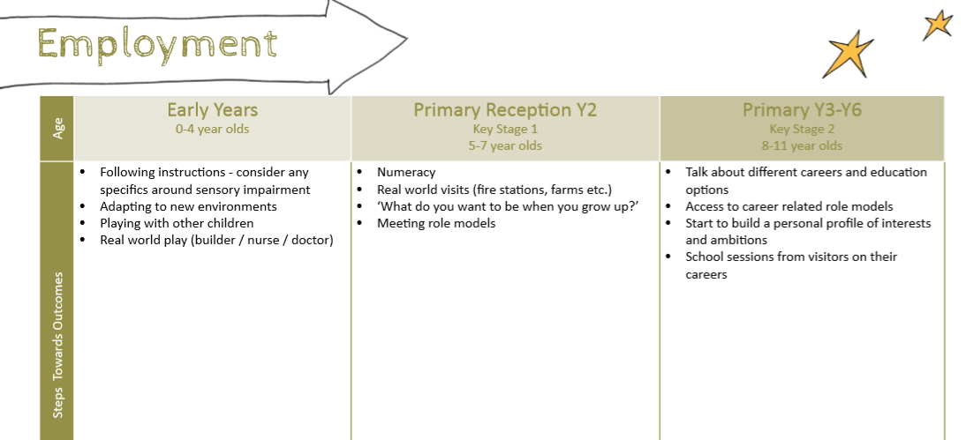
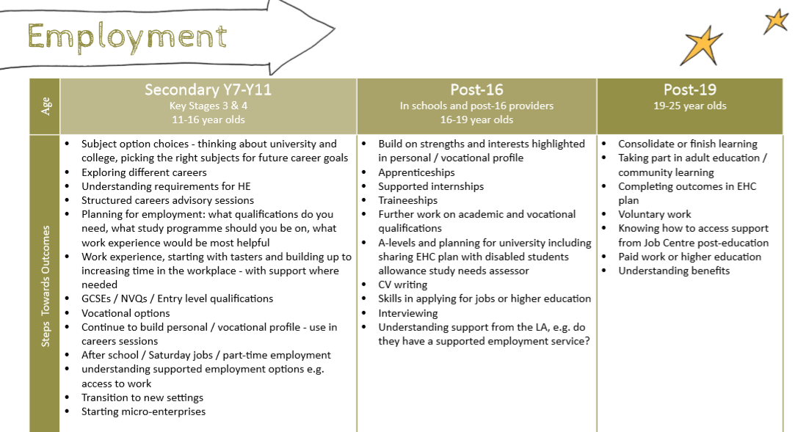
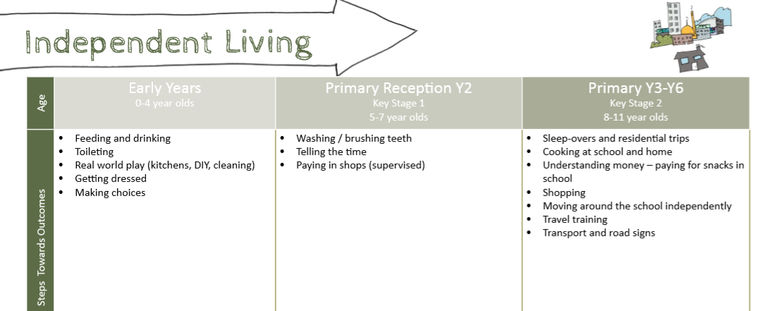
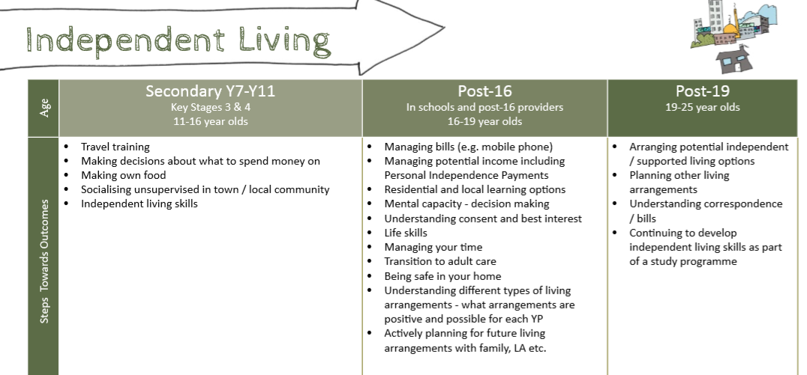

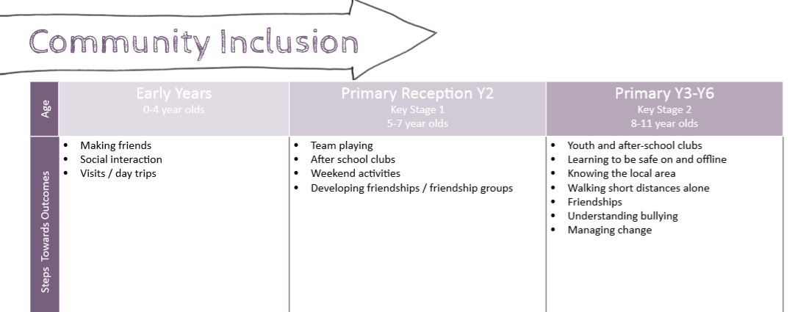

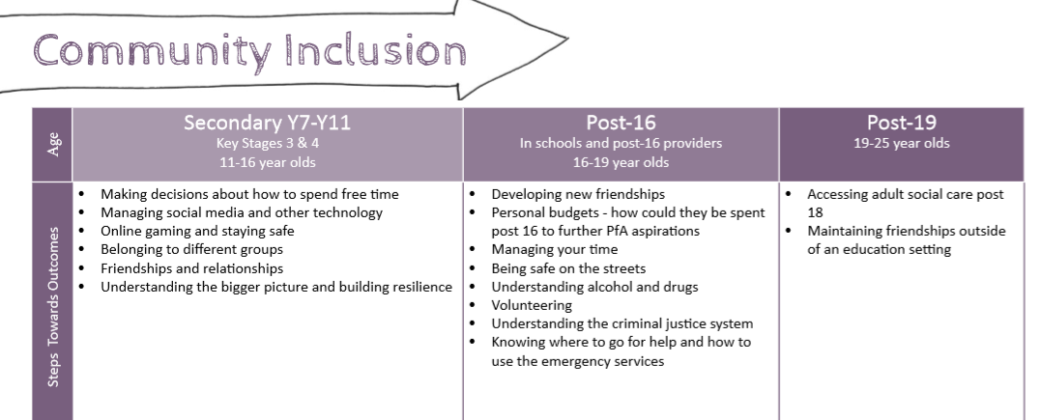
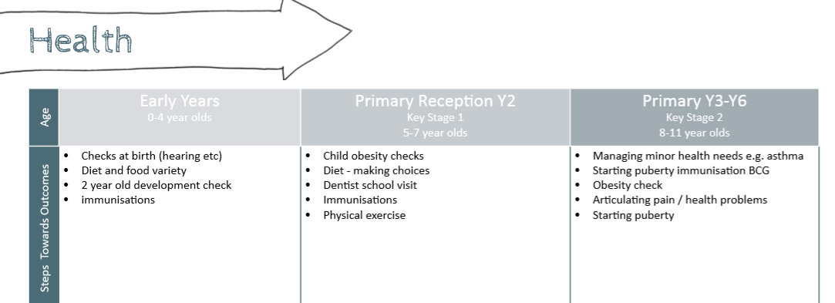
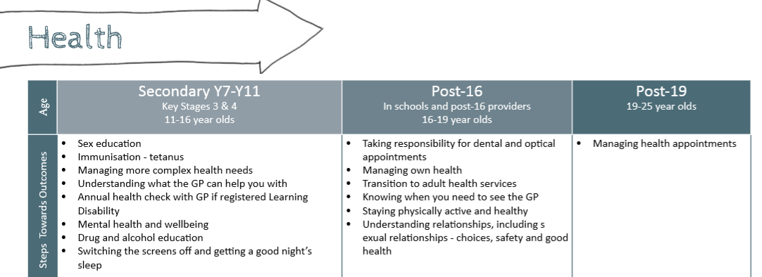
References
DfE (Feb 2018). The role and responsibilities of the designated teacher for looked after and previously looked after children.
DfE (Feb 2018). Promoting the education of looked after children and previously looked after children - statutory guidance for local authorities

