Chapter on impact on BAME communities
Section taken from LRF Data Cell Briefing 12

Public Health England report on Disparities – Ethnicity Chapter
PHE recently released a report describing some of the differences in the impact COVID-19 that has been seen between different groups of people. We will continue to provide summaries of chapters in this report in future briefings. One group that has been particularly affected is people from Black, Asian and Minority Ethnic (BAME) backgrounds where increased rates of severe disease and death related to COVID-19 have been reported.
The COVID-19 Hospitalisations in England Surveillance System (CHESS) is a system of NHS trusts reporting hospital activity data. Reporting rates are variable and it should be noted that this is not consistent for most London trusts and so the dataset will not be fully representative. The CHESS dataset showed that 11% of lower level of care patients were BAME. The proportion of BAME patients was substantially higher, 36%, in critical care.
For deaths reported to PHE by 13th May 2020, 99.4% were coded with ethnicity data. The data show that the highest age-standardised death rates occur in the Other ethnic group, which is likely due to differences in the ways ethnicity codes are allocated between data on deaths and population demographic data. The next highest rate was seen in the Black ethnic group, with Asian and Mixed ethnic groups also having greater mortality rates than those of White ethnicity. When compared to all-cause mortality data from previous years, Asian and Black ethnic groups have lower mortality rates than the White ethnic group, which means the inequality in COVID-19 mortality is the opposite of that in all cause mortality in previous years.
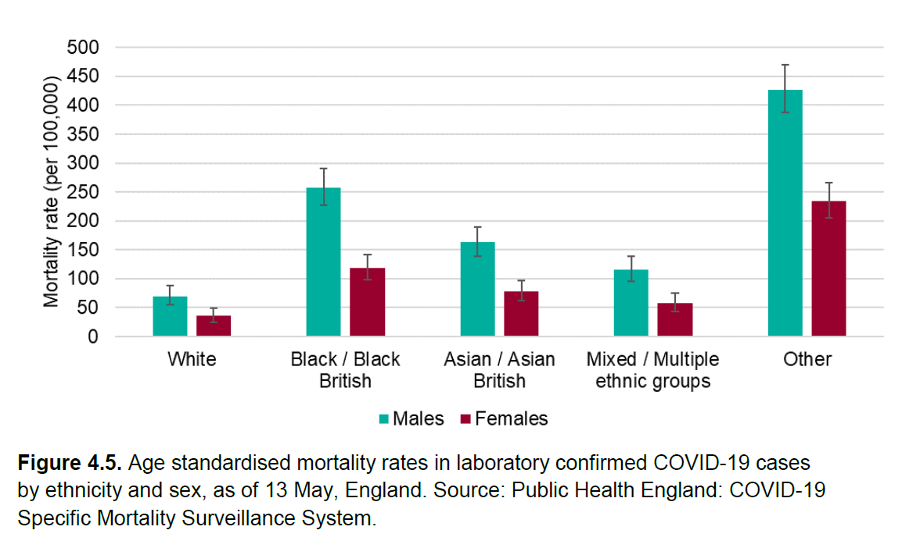

Mortality rates in those infected with COVID-19
For those with confirmed COVID-19 infection, it was shown that mortality rates were higher in a number of ethnic groups. The biggest increase in mortality risk was seen in those of Bangladeshi ethnicity, where the risk of mortality was twice that of White ethnicity. For COVID-19 patients of Chinese, Indian, Pakistani, Other Asian, Caribbean and Other Black ethnic groups, there was an increased risk of mortality of between 10 and 50%. This analysis accounted for the age, sex, deprivation and region of the patients included in the analysis. However, the analysis does not consider the co-morbidities and obesity of patients.
The lack of data on obesity and co-morbidities is an important limitation. A recent study compared the rates of hospital and ICU admissions and mortality rates between different ethnic groups in a sample of over 10,000 patients. The study found that when patient characteristics including obesity and co-morbidities were adjusted for, there were no excess admissions or deaths in the BAME group.

Excess deaths
In the PHE report, “excess deaths” refers to the increase in deaths between 20th March – 7th May in 2020, compared with the average number of deaths over the same period in previous years (2014-18). The analysis showed that Black males had 3.9 times as many deaths in this period compared to the average in previous years. Asian males had 2.9 times the expected deaths and White males 1.7 times. For females, Black, Mixed and Other ethnic groups had 2.7-2.8 times more deaths compared to the same period in previous years. Asian females had 2.4 times the expected deaths and White females 1.6 times the expected deaths. It is clear that all ethnicities had additional mortality due to COVID-19, but this increase has been higher in BAME populations.
There are a number of factors that could increase the risk of infection, or the risk of severe disease for those who do become infected for people of BAME backgrounds. There is evidence to show that people of BAME backgrounds are more likely to live in urban areas, in crowded households and in deprived areas, factors that have been linked to the risk of infection or severe disease.
One key limitation of the report is that it does not account for combined effects of deprivation, ethnicity and occupation. Many people of BAME backgrounds work in occupations that may have faced increased risk of transmission of COVID-19 due to greater exposure levels. There is evidence that some occupations have greater rates of death due to COVID-19, however this does not account for differences in deprivation between different occupations. Some types of jobs are more likely to be done by people from areas of higher deprivation – a key factor that is likely to increase the risk of death due to COVID-19. The different contribution of deprivation, ethnicity and occupation to the risk of COVID-19 infection and mortality is an area that will be important to try to understand going forward.
References
Public Health England, 2020., Disparities in the risk and outcomes of COVID-19. Available from: https://assets.publishing.service.gov.uk/government/uploads/system/uploads/attachment_data/file/891116/disparities_review.pdf
Harrison et al. 2020., Investigating associations between ethnicity and outcome from COVID-19., Available from: https://assets.publishing.service.gov.uk/government/uploads/system/uploads/attachment_data/file/886433/s0238-co-cin-report-ethnicity-outcomes-250420-sage29.pdf

Further studies on the effects of COVID-19 on BAME Communities

ONS analysis
The Office for National Statistics (ONS) released a study on the 7th May in which they analysed census records of people who have died with COVID-19. After adjusting for age, all ethnic groups considered were shown to be at a higher risk of mortality from COVID-19 (except for females of Chinese ethnicity) relative to people of White ethnicity. For males, the highest increase in risk is for Black and Bangladeshi / Pakistani ethnicity, who are 4.2 and 3.6 times more likely to die with COVID-19 than White males respectively. For females, Black and Bangladeshi / Pakistani ethnic groups again have the highest increase in risk, 4.3 and 3.4 times more likely to die with COVID-19 than White females respectively. These results are shown in Panel A of the figure below.

Causes of the differences in mortality between ethnic groups
The reduction in the increased mortality rates in the fully adjusted model shows that some of these differences are due to factors including the areas in which people are living, the deprivation level in these areas, and differences in self-reported health in different ethnic groups relative to those of White ethnicity. However, after adjusting for these factors, the ONS study still found a significantly increased risk of COVID-related death for people of Black, Bangladeshi / Pakistani and Indian ethnicities for both men and women – shown in Panel B of the figure below. The presence of this increased mortality rates in the fully adjusted model shows that some of the difference in mortality has not yet been explained.
Previous analyses have suggested that BAME populations in Nottingham and Nottinghamshire face a similar increased risk from COVID-19 as has been seen nationally. We are continuing to monitor and explore local data in order to increase our understanding and support efforts to mitigate these effects

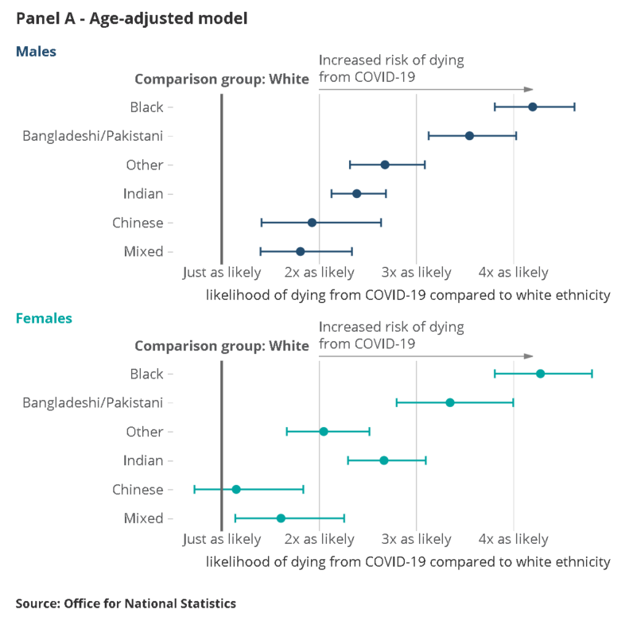

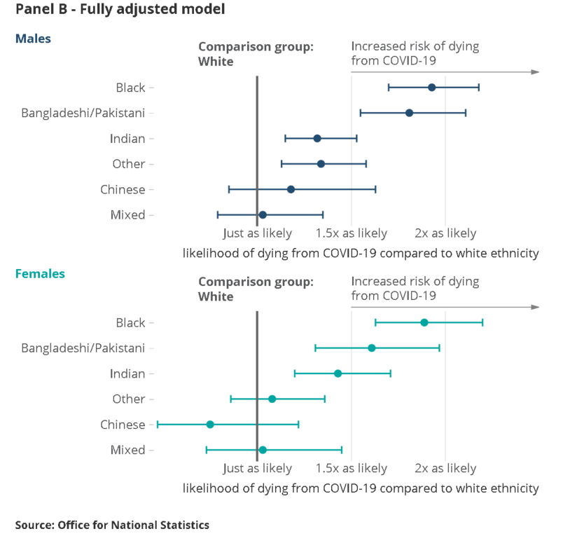
Risk ratios for different ethnic groups relative to people of white ethnic background.
This chart represents the risk of mortality for different ethnic groups after adjustment for differences in:
A Age
B Age, region, rural and urban classification, area deprivation, household composition, socio-economic position, highest qualification held, household tenure, and health or disability reported in the 2011 Census
Source: ONS. Coronavirus (COVID-19) related deaths by ethnic group, England and Wales: 2 March 2020 to 10 April 2020

OpenSAFELY study
Similar results have been found by other studies. The OpenSAFELY Collaborative and co-authors used pseudonymised primary care records to analyse healthcare outcomes for over 17 million UK adults. They found that people of Black and Asian ethnicity are at increased risk of COVID-related death and that only a small part of this risk can be explained by differences in deprivation and pre-existing health conditions.

ICL hospital study
A report from Imperial College London analysed the background characteristics of COVID-19 patients in several London hospitals. They showed that people of BAME backgrounds were over-represented among COVID-19 patients, compared to patients at the same hospitals in previous years. Compared to people of White ethnicity, people of Black ethnicity had a significantly higher mortality rate after adjusting for age, comorbidities and admission severity. The exact cause, or combination of causes, of these differences remains unknown.
We understand these differences are particularly concerning and we are working to fully understand the reasons for these differences, how they may impact our local populations and how we can help to mitigate these effects. Analysis of local data from Nottingham University Hospitals (this data is not publicly available and so the analysis cannot be published here) has not suggested that the picture is substantially different in Nottingham and Nottinghamshire relative to the rest of the UK. However, hospitalised COVID patients are a fraction of all people with COVID-19 and so we cannot be certain of the effects of COVID-19 on local BAME communities from this data alone. We will continue to monitor evidence, but until more information is available on the specific causes of the increased risk from COVID-19 faced by people of BAME backgrounds, we do not have any specific recommendations regarding this issue.
Sources:

- Imperial College COVID response team., Report 17: Clinical characteristics and predictors of outcomes of hospitalised patients with COVID-19 in a London NHS Trust: a retrospective cohort studyhttps://www.imperial.ac.uk/media/imperial-college/medicine/mrc-gida/2020-04-29-COVID19-Report-17.pdf

- ONS. Coronavirus (COVID-19) related deaths by ethnic group, England and Wales: 2 March 2020 to 10 April 2020. https://www.ons.gov.uk/peoplepopulationandcommunity/birthsdeathsandmarriages/deaths/articles/coronavirusrelateddeathsbyethnicgroupenglandandwales/2march2020to10april2020#analysis-of-covid-19-deaths-by-ethnicity-in-england-and-wales

- The OpenSAFELY Collaborative., et al., Factors associated with COVID-19-related hospital death in the linked electronic health records of 17 million adult NHS patients. https://opensafely.org/outputs/2020/05/covid-risk-factors/

