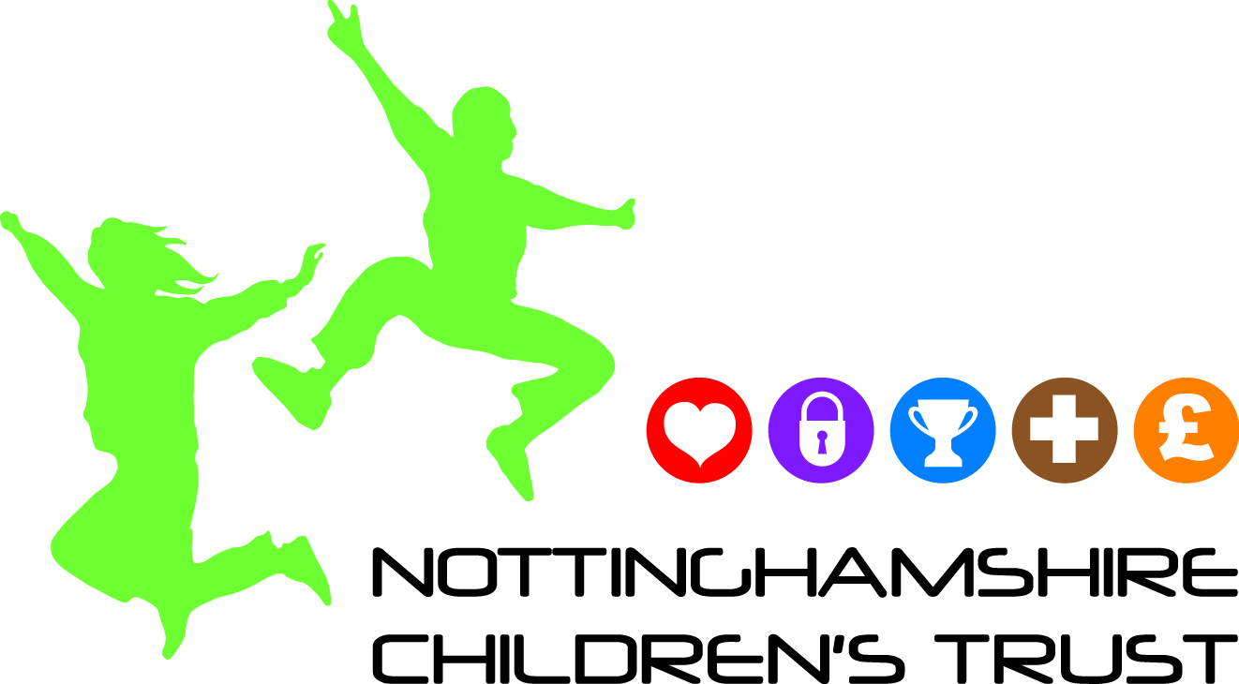

Getting to Know Me Additional Information
You can use this form if you want to gather more information from those involved with the child/young person/family at stage 2 of the Concerning Behaviour pathway. Ask them to complete. Make sure you attach copies with any referrals you make (with family/child consent).
Child’s Name
Key Worker (the person who this form should be returned to ) | Name:  Email:  Phone:  Address:
Your Name
Your Role
Capacity in which you work with child
Please provide: | Address:  Email:  Telephone:
What does the child need help with?
(Please elaborate concerns using the headings and indicate what support is in place)
Learning

Speech, language and communication

Self-help and independence skills

Physical skills

Behaviour and social interaction

Medical needs

Child’s strength’s /what is working
What is the child good at and proud of?
What’s working well?
What interventions/assessments have been done so far? Please attach copies of any reports
Type of intervention/assessment | Outcome | Name and contact details of person carrying out the assessment

Tell us anything else that is impacting on family/siblings/work/home.
Any additional Information.

