Invitation to Submit an
Expression of Interest to run a new primary school

Background, School
Specification & Application
for
A new, 210 place primary Free School to serve the new housing development at:
RIVENDELL
Teal Close
Colwick
Nottinghamshire
NG14 5HN

School to open in September 2021

Closing date for submission of bids is 5pm on
Friday 15th November 2019

NB: It is the potential sponsor’s responsibility to check online regularly for any additional information

INTRODUCTION

Nottinghamshire County Council (NCC), as the Strategic Commissioner of Education Provision in the County, is responsible for ensuring there are enough high-quality places for all learners, while at the same time fulfilling the Local Authority’s other responsibilities to raise education standards and to be the champion of children and their families in securing good quality education.

The Local Authority has been working closely with its partner Planning Authorities to identify where significant housing development will require new school place provision.

The opening of new schools will be the subject of discussion with the appointed Free School sponsor to ensure they are timed to meet demand for places arising from the new housing.

‘Your Nottinghamshire, Your Future’ - the Vision for Nottinghamshire

We want Nottinghamshire to stand out as -

• A great place to bring up your family
• A great place to fulfil your ambition
• A great place to enjoy your later life
• A great place to start and grow your business

The Local Authority has made twelve commitments to the people of the County and has set out its vision for the next five years. The full statement can be viewed here.

Education Vision

‘Your Nottinghamshire, Your Future’ makes several direct references to our vision for education, as follows:

‘We want all children to attend good schools, where they can enjoy their learning and achieve their potential, regardless of their background. We will work to ensure there are enough school places so that parents have choice. We believe all local schools should be able to achieve at least a “good” standard, as judged by Ofsted, and we will work with our schools and academies to achieve this. Where schools are not hitting this target, we will stand up for parents and children by challenging the schools to improve quickly,
brokering the necessary support for them to do so, through high quality partnership
working.

We will continue to support children and young people who have special educational needs and disabilities. We will help to break down barriers and encourage greater
independence, by working closely with families, schools and partners in the health
services.

When young people leave school, it is important that they move on to a destination which suits them and enables them to secure a good job. We will work with our schools,
colleges, universities and training providers to ensure that our young people have a range of
education and employment options, so that they can choose the direction which best matches their talents and interests.’

Furthermore, ‘Your Nottinghamshire, Your Future’ states that:

‘Working in partnership with early years’ providers, schools, colleges and our universities, we will make sure that people can acquire the skills and qualifications they need to build a rewarding life and career.

We will focus on encouraging those children who are high performers, whilst supporting those who are not yet achieving their full potential, for whatever reason. We want all children to have the same opportunities and life chances.’

‘We want all children to have the chance to realise their potential, so they can enjoy a happy and prosperous life, where high aspirations are the norm. Children and young people who are healthy are more able to enjoy life, achieve their ambitions and carry this success into adulthood. We will support families to make informed and healthy lifestyle choices for their children.’

The Council’s ‘Partnership Strategy for Looked After Children and Care Leavers in Nottinghamshire (2018-2021)’ presents its vision and commitment to children in Care and to Care Leavers. The education achievement of this group of children and young people is a key priority for this Council. The successful sponsor should share that commitment, providing additional support to enable these learners to achieve their potential.

PROJECT DETAILS

Curriculum

Applicants should take account of the relevant criteria in Annex C of the free school presumption guidance.

Applicants should note that the free school presumption guidance explains in the Summary (from page 3) how the presumption route differs from the DfE’s central mainstream free schools programme, and details the key differences (from page 20).

As a minimum, please ensure you include the following:

- An ambitious, broad and balanced, deliverable curriculum plan which is consistent with the vision and pupil intake and should;

  - promote children’s engagement in learning by developing skills,
dispositions and attitudes to learning;
  - develop children’s spoken language, reading, writing and vocabulary as integral aspects of the teaching of every subject;
  - prepare children for a future in a rapidly changing world by developing their intellectual, practical, aesthetic, spiritual, social and emotional
capacities;
  - enable all pupils to set their life and society in a relevant cultural,
historical and geographical context and understand the nature of the world in which they live;
  - help pupils acquire the knowledge, concepts, basic and transferable skills, values and attitudes which will serve them now and in the future;
  - provide pathways into work that meet the specific need of each
individual pupil.

- Strategies for measuring pupil performance effectively and setting challenging
targets so that:

  - Pupils’ starting points and capabilities are recognised and used to
tailor a curriculum to ensure they make all the progress of which they are capable;
  - achievement and development in every individual’s personal growth and academic results are recognised.

- A staffing structure that will deliver the planned curriculum within the expected
income levels; with a focus on outstanding teaching (including strategies for effective performance management).

- The needs of all children (i.e. those who are disadvantaged or vulnerable learners including looked after children) are fully provided for and how the school will be fully inclusive so that pupils can:

  - reflect sensitivity to issues of gender and culture, and commitment to whole school action in the pursuit of good practice in these important
areas;
  - overcome any barriers to achievement and curriculum engagement
to become resilient, independent and successful learners.

- Enrichment and extended services, for example, breakfast clubs, sports clubs,
homework clubs and music/art clubs that:

  - provide a wide range of high-quality learning experiences which
engage students and stimulate their imagination;
  - provide opportunities for aesthetic and creative development,
including interpreting, performing, designing, making and problem solving;
  - provide opportunities for taking part in a wide range of physical
activities, sports and games to promote lifelong healthy living.

- The school’s approach to: PHSE; the Prevent Duty; safeguarding and welfare; and promoting fundamental British values (democracy, the rule of law, individual liberty, mutual respect and tolerance of those with different faiths and beliefs).

Admission Arrangements

The approved sponsor will become the admission authority for the school.

Admission authorities of maintained schools in England have a statutory duty to act in accordance with the relevant provisions of the School Admissions Code (SAC). This includes setting admission arrangements, participating in Nottinghamshire County Council’s (NCC) coordinated scheme for the normal admission rounds and NCC’s Fair Access Protocol.

The admission authority for the new school will need to comply with the School Admission Appeals Code and other guidance and law that affect admissions and admission appeals in England.

Revenue Funding

Given that the educational landscape is maturing, with Multi-Academy Trusts developing their own infrastructure and capacity, it is the view of the County Council that all publicly funded stakeholders should ensure that available resources are pooled to meet the need for new school places.

There is a shared duty that Multi-Academy Trusts, Local Authorities and the DfE should work together to maximise resources and minimise the duplication of effort and provide value for money. Therefore, this Local Authority will not forward fund senior leadership salaries as we expect that Multi-Academy Trusts will have the capacity to do so.

Pre-opening funding

In the run up to opening, DfE will provide a one-off Project Development Grant (PDG) payment of £25,000 to the successful proposer for the legal costs associated with establishing the new school.

NCC will not pay leadership and governance costs to the approved sponsor of the new free school. Therefore, prospective sponsors of the new free school will need to confirm that they would be prepared to proceed on this basis if they are selected.

The Local Authority must make provision in their growth funds to support increases in pupil numbers related to basic need. Therefore, NCC will make Pupil Growth Funding available in accordance with the policy established by NCC. The primary school will be able to access Primary Pupil Growth Fund under the terms agreed by the School Forum.

NCC will provide a Primary Growth Fund financial contribution of up to £200,000 towards revenue costs associated with pre-opening and early operation, which will commence from January through to 31 August prior to the new school opening on 1 September 2021. On opening, the new school will be funded directly by the Education & Skills Funding Agency (ESFA).

Application Process and Assessment Criteria

Potential proposers are asked to complete the full application form that is available on the Nottinghamshire County Council webpage.

NCC will then use published criteria to evaluate and assess all completed applications that are received before the stated deadline. These criteria reflect, as far as possible, those suggested by the DfE in their own published guidance. The criteria focus on strategic vision, educational capacity and performance, financial planning and operational capacity and governance.

Following the evaluation, NCC will provide the Department for Education (DfE) with copies of all completed applications. NCC Elected Members will also make a recommendation to the Secretary of State as to the preferred sponsor.

It is recognised that the Secretary of State, through the office of the Regional Schools Commissioner, will make a final decision regarding the prospective sponsor whom they intend to enter into a Funding Agreement. The DfE will consider entering into a funding agreement with an applicant who is an approved sponsor only. If you are a new proposer, you will need to follow the DfE’s sponsor approval process and should therefore contact the DfE as soon as possible, before submitting your full application form to the Local Authority.

Additionally, the Local Authority would expect the prospective sponsor to demonstrate:

- How they will ensure that pupil achievement and rates of progress are above national expectations;
- How they will ensure vulnerable groups of pupils perform as well as other children;
- That they have a strong culture of working collaboratively with other education providers locally and in other parts of Nottinghamshire, and specifically in and around the Gedling area;
- How they will work in close partnership with NCC.

Applicants will need to submit a focused and coherent education plan as part of Section C of the application. Also, they will need to submit a three-year financial plan as part of Section D of the application.

The completed form should be sent electronically, by no later than 5pm on Friday 15th November, to place.planning@nottscc.gov.uk

A NEW SCHOOL FOR CARLTON

Additional demand for primary and secondary school places is anticipated to come from the housing development at Rivendell, Colwick. This housing plan has secured section 106 funding together with a 1.2 -hectare site, which is large enough to accommodate a one form entry (1 FE (210 places)) school + 26 place nursery, with the capacity to extend to 1½ FE / 315 places should the need arise. The development sits within the Carlton primary planning area.

The need for a new school

Current pupil projections for the Carlton primary planning area are as follows:

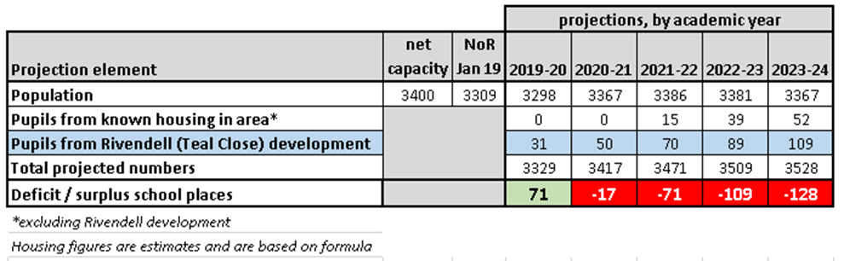

The above indicates that the Rivendell development will necessitate additional school places. Nottinghamshire County Council’s assessment is that there is insufficient additional capacity at existing local schools, which are listed below:

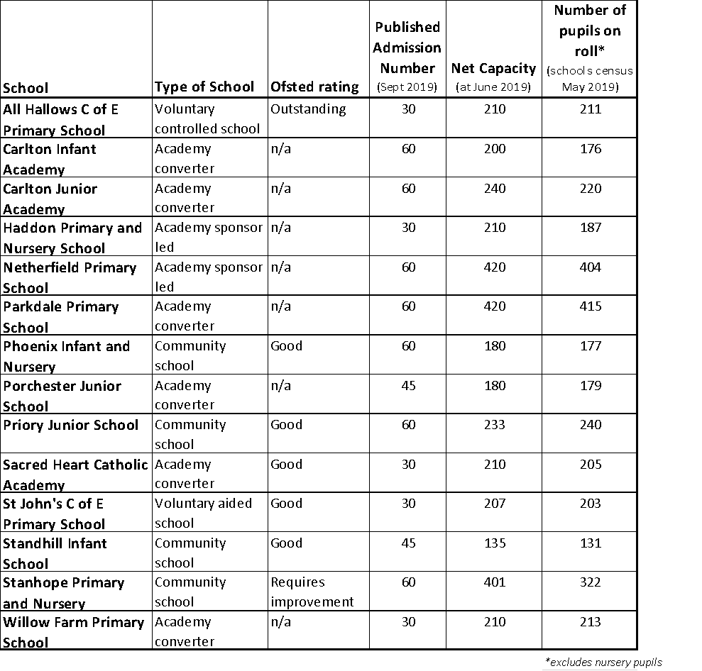

The local area

The Carlton planning area is located in the wider Gedling district.

Pupils currently attending primary schools in Carlton show the following characteristics:

- 24% are BAME
- 14% are eligible for free school meals
- 22% are eligible for pupil premium (for deprivation, services children, looked after children (LAC) or post-LAC)
- 13% have identified SEND

The planning area has experienced significant population growth in recent years and has already witnessed the creation of 260 additional school places since 2013.

The creation of this new, 210-place primary school will meet the projected demand for primary phase places in the planning area. However, the new school’s capacity to expand reflects the possibility of further house building in the future.

This primary school will be linked to the Carlton le Willows (secondary) Academy.

School Specification

The new school will be procured by Persimmon and will be built to the agreed Education & Skills Funding Agency (ESFA) specification (Building Bulletin 103) for a 1 form entry primary school (210 pupils), including provision for a 26 place early years provision.

The site and buildings will be leased by NCC to the Academy Trust for 125 years.

Age Range

The age range of the schools will be Reception to year 6. In addition, the 26 place early years provision on the school site will be run by the school and is therefore covered by this presumption.

Opening the School

It is expected that the school will open in September 2021.

There are a number of key principles that guide how the Authority wishes to see the new school opened.

- There should be sufficient places to ensure that families moving into the new housing development are able to secure places at the school;
- The school serving the new housing development should not open in a way that causes problems at existing primary schools within a two-mile radius;
- The school should be part of the NCC coordinated Admissions arrangements; and
- The school shall take part in the NCC agreed Fair Access protocol.

It is expected that there would be a clear commitment to serve the local community of the new development at Rivendell, and to support the creation of a community in this area. The school is intended to serve families living within walking distance of the school in order to reduce the need for car journeys.

NCC would be pleased to work with the approved sponsor of the new free school to agree a pattern for the phased opening of the new school to ensure that this policy is maintained, whilst working with and supporting the existing local schools. These proposals will form part of the evaluation of bids.

However, NCC’s intention is that the school will be opened in two phases:

Phase 1: 4 classrooms
Phase 2: a further 3 classrooms, to be made available on the occupation of the 500th Rivendell dwelling

Capacity and Structure

On opening in September 2021, the school will initially make available the following places:

Year Group(s) | No. Places
Reception | 30
Years 1 & 2 | 15 & 15
Years 3 & 4 | 15 & 15
Years 5 & 6 | 15 & 15
Total | 120

The published admission number (PAN) for the school will be 30 (in the first instance) in reception.

NCC anticipates that the school may develop as follows:

 | September 2021 | September 2022 | September 2023 | September 2024 | September 2025
Reception | 30 | 30 | 30 | 30 | From this stage in its growth, it is anticipated that the budget will be determined by numbers on roll and the school budget allocation.
Year 1 | 15 | 30 | 30 | 30
Year 2 | 15 | 15 | 30 | 30
Year 3 | 15 | 15 | 15 | 30
Year 4 | 15 | 15 | 15 | 15
Year 5 | 15 | 15 | 15 | 15
Year 6 | 15 | 15 | 15 | 15

KEY DATES

Event | Date
Invitation to submit a proposal published and presumption competition opens | 23rd September 2019
Deadline for receipt of applications | 15th November 2019
NCC informs DfE of all proposals received | w/c 18th November 2019
Local Authority Assessment Panel meets | 8th January 2020
Local Authority submits details of recommended proposer / sponsor to the Secretary of State | w/c 13th January 2020
Secretary of State appoints the successful sponsor of the new free school | To be confirmed

Background Documents

Your Nottinghamshire, Your Future – Nottinghamshire County Council Plan 2017-21

Pupil Place Planning and School Capital Policy – November 2017

School Admissions – Information and Guidance

Special Educational Needs and Disabilities (SEND) – Local Offer and Information

School Attendance, Discipline and Exclusion – Information and Guidance

Looked After Children Strategy 2018-2021

Place Departmental Strategy

APPLICATION FORM

NEW PRIMARY FREE SCHOOL: Rivendell, Teal Close, Colwick, Nottinghamshire NG14 5HN

Section A: Applicant details (personal information will be treated in accordance with the Data Protection Act)
Main contact for this application
1 | Name
2. | Address
3. | Email address
4. | Telephone number
About your organisation

5. | Please give details about your organisation or group
6. | Has your organisation/group been approved by the DfE as an academy sponsor?  Yes/No
7. | Outline some context about schools with whom you are working currently –  a) Please provide details of the schools you are running/sponsoring currently; and  b) To what extent are you supporting and/or working with other schools in their school improvement and what impact has this had, or is having?
8. | How many schools do you have DfE approval to open in the next two years?
9. | Did you put together this application with support from another company or organisation?  Yes/No
10. | If Yes, please list the name(s) of the organisation(s) and describe clearly the role they played in developing your application. Please describe the role (if any) you envisage for them in setting up and/or running the new Free School if your application is successful.
11. | Through its members, directors or otherwise, does the company limited by guarantee have any formal or informal links (e.g. financial, philosophical or ideological) with any other organisations within the UK or overseas? These may include other Academy or Free School groups, other institutions, charitable bodies and/or commercial or  non-commercial organisations.  Yes/No
12. | If yes, please provide details
13. | Would your proposed school be designated as having a religious character or have a faith ethos? Please give details below.
14. | Declaration of Personal/Business Links with Elected Member(s) and/or Senior Officer(s) of Nottinghamshire County Council
15. | Have you submitted an application to the DfE Free Schools Group to open a primary school at this site through the Direct Route already?  Yes/No

Section B: Strategic vision
Section C: Education Plan
Section D: Relationship with other schools, the Council and the wider education community
Section E: Capacity and capability
Section F: Financial planning and viability

We confirm that:

We will comply with the requirements of the School Admissions Code (SAC), and other guidance and law relating to admissions | Yes/No
We accept the funding arrangements for set up and resourcing the school, including the fact that we will receive no further “Project Management Funding” | Yes/No
We will participate in Nottinghamshire County Council’s agreed Fair Access protocol | Yes/No
We will accept the Local Authority’s policy on Safeguarding and implement it within the school | Yes/No

We understand that Nottinghamshire County Council does not bind itself to accept any of the submissions, and will not be responsible for any costs, expenses or losses of whatever nature incurred in connection with the process.

Signature ……………………….

(Print Name …………………………………………………..) Date …………

Position…………………………….. Title………………………..

Note: Application forms must be returned electronically no later than

5pm on Friday 15th November 2019

to:

place.planning@nottscc.gov.uk

Equalities and Impact Assessment

As prescribed by section 9 of the Academies Act 2010 and section 149 of the Equality Act 2010, the local authority must assess the potential impact of any new school on existing educational provision in the area. The local authority must also consider whether the new school would impact on any groups with the following “protected characteristics”: age,
disability, gender reassignment, pregnancy and maternity, race, religion or belief, gender,
sexual orientation. The county council must, therefore, have due regard to the need to:

1. Eliminate discrimination, harassment, victimisation and any other conduct prohibited
under the Equality Act 2010.

2. Advance equality of opportunity between persons who share a relevant protected
characteristic and those do not share it. This involves having due regard, in particular, to the need to:

- remove or minimise disadvantage suffered by persons who share a
relevant protected characteristic.

- take steps to meet the needs of persons who share relevant protected
characteristic that are different from the needs of people who do not share it (in relation to disabled people, this includes, in particular, steps to take account of disabled persons' disabilities);

- encourage persons who share a protected characteristic to participate in public life or in any other activity in which participation by such persons is disproportionately low.

3. Foster good relations between persons who share a relevant protected characteristic
and those who do not share it. This involves having due regard, in particular, to the
need to tackle prejudice and promote understanding.

The organisation of school places, and admissions to those places, are required to
comply with relevant legislation and Codes of Practice. Any change to school provision
in an area would potentially affect all pupils in that area, including those from minority
ethnic groups. The proposed new free school has been assessed as having no negative
impact in regard to any protected characteristic groups set out within the Equality Act
2010.

NCC Assessment Criteria
(Based on Criteria developed and published by the DfE –
The Free School Presumption Guidance - Annex C)

Applications to promote a Free School will be assessed using the criteria detailed below. These relate to the sections and numbering on the application form. The responses will be evaluated by a working group of County Council officers and elected members.

Strategic Vision (Section B of the Application Form)

The Local Authority will be using two criteria to assess this section of your application.

Criterion B1 - Provides a clearly focused, coherent vision that underpins the application with a compelling rationale for establishing the school.

This is your opportunity to tell us in your own words about the overarching vision for the new school and how it informs your education plan. You will need to demonstrate in later sections that the vision is both deliverable and affordable within the available funding. Your vision should be coherent and consistent with the other sections of your application.

You do not need to provide details of your intended enrichment programme at this stage; however, if an enrichment programme is crucial to achieving your vision you should
mention it in this section and provide more details in the education plan.

If you already have more than one school please provide a brief overarching vision for your chain and your planned expansion strategy (including how many schools you hope to have in total, geographical spread and timescales).

You must:
- set out clearly why you are seeking to sponsor the school;
- identify any particular ethos you wish your school to have (including any religious or other beliefs);
- identify how your vision and ethos (including any religious or other beliefs) are reflected in the education plan and the curriculum; and
- set out your aspirations for the achievement of individual pupils, and the school as a whole, demonstrating your commitment to achieving outcomes and rates of progress above national expectations.

Criterion B2 - Sets out how proposers will demonstrate they support UK democratic values

You must:
- provide evidence that you support UK democratic values including respect for the basis on which UK laws are made and applied, and respect for democracy; and
- support for individual liberties within the law, including mutual tolerance and respect, and how you will ensure the academy meets this objective.

Education Plan (Section C of the Application Form)

The Local Authority will be using eight criteria to assess this part of your application.

You should only seek to address criterion C8 if you are intending to be a faith ethos school, a school designated as having a religious character or if you are proposing a school with a particularly distinctive educational philosophy and worldview.

Criterion C1- Explains the rationale for the proposed curriculum, how it reflects the needs of the anticipated pupil intake and the plans for their progression and transition.

Criterion C2 - Sets out a viable curriculum plan with appropriate focus on breadth and balance, core areas of learning, and calendar and timetable.

You must:
- describe the curriculum, setting out how it will be broad and balanced; and
- detail your expectations around the length of the school day, term and year.

Criterion C3 - Shows how the staffing structure will deliver the planned curriculum.

You must:
- set out plans showing an appropriate and phased development of the staffing establishment in line with planned pupil numbers and financial resources;
- describe the final staffing structure and show how it is sufficient, affordable and appropriate to deliver the education vision and plan; and
- set out the structure of the senior leadership team, middle leaders, teaching staff and any non-teaching support staff, as well as a clear description of their roles and responsibilities, both in the development phase of establishing the staffing structure and when at full capacity.

Criterion C4 - Sets out a clear strategy for ensuring that the needs of pupils with differing abilities are met.

You must:
- demonstrate an awareness of the varying needs of individual pupils and have an effective strategy for meeting them, including supporting those who need it and stretching the most able (gifted and talented pupils);
- show how you will use ICT, other agencies and partners’ resources to support the learning and maximise the achievement of pupils of varying abilities and needs;
- describe the strategies you will use to overcome barriers to learning and achievement, such as having English as an additional language;
- set out how you will have regard to the Special Educational Needs Code of Practice; and
- set out your approach to supporting disabled pupils and pupils with special educational needs, including those with and without a statement of special educational needs to ensure they are fully included;
- set out your approach to ensure that Children in Care and disadvantaged children make more than expected progress utilising the Pupil Premium; and
- set out how you will work with the NCC approach to the graduated SEND process.

Criterion C5 - Details the definitions and measures of success which will deliver their aspirations for pupil achievement.

You must:
- outline the targets that are proposed, why they are suitable to measure the delivery of your education vision, and what your strategy will be to achieve them;
- describe the proposed success measures for individual pupils and the whole school, including teaching;
- explain how these success measures will be monitored, reviewed and reported, including your plans to develop pupil assessment and tracking systems;
- explain how pupil progress will be reported to parents/carers, how their views will be gathered and how parents/carers will play an active role in improving their child’s progress, and
- confirm your willingness to engage in annual standards and performance review with the Local Authority.

Criterion C6 - Describes the admissions policy, confirming commitment to fair and transparent admissions practices.

You must:
- set out your proposed admissions policy, including the criteria to be used to set priorities for places if your school is oversubscribed. The admission arrangements must comply with the School Admissions Code (SAC) and related admissions law that applies to maintained schools in England.

Criterion C7 - Describes how the approach to behaviour management, pupil safeguarding, pupil wellbeing and attendance will improve pupil outcomes.

You must:
- set out detailed strategies for promoting good behaviour and attendance;
- describe how you will promote pupil well-being, including through pastoral care and strategies for tackling bullying;
- describe how these strategies are informed by your education vision and linked to raising standards and educational outcomes; and
- explain how you will help to achieve Nottinghamshire’s vision of zero permanent exclusions.

Criterion C8 - (If Appropriate) The application to set up a faith ethos Free School, a school designated as having a religious character, or one with a particularly distinctive educational philosophy and worldview, shows how the needs of all children are fully provided for within the education plan.

If you are proposing a free school designated as having a religious character or a school with a religious ethos, you must:
- describe how you will ensure that the school will be welcoming to pupils of all faiths and none, and show how the school will meet the needs of pupils of other faiths and none. You will need to set out how you think school policies will impact on these pupils. You will need to consider uniform and the wearing of religious symbols, the school meals you will provide and whether there will be dietary requirements, your religious education curriculum and the nature of collective worship; and

- explain how the school’s religious character or ethos will be reflected in the curriculum, including what percentage of your timetable will be devoted to religious education and other faith-related subjects and why this percentage is appropriate. Please set out what alternatives will be available for pupils not of the faith.

If you are proposing a school with a particularly distinctive educational philosophy and worldview, you must:
- describe how you will ensure that the school will be welcoming to all pupils within the local community. You will need to set out how you think the curriculum and school policies will impact on all pupils and how you will explain the curriculum to parents and pupils who are not familiar with this alternative method; and
- confirm what percentage of time is devoted to each subject.

Relationships with other Schools, the Local Authority and the Wider Education Community (Section D of the Application Form)

The Local Authority will be using one criterion to assess this section of your application.

Criterion D1 - Demonstrates how the prospective sponsor will work with and for the local community and is committed to work for the benefit of the wider education community.

Proposers need to demonstrate/provide details on:
- your understanding of the community that the Free School will serve and how your education plan addresses the needs of that community;
- how you will make the school attractive to pupils of different backgrounds and abilities. This should include pupils from deprived or disadvantaged families;
- arrangements for home to school partnerships and communications to ensure parents are fully engaged in all aspects of their child’s development and achievement;
- how you will demonstrate your commitment to working collaboratively with other schools, and in particular the existing local primary school(s), and in close partnership with Nottinghamshire County Council;
- how you will support the vision of the Nottinghamshire County Council as set out in the policy statement ‘Your Nottinghamshire: Your Future’; and
- arrangements you will put in place to make the building and facilities available to the local community outside of school hours.

Proposers need to demonstrate how they will respond to the Local Authority’s stated position on revenue funding at the inception of the project to open this new school. Given that the educational landscape is maturing, and Multi-Academy Trusts are developing their own infrastructure and capacity, it is the view of the County Council that all publicly funded stakeholders should ensure that available resources are pooled to meet the need for new school places.

There is a shared duty that Multi-Academy Trusts, Local Authorities and the DfE should work together to maximise resources and minimise the duplication of effort, and provide value for money. Therefore, this Local Authority does not envisage forward funding senior leadership salaries as we expect that Multi-Academy Trusts will have the capacity to do so.

Capacity and Capability (Section E of the Application Form)

The Local Authority will be using three criteria to assess this part of your application.

Criterion E1 - Demonstrates a clear understanding of the respective roles of the company members, governing body and principal in running the school.

You must:
- describe clearly in both writing and in a diagram the structure, lines of accountability and methods of escalation between the company members, the school’s directors (who also act as governors and trustees) and the principal;
- define clearly and set out the respective roles and responsibilities of the company members, the directors (who also act as governors and trustees), any proposed committees and the principal; and
- set out your protocols for avoiding and minimising conflicts of interest, confirming any you have already identified, and for securing independent challenge to executives.

Criterion E2 - Show how the prospective sponsor will access appropriate and sufficient educational, financial, and other expertise to deliver their vision.

You must:
- show that you have identified the educational resources, people and skills that you will need to set up and operate a school;
- show that you have identified the resources, people and skills that you will need to set up arrangements for and undertake the financial management of a school;
- show that your group has identified other relevant expertise, such as individuals or organisations with successful experience of setting up a new organisation or business, school governance, human resources, ICT, property/construction, marketing and project management;
- confirm sufficient time commitments to the project from relevant individuals;
- explain how work on this school will be balanced against the development of others if your group is seeking to establish more than one school; and
- set out clear and detailed plans for identifying and securing any necessary expertise currently missing from your group.

Criterion E3 - Provides realistic plans for recruiting a high-quality Principal, other staff and governors in accordance with the proposed staffing structure and education plans.

You must:
- set out plans for recruiting your school’s principal (head teacher) and the role you envisage him/her playing in the pre-opening phase;
- set out your plans for recruiting and developing high quality members of staff;
- identify for NCC any individuals you have identified already as prospective governors and their relevant skills and expertise; and
- describe how you will identify and appoint committed governors with the necessary skills to oversee both the establishment and running of a school.

Financial Planning and Viability (Section F of the Application Form)

The Local Authority will be using one criterion to assess this part of your application.

Criterion F1 - Provides accurate financial plans that are consistent with the rest of the application and based on realistic assumptions about income and expenditure.

You must:
- set out your views on the key financial challenges you might encounter and how you will seek to address these;
- detail the systems you would put in place to ensure that the school’s finances are properly managed;
- outline your assumptions in estimating the income and expenditure for the school, and confirm which benchmarking data you have used;
- explain any unusual items of income and expenditure in the financial plans;
- show that you have allowed for unforeseen contingencies;
- demonstrate that any third-party income you have included is realistic and achievable; and
- confirm agreement to proceed according to the local authority’s revenue funding arrangements set out in the ‘Invitation to Submit a Proposal’.

Sharing your information

The identities of applicants will be shared with the Department for Education, which will gather relevant evidence regarding each proposer / potential sponsor.

Nottinghamshire may provide the Department for Education with a copy of your application. The information you have provided on your application may be subject to publication or disclosure in accordance with the Freedom of Information Act 2000 and the Data Protection Act 1998.

Following the closing date for applications

Assessment

Proposals will be assessed as follows:

- An initial, paper assessment will be undertaken, based on the evidence contained in each proposal
- Each selected proposer will be invited to attend an interview, at which they will be asked to present their case and to answer questions to provide clarification and further detail
- The assessment and interview panels will include some or all of the following:
  - Nottinghamshire County Council Officers
  - Local Councillors
  - Representatives from the local community
  - A representative from the DfE

Scoring

Nottinghamshire will use the scoring system recommended by the DfE:

- 0 = The evidence and argument contained in the application is ‘inadequate’.
- 1 = The evidence and argument contained in the application is ‘adequate’.
- 2 = The evidence and argument contained in the application is ‘good’.
- 3 = The evidence and argument contained in the application is ‘excellent’.

Following assessment

The LA will undertake due diligence on all applicants. Proposals should demonstrate that the sponsor would:

- support UK democratic values, including respect for the basis on which UK laws are made and applied
- demonstrate respect for democracy
- support individual liberties within the law
- demonstrate and mutual tolerance and respect

The LA will make a recommendation to the DfE, along with reasons for its decision. It will provide the scores given to each bid / proposal.

The recommendation will give evidence that the new presumption free school will raise the overall standard of education and reduce social disadvantage in the local area, and will add high quality places to the system.

The Secretary of State may choose to agree a sponsor other than the one proposed by the LA, if they have evidence regarding the sponsor’s suitability or lack thereof.

The final decision will be made by the Secretary of State. The DfE will then inform the LA, the successful proposer and the local MP

The LA will inform the unsuccessful candidates, providing feedback where necessary.

