Careers Local helps young people to “Grow”
Pupils from the Derbyshire Virtual School showcased their Careers Local funded “Grow” themed display at the RHS Chatsworth Flower show this summer. Careers Local provides grants of up to £10,000 (and up to £20,000 where need is evidenced) to eligible educational institutions in the D2N2 area, for provision which will help young people develop employability skills and make the right career choices. The programme is managed by Nottinghamshire County Council on behalf of the D2N2 LEP.
The pupils, aged from 15 to 19, met weekly over several months to develop the exhibit, supported by their Virtual School creative mentors and tutors from the Derbyshire adult community education service. The design, which featured pottery, carpentry, mosaic and horticulture, was based on the students’ own experience and memories of working together, showing how shared experiences and relationships based on trust help everyone involved to grow and flourish.
Kim Johnson, arts education consultant for the Virtual School, said;
“This wonderful opportunity is the realisation of their own collective ambition to put a display together for the RHS Show, and we’re very grateful for the help we’ve received to make it happen.”
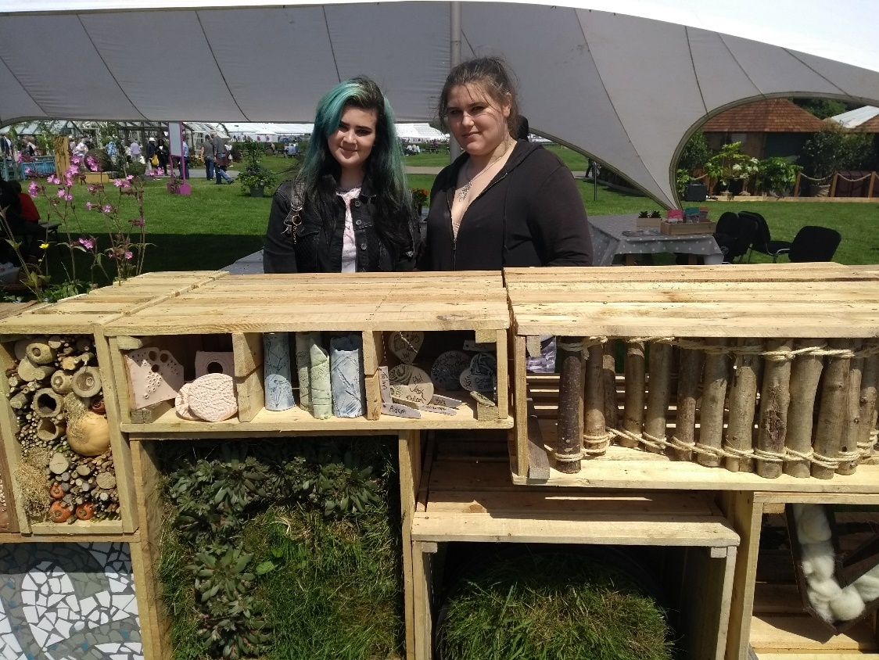

The final exhibit, featured in the education section of the show, consisted of a wooden unit made from recycled materials with several compartments containing different interpretations of the theme. All the participants demonstrated a real pride and dedication to the project, giving up their holiday time to ensure it was completed for the deadline. They pooled their own creative ideas for the design, worked with a range of people, developed their communication and organisational skills, and gained practical experience towards obtaining horticultural and arts qualifications.
Most importantly, the young people forged lasting friendships and developed their skills in working together, communication and confidence, whilst gaining valuable experience to support their next steps in employment and training. Some of the participants commented “it’s really helped my confidence” and “one of the best things has been making new and lasting friendships”.
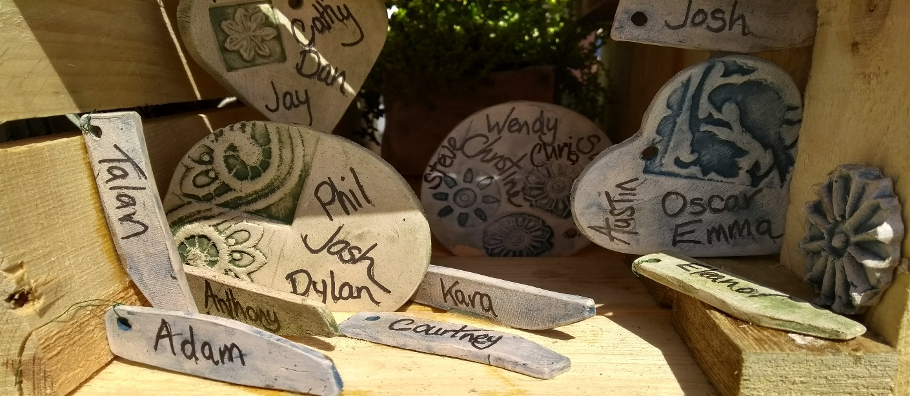

Careers Local is a European Social Fund project and is delivered through a partnership between Nottinghamshire County Council, the D2N2 LEP and the Education and Skills Funding Agency. The programme is open for bids until October 22nd 2018, with provision until January 2019. For more information and to make an application see Careers Local Grants.

