Parenting Adopted Children - Therapeutic Needs & Realities

Parenting adopted children is different. Adopted children's early life or prenatal experience of neglect, abuse, loss, abandonment and chaos may continue to impact on them as they move through childhood to adolescence and into young adulthood. The emotional demand this places on adoptive parents can be exhausting. This course will enable you to consider the impact of a child's early years’ experience, how it can affect adoptive parents, support your child’s emotional needs and gain therapeutic parenting strategies to manage their presenting behaviours.

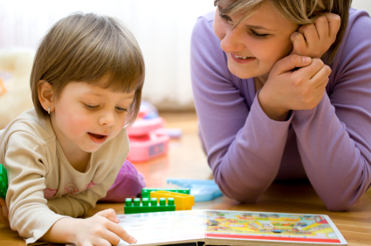

Aims:

- To reflect on how neglect and abuse impacts on a child's brain development and how this may present in the 'here and now'

- To gain an understanding of PACE and develop strategies to support and manage your child's presenting behaviours and emotional needs.

- To develop awareness of how parenting can impact on yourself and how to take care of yourself.

- To consider why adoptive children may find it hard to regulate themselves and gain strategies to enable them to calm and promote self-regulation.

Trainers: Experienced post adoption workers from Support after Adoption.
Date: Thursday 22nd March 2018
Time: 6.30pm - 9 pm
Where: Rufford Suite, County Hall, West Bridgford, NG2 7QP

Apply for this course by completing the on-line application form at http://www.nottinghamshire.gov.uk/adoption-courses
(click through via the appropriate course) or find out more by emailing adoption.learning@nottscc.gov.uk
For more information on therapeutic parenting visit our portal at www.nottinghamshire.gov.uk/fanotts

