Admission Policy for
Greythorn Primary School

2018/19
Admission arrangements for children starting school

Admissions for children about to start school are decided by the governors of the school, but the process is coordinated either by Nottinghamshire County Council’s Admissions Office – 01623433499 or http://www.nottinghamshire.gov.uk/education/school-admissions
Or, for parents living in Wilford village:
Nottingham City Council Admissions Office- 0115 8415568
www.nottinghamcity.gov.uk/education-and-schools/school-admissions
and parents/carers are required to apply on a common application form through their ‘home’ local authority.

The published admission number per year group is 45.

Admission oversubscription criteria

In the event of over subscription, the following criteria will be applied, in priority order, to determine which applications will be granted once places have first been allocated to pupils who have a statement of special educational needs or an Education, Health and Care Plan which names the school:

- Children looked after by a local authority and previously looked
after children
- Children who live in the catchment area* and who, at the time of admission, will have a brother or sister attending the school
- Children who live in the catchment area*
- Children who live outside the catchment area and who, at the time of admission, will have a brother or sister attending the school
- Children who have a parent working at the school where the member of staff has been employed at the school for two or more years at the time at which the application for admission is made or the member of staff is recruited to fill a vacant post for which there is a demonstrable skill shortage
- Other children

*Following a period of consultation the governors of Greythorn Primary School have changed the catchment area for Greythorn for admissions in September 2018/19. Please see the map in Appendix 1 for the catchment area.

In the event of over subscription within all but the first criterion, preference will be given to children who live nearest to the school as the crow flies. Distances are measured from the entrance to the child’s home to the principal entrance to the main administrative building of the school using the Nottinghamshire County Council’s computerised distance measuring software.

In the event of two distances being equal, random allocation will be used as tie-break. This process will be independently verified.

Where one child of a multiple birth can be admitted, the other child/children will also be admitted.

Waiting lists are held for the reception intake year and will be held until 31st December of the intake year.

Children offered a place in our school who were born between 1 September and 31 August of the appropriate admission year, have the option to start full-time school from the beginning of the autumn term. Parents may choose to defer their child’s admission to the following term or until the beginning of the term following their child’s fifth birthday, provided that the child’s admission takes place within the current school year and subject to discussion with the Head of School.

Should parents of summer born children choose to defer their child’s admission until the September after their fifth birthday and request their child enter the reception class the admission authority will make a decision on the basis of the circumstances of each individual case.

Special Circumstances

The following groups of children will be given special consideration in their application for a particular school: children whose particular medical needs, mobility support needs, special educational needs or social circumstances are supported by written evidence from a doctor, social worker or other relevant professional stating that the school is the only school which could cater for the child’s particular needs. The evidence must be presented at the time of the application.

The governors will consider each case on its merits and determine the allocation of any such place on the basis of the written evidence. Admission under ‘special circumstances’ will take precedence over all but the first of the numbered criteria.

Late Applications

Late applications will be processed in line with the co-ordinated scheme.

In year admissions to year groups other than the intake year

Admission into school is decided by the governors of the school, but coordinated by Nottinghamshire County Council and, in the case of residents of Wilford village, Nottingham City Council. Applications forms can be obtained from:
Nottinghamshire County Council: www.nottinghamshire.gov.uk/education/school-admissions
Nottingham City Council: www.nottinghamcity.gov.uk/education-and-schools/school-admissions
Applications for admission to year groups other than the intake year group will be considered in relation to the published admission limit which applied when the year group was first admitted to the school, subject to infant class size restrictions. If places are available within the year group, the child will be admitted. If there are more applications than places available, the oversubscription criteria above will be used to determine which child can be offered a place.

A waiting list will be in operation for all other years where the academy receives more applications than places available. The waiting lists will remain open whilst the number of places in the year group is full, or until the end of the academic year.
Where the number of students in a particular year group falls below the published admission number, the person whose name appears first on that particular year group’s waiting list will be offered a place. A child’s position on this waiting list will be determined by the application of the academy’s published oversubscription criteria.
Parents of children who are on the waiting list will be contacted at the start of each half term to establish if they wish to remain on the waiting list.
Parents are welcome to ask what position they currently hold on the list. However, because the academy constantly receives applications for admission throughout the year, the waiting list is continually being re-ordered. Parents need to be aware that their position on the list may rise and fall over time and therefore a higher position on the list is not necessarily a good indicator of the likelihood of a place being offered. Length of time on the waiting list will not be a factor in offering a place.
Children who are the subject of a direction by a Local Authority to admit or who are allocated to the academy in accordance with the In-Year Fair Access Protocols, will take precedence over those children on a waiting list.
The governors use the same definitions (sibling, parent, home address) as those of Nottinghamshire County Council – these are published in the “Admissions to schools: guide for parents”.

A definition of a “looked after child” is a child who is:
A looked after child is a child who is (a) in the care of a local authority, or (b) being provided with accommodation by a local authority in the exercise of their social services functions in accordance with section 22(1) of the Children Act 1989 at the time of making an application to a school.
Previously looked after children are children who were looked after, but ceased to be so because they were adopted (or became subject to a child arrangements order or special guardianship order). This includes children who were adopted under the Adoption Act 1976 and children who were adopted under section 46 of the Adoption and Children Act 2002.
Child arrangements orders are defined in section 8 of the Children Act 1989, as amended by section 12 of the Children and Families Act 2014. Child arrangements orders replace residence orders and any residence order in force prior to 22 April 2014 is deemed to be a child arrangements order. Section 14A of the Children Act 1989 defines a ‘special guardianship order’ as an order appointing one or more individuals to be a child’s special guardian (or special guardians)

Further guidance on the way in which applications are dealt with can be found in the current Nottinghamshire County Council’s “Admissions to Schools” booklet and the County Council website www.nottinghamshire.gov.uk/education/school-admissions. This also outlines how the co-ordinated admissions scheme and late applications are processed.
For parents living in Wilford village the documents ‘Going to school in Nottingham 2018/19’ and ‘Summary Guide for infant, junior and primary applicants 2018/19 are available from the Nottingham City admissions team: www.nottinghamcity.gov.uk/education-and-schools/school-admissions

Admission of children outside the normal age group
Parents may seek a place for their child outside of the normal age group, for example, if the child is gifted and talented or has experienced problems such as ill health. In addition, the parents of a summer born child may choose not to send that child to school until the September following their fifth birthday and may request that they are admitted out of their normal age group – to reception rather than year 1. Children should only be educated out of the normal age group in very limited
circumstances.
Residents should submit a request in writing to their home local authority school admissions team as early as possible. Designated officers will make decisions based on the circumstances of each case and in the best interests of the child concerned. This will include taking account of the parent’s views; information about the child’s academic, social and emotional development; where relevant, the child’s medical history and the views of a medical professional; whether they have previously been educated out of their normal age group; and whether they may naturally have fallen into a lower age group if it were not for being born prematurely. The views of the head teacher of the school concerned will also be taken into account.

When informing a parent of the decision on the year group to which the child should be admitted, the parent will be notified of the reasons for the decision. Where it is agreed that a child will be admitted out of the normal age group and, as a consequence of that decision, the child will be admitted to a relevant age group (i.e. the age group to which pupils are normally admitted to the school) the local authority and admission authority must process the application as part of the main admissions round on the basis of their determined admission arrangements only, including the application of oversubscription criteria where applicable.

The parent has a statutory right to appeal against the refusal of a place at a school for which they have applied. This right does not apply if they are offered a place at the school but it is not in their preferred age group.

Part-time education for children below compulsory school age
Some parents/carers may choose to defer the start of full-time education for their child until compulsory school age. If parents/carers wish to take up this option, they may arrange the details with the head teacher of the school. However, if their child’s birthday falls between 1 April and 31 August, deferring admission until compulsory school age would result in the child being admitted into a different school year. In this case, the child could not be allocated a reception place at the school during the 2018/19 year and the parent would have to apply for a place during the 2019 summer term for admission into year 1 in September 2019. The Local Authority strongly recommends that parents/carers do not defer the start of their child’s full-time education as children’s learning chances are likely to be better if they start school with their peers at the beginning of the 2018/19 school year. Parents/carers can request that their child takes up a school place part-time until their child reaches compulsory school age.

Transfer to junior and secondary school
Where a child has been educated out of the normal age group it is the
parent’s responsibility to again request admission out of the normal age group when they transfer to junior secondary school. It will be for the admission authority of the preferred school to decide whether to admit the child out of the normal age group. The admission authority must make a decision on the basis of the circumstances of each case and in the child’s best interests, and will need to bear in mind the age group the child has been educated in up to that point.

Appeals

In the event of oversubscription and applications being refused, applicants have the right to an independent appeal. Applicants wishing to appeal should contact the school within 20 school days of the refusal letter to obtain the necessary forms.

Fair Access Protocol

Greythorn Primary School participates in Nottinghamshire County Council’s Fair Access Protocol.

Written: February 2017
Review: Annually

Chair of Governors: 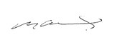

Head Teacher: 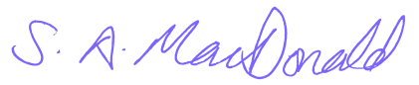

Appendix 1- Map showing Greythorn’s catchment area for 2018/19

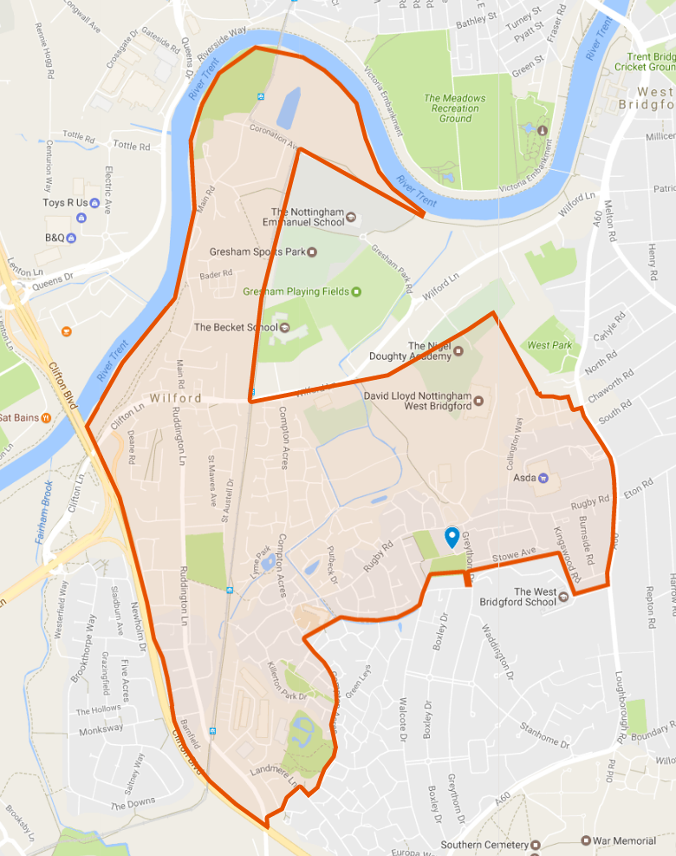
Key
Existing catchment

Proposed addition

Key
Existing catchment

Proposed addition
Key
Existing catchment

Proposed addition
Key
Existing catchment

Proposed addition
Key
Existing catchment

Proposed addition

