
Admissions Arrangements
2018-19
Sturton Le Steeple C of E Primary School

Admissions Policy

ADMISSION ARRANGEMENTS

The published admission number is 10 children per year.

Children who are allocated a place will be admitted full-time in September if they are 5 in the academic year (DOB 1.9.2013 to 31.8.2014). Parents may defer their child’s admission until the start of the term after their 5th birthday. Parents can request that their child attends on a part-time basis until they reach compulsory school age.

Attendance at the early years provision (Foundation 1) at the school does not automatically guarantee a reception (Foundation 2) place.

The closing date for applications is 15th January 2018. Late applications will be dealt with by Nottinghamshire County Council Admissions team.

Applications must be made to the home local authority by the closing date. A supplementary information form should also be completed and returned to school by the closing date in support of applications made in accordance with Criterion 5 as published below (to confirm regular attendance at Church).

The offer of a school place will be made by the L.A. to all parents on the ‘offer day’ which is Monday 16th April 2018, as set out in the co-ordinated scheme.

The school operates a waiting list for its intake year group in partnership with Nottinghamshire LA. This is kept and prioritised following the oversubscription criteria until the end of the first week of the spring term.

ADMISSION OVERSUBSCRIPTION CRITERIA
In the event of over-subscription, all applications for the reception year will be considered in accordance with the admission criteria, as set out below.

Children who have an Education, Health Care Plan, which names the school will be admitted which will reduce the number of places available to other applicants.

- Looked after children and previously looked after children

- Children who live in the school’s catchment area (Parish of Sturton Le Steeple) who will have a brother or sister at the school at the time of admission

- Other children who live in the catchment area (Parish of Sturton Le Steeple)

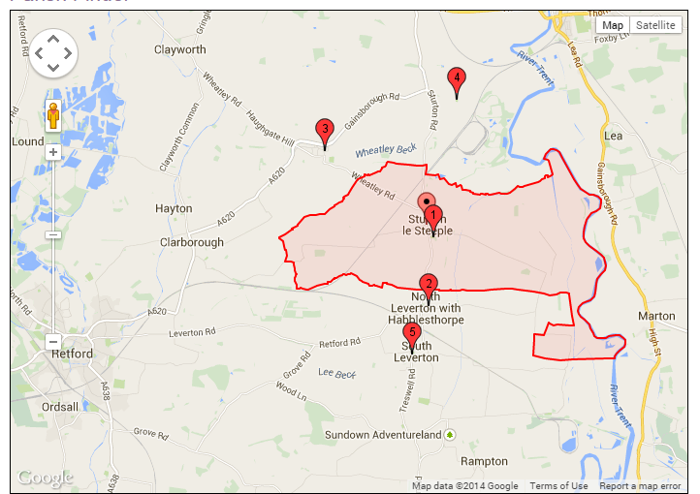

- Children who live outside the catchment area who will have a brother or sister at the school at the time of admission

- Children who have regularly attended worship with their parent(s) or another carer at a Church of England church or a church that is a member of “Churches Together in England”.

- All other children

In the event of over-subscription within any criteria, priority will be given to children living nearest to the school at the time of application. Distances will be measured ‘as the crow flies’ from the child’s home address to the main entrance of the school (using Nottinghamshire County Council’s computerised distance measuring software).

In cases where parents have shared responsibility for a child following the breakdown of their relationship and the child lives for part of the week with each parent, the distance measurement used will be the shortest home to school house.

In the event of two distances being equal, lots will be drawn and independently verified.

Where one child of a multiple birth can be admitted, his or her brother or sisters will also be admitted unless this would create an infant class of more than 30 children (multiple births are an exception).

Special Circumstances: The following groups of children will be given special consideration by the Governors in their application to the school.

Children whose particular medical needs, mobility support needs, special educational needs or social circumstances are supported by written evidence from a doctor, social worker or other relevant professional stating that the school is the only school which could cater for the child’s particular needs. The evidence must be presented at the time of application.

Parents may seek a place for their child outside of their normal age group, for example, if the child is gifted and talented or has experienced problems such as ill health. In addition, the parents of a summer born child may choose not to send that child to school until the September following their fifth birthday and may request that they are admitted out of their normal age group – to reception rather than year 1.

Cases agreed under ‘special circumstances’ will take precedence over all the above numbered criteria.

The school operates a waiting list for its intake year group in partnership with Nottinghamshire LA. This is kept and prioritised following the oversubscription criteria until the end of the autumn term. The school continues to maintain a waiting list until the end of the first week of the spring term.

IN-YEAR ADMISSIONS

All other admission requests will necessitate the completion of the appropriate application form by parents/carers. The school will normally admit pupils up to the PAN set for the year group when it was first admitted. Parents should apply in writing to the Governing Body. The above criteria will apply.

Governors will consider admission requests and places will be filled in accordance with the admissions criteria.

Distance will be calculated using Google Maps.

All students admitted will normally be placed on the school roll at the start of the next term or half term unless there are genuine reasons for an earlier admission (e.g. students moving into the catchment area or coming under the Special Circumstances of Section B)

In the case of a ‘waiting list’, this will be held by the school and monitored by the Governing Body.

RIGHTS OF APPEAL

When requests for admission is refused, the applicants will be informed in writing of the reasons for the refusal. For applications during in-year, the Clerk to the Governors Admissions Committee will write to parents advising them of their rights of appeal.

Appeals should be made to the Governing Body.

For admissions into the intake year through the co-coordinated admissions scheme, the home local authority will inform applicants of the outcome of their application and of their right of appeal.

All appeals should be lodged within 20 school days of the date of the refusal letter.

DEFINITIONS

Parent
The term ‘parent’ is defined as those who have legal responsibility for the upbringing of a child.

Looked after children and previously looked after children
Children who are in the care of local authorities as defined by Section 22 of the Children Act 1989. In relation to school admissions legislation a ‘looked after child’ is a child in public care at the time of application to a school.

Previously looked after children are children who were looked after, but ceased to be so because they were adopted (or became subject to a child arrangements order or special guardianship order).

Siblings
- A brother or sister who share the same parent
- A half brother or sister where two children share one common parent
- A step brother or step sister, where two children are related by a parent’s marriage
- Adopted or fostered children living in the same household under the terms of a residence order

If we receive an application which contains fraudulent or deliberately misleading information any offer of a place based on that information will be automatically withdrawn.

SUPPLIMENTARY INFORMATION FORM- MINISTER’S VERIFICATION

Applications on denominational grounds must be supported by a supplementary form completed by the parent(s) with verification from a minister of religion that both the child and parent(s) have practiced their faith by worship at least once per calendar month at the minister’s place of worship for at least the past year.

At all times the Governing Body will work with Nottinghamshire Admissions team to ensure the Fair Access Protocol is upheld.

Sturton le Steeple CE Primary School

Supplementary Information Form

You should complete this form if you are applying for a place and consider that you and your child meet the school’s faith-based admissions criterion.

This supplementary form must be returned directly to the school.
The formal admission application should be returned to the home local authority.

- In determining faith admission applications priority is given to children who have worshipped regularly with their parent (at least monthly for at least the previous year) at either a Church of England church or another Christian church which is a member of Churches Together in England.

Please complete the first two sections (Child details and Parent Carer declaration) and ask your minister to complete the third section. The completed form should be returned to the school office.

1. Child details:

Child’s name:

Child’s date of birth:

Parent/carer’s name:

Parent/carer’s address:

2. Parent/Carer Declaration

I the parent/Carer_______________________ have worshipped at least once a month for the last year at

My child has also worshipped at least once a month for the last year at

Signed (Parent/Carer) Date
3. Minister’s section

Countersigned by minister of religion Date

Name of Minister

Telephone number

Address

