Hucknall Town Centre Improvement Scheme

Traffic Management Bulletin

From Saturday 4th June 2016, Network Rail will close Station Road Bridge. We will keep you updated with progress throughout these works.

Week Commencing 1st August 2016

Monday 1st August to Sunday 7th August 2016
Carillion/Tarmac - 2 way traffic lights on Albert St & Perlthorpe Drive junction.
Carillion/Tarmac - Baths Lane is closed to vehicles and pedestrians. A pedestrian diversion is available through the new works area on Ashgate Road to access the Tram.
Network Rail – Station Road Rail Bridge closed with 2 way traffic lights at the junction of Wigwam Lane and Papplewick Lane.

Monday 1st August 2016 Only
Carillion/Tarmac - Titchfield Street closed at the junction of High Street, access only for businesses and a diversion via Albert Street for residents.

Tuesday 2nd August to Sunday 7th August 2016
Carillion/Tarmac – The junction of Albert Street & Perlthorpe Drive is closed.
For Albert Street & Titchfield Street use the High Street (Access Only)
For Perlthorpe Drive use Thoresby Dale only. See reverse.

Week Commencing 8th August 2016 (Subject to Change)

Monday 8th August to Sunday 14th August 2016
Carillion/Tarmac - Baths Lane is closed to vehicles and pedestrians. A pedestrian diversion is available through the new works area on Ashgate Road to access the Tram.
Network Rail – Station Road Rail Bridge closed with 2 way traffic lights at the junction of Wigwam Lane and Papplewick Lane.
Carillion/Tarmac – Vehicle access for residents to Albert Street North and Titchfield Street North use the new relief road via Annesley Road / Baker Street.
Vehicles for Perlthorpe Drive use Thoresby Dale only.
Vehicles for Albert Street South and Titchfield Street South use the High Street (Access Only). See reverse.

Pedestrian access will be maintained.

Site Public Liaison Details
harold.shaw@tarmac.com
07484029694

1st August to 8th August

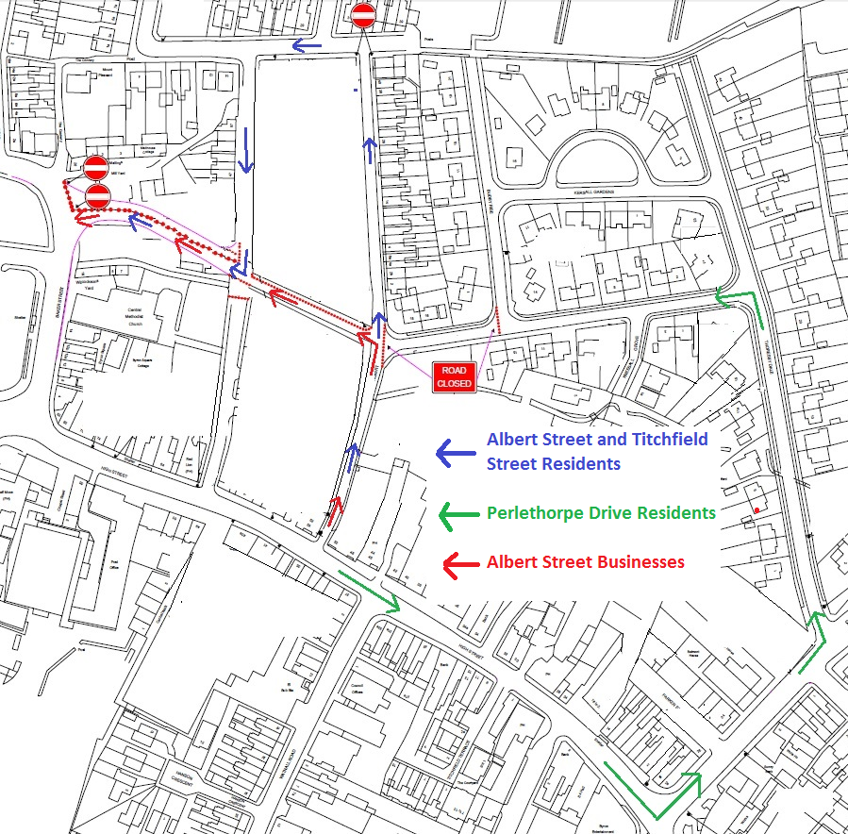

8th August to September

