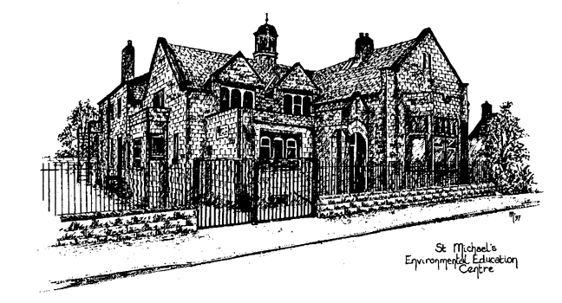

St.Michael’s Environmental Education Centre

St.Michael’s Environmental Education Centre
Schools and academies from outside Nottinghamshire
Booking Opportunities
April 2016 to Easter 2017

St.Michael’s is Nottinghamshire County Council’s environmental education centre for Primary and Special Schools offering high quality residential accommodation and activities for Key Stages 1 & 2 (and all phases from Special Schools).

Activities are linked to the curriculum to maximise the benefits of your visit in a safe and exciting environment. You are encouraged to tailor your visit to suit the needs of your pupils.

To make a booking, complete the attached booking form. If your school has not visited before, and/or you would like more information please contact Bill Hanley, Head of Centre on 01433 650309. Pre-booking visits are very welcome.

Booking Information

- The Centre has 34 pupil and 4 staff beds. An extra 4 adults can be accommodated in the adjoining cottage. By using the cottage it is possible for staff to enjoy single occupancy of the staff bedrooms.
- Schools wanting to bring over 34 pupils can book multiple visits of 2 or more nights, so that all pupils in a year group or cohort can visit.
- You can book a stay for 2 nights or longer, at any time of the year.
- There are special, reduced rates for weekend visits.

What we offer

- High quality residential accommodation with exclusive use.
- Free induction course and full pre visit planning.
- A highly qualified and experienced outdoor tutor to work with you and your pupils throughout your visit. There is no need for school staff to have specialised outdoor skills.
- Outdoor clothing including waterproofs, rucsacs, boots, gloves and hats.
- Facilities and activities for pupils with disabilities.
- Ready to use curriculum resources to make your visit more rewarding.
- Risk assessments and safety procedures of a high standard that meet all requirements of the LA Visits Guidance for Children and Young People (2011).
- All bedding provided; duvet, pillow, duvet cover, fitted sheet and pillow case.
- Catering support for all groups with enhanced catering package available (see below). Most schools opt for the catering package.

Prices
St Michael’s Environmental Education Centre
(Individual pupil charge based on 34 pupils. Staff places are free.)
Length of booking | Centre charge per night | Cost per pupil per night
5 nights | £757 | £22.27
4 nights | £787 | £23.15
3 nights | £829 | £24.38
2 nights mid week | £958 | £28.18
2 night weekends: April 2016 to July 2016 | £741 | £21.80
2 nights weekends: Sept 2016 to March 2017 | £556 | £16.36

Additional booking options

St.Michael’s Cottage £58 per night
Catering package at £10.50 per person per night; we will plan, with yourselves, a menu and have all your food available and ready for you. All you need to do is complete some of the final preparation. Schools are responsible for making breakfast, serving the evening meal, washing up, and laying tables etc.

Booking notes

- These charges are fixed and not subject to change.
- Split weeks and multiple bookings will be charged at the night rate for each visit by a separate group of pupils.
- Priority is given to schools in the following order; schools that
(a) Are from Nottinghamshire LA,
(b) Maximise the length of their visit,
(c) Include a Friday, Saturday, or Sunday night in their visit.
(d) Have most flexibility in the dates they want to book (eg three different dates at differing times of the year).
- Bookings will be confirmed as soon as possible.
- You can also make a private booking for the Centre and Cottage when these aren’t needed by schools. Please enquire for prices and availability.

Please send the attached booking form, giving as much detail and flexibility in dates as possible to:

Head of Centre, St.Michael’s Environmental Education Centre
Main Road, Hathersage, Hope Valley, S32 1BB
Or fax to 01433 650309.


