Report to Children’s Trust Board
08 October 2015
Agenda Item: 4

Children’s Trust Board Sponsor: Derek Higton, Service Director, Youth, Families and Culture
Children, young people and families plan 2016-18
Purpose of the Report
- To outline the proposed process including the timeline and proposed format for the development of the Nottinghamshire Children, Young People and Families Plan (CYPF Plan) for 2016-18.
- To agree the draft priorities for the CYPF Plan prior to consultation with key stakeholders.

Information and Advice
- Background

- The current CYPF Plan covers the two year period up to the end of March 2016, and will therefore need updating and revising over the next few months.

- It is intended the CYPF Plan for 2016-18 will be a published document outlining the priorities and key actions of Nottinghamshire Children’s Trust.

- The CYPF Plan will describe how Nottinghamshire County Council will fulfil its statutory responsibility, as the lead partner in the Children’s Trust, to make arrangements to promote co-operation to improve children’s well-being (Children Act 2004).

- The CYPF Plan will not detail all the services of partner organisations within the Children’s Trust, but instead will focus on co-ordinated planning and integration of services in order to improve the outcomes for children, young people and their families in Nottinghamshire. It will also provide a framework for the management of performance improvement.

- The proposed timeline and consultation process for developing the CYPF Plan 2016-2018

- Table 1 below summarises the proposed timeline for developing the CYPF Plan for 2016-2018.

Table 1 Timeline for the development of the CYPF Plan for 2016-2018
Activity | By when
Approval by the Children’s Trust Board of proposed timeline, format and draft priorities for the CYPF Plan for 2016-2018 | 8 October 2015
Consultation with key stakeholders including Nottinghamshire Safeguarding Children Board (NSCB), children and young people | October to December 2015
Children’s Trust CYPF Plan workshops for the Children’s workforce | November 2015
First draft of the CYPF Plan for approval by the Children’s Trust Board | 4 February 2016
CYPF Plan approved by the Children’s Trust Board | 18 March 2016
CYPF Plan approved by the County Council’s Children and Young People’s Committee | 21 March 2016
CYPF Plan approved by the Health and Wellbeing Board | 6 April 2016
CYPF Plan approved by the County Council’s Policy Committee | 20 April 2016
CYPF Plan is published on the County Council’s website | 6 May 2016

- Between October and December 2015 it is proposed a short consultation process will take place across the Trust with key stakeholders and service users.

- Key groups to be consulted with will include the Nottinghamshire Safeguarding Children Board (NSCB) and the Young People’s Board. During November 2015, three locality ‘roadshows’ will be held to consult front line practitioners and team managers about the CYPF Plan.

- Following this consultation a final draft of the CYPF Plan will be presented to the Children’s Trust Board at its meeting in February 2016.

- Partners represented on the Children’s Trust will be invited to seek approval through their own governance structures. The County Council will seek approval for the CYPF Plan at the meetings of the Children and Young People’s Committee in March 2016 and the Policy Committee in April 2016. Following approval it will then be published on the Council’s website.

- To support the delivery of the CYPF Plan, annual delivery plans will be developed to provide more detail on specific actions and responsibilities.

- The proposed format of the CYPF Plan 2016-18

- It is suggested that the CYPF Plan be produced as an electronically-published document, its size being the equivalent of no more than about twelve pages of A4. Table 2 below outlines the proposed structure and contents of the CYPF Plan.

Table 2 Proposed structure and content of the CYPF Plan for 2016-2018

Section | Notes
Foreword | Chair of the Children and Young People’s Committee and the Corporate Director for Children, Families and Cultural Services
Introduction | Purpose of the CYPF Plan; the contributing partners, ambition and principles
Context | Current performance (KPI’s), Ofsted, JSNA, key drivers & priorities for the next couple of years including why the priorities were chosen, and the consultation process to produce the plan
Priorities for 2016-2018 | For each priority no more than two sheets will provide the following information:  Why is this important  What are our key actions  What will success  What children, young people and families tell us?  What we will do – including milestones and outcome measures
How we will deliver these priorities? | Developing the children’s workforce, further integration of services based upon localities and the targeting of resources
Additional information | How the CYPF Plan will be monitored and reviewed; related plans and strategies, glossary

- An Equality Impact Assessment will be developed alongside the CYPF plan.

- Appendix A provides an example of the proposed layout for each of the Plan’s priorities.

The proposed priorities for the CYPF Plan 2016-18

- It is proposed that the four priorities for the CYPF Plan for 2016-2018 will be as follows:

  - Children and young people are safe in Nottinghamshire

  - Children and young people are happy and healthy in Nottinghamshire

  - Children and young people achieve their potential in Nottinghamshire

  - Children and young people and families receive the support they need when required in Nottinghamshire

- Appendix B illustrates how these proposed priorities match across to the priorities in other strategic plans including the Health and Wellbeing Board Strategy and the County Council’s Strategic Plan.

- The CYPF Plan 2012-2014 had a fifth priority which was for the delivery of integrated services for children and young people with complex needs or disabilities. The last two years has seen the implementation of the SEND reforms including the Education, Health and Care Plan, as outlined in the Children and Families Act 2014. In addition, a work programme has been established for the integration of services. The various elements of this work programme will be covered by the four priorities in paragraph 15 above. It is therefore proposed not to have a separate priority covering the needs of children and young people with complex needs or disabilities.

- In addition to the four priorities two key areas for development running through the CYP Plan 2016-2018 will be the further integration of children’s services and the workforce development of the children’s workforce.

RECOMMENDATION/S

- That the Children’s Trust Board approves the proposed process and timeline for the development of the Nottinghamshire Children, Young People and Families Plan for 2016-18.

- That the Children’s Trust Board approves the draft priorities for the CYPF Plan for consultation with key stakeholders.

Chris Jones
Senior Practitioner, Strategy and Planning

For any enquiries about this report please contact:
Chris Jones, Senior Practitioner, Strategy and Planning
T: 07824869067
E: christopher.1.jones@nottscc.gov.uk

Background Papers None

Appendix A – Proposed format of the Children, Young People and Families Plan (2016-2018)

Appendix B – Related Priorities in Key Strategic Plans

Appendix A – Proposed format of the CYPF Plan (2016-2018)

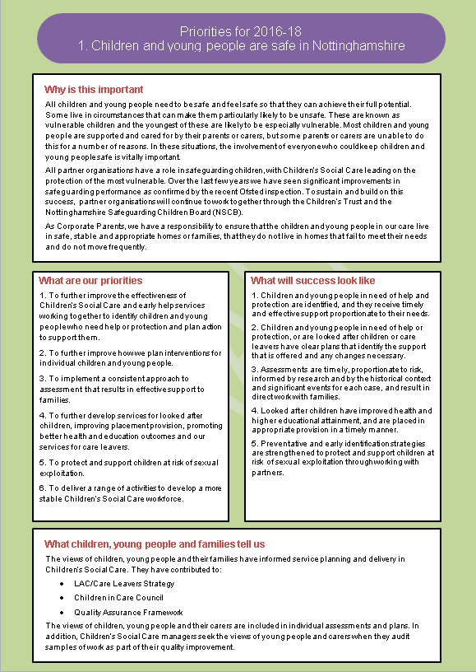

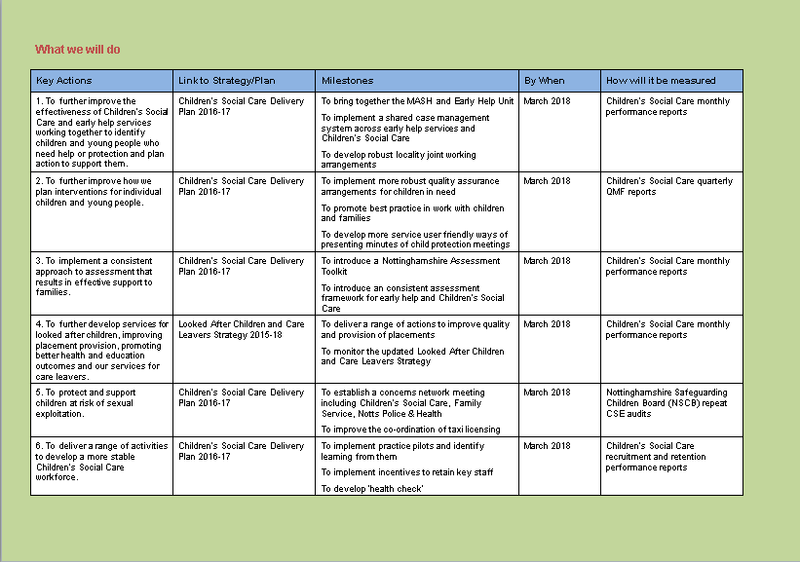
Appendix B – Related Priorities in Key Strategic Plans

Proposed priority for the CYPF Plan 2016-2018 | NCC Delivery Plan 2014-18 | Health and Wellbeing Strategy 2014-17 | NSCB Business Plan 2014-16
Children and young people are safe in Nottinghamshire | The most vulnerable children and adults will be effectively protected and supported | Work together to keep children and young people safe | To ensure that the work of the NSCB and its partner agencies is focussed on the most vulnerable  To provide effective scrutiny of safeguarding outcomes for children (including workforce development, procedures & guidance)  To strengthen the role and engagement of partner agencies in the work of the NSCB  To ensure frameworks to support safeguarding are in place and that the NSCB is effective at the delivery of its core purpose
Children and young people are happy and healthy in Nottinghamshire |  | Improve children and young people's health outcomes through the integrated commissioning of services
Children and young people achieve their potential in Nottinghamshire | More young people will be in work, education or training  Our children and young people will attain higher educational standards than the national average in good and outstanding schools  The attainment gap in education continues to close for all ages  Additional school places will be available where they are most needed  Young people are supported to reach their potential | Close the gap in educational attainment
Children and young people and families receive support when required in Nottinghamshire | Children and young people receive the help and support they require to be safe and thrive | Provide children and young people with the early help support they need
 |  | Deliver integrated services for children and young people with complex needs or disabilities

